Canine Vaccination Record

Dog’s Information:

Name

Veterinarian

Registration# & Association (if applicable)

Breed

Markings

Date of Birth Sex

Owner’s Information:

Name

Address

City |  |  | State |  |  | Zip
Phone

Vaccination Record
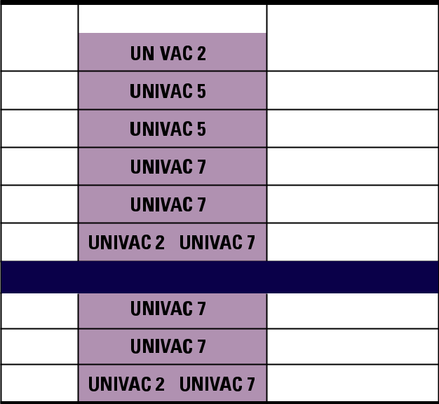

Age | Vaccines |  | Immunization Date
6 wks

9 wks

12 wks

15 wks

18 wks

Annual

Adult Dogs (over 18 weeks of age without previous vaccination)

Initial

Booster*

Annual

Note: It is important to


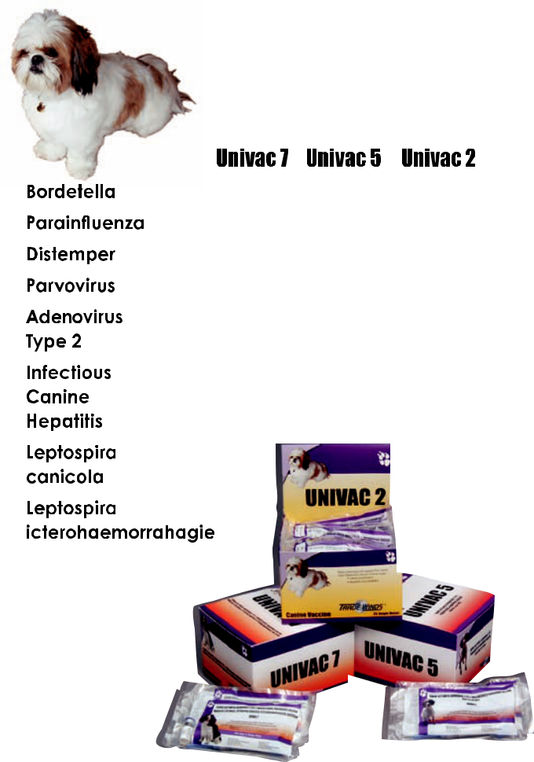
keep your pets’

vaccination records

current. Use attached

form for your records.


®


Dg








SafeEasyEconomical



CANI-0040 Rev 0110




1

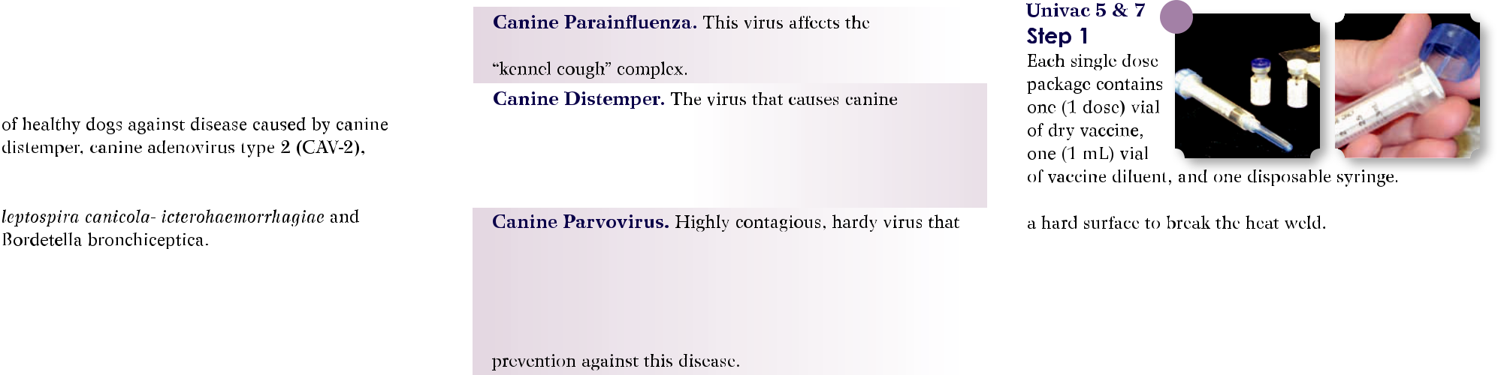

2

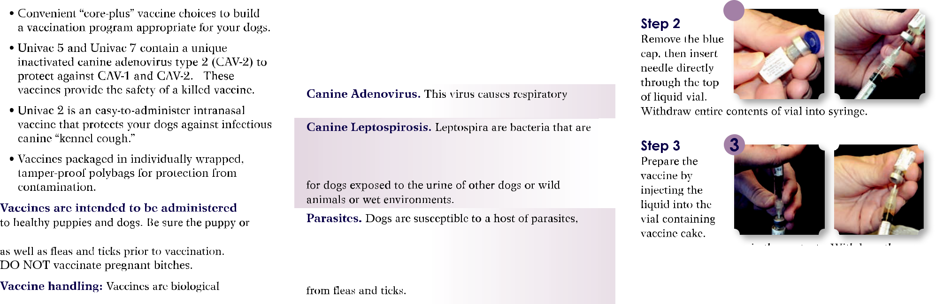

4

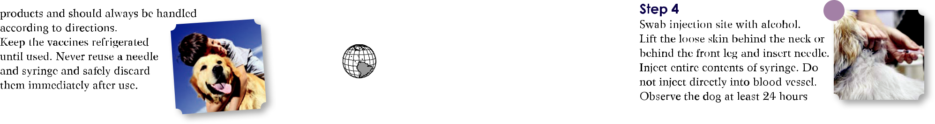

 877-734-7565

TradeWindsForPets.com

