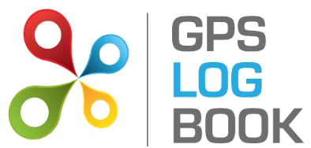

SAMPLE User Manual

Table of Contents

1 | Introduction ......................................................................................................................................... |  |  | 3
 | 1.1 | Who can benefit from keeping an accurate Log Book .......................................................................................................................... |  | 3
 | 1.2 | Key Features of GPS Log Book ............................................................................................................................................................. |  | 3
2 | In the Box ............................................................................................................................................. |  |  | 4
3 | Technical Specifications ........................................................................................................................ |  |  | 4
4 | Requirements ....................................................................................................................................... |  |  | 4
 | 4.1 | Minimum PC Requirements................................................................................................................................................................. |  | 4
 | 4.2 | Supported web browsers include ........................................................................................................................................................ |  | 4
5 | Using the Device .................................................................................................................................. |  |  | 4
 | 5.1 | Guidelines on how to use the GPS Log Book device ............................................................................................................................. |  | 4
 | 5.2 | LED Information .................................................................................................................................................................................. |  | 5
6 | Getting Started .................................................................................................................................... |  |  | 5
 | 6.1 | Download the GPS Log Book Sync Application ..................................................................................................................................... |  | 5
 | 6.2 | Plugging your device into the computer for the first time .................................................................................................................... |  | 6
 | 6.3 | Upload Data from the GPS Log Book Device ...................................................................................................................................... |  | 10
 | 6.4 | Register an Additional Vehicle ........................................................................................................................................................... |  | 10
7 | Managing Trip Data ............................................................................................................................ |  |  | 12
 | 7.1 | Trips Page ......................................................................................................................................................................................... |  | 12
 | 7.1.1 | Create and Edit Zones ....................................................................................................................................................... |  | 12
 | 7.1.2 | Change designation of a trip ............................................................................................................................................. |  | 13
 | 7.1.3 | View Trip detail ................................................................................................................................................................. |  | 14
 | 7.1.4 | Add a comment about a specific trip ................................................................................................................................ |  | 14
 | 7.1.5 | Snap To Zone ..................................................................................................................................................................... |  | 14
 | 7.1.6 | Selected Zone .................................................................................................................................................................... |  | 14
 | 7.2 | Zones Page ........................................................................................................................................................................................ |  | 15
 | 7.2.1 | Create a New Zone ............................................................................................................................................................ |  | 15
 | 7.3 | Reports ............................................................................................................................................................................................. |  | 16
 | 7.3.1 | SARS Vehicle Tax Log Book ................................................................................................................................................ |  | 16
 | 7.3.2 | Business Travel Clam Report ............................................................................................................................................. |  | 17
 | 7.3.3 | Trip List for All Vehicles ..................................................................................................................................................... |  | 18
 | 7.3.4 | Trip List for All Vehicles CSV .............................................................................................................................................................. |  | 18
 | 7.3.5 | Zone Detailed Report ........................................................................................................................................................ |  | 19
8 | Managing the Account ........................................................................................................................ |  |  | 20
 | 8.1 | Update Details .................................................................................................................................................................................. |  | 20
 | 8.1.1 | Edit Personal Details ......................................................................................................................................................... |  | 20
 | 8.1.2 | Change Password .............................................................................................................................................................. |  | 20
 | 8.1.3 | Settings .............................................................................................................................................................................. |  | 20
 | 8.1.4 | Personal Selection ............................................................................................................................................................. |  | 20
9 | Recommendations .............................................................................................................................. |  |  | 21
GPS Log Book – User Manual |  |  | www.gpslogbook.co.za | Page 1 of 21

9.1 Upload Data Every Two Weeks 21

9.2 Update Vehicle Information 21

10 Frequently Asked Questions 21

GPS Log Book – User Manual www.gpslogbook.co.za Page 2 of 21
1 Introduction

Maintaining an accurate log book can be a tedious affair. The GPS Log Book is a simple device that, together with an online system, greatly simplifies and assists this process. The benefits of the additional tax savings make it a very worthwhile device to own.

Keeping an accurate log book of business and personal travel is not only required as a legal prerequisite by the South African Revenue Service (SARS) if travel expenses are to be claimed, it also allows claims to be based on the actual distances travelled. Without a Log book it would not be possible to claim for travel deductions.

1.1 Who can benefit from keeping an accurate Log Book

- Sole proprietors, commission earners

- Employees who receive a travel allowance

- Employees, directors, members who use a company owned vehicle

1.2 Key Features of GPS Log Book

- User friendly and well-designed online system

- SARS Compliance

- Google Maps used to display trips

- Customisation of start and end points (zones) specific to any trip

- One year warranty period from date of purchase

- Easy to add new vehicles

- Easy to use on different computers

- Ample storage capacity

- Frequent recording interval on the device

- No annual or monthly subscription fees are associated with the GPS Log Book and related services

GPS Log Book – User Manual www.gpslogbook.co.za Page 3 of 21
2 In the Box

When receiving the GPS Log book, the following items will be found in the box:

- GPS Log Book device

- Illustrated quick start guide

- USB Cable

3 | Technical Specifications
 |  | Component | Rating
 |  | Assisted GPS | High sensitivity 50 Channel GPS with a maximum accuracy of 2.5m
 |  | Power supply (input voltage range) | 8V - 30V DC with transient protection. Internally fused at 8A.
 |  | Power supply (average current draw) | Approximately 45mA acquiring, 35-40mA tracking
 |  | USB Charger | 5V, max 1A continuous
 |  | USB interface to PC | HID (Human Interface Device) via a USB Mini-B cable.
 |  | Super capacitor | Sufficient charge to hold the GPS time and data for > 8 hours.
 |  | Internal Flash Memory | 4Mbytes total, 3.6Mbytes for trip data.
 |  | Metal components | Nickel plated mild and spring steel
 |  | Plastic | ABS Plastic
 |  | LED | Tri colour
 |  | Operating temperature | -10 to + 60 degrees C with 0.5A charging load
 |  | Dimensions | 102mm x 41mm x 22mm

4 Requirements

4.1 Minimum PC Requirements

The minimum requirements for running the software required to operate the GPS Log Book are listed below:

- Microsoft Windows 7 / Vista / XP SP2

- MAC OS X 10.4 or later

- Internet Connectivity

- 1 x USB port

4.2 Supported web browsers include

- Microsoft IE8 or greater

- Mozilla Firefox

- Google Chrome

5 Using the Device

5.1 Guidelines on how to use the GPS Log Book device

Once the GPS Log Book device has been removed from the packaging, it is ready to start recording the first trip:

- Plug the device into the 12V outlet / cigarette lighter of the vehicle.

- Turn the ignition of the vehicle on.

GPS Log Book – User Manual www.gpslogbook.co.za Page 4 of 21
- The LED will be solid red – this indicates that the device has not yet found its position and is searching for satellites.

- The LED will turn green – this indicates that the device has found its location and tracking is in progress.

- The vehicle can now be driven and the GPS Log Book device will record the trip.

- Remove the device at any stage to stop the recording.

NOTE:

The device will end a trip when it loses power. Some vehicles’ 12V outlet / cigarette lighter do not switch off when the ignition is turned off. In these cases the device will stop recording data and go into a low power mode when the vehicle does not move for 5 minutes.

5.2 | LED Information
 | Red | The log book has power and is searching for satellites
 | Green | The log book has found satellites and is logging
 | Flashing Red | The log book is 80% full and will need to be connected to the server soon to upload the data (see
 |  | below).

NOTE:

- If the solid Red does not turn Green then the device is unable to find any satellites (e.g. if the vehicle is parked in a basement) and no data will be recorded.

- It is recommended that the device is synchronised at least every 11 to 14 days. This will ensure optimal GPS performance is maintained.

- The log book will find satellites faster if it has valid aiding data. Roughly speaking, aiding data gives the GPS an idea of where to start looking for satellites and hence helps it to find its location faster. This data will be loaded onto the device almost every time it is connected to the computer, and is valid for 14 days.

6 Getting Started

6.1 Download the GPS Log Book Sync Application

The Sync Application is the application used to read data off the device and send it to the GPS Log Book server for processing and storing. Download and install this application before connecting the GPS Log Book device to your computer/laptop for the first time

- Navigate to the Downloads page of the GPS Log Book website www.gpslogbook.co.za/downloads
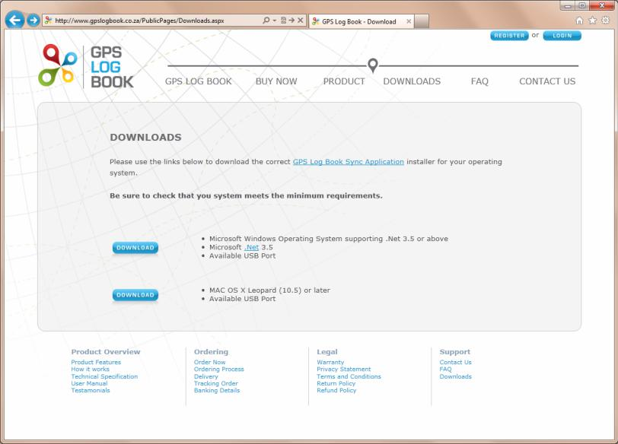

- Ensure that the system requirements of the computer or laptop in use, meet those listed on the page.

- Click on the relevant download icon.

GPS Log Book – User Manual www.gpslogbook.co.za Page 5 of 21
In the case of a computer running Microsoft Windows, the following steps are applicable.

- If anti-virus software is installed on the computer, it may ask for confirmation that the download is allowed.

- Once the file is downloaded, start the installation by running the downloaded file.

- The GPS Log Book Sync Setup Wizard will open in a new window, and the installation will begin immediately. Please wait while the files are installed.

- When the installation is complete click on Finish to end the Sync App installation process.

Now you are ready to connect your device for the first time.

6.2 Plugging your device into the computer for the first time

The first time the device is connected to the computer, the computer will attempt to install a driver. The Sync Application will then run, communicate with the server, and automatically load the Register Device page on the website in order to capture details that will be associated with that specific GPS Log Book device.

- Connect the GPS Log Book device to the computer using the USB cable provided.

- The computer will install the device driver software. Please wait for this to complete.
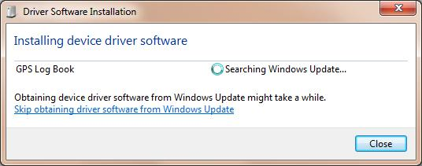

- Once the driver has installed, the Sync Application will automatically load the Register Device page.

- The website will open in your browser and you will be asked to either register a new account or use an existing account.
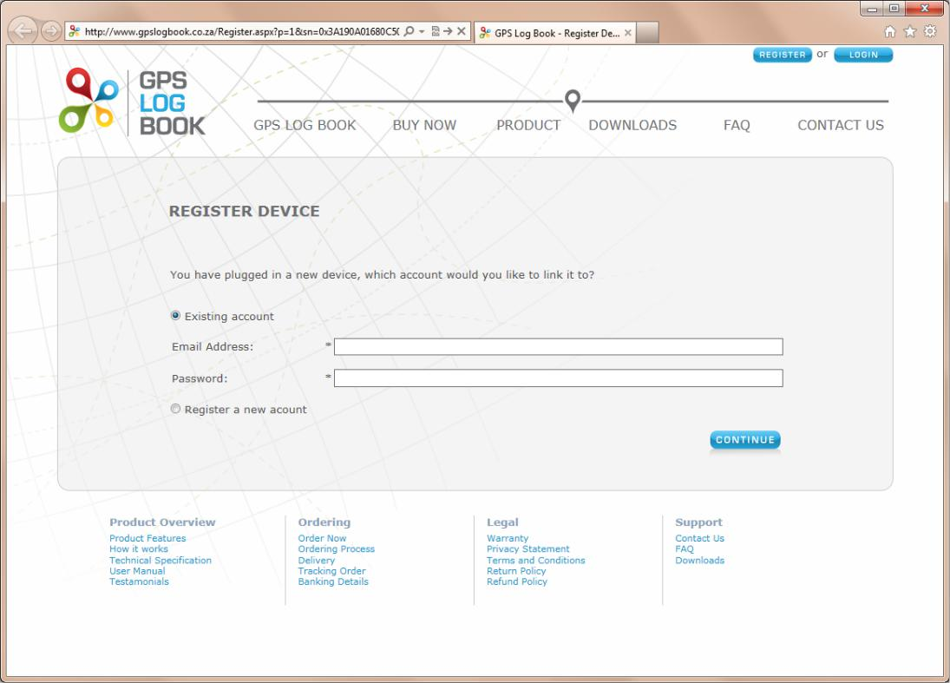

- If you have not setup an account before, select “Register a new account” and click the continue button. If you have already registered an account go to step 6.

GPS Log Book – User Manual www.gpslogbook.co.za Page 6 of 21
5.1. You will be asked to give some personal details, information about the vehicle you intend to use the device in and some optional tax details. You will also have to give your device a name. This will make it easy to differentiate between devices, if you have more than one linked to your account.
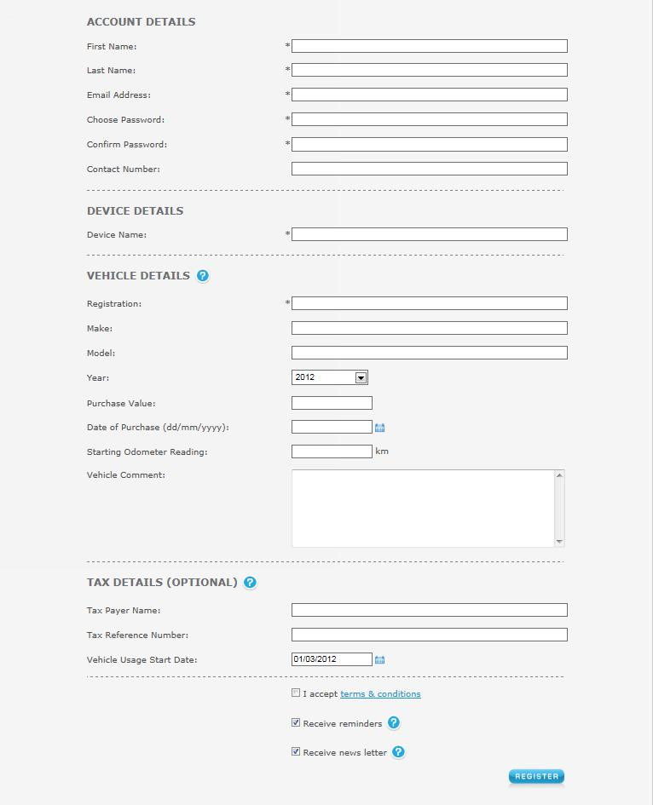

GPS Log Book – User Manual www.gpslogbook.co.za Page 7 of 21
5.2. Once you click register your will see the page below. You can close this window and wait for your account validation email.
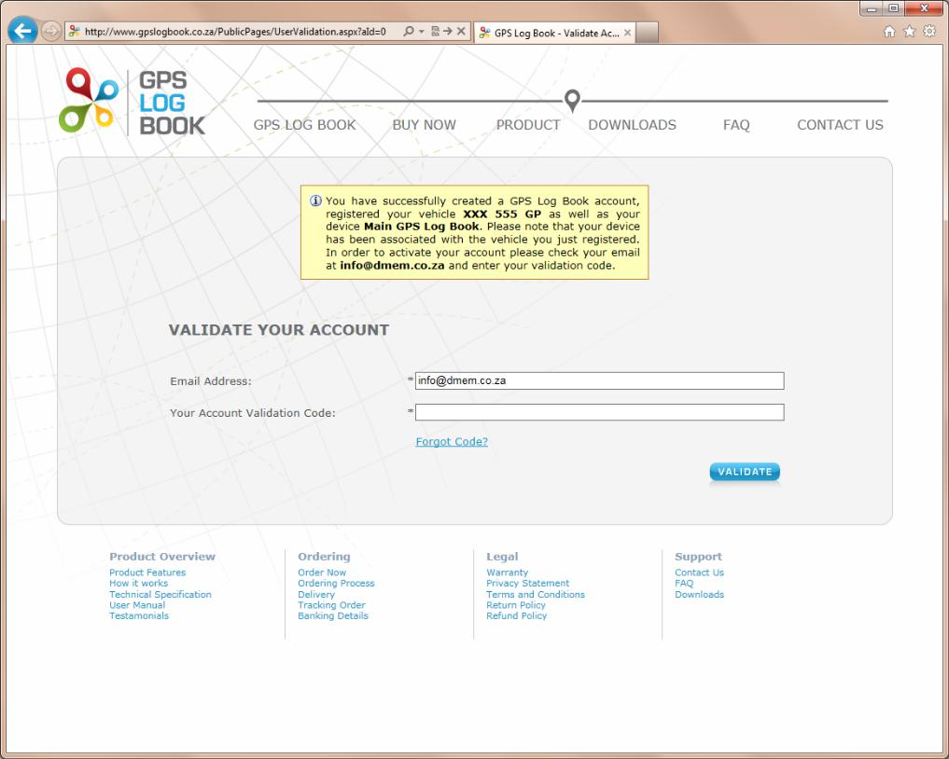

5.3. Once you receive your account validation email, click on the first link to validate your email address.
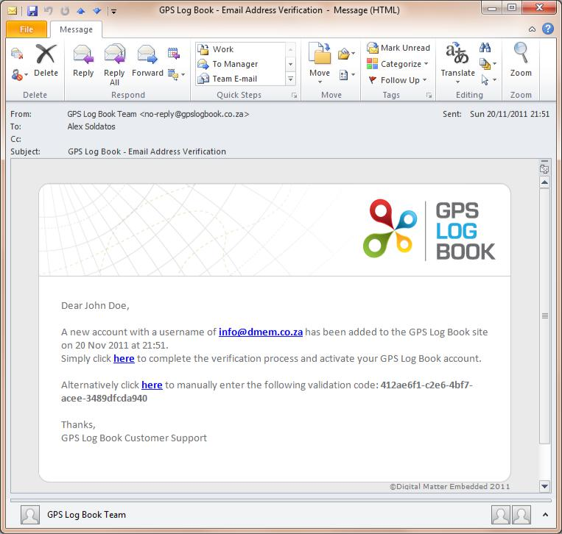

5.4. You are now ready to start using the system! (Step 6 is not required!)

GPS Log Book – User Manual www.gpslogbook.co.za Page 8 of 21
- If you already have an account, fill in your login details and click on the Register button. (If you performed step 5, skip this step) 6.1. You will now see the Register Device page like the picture below.
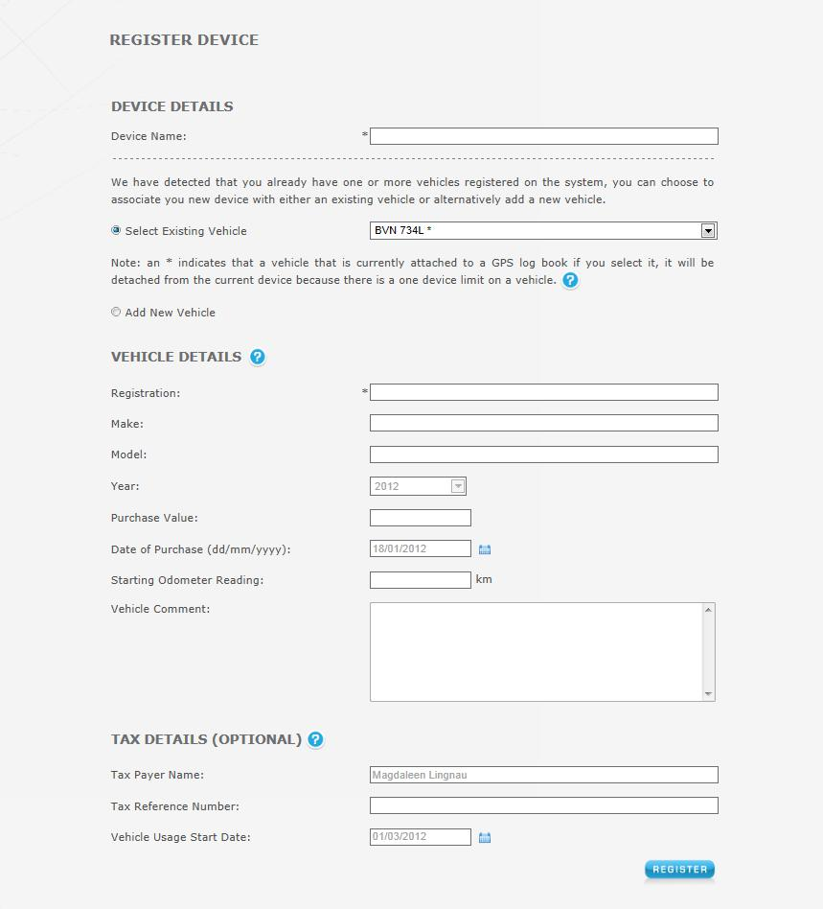

6.2. You can now give your device a name, select an existing vehicle or create a new one, and enter the optional tax details.

6.3. Click the Register button to complete the process.

GPS Log Book – User Manual www.gpslogbook.co.za Page 9 of 21
6.3 Upload Data from the GPS Log Book Device

After successfully creating an account and registering your device, you are ready to upload trip data to the website.

- Connect the GPS Log Book device to the computer using the USB cable provided.

- The Sync Application will automatically download any trip data from the device and upload it to the GPS Log Book server.

- The LED on the device will turn Red while data transfer is in progress.

- Once all the data has been downloaded from the device and new aiding data downloaded to the device, a message will be displayed stating that it is safe to disconnect the device and the LED on the device will turn Blue.
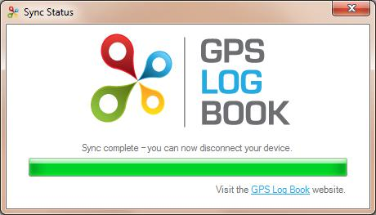

6.4 Register an Additional Vehicles

The following process outlines how to add additional vehicles to an existing account. Please note that a device can only have one active vehicle linked to it. This means that even if you have multiple vehicles registered only one can be linked to a specific device. All the trips recorded by the device will be assigned to the active vehicle.

- Navigate to the Account tab on the main menu and select Vehicles from the drop down list.

- A list of vehicles associated to the account will be displayed.
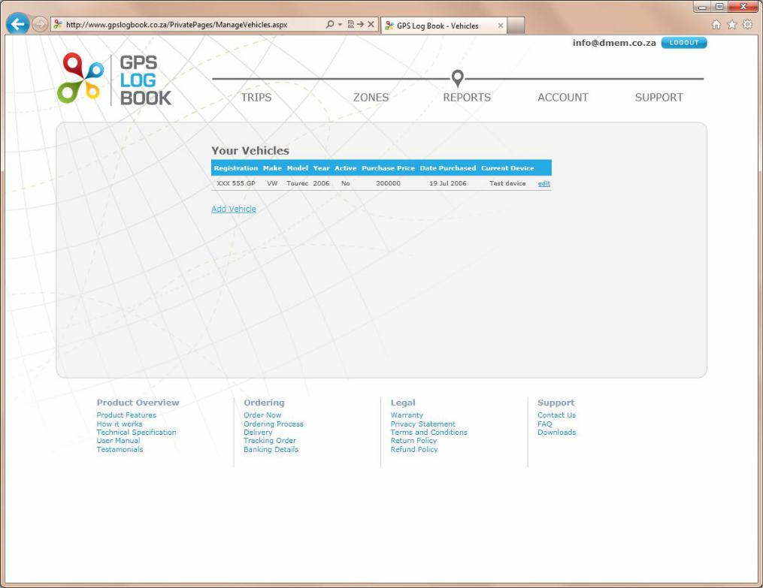

GPS Log Book – User Manual www.gpslogbook.co.za Page 10 of 21
- Click on Add Vehicle to register a new vehicle.

- Enter all the information relating to the new vehicle and click Save when done.
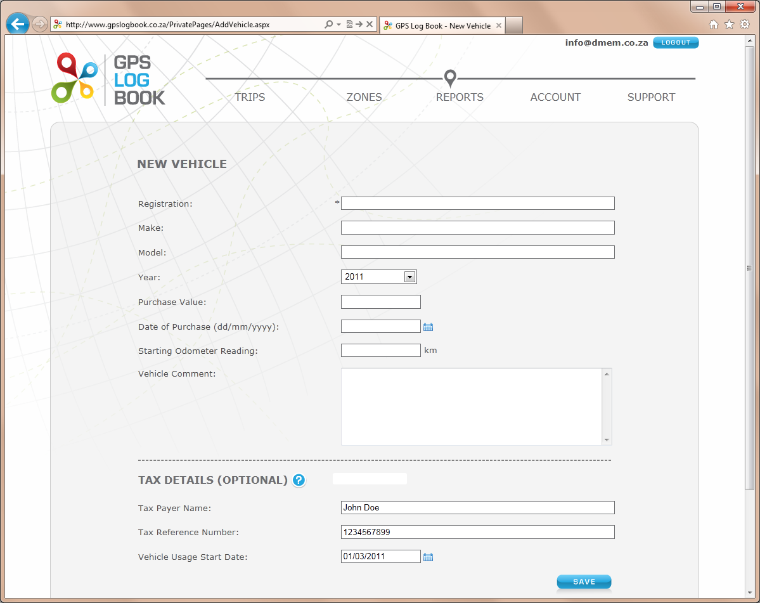

- The new vehicle information will now be visible in the Vehicles table.

GPS Log Book – User Manual www.gpslogbook.co.za Page 11 of 21

7 Managing Trip Data

7.1 Trips Page

The GPS Log Book system will display all the trips for a specific vehicle. The account user has the ability to perform the following functions under the Trips section:

7.1.1 Create and Edit Zones

The zone is the area in which any given trip starts or ends. If it is the first time you view your trips all the zones will be labelled “Unknown”. To create a zone at that point, click on the “Unknown”. You will then be presented with the “Create new zone” dialog.
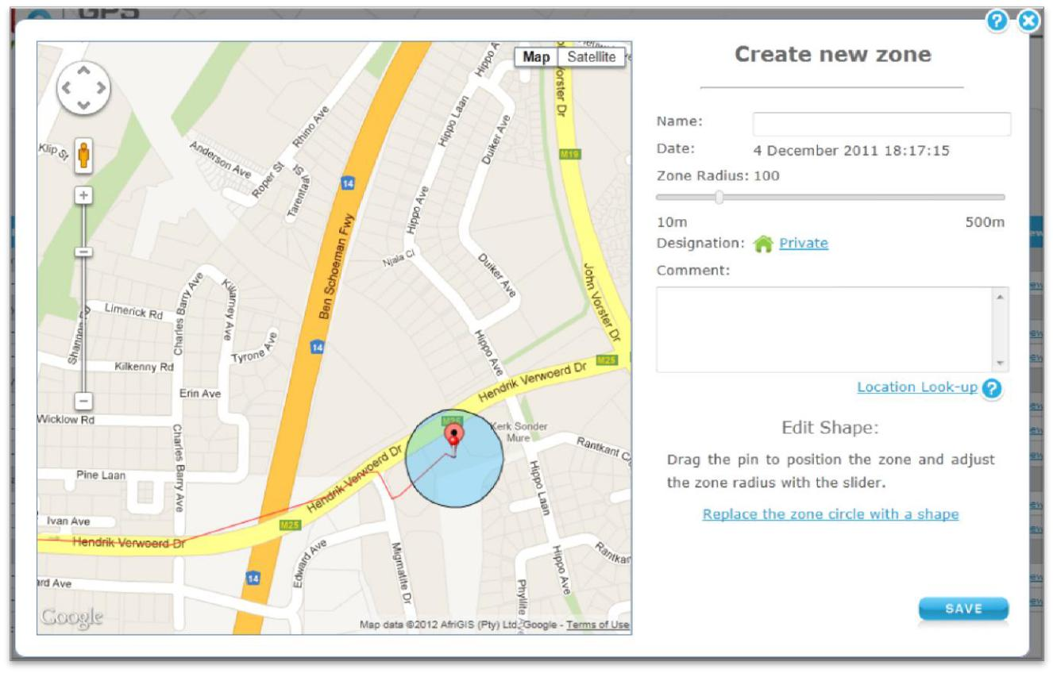

The default zone radius is set to 100m. This can be changed at any stage and may be increased to a maximum of 500m and minimum of 0m. The zone radius is the area directly surrounding the point at which the trip started or ended. You can also change the zone to be a polygon or shape instead of a circle, by clicking on the “Replace the zone circle with a shape” link. If you click the “Location Look-up” link, the web page will attempt to get the closest street address from Google Maps and display it in the Comment box.

You can at any time change any of the information about the zone, including in the shape and size of the zone, by clicking on the name of the zone in the trip table.

Click Save when you are done with creating or changing the zone. To undo the changes click on the cross in the top right-hand corner of the dialog box.

Once you have created or update a zone, all the trips will be reprocessed and the new zone will be applied to the trips and the trip table will be update to reflect the change.

GPS Log Book – User Manual www.gpslogbook.co.za Page 12 of 21
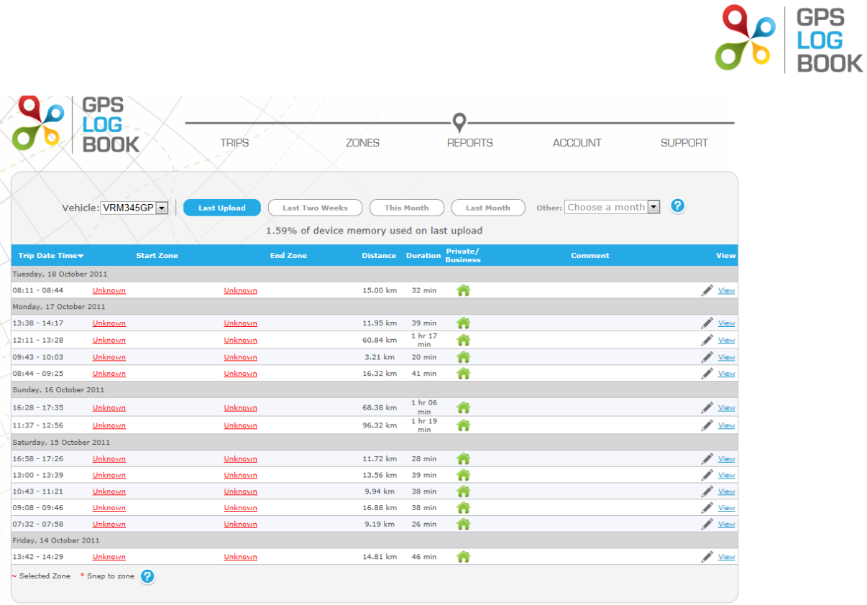

7.1.2 Change designation of a trip

There are only two types of designation for a trip, business or private. It is important to indicate all business trips when claiming for business mileage in a tax return. To change the designation of a trip, click on the icon adjacent to the trip and it will change from personal (a picture of a house) to business (a picture of a briefcase) or vice versa. The designation can also be changed in the View Trip screen.
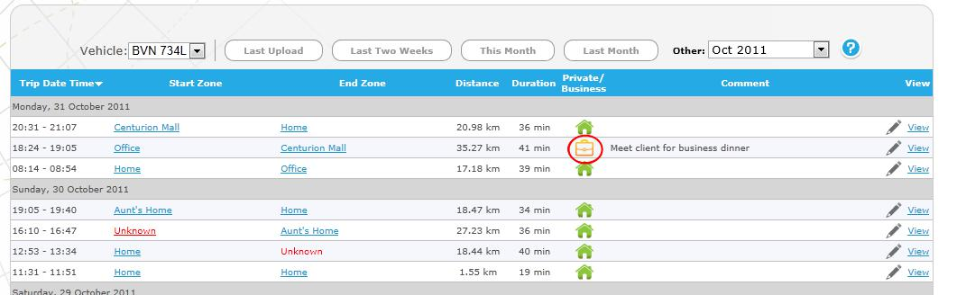

GPS Log Book – User Manual www.gpslogbook.co.za Page 13 of 21
7.1.3 View Trip detail

To view the detail of a trip, click on View. The trip will be displayed on a map showing the trip in red. The trip can then have a comment added, or can be deleted. It is also possible to move to the next or previous trip from this page. Any changes made to the trip will be saved when you close the dialog or click the next or previous button. You must undo the changes manually if you don’t want to keep them.
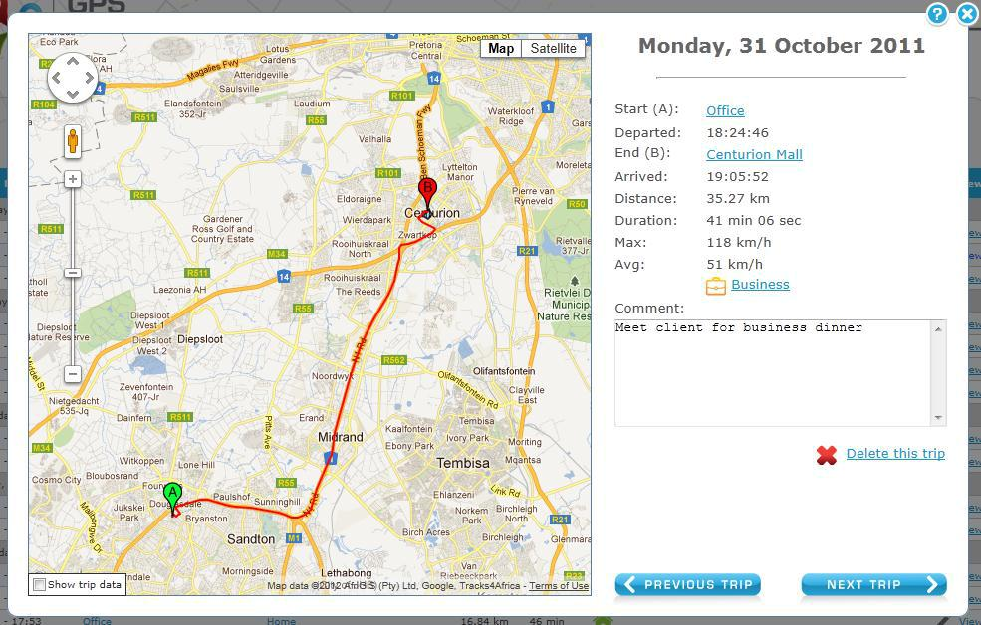

7.1.4 Add a comment about a specific trip

To add a comment to a trip, click on the comment field in the table or click on “View Trip”.
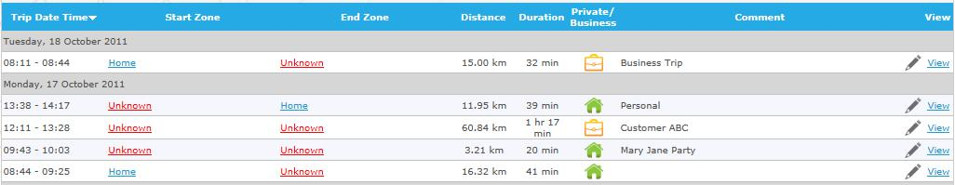

7.1.5 Snap To Zone

When a trip starts or ends within the snapping distance of a specific zone, that zone will automatically be selected. The zone selected will be referred to as a Snapped Zone. These zones will have an asterisk (*) next to them on the Trip Table.

7.1.6 Selected Zone

If a starting or end point cannot be ‘snapped’ to a nearby zone, it is then possible to select an existing zone. Select the zone to be edited and then select the nearby zone from the drop down list provided. The assigned zone is referred to as a Selected Zone and will be marked with a tilde (~) next to the zone name on the Trip Table.

GPS Log Book – User Manual www.gpslogbook.co.za Page 14 of 21
7.2 Zones Page

The Zone Table contains all zones that have been created. The zones can be edited or deleted from this table. It is also possible to add a comment or change the designation of the zone from this page.
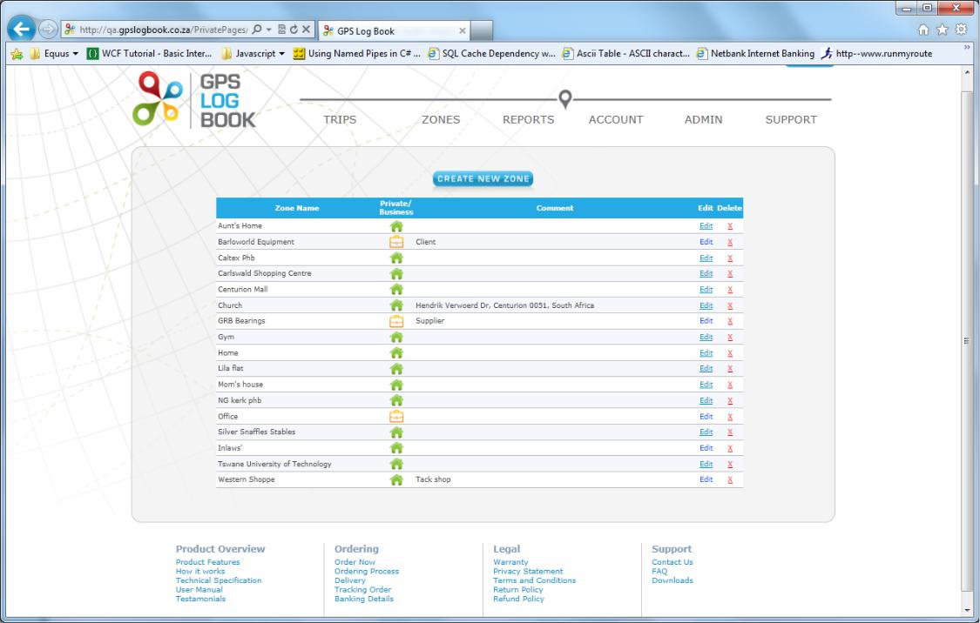

7.2.1 Create a New Zone

To create a new zone, click on the Create New Zone button on the Zones page. A dialog will be displayed with a map of the world as well as an option to draw a circle or a specific shape. Once the specific location on the map where the zone is to be created has been found using the Google Maps controls, the pin can be dragged to the relevant area, or the outline of the area defined. The zone can be named, and the correct designation selected. The new zone will then be added to the Zone Table.
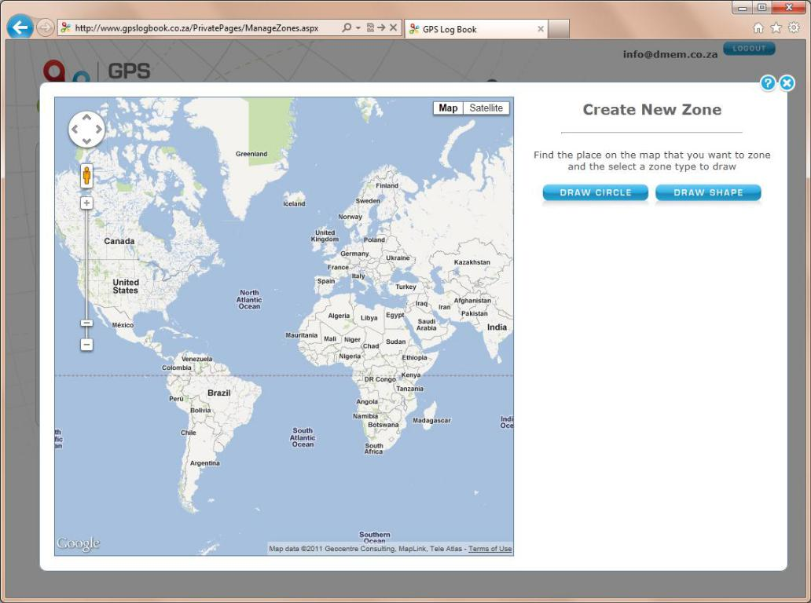

GPS Log Book – User Manual www.gpslogbook.co.za Page 15 of 21
7.3 Reports

There are five of reports that are available on the GPS Log Book website. These can be found under the Reports tab.
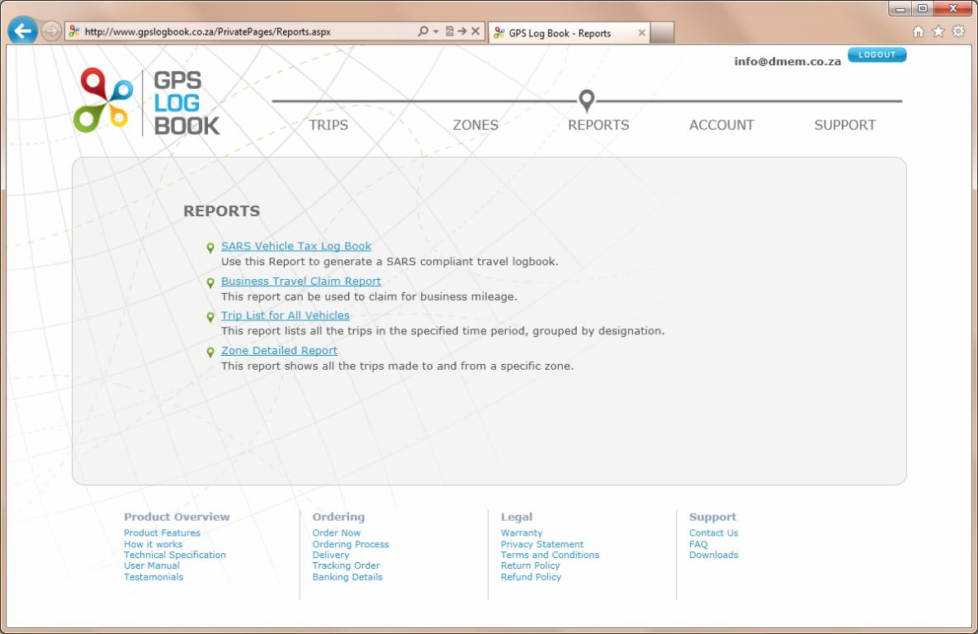

7.3.1 SARS Vehicle Tax Log Book

The SARS Vehicle Tax Log Book a report that is generated when it is time to submit a tax return to SARS. A vehicle has to be selected for which the report is to be generated. Additional information is then required to complete the Log Book. Only trips that have been marked as business under the ‘Trips’ page, will appear on these reports.
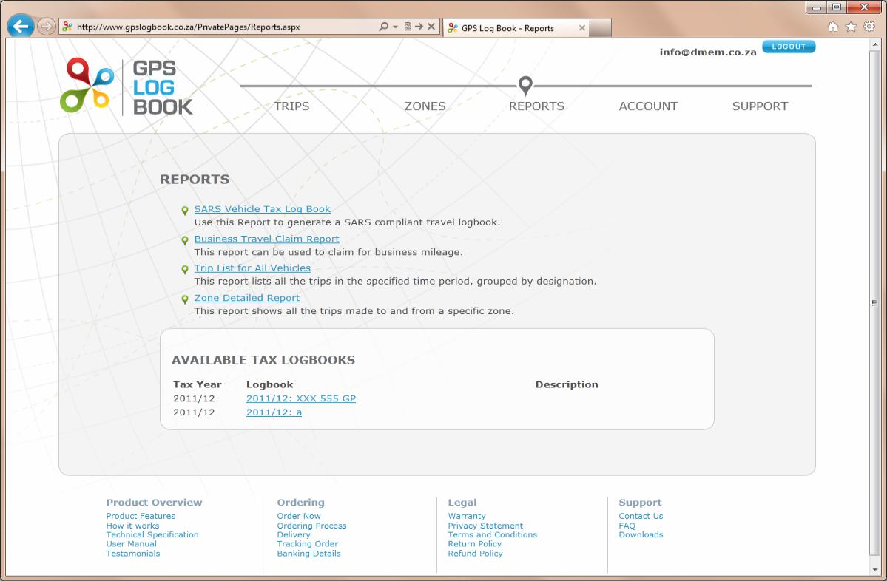

GPS Log Book – User Manual www.gpslogbook.co.za Page 16 of 21
There are three options for viewing the report and each is available for download (in a PDF format):

- Business Trips Report

- Summary Report

- Detailed Report

7.3.2 Business Travel Clam Report

This report can be used to claim for business mileage. Only trips that have been marked as business under the ‘My Trips’ page, will appear on this report.
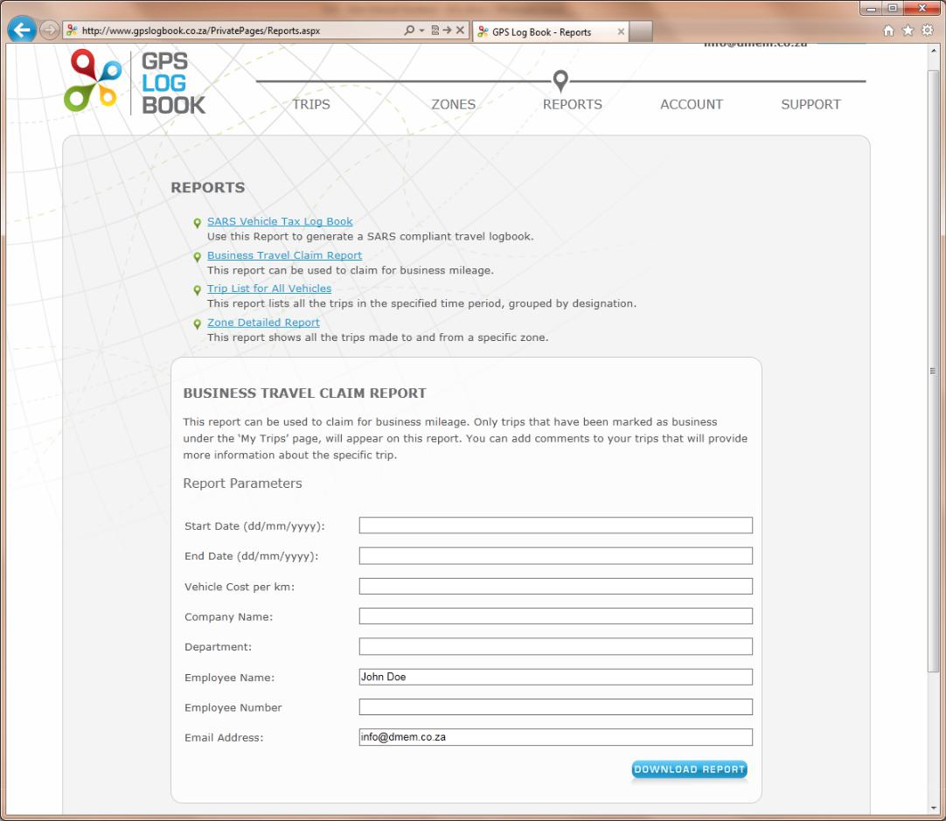

GPS Log Book – User Manual www.gpslogbook.co.za Page 17 of 21
7.3.3 Trip List for All Vehicles

This report lists every trip for every vehicle linked to the account, within the selected date range. Trips are grouped by vehicle and designation (private or business).
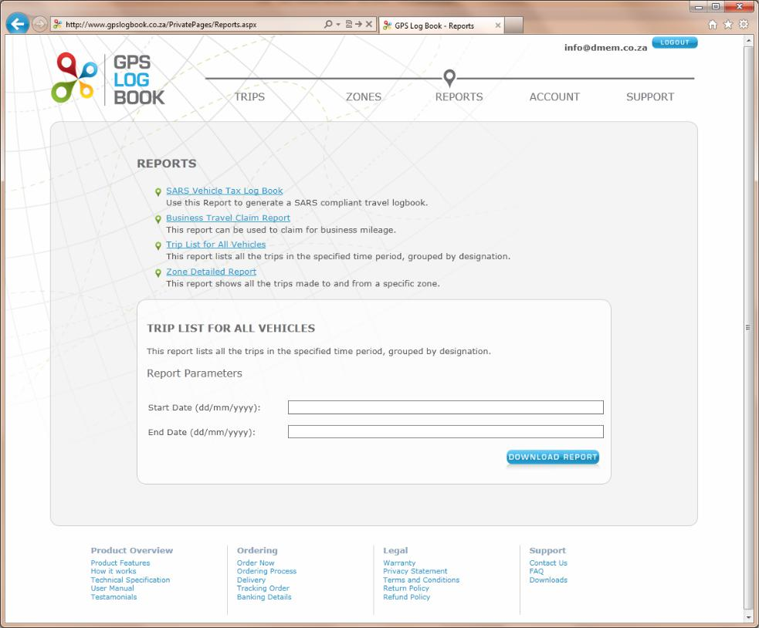

7.3.4 Trip List for All Vehicles CSV

This report lists all the trips made by all the vehicles linked to the account, ordered by date and time. It is exported to a csv file that can be viewed with any spread sheet editing software, such as Excel

GPS Log Book – User Manual www.gpslogbook.co.za Page 18 of 21
7.3.5 Zone Detailed Report

The Zone Detailed Report shows all the trips that have been made to and from a specific zone. This report is valuable if information is required for business trips to a specific customer or supplier for example. The zones that are currently listed under the account will display in a drop down list before the report is generated.
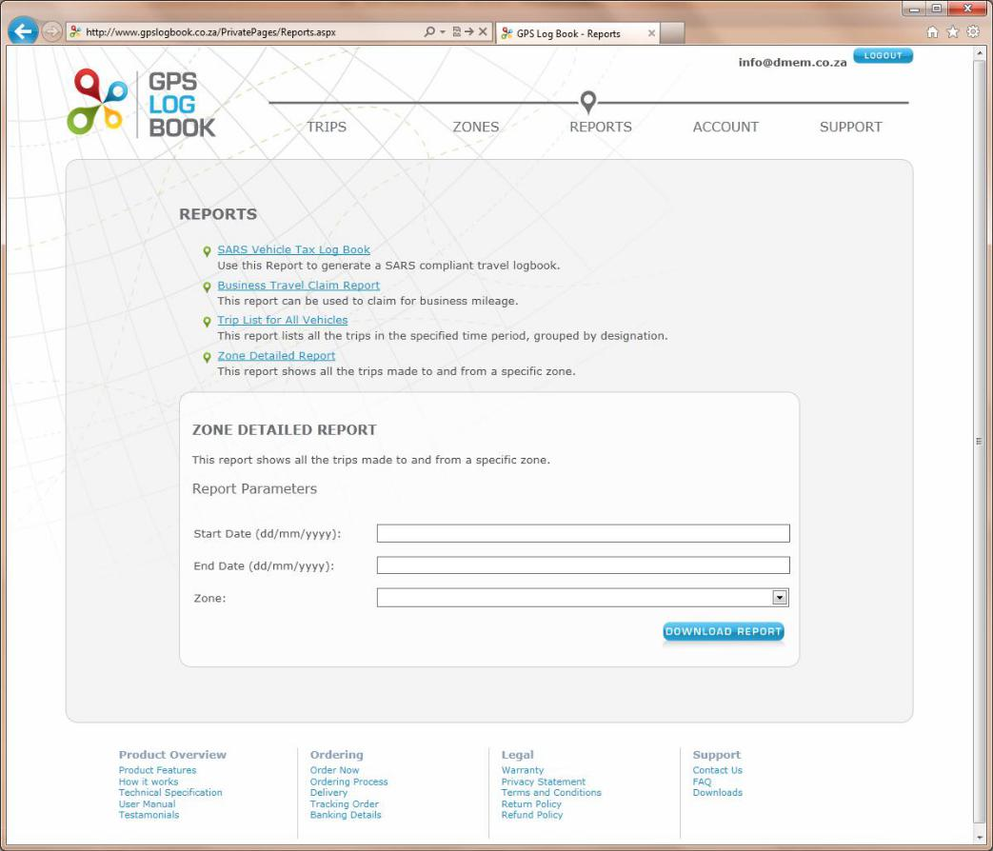

GPS Log Book – User Manual www.gpslogbook.co.za Page 19 of 21
8 Managing the Account

8.1 Update Details

8.1.1 Edit Personal Details

Once logged in, it is possible to change the name, surname, contact number or email address of the user in the Update Details menu under Account. Save changes by clicking on the Save button at the bottom of the page.

8.1.1.1 Change Email Address

In order to change an email address, the user will be required to enter and confirm the new email address before this will be changed. An email will be sent to the new email address to verify that the change is correct. An email confirming the change will also be sent to the old email address.

8.1.2 Change Password

To change your login password go to the Update Details page. Scroll down to the Reset Password section and enter the current password and the new password. Please remember to click Save after the new password has been entered.

If you have forgotten your password and cannot log in, go to the Login page and hit the “Reset Password” link. Enter your username (email address used with your account) and hit the Reset button. A new password will be emailed to you. You should be able to log in now using this password. It is recommended that you change your password back to something that is easier to remember.

8.1.3 Settings

It is possible to change the settings that are used to process trip data and display information about trips and zones that are created.

8.1.3.1 Snapping Distance

When a trip starts or ends just outside a zone, that zone will be assigned to the trip if it is within the “snapping distance”. This is useful when, for example, you forget to plug your device in before you drive off or the device takes too long to find a satellite which causes the trip to start just outside a known zone. You can change this zone by creating another zone at that point or selected one of the other nearby zone (if any exist).

8.1.3.2 Minimum Trip Time

Any trips shorter than this time period will not appear in the trip list. This could be caused by switching the car’s ignition on and then immediately off again.

8.1.3.3 Minimum Trip Distance

Any trips shorter than this distance will not appear in the trip list.

8.1.3.4 Nearby Zone Metres

Any zone that falls within this distance of a trip start or end point is considered a nearby zone. Only nearby zones are shown as alternatives to snapped zones when editing a trip.

8.1.4 Personal Selection

There are three additional preferences that can be updated. These include the following:

8.1.4.1 Receive Reminders

When selected, a notification email will be sent when the recommended time limit for uploading data has expired.

8.1.4.2 Receive Newsletters

When selected, the GPS Logbook newsletter will be emailed to the email address in the account. The newsletter contains information about Special Offers, Industry developments, and the latest GPS Logbook news.

8.1.4.3 Open Webpage on Device Upload

When selected, the trip list will be opened in the browser after the GPS Log Book device is plugged into the computer and has successfully uploaded data. The software must have been downloaded in order for this to happen.

GPS Log Book – User Manual www.gpslogbook.co.za Page 20 of 21
9 Recommendations

To get the most out of the GPS Log Book device and website, the following best practises are recommended.

9.1 Upload Data Every Two Weeks

It is highly recommended that the GPS Log Book device is synchronised to the website at least every two weeks. This is ensures that the GPS aiding data is updated and the trip data is saved onto the system. Updates should be done at least once a week to achieve the best results.

9.2 Update Vehicle Information

The odometer reading is crucial for the generation of a SARS Vehicle Tax Log Book. It is recommended that the odometer reading of the vehicle is accurately recorded from the date that the GPS Log Book system is first used.

10 Frequently Asked Questions

The FAQ’s can be viewed on the GPS Log Book website www.gpslogbook.co.za under the Support menu

GPS Log Book – User Manual www.gpslogbook.co.za Page 21 of 21

