
BUILDING USER GUIDE

Building user guide template

Insert picture of your building in box

Address:

Responsibility

of:

Building User Guide Issue

Number:

Date:

This Building User Guide should be kept at all times in:

Electronic version located at:

Position

:

Prepared by:

 | BUILDING MANUALS AND BUILDING USER
GUIDES | 1
 | © BSRIA BG 26/2011


BUILDING USER GUIDE

CONTENTS

 | 1 |  | 5
 | 1 BUILDING SERVICES INFORMATION |  | 5
 | 1.1 | General building information | 5
 | 1.2 | Building environment | 9
 | 1.3 | Lifts and escalators | 9
 | 1.4 | Security system | 10
2 | EMERGENCY INFORMATION |  | 12
 | 2.1 | Fire response and alarm system | 12
 | 2.2 | Fire evacuation procedures | 12
 | 2.3 | First aid | 13
3 | BUILDING UTILITY AND ENVIRONMENTAL INFORMATION |  | 14
 | 3.1 | Overview of company policy and practices | 14
 | 3.2 | Energy and environmental strategy | 14
 | 3.3 | Annual building energy consumption | 15
 | 3.4 | Energy conservation | 15
 | 3.5 | Mechanical | 16
 | 3.6 | Electrical | 16
 | 3.7 | Communications | 17
4 | WATER MANAGEMENT |  | 18
 | 4.1 | Water strategy | 18
 | 4.2 | Domestic water | 19
5 | MATERIALS AND WASTE MANAGEMENT |  | 20
 | 5.1 | Materials purchasing policy | 20
 | 5.2 | Waste management policy | 20
6 | TRANSPORT FACILITIES |  | 21
 | 6.1 | Transport | 21
 | 6.2 | Parking | 21
7 | REFIT AND REARRANGEMENT CONSIDERATIONS |  | 22
 | 7.1 | Re-fit building/building sections | 22
 | 7.2 | Re-arrangement/addition of furniture | 23
8 | REPORTING PROVISION |  | 24
 | 8.1 | Reporting procedures | 24
 | 8.2 | Responsible parties | 25
9 | TRAINING |  | 26
 | 9.1 | Compulsory training | 26
 | 9.2 | Additional training | 26

- BUILDING MANUALS AND BUILDING USER GUIDES © BSRIA BG 26/2011

BUILDING USER GUIDE

BUILDING USER GUIDE PURPOSE

The Building User Guide provides the end users/occupants of the building with a simple, quick and easy guide to the everyday functions of the building in order to ensure a safe and healthy work environment while complimenting the efficient operation of the building to the full potential provided by the design.

The production of a Building User Guide in conjunction with the Building Manual based on these BSRIA guidelines will meet relevant BREEAM credit requirements. Within the Man 4 credit, the criteria relating to these documents are a minimum standard required for various BREEAM ratings depending on which scheme the assessment is being carried out under. In most cases this applies to excellent or better ratings, but some international schemes require the credit for good or better ratings.

It is intended that the Building Manual will focus on information that is relevant to the building and its operation; while the Building User Guide will focus on information relating to the management of people and how they interact with the building. For example, information on how to shut down the main gas supply in the event of a gas leak should be included in the Building Manual and information on the occupants fire evacuation procedures included in the Building User Guide.

With the gap that often exists between the design concept and the operators’ understanding of how the building works, the Building Manual and Building User Guide offer the opportunity to close this gap, and in doing so reduce excessive energy use and increased maintenance costs.

 | BUILDING MANUALS AND BUILDING USER
GUIDES | 3
 | © BSRIA BG 26/2011


BUILDING USER GUIDE

BUILDING USER GUIDE UPDATES AND REVIEWS

This user guide should be reviewed six monthly/annually (delete as necessary) and updated when changes to structure, layout, fabric or services of the building have been made. Any changes to the document including removal or adding of pages should be recorded.

Review

date

Description and

updates/changes

Pages updated or | Facilities manager
removed | signature

- BUILDING MANUALS AND BUILDING USER GUIDES © BSRIA BG 26/2011


BUILDING USER GUIDE

- BUILDING SERVICES INFORMATION

1.1 GENERAL BUILDING INFORMATION

Provide a general description of the building, location, design features, services and local infrastructure/amenities available. Provide a “Pre-arrival pack” or list of information to be passed on to planned visitors/contractors/new staff telephonically, electronically or by post as appropriate, when booking an appointment. Also provide details of any shared facilities including who has access to these, when, why and how. For example in a multi storey building where tenants have independent sections served by independent services, but have shared access via lifts and stairwells, or a business park with shared security access to communal visitor parking and dedicated tenant parking.

Building description

BUILDING SERVICES

Insert your picture here

Insert your picture here

Location map

 | BUILDING MANUALS AND BUILDING USER
GUIDES | 5
 | © BSRIA BG 26/2011

BUILDING SERVICES

6
BUILDING USER GUIDE


General floor plan – First floor

BUILDING MANUALS AND BUILDING USER GUIDES

© BSRIA BG 26/2011



General floor plan – Ground floor
BUILDING USER GUIDE

BUILDING SERVICES

 | BUILDING MANUALS AND BUILDING USER
GUIDES | 7
 | © BSRIA BG 26/2011

BUILDING SERVICES

BUILDING USER GUIDE


General site plan

Visitor information

Building shared facilities

- BUILDING MANUALS AND BUILDING USER GUIDES © BSRIA BG 26/2011


BUILDING USER GUIDE

1.2 BUILDING ENVIRONMENT

Include details on heating, cooling, ventilation, lighting and acoustics. Also include a brief description of distribution/attenuation method(s) and positioning of units (walls, floor, or ceiling). Provide a floor plan showing main control point locations and state the maximum and minimum set points, operational times, override/alternate settings. Also provide a brief description on who should adjust the temperatures on the main controls and how to and when to adjust the temperatures on main controls, and details of zone and or local user control settings such as TRVs on radiators, and detail optimum settings for efficient operation.

Element | Distribution/attenuation method | Photos
description

BUILDING SERVICES

Temperature control |  | Photos
Time schedule
Temperature
setpoints
Out-of hours
operation

1.3 LIFTS AND ESCALATORS

Include details on the following information: provide a floor plan showing location of the mechanical lifts/escalators and provide capacities of the lifts or escalators. Also provide a brief description on how to operate lifts/escalators with Emergency/stop button, information in case of fire, procedure in case of fault/failure, and call button/intercom.

How to operate lifts and escalators
Procedure | Description | Photo
Standard
operation
Emergency/stop
button.
In case of
fault/failure, call
button/intercom
In case of fire

 | BUILDING MANUALS AND BUILDING USER
GUIDES | 9
 | © BSRIA BG 26/2011

BUILDING SERVICES

BUILDING USER GUIDE


1.4 SECURITY SYSTEM

Include details on the type of security system, times for manual and automatic activation, and which personnel are authorised to activate or deactivate the system. Provide details of the entry and exit procedure during normal hours and outside of normal working hours and provide a list of personnel who are authorised to activate or deactivate the system. Include a list times for manual and automatic activation. Provide details of entry/exit procedure during normal hours and outside normal working hours.

Security system description

Links to external

organisation

Name and contact details of authorised | Telephone number
personnel

Normal operating | Times
Alarms off
Alarms on
Alarms on (out-of-office hours)

Entry procedure during normal working hours

Photos

- BUILDING MANUALS AND BUILDING USER GUIDES © BSRIA BG 26/2011



Exit procedure during normal working | Photos
hours

Entry procedure outside normal working | Photos
hours

Exit procedure outside normal working | Photos
hours
BUILDING USER GUIDE

BUILDING SERVICES

 | BUILDING MANUALS AND BUILDING USER
GUIDES | 11
 | © BSRIA BG 26/2011


BUILDING USER GUIDE

- EMERGENCY INFORMATION

Provide reference to master Health & Safety documents.

Health and Safety documents

2.1 FIRE RESPONSE AND ALARM SYSTEM

Type of alarm system

2.2 FIRE EVACUATION PROCEDURES

Include details on the procedure for calling the fire brigade, show locations of the fire escape routes and exit doors and assembly points outside the building in respective drawings in section 1.1.

Fire emergency procedure

Use of fire equipment

- BUILDING MANUALS AND BUILDING USER GUIDES © BSRIA BG 26/2011

BUILDING USER GUIDE

2.3 FIRST AID

Provide a link to the list of registered first-aiders in the building with, contact numbers and areas of responsibility, also include the level of first aid training (use of defibrillator if applicable). Also give the procedure on calling for assistance, for example, in an emergency – person collapsed, chest pain, difficulty breathing, or serious injury, or with an incident – person feeling unwell, a minor trip, fall or injury. Also provide a floor plan showing the location of first aid facilities or equipment.

Calling for assistance

Emergency first-aid procedure | Photo

EMERGENCIES

Minor injury/illness first-aid procedure

 | BUILDING MANUALS AND BUILDING USER
GUIDES | 13
 | © BSRIA BG 26/2011


BUILDING USER GUIDE

- BUILDING UTILITY AND ENVIRONMENTAL INFORMATION

3.1 OVERVIEW OF COMPANY POLICY AND PRACTICES

Provide an overview of the company policies and practices relating to company culture, desk-top policies, telephone equipment and protocol, media, email and internet protocols, dress code. If a canteen is provided include eating and drinking protocols. In addition include the facilities provided using dispensing machines for tea, coffee, cool drinks, and snacks. List recreational facilities included such as social and sports clubs. Show amenities such as, post office/box, food store/restaurant, bank/atm, pharmacy; and childcare on the location map section 1.1 (and/or include links to websites).

Company policies and protocols

ENERGY

Canteen, refreshment s and public amenities

Photos

3.2 ENERGY AND ENVIRONMENTAL STRATEGY

Provide energy and environmental policy documents, including general company policies and site specific application of above and or separate site policies

- BUILDING MANUALS AND BUILDING USER GUIDES © BSRIA BG 26/2011


BUILDING USER GUIDE

Energy and environmental policies and protocols

Photos

3.3 ANNUAL BUILDING ENERGY CONSUMPTION

Provide details on the main heating fuel and secondary fuel(s); gas/electricity supply and management/monitoring; gas/electricity metering and areas of sub-metering; low or zero carbon technologies and renewable energy sources; provision and location of EPC and DEC certificates and Advisory Report. Also provide the provision of environmental rating and relevant assessment method.

Management monitoring

Low or zero carbon technology and renewable energy sources

List of certificates and reports | Location

ENERGY

3.4 ENERGY CONSERVATION

See Section 3.3 and add any relevant protocols on energy conservation.

 | BUILDING MANUALS AND BUILDING USER
GUIDES | 15
 | © BSRIA BG 26/2011


BUILDING USER GUIDE

ENERGY

List actions that affect energy efficiency and conservation

3.5 MECHANICAL

Provide information for manual and automated blinds and how these can be adjusted, and ventilation strategies in natural/mechanical/mixed mode. List actions that can affect the efficiency of the systems and the energy conservation in the building such as, blocking supply outlets with filing cabinets or storage boxes, use of natural ventilation when the system is in automated modes, the opening of windows and doors – when to and when not to, the use of blinds in winter time affecting the natural lighting, and lack of use of blinds in summer time, causing additional solar heat gain. Give high flow temperature set points for each season.

Blind adjustment

Ventilation strategy

- BUILDING MANUALS AND BUILDING USER GUIDES © BSRIA BG 26/2011


BUILDING USER GUIDE

Set-point for winter temperatures

Set-point for summertime temperatures

3.6 ELECTRICAL

Provide information on lighting and small power strategy, provision of UPS if applicable, provision of emergency lighting. List actions that can affect the efficiency of the systems and the energy conservation in the building such as: desk electric heaters/desk electric fans, use of override/local controls in areas with automated lighting systems and the use of lighting control procedures in lightly used areas. Provide Switch-off policy what, where and when.

Lighting and small power strategy | Photos

Uninterruptible power supply (UPS)

Emergency lighting

List actions that affect energy efficiency and conservation

ENERGY

Switch-off policy

 | BUILDING MANUALS AND BUILDING USER
GUIDES | 17
 | © BSRIA BG 26/2011


BUILDING USER GUIDE

3.7 COMMUNICATIONS

Provide information on the telephone system and operational procedures needed. And also provide information on the computer system used and include whether connectivity by Ethernet, or wireless and whether access is via intranet, extranet, interne.

Communication procedures and policies

ENERGY

Computer system connectivity

Ethernet | Wireless

Company network options

- BUILDING MANUALS AND BUILDING USER GUIDES © BSRIA BG 26/2011


BUILDING USER GUIDE

- WATER MANAGEMENT

4.1 WATER STRATEGY

Provide information on the water supply and management strategy, water metering, sub -metering and monitoring (BMS linked?) and water saving/recycling features such as recycled grey water, and rainwater harvesting. Provide a description of internal and external landscaped areas, irrigation system/hand watering/plants and reliance on natural precipitation only.

Water supply and management strategy

Water metering | Sub-metering |  | Monitoring
Water saving features |  | Photos
Internal landscape areas |  | Photos
External landscape areas |  | Photos
Water leaks |  | Photos

 | BUILDING MANUALS AND BUILDING USER
GUIDES | 19
 | © BSRIA BG 26/2011


BUILDING USER GUIDE

4.2 DOMESTIC WATER

Provide information on the areas where potable water is supplied, the location of water coolers, bottled water and hot water supplies. List water saving features such as aerating taps, timed shut off, proximity sensors, flow rate restriction on showers, dual/low flush toilets, waterless urinals, occupation sensors and solenoid shut off/isolation valves.

Potable water locations

Water cooler/bottled water locations

Photos

Hot water supplies

Photos

Water saving features

WATER

- BUILDING MANUALS AND BUILDING USER GUIDES

© BSRIA BG 26/2011

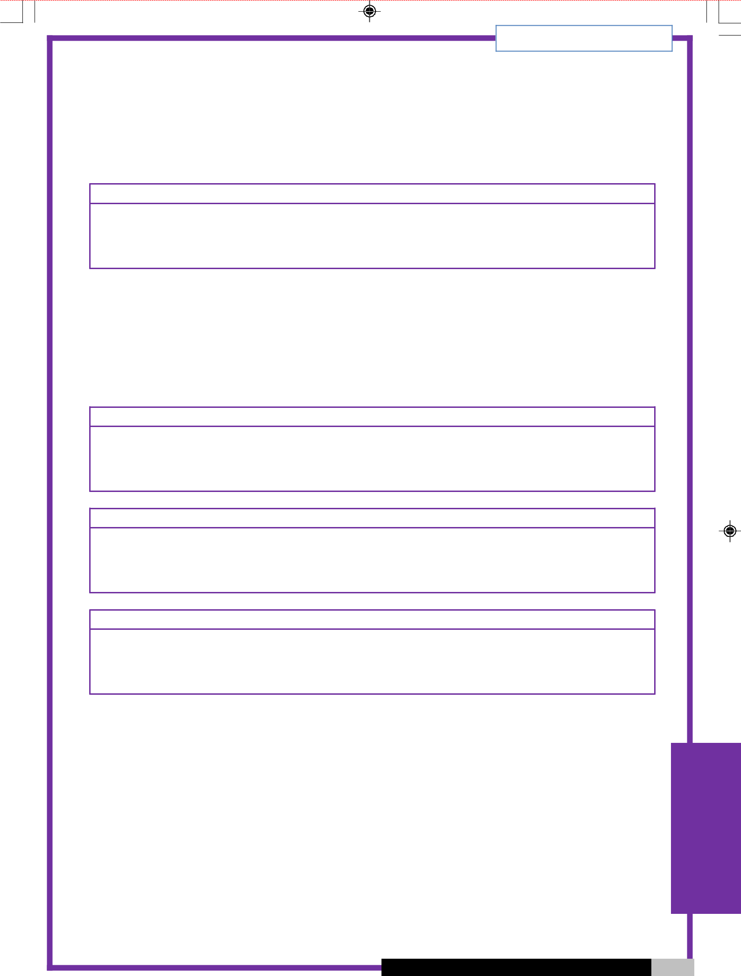
BUILDING USER GUIDE

- MATERIALS AND WASTE MANAGEMENT

5.1 MATERIALS PURCHASING POLICY

Include information such as a responsible sourcing of materials and the use of recycled materials.

Materials purchasing policy

5.2 WASTE MANAGEMENT POLICY

Include information about the recycling facilities used in the building, such as the use of bins, shredders, and compactors. Also include information on the use of recycling strands, such as paper, cardboard, plastic, cans, glass, and batteries. Show locations of the recycling collection points on floor plan in section 1.1, and provide a timetable for collections and contact details for special arrangements.

Recycling facilities

Recycling strands


Contact details

WASTE

 |  |  |  |  | BUILDING MANUALS AND BUILDING USER
 |  | GUIDES | 21
 |  |  | © BSRIA BG 26/2011



WASTE

BUILDING USER GUIDE

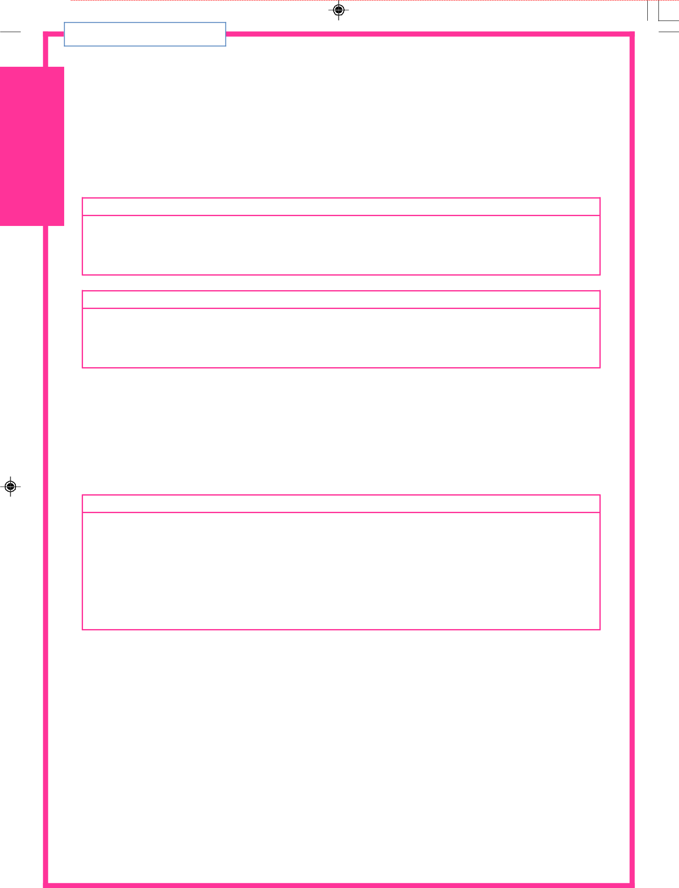

- TRANSPORT FACILITIES

6.1 TRANSPORT

Include information on public transport, show bus stops, train stations and taxi ranks on location map in section 1.1 and provide links to websites showing timetables, ticket prices and alternative transport, provide details of car pool/care share schemes and provide details of ‘Ride to Work’ schemes.

Public transport

Alternative transport

6.2 PARKING

Show the location of the building, location of offsite parking and other details on location map in section 1.1. Show dedicated visitor parking, dedicated/preferential car share parking, general staff parking, location of bicycles racks and location of access to site for pedestrians and cyclists, and all pedestrian and cycle routes on site on the general site plan in section 1.1.

Parking and cycle racks

- BUILDING MANUALS AND BUILDING USER GUIDES © BSRIA BG 26/2011


BUILDING USER GUIDE

- REFIT AND REARRANGEMENT CONSIDERATIONS

7.1 RE-FIT BUILDING/BUILDING SECTIONS

Provide information on the following considerations, design load/occupation densities, design levels/limitations of existing building services, scope for extending/upgrading existing building services, and provision for additional building services. Include the application of the material and waste management policies (see Section 5).

Design load/occupational densities

REFIT

Design levels/limitations of existing building services

Additional building services

Material and waste management policies

 | BUILDING MANUALS AND BUILDING USER
GUIDES | 23
 | © BSRIA BG 26/2011


BUILDING USER GUIDE

7.2 RE-ARRANGEMENT/ADDITION OF FURNITURE

Provide information about the impact on all aspects of the building environment (heating, cooling, ventilation, lighting and acoustics) due to moving furniture/partitions from designed layout, adding furniture/partitions/shelving and changing occupation densities.

Also consider temporary/permanent placement of loose furnishings such as, spare chair, coat rack, filing cabinet, and storage boxes. List the impact this has on all aspects of the building environment (heating; cooling; ventilation; lighting and acoustics) through blocking or restricting access to supply grills, extract vents, control points, sensors, service and maintenance hatches, and emergency routes or services. Show layout of furniture fittings on the floor plans in section 1.1.

Furniture and fittings

Temporary/permanent furnishings

- BUILDING MANUALS AND BUILDING USER GUIDES © BSRIA BG 26/2011

BUILDING USER GUIDE

- REPORTING PROVISION

8.1 REPORTING PROCEDURES

Include details on the protocol for reporting conditioning requirements such as temperature setting, and ventilation. General maintenance requirements such as a faulty light fitting, leaking tap, window not opening, and blinds not working should also be provided. List operational maintenance requirements, no power supply, no telephone/internet connection, and toilet not flushing and report any emergency requirements, such as burst pipes, and electrical short or sparking (also see Section 2).

Conditional requirements

General maintenance requirements

Operational maintenance requirements

Emergency requirements

 | BUILDING MANUALS AND BUILDING USER
GUIDES | 25
 | © BSRIA BG 26/2011


BUILDING USER GUIDE

REPORTING

26

8.2 RESPONSIBLE PARTIES

Include contact information for the following, help desk, health and safety manager, facilities manager and maintenance team.

Department | Contact information
Facilities Manager
Facilities Manager | Name:
 | Telephone:
 | Email:
Facilities Maintenance | Name:
Manager
Manager | Telephone:
 | Email:
Administration Manager | Name:
 | Telephone:
 | Email:
Health & Safety Officer | Name:
 | Telephone:
 | Email:
Reception (Help Desk) | Name:
 | Telephone:
 | Email:

BUILDING MANUALS AND BUILDING USER GUIDES

© BSRIA BG 26/2011

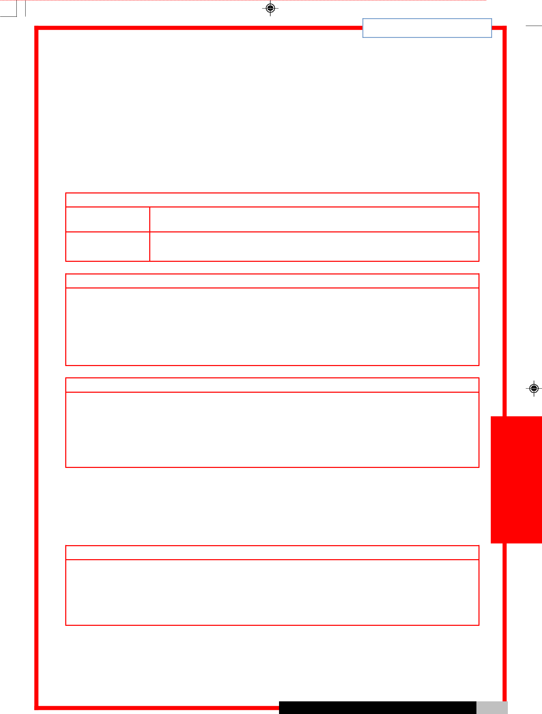
BUILDING USER GUIDE

- TRAINING

9.1 COMPULSORY TRAINING

This should include training details on the following information: site induction for new employees (building users/occupants), visitors, and contractors. Provide specialist training for selected personnel in air conditioning and heating, lighting and control, water waste management and recyclable procedures. Also include training for emergency procedures, including general aspects covered in site induction, with specialist training for selected personnel such as fire, first aid and lift failures.

Site induction

Visitors

New staff

Specialist training for building services

Emergency procedures

9.2 ADDITIONAL TRAINING

This should include training details on any innovative/energy saving methods or equipment and training for general internal/external projects aimed at meeting areas of corporate social responsibility.

Additional training

TRAINING



 |  |  |  |  | BUILDING MANUALS AND BUILDING USER
 |  | GUIDES | 27
 |  |  | © BSRIA BG 26/2011

