Cover Letter and Resume Guide

Advising, Retention + Career Center | Old Library 2100 | 715-836-3487 | arcc@uwec.edu

COVER LETTERS

A cover letter serves as the introduction to your resume. It is specific to each position and demonstrates interest in a particular employer or job. It should include expanded information from the resume, and should not repeat things.

Because it is often the first contact with a prospective employer, it should be concise, well-written, and demonstrate effective communication.

COVER LETTER SECTIONS

The cover letter typically consists of three parts: introduction, body, and closing. Within these three parts, include:

- why you are interested in the organization
- why the organization should be interested in you
- when and how you will contact the organization to follow up

Introduction
- Capture the reader’s interest
- Tell the reader how you learned of an opening
- If appropriate, mention the name of someone who suggested you apply for the company and/or the job opportunity

Body
- Demonstrate your ability to do the job in 1-3 paragraphs
- Promote your education, experiences, past jobs, internships, and student activities
- Use examples and tell your story
- Illustrate the skills that are related to the position
- Enhance your accomplishments with details, do not repeat what is on your resume

Closing
- Indicate next steps, including a plan to follow up with the employer
- Thank the employer for taking the time to consider your application materials
- Close the cover letter with “Sincerely” or “Respectfully”

TIPS

- Proofread
- Personalize each letter, make every attempt to address each letter to a specific individual
- Limit the cover letter to one page, be concise and compelling
- Avoid overusing the word “I”
- Vary writing style, try to offset long sentences with short ones
- Sign the cover letter
- Use a 10-12 font size
- Use paper and font that match your resume to make a consistent application package
- If including items with the cover letter such as a resume, references or writing samples, use one of the following notations below your name: Enclosure, Encl., or Enc.
- Keep a copy of every letter you send as part of your job search file

1

COVER LETTER SAMPLE
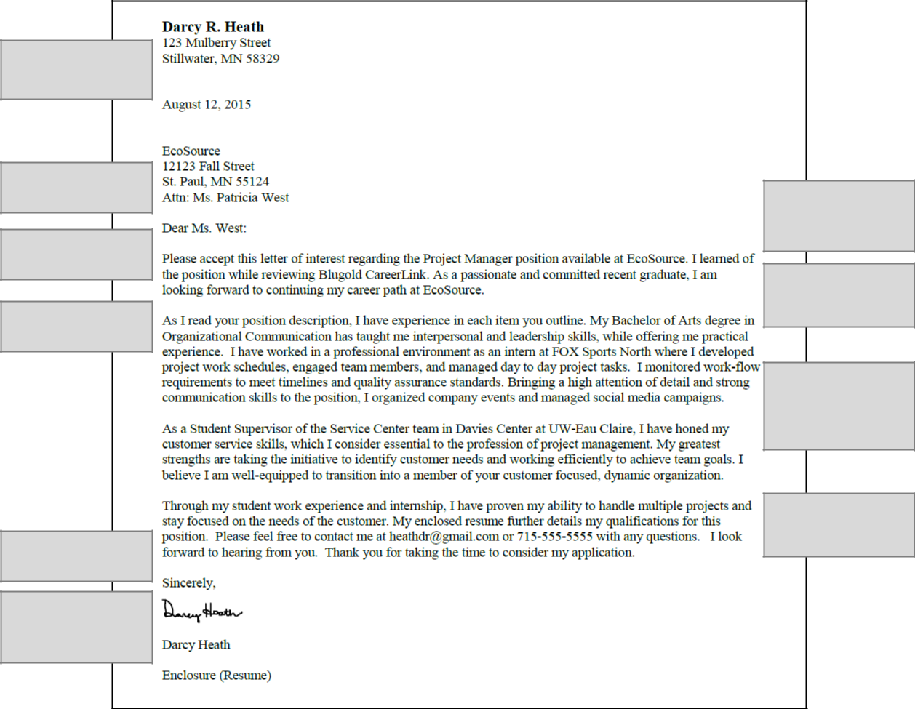

Utilize block format to
give a professional first
impression to the
reader.

Address the letter to a
specific person or hiring
team.

State in the first
sentence why you are
writing the letter.

Explain qualifications
and skills in relation to
the open position.

Sign the cover letter
before sending it to the
employer.

If including other
documents with the
cover letter, use
Enclosure, Encl., or
Enc.

Note how you found the
position. If referred by a
company employee,
include the contact’s
name in the letter.

Demonstrate how your
career goals align with
the position and
organization.

Demonstrate your
knowledge of the
position and company.
Frame experiences to
focus on skills relevant
to a particular job.

Include contact
information in the last
paragraph of the cover
letter.

A cover letter accompanies a resume and other application documents. It serves as your first impression to an employer and helps you to stand out from other job seekers.

- Write the cover letter targeted to an industry, company, or job

- Determine important job requirements from the position description and customize your cover letter to highlight key skills and experiences
- Do not copy and paste information from the resume; expand on experiences, skills, and accomplishments
- Proofread, spell check, and edit the cover letter
- Make your points succinctly and concisely; do not ramble
- Do not send the same generic cover letter for all jobs

2

RESUMES

A resume highlights qualifications for employment including education, experience, skills, and other relevant information. The resume is used by employers to determine potential interview candidates for specific opportunities. Tailor the resume to a specific career opportunity and company. This is your chance to tell your story.

Basic types of resumes include:

Chronological-It is the most frequently used resume by new college graduates and people with continuous employment history. Chronological resumes list information in reverse chronological order (most recent items first) and give a brief account of education and experiences.

Functional-It focuses on an individual’s professional skills and most often is used by individuals whose education and experiences do not match career objectives. A functional resume is used when there are noticeable gaps in experience. Skills are used as headings followed by statements demonstrating accomplishments and utilization of skills.

Combination- It is a mix of chronological and functional resumes. Combination resumes list information in reverse chronological order and focus on skills.

Scannable-A scannable resume is one that can be “read” by Applicant Tracking Software (ATS) and scanned for keywords and specific information. Keyword searches focus on words used in the position description.

Information should be presented in the order that best supports the individual’s objective and enhances candidacy for career opportunities. Do not hesitate to create headings specific to experiences. Resumes should stand out from other applicants’ documents; do not use resume templates.

CURRICULUM VITAE (CV)

A CV is a document similar to a resume in that it provides an overview of your professional and educational experiences. The difference between the two documents primarily lies in the content and purpose. CV content may include publications, presentations, research, honors and other relevant information. A CV is typically developed for application for international jobs, graduate programs, teaching or research positions in a university or research setting. A resume is prepared for employers outside of academic settings.

SAMPLE RESUME HEADINGS

Academic Achievements | College Activities | International Experience | Skills and Qualifications
Academic Honors | Community Involvement | Internship Experience | Skill(s) Summary
Accomplishments | Computer Experience | Job History | Special Training
Activities | Computer Knowledge | Leadership Roles | Special Awards
Additional Experience | Computer Skills | Honors | Special Licenses and Awards
Associations | Credentials | Memberships and Activities | Student Teaching Experience
Athletic Involvement | Education | Military Experience | Study Abroad
Awards and Distinctions | Education and Training | Military Service | Summary of Qualifications
Campus Involvement | Employment | Military Training | Teaching Experience
Career Goal | Employment Objective | Objective | Technical Skills
Career Highlights | Employment History | Professional Affiliations | Volunteer Experience
Career Objective | Exhibitions and Awards | Professional Experience | Work Experience
Career Related Experience | Experience(s) | Professional Organizations | Work History
Career Summary | Extracurricular Involvement | Related Experience | Workshops and Seminar
Certifications | Field Placement | Relevant Course Work
Classroom Experience | Foreign Language | Relevant Experience
Coaching Experiences | Highlights of Qualifications | Research Experience

3

RESUME SECTIONS

Heading
- Name, mailing address, email address and phone number
- LinkedIn account information is optional

Professional Objective (Optional)
- A brief statement that tells the reader about career goals and/or expresses interest in a specific job
- Include a specific job title, company name, general occupational field, and qualifications

Education
- Universities attended and location (city and state)
- Degree(s), major(s), minor(s), academic certificate(s)
- Date of graduation (month and year)

Optional educational information may include:

- Study abroad experience (university, location, and dates)
- Cumulative and/or Major GPA (3.0 or better)
- Relevant course work
- Scholarships and academic honors

Experience
- Job title from employment, research, internship, student teaching, etc.
- Employer name and location (city and state)
- Dates of employment
- Description of responsibilities and accomplishments using action verbs

Special Skills
- Skills related to the position (typically technical and language skills) and level of proficiency

Awards and Honors
- Scholarships, academic honors (i.e. Dean’s List), and special recognitions (i.e. Employee of the Month)

Activities
- Campus and community activities including organizations, clubs, student government, athletics, and professional affiliations

References
- Reference name and title, organization, phone number, and email address
- Include references on the resume or on a separate document

Make sure you have asked each person for permission to be used as a reference.

ACCOMPLISHMENT STATEMENTS

A Good Accomplishment Statement Should Contain:
- An action verb describing role and/or responsibilities
- The scope of activities (i.e. size of unit managed, size of budget managed, or a number of personnel affected)
- The results of activities, given in measurements such as, numbers/percent, amount of money, or value-added for customers

- Specific skills gained from the experience

Tips for Writing Effective Accomplishment Statements:
- Tailor statements to company and job of interest
- Use approximately 2-5 statements for each position
- Bulleted action statements are much easier and quicker to read then paragraphs
- Use indenting where appropriate to signify points that are a subset of an accomplishment

Examples:
- Initiated advanced assembly procedures to increase production 15% by reducing turnaround time from six to five days
- Led a team of volunteers in planning, preparing, and serving a weekly meal for 90 residents at a local shelter
- Coordinated a community event for 150 individuals that resulted in $1000 collected for the New York Disaster Relief Fund

4

ACTION VERBS

Administrative Skills | Establish | Compile | Execute | Summarize
Approve | Fashion | Compose | Improve | Survey
Arrange | Find | Convey | Increase | Verify
Catalogue | Illustrate | Copy | Organize
Classify | Initiate | Correct | Plan | Teaching Skills
Collect | Institute | Define | Prioritize | Adapt
Compile | Integrate | Document | Produce | Advise
Execute | Introduce | Gather | Recommend | Clarify
Generate | Invent | Inform | Review | Coach
Implement | Perform | Proofread | Schedule | Communicate
Inspect | Plan | Question | Strengthen | Coordinate
Monitor | Publish | Review | Supervise | Develop
Operate | Shape | Specify |  | Enable
Organize |  | Survey | Problem-Solving | Encourage
Prepare | Financial Skills | Tabulate | Skills | Evaluate
Process | Administer | Test | Analyze | Explain
Purchase | Allocate | Verify | Apply | Facilitate
Record | Analyze |  | Calculate | Guide
Retrieve | Appraise | Leadership Skills | Compile | Inform
Screen | Audit | Appoint | Consult | Initiate
Specify | Balance | Approve | Correct | Instruct
Validate | Budget | Arrange | Create | Persuade
 | Calculate | Assess | Critique
Communication Skills | Compute | Assign | Design | Teamwork Skills
Address | Develop | Authorize | Develop | Accomplish
Arbitrate | Forecast | Coach | Diagnose | Assist
Arrange | Manage | Complete | Discover | Collaborate
Author | Market | Consult | Dissect | Coordinate
Collaborate | Plan | Delegate | Examine | Corroborate
Develop | Project | Demonstrate | Explore | Encourage
Direct | Research | Direct | Problem solve | Explain
Draft |  | Enlist | Propose | Help
Edit | Helping Skills | Facilitate | Research | Share
Formulate | Assist | Head | Resolve | Volunteer
Influence | Assess | Initiate | Revise
Interpret | Clarify | Launch | Search | Technical Skills
Mediate | Coach | Motivate | Study | Assemble
Moderate | Counsel | Negotiate | Track | Build
Motivate | Demonstrate | Nominate | Troubleshoot | Calculate
Negotiate | Educate | Preside |  | Compute
Persuade | Facilitate | Start | Research Skills | Design
Promote | Familiarize |  | Clarify | Devise
Publicize | Guide | Management Skills | Collect | Engineer
Recruit | Refer | Administer | Critique | Fabricate
Speak | Represent | Analyze | Diagnose | Maintain
Translate | Service | Assign | Evaluate | Operate
 | Support | Attain | Examine | Overhaul
Creative Skills | Tend | Contract | Identify | Program
Act | Tutor | Consolidate | Inspect | Remodel
Conceptualize |  | Coordinate | Interpret | Repair
Create | Information Skills | Delegate | Interview | Solve
Design | Catalogue | Develop | Investigate | Train
Develop | Clarify | Direct | Organize | Upgrade
Direct | Classify | Evaluate | Review

5

RESUME SAMPLE
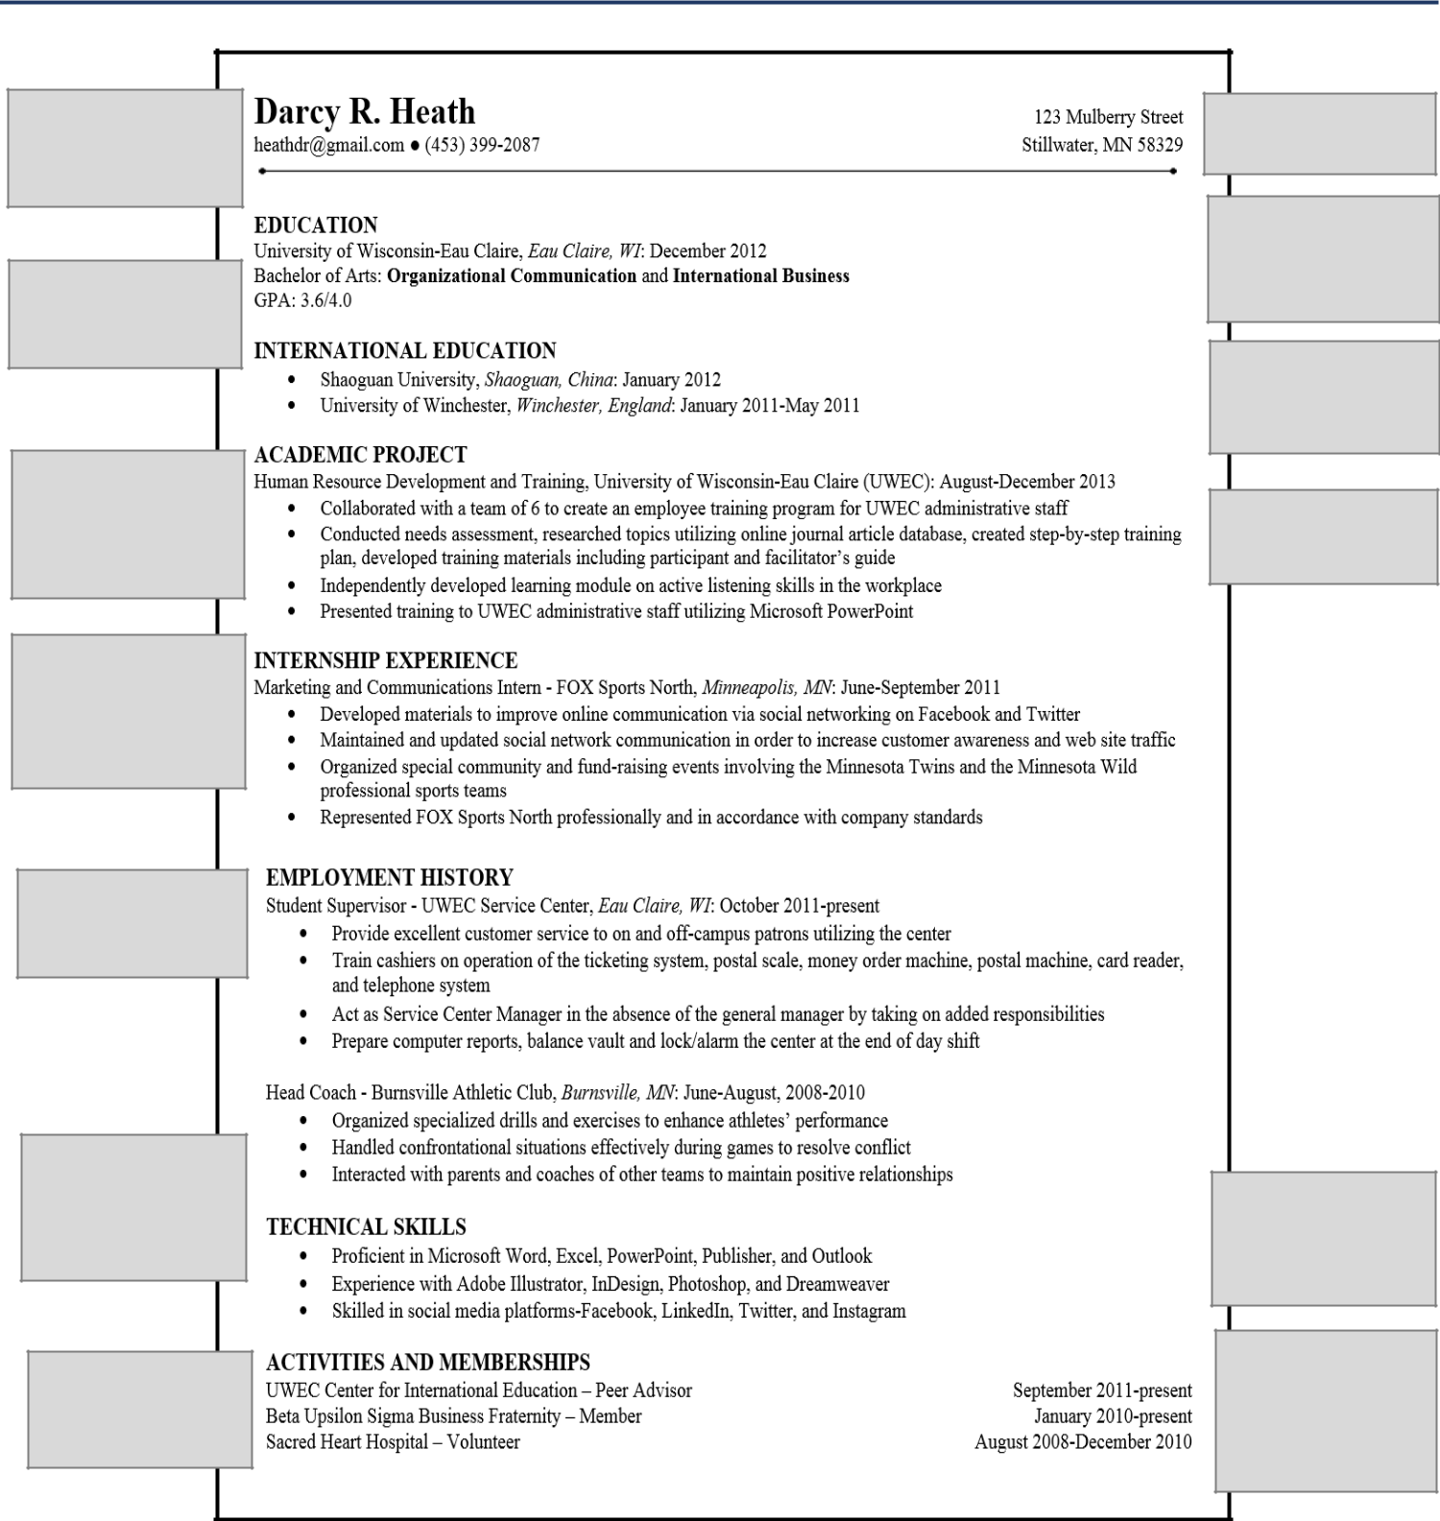

Name should be large (18-24 font size) and bold to stand out on the resume.

Write out acronyms and/or abbreviations on the resume.

Use bullet points focused on the scope of activities, results, and skills utilized in the experience.

Refrain from using complete sentences. Instead, use action verbs to start accomplishment statements.

Include name, address, phone number, and a professional email.

Include university name, location, degree, major, minor, certifications, GPA, and honors.

International education and work experiences should be listed on the resume.

Add relevant projects, work experiences, skills, and activities.

Avoid using “I”, “we”, possessive pronouns or possessive adjectives.

Avoid using cliché

statements like

excellent

communicator, team

player, or hard worker.

In the Activities section, include role, organization name, and dates.

Skills that are relevant and applicable to the job should be incorporated into the resume.

Include volunteer experience, professional memberships, athletic participation, and other related activities.

A resume is a summary of education, professional experiences, and activities. The best resumes are tailored to an industry, company, and job of interest.

- Utilize a chronological format where the most relevant information listed in sections toward the top of the document
- Keep the document concise, 1-2 pages, using 10-12 font size
- Highlight important information with bold, italics, and bullet points
- State clear and concise statements
- Utilize a professional layout with a balance of white space to text
- Proofread, spell check, and edit the resume

6

REFERENCE PAGE SAMPLE
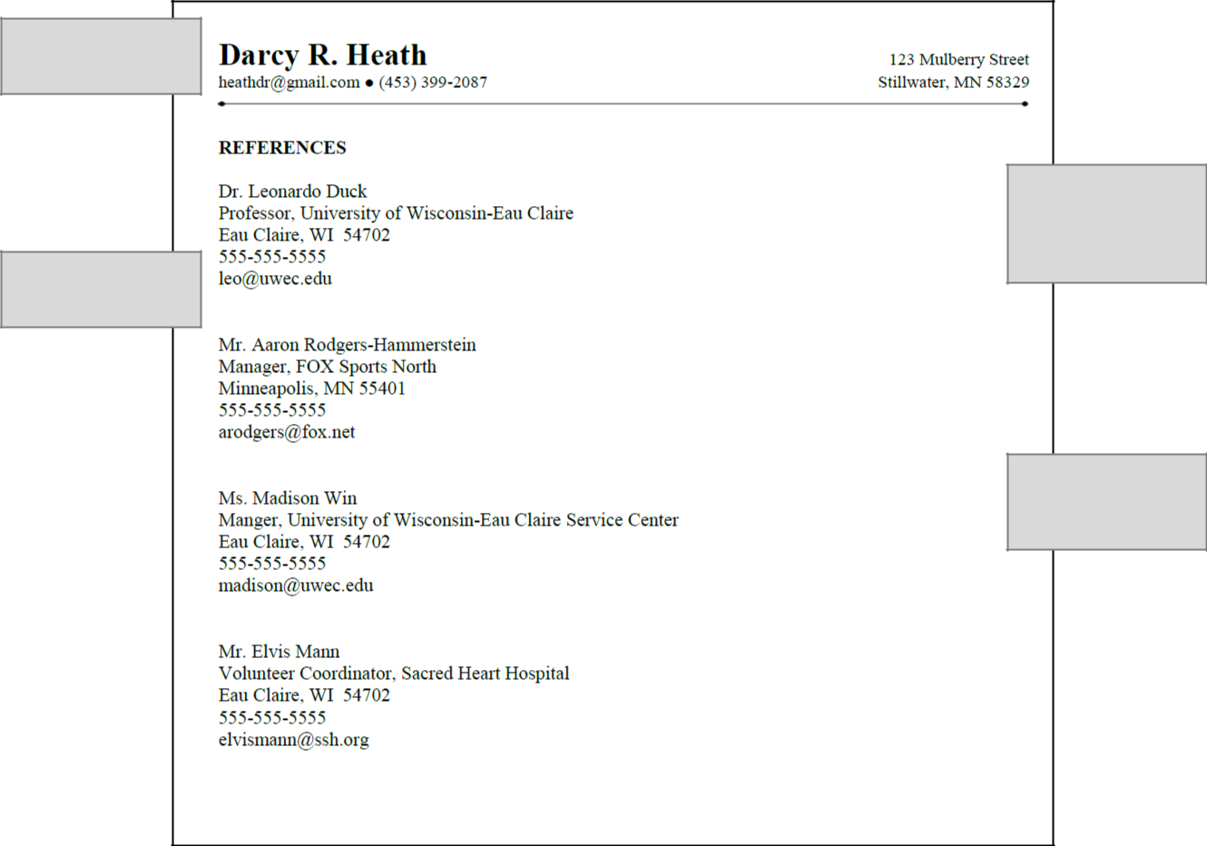

Utilize the same header
as the resume to create
- streamlined application package.

Include 3-5 professional
references. Do not
include family members
or friends.

Professional references
can include a faculty
member, academic

mentor, advisor,
supervisor, co-worker,
and colleague.

Include reference’s
name, title, organization,

address, phone number,
and email.

A reference page is a part of the application process. References provide recommendations to potential employers about your professional experiences, skills, and work values.

- Choose references that are able to speak about your skills and experience in a positive and professional manner.
- Ask a reference for permission prior to applying to open positions.
- Provide your references a copy of your resume and the position description.
- Submit the reference page when it is requested by the hiring manager or recruiter.
- Do NOT include “references available upon request” at the bottom of the resume.

7

