

Resume and
Cover Letter

Guide

Helpful tip

Look for this symbol throughout

the guide to point you to additional

resources and helpful quick tips.

CONTENTS

What Is a Resume? 3

Resume Rubric 4

Bullet Points 5

Descriptive Verbs for Writing Bullet Points 6

Resume Examples 7

Job vs. Graduate School? 10

What Is a Cover Letter? 11

Cover Letter Examples 12

References 14

Professional Profiles 15

Visit the Career Center

Career advisors are here to help, both virtually and in person. Make an appointment via Handshake, Creighton University’s online Career Management system, anytime. Appointments are also free for life to all Creighton alumni!

To access Handshake, scan the QR code.

Thank you to our employer sponsors

2

What Is a Resume?

- resume is a one-to-two page document that demonstrates your value to a future organization. This document can include a lot of different information, but the purpose of all resumes is the same—to get an interview, not necessarily the job! A resume is simply an introduction to you— and just needs to get a reader’s attention enough to want to look further at your experiences and qualifications.
_{Did you know?} Recruiters spend only an average of
7.4 seconds looking at a resume the first time!

–prnewswire.com

Top 5 Resume Do’s:

- Consistency is key! The biggest rule to follow on resumes is consistency—keep your formatting consistent throughout the document to make it easy to read. List all items in reverse chronological order.

- Be descriptive, but concise: Details are helpful to paint a picture of your experience, but be brief (again, it’s just an introduction)!

- Use a legible font and text size: Use a font size between 10–12 and keep fonts easy to read. Margins should be between 1 inch and .5 inch.

- Include education, experiences and skills: Sections can be customized, but students should start with these three basic sections.

- Make it yours! Remember, this is you on paper, so make sure it looks and sounds like you, and not someone else!

Formatting vs. Branding—What Can I Customize?

As mentioned above, consistency in formatting is key to all successful resumes. This means that sections should follow the same organization and design. For example, if a document bolds a company name and italicizes a position, then every entry (across all sections) should follow this same formatting:

 Company name, Omaha NE

Intern

- bullet point

Branding, on the other hand, is much more customizable. You may choose to align your headings on the right-hand side or in the center, or to use a font other than Times New Roman. As long as the document is organized and legible, you can make the document feel true to you by adding these branded elements.

Top 5 Resume Don’ts: 

- Internet templates: Templates are a great place to start, but many internet templates do not offer flexibility or customization. They can also signal a lazy approach to creating a resume, as they are overused. The Career Center provides easy-to-use Word templates to help you get started. Scan the QR code below to find these templates.

- Grammatical errors and typos: This is a first impression, so be sure to ask others (like the Career Center) to proofread your document.

- Disorganization: When a document is not easy to read, recruiters won’t try to figure it out, they’ll just trash it. Keep your document organized.

- Objective or references: Do not include an objective or summary statement or references on a resume— these are outdated practices.

- More than one page: Again, keep it concise. This document is meant to get you the interview—and in that interview, you can expand.


Helpful tip

For specific resume examples by major, and Word templates, check out our website here:

3

 Resume Rubric

While resumes can be customized in many ways, there are general guidelines that all industries abide by. Here’s a simple rubric to follow—you can also download a Word document from our website using this QR code:
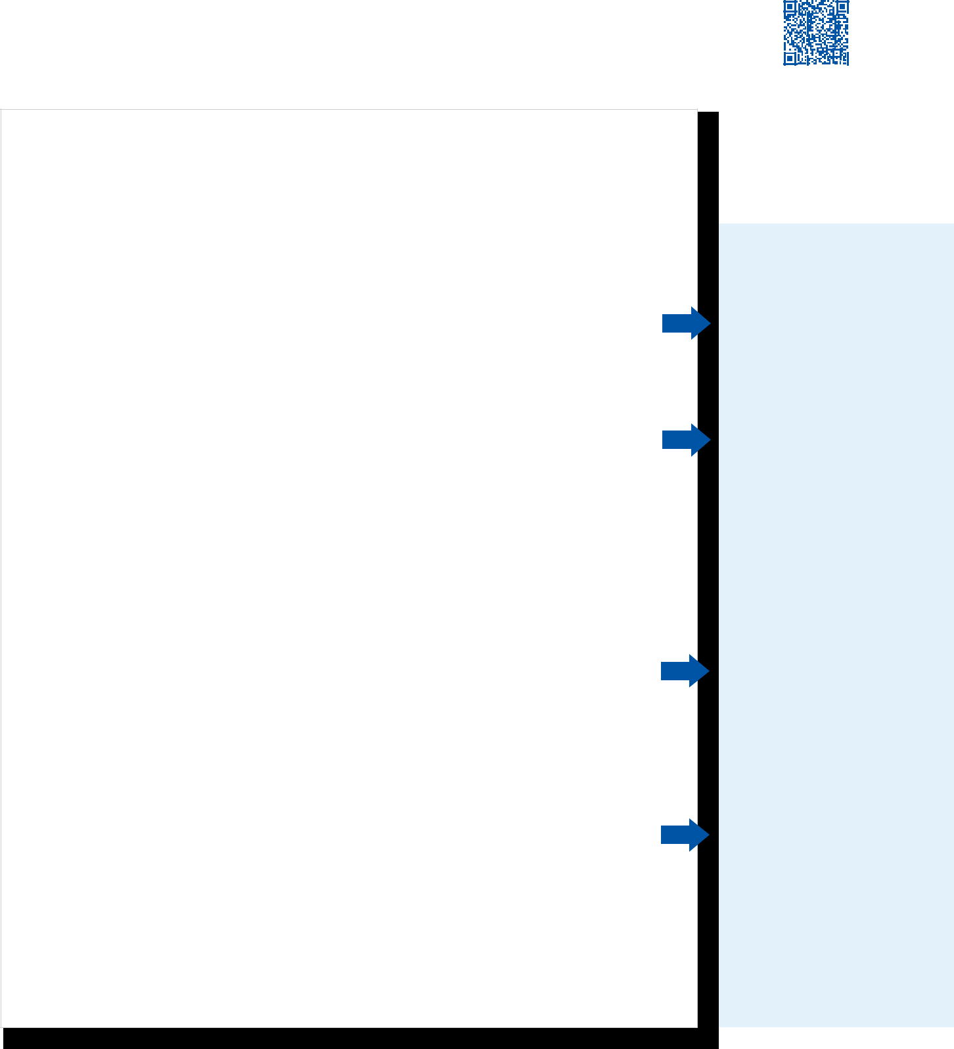

First Name Last Name

Contact info: email, phone number, optional mail address, LinkedIn URL

Education: |  |  | Grad date
Name of School, Possible College, City, State |  |  | Grad date
Degree earned (or will earn) (i.e., Bachelor of ...) |  |  | GPA
Majors/Minors
Experience: |  |  | Month year–Present
Name of Company/ Organization, City, State |  |  | Month year–Present
Position
- Bullet point describing the skill or learning outcome gained

- Most entries use between 1–7 bullet points

- Use present tense verbs for current involvements and past tense for experiences that have concluded
- Do not use “I,” “we,” or “my”—resumes are not written in first person

Name of Company/ Organization, City, State Month year–Month year

Position

- Do not use punctuation at the end of each bullet

- Avoid phrases like, “responsible for” and “duties include”

Additional Sections

(activities, service, research, publications, awards, honors etc .)

Remember to spell out all acronyms (i.e., Creighton Students Union, not CSU)

Provide descriptions and/or bullet points when necessary

(i.e., Cortina Community—a service-focused residence community)

Skills:

Category: level of proficiency (exposure to, intermediate, advanced, etc.) skill

Category: level and skill, level and skill, level and skill


Education can also include education abroad experiences. This section should include only institutions where you earned a degree.

Experience can encompass all areas of experiential learning— classes, internships, part-time jobs, leadership, service and more. The point of this section is to showcase your skills in each experience, so choose experiences that best speak to the opportunity.

Additional Sections can be anything that best describes YOU—some students use several sections, and some use just one. These sections will grow as you do at Creighton!

Skills should include hard skills or skills that could be tested (think software, certifications, etc.) Soft skills (i.e., teamwork, organization, etc.) should be detailed in bullet points of

Experiences.

Helpful tip

Your Career Advisors are here to help you with every step of the resume process—from blank document to writing descriptive bullet points. Make an appointment via Handshake or stop by one of our Resume Labs for assistance.

4

Bullet Points

Bullet points are utilized to provide descriptions. They can be used

for your responsibilities, accomplishments, activities, projects and skills.
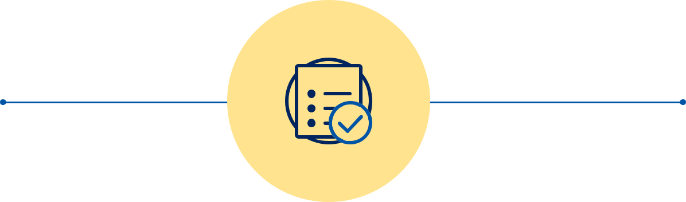
Helpful tip

Each experience does not necessarily need the same number of bullet points.

Bullet point basics: Helpful transition words:

- Start with a strong action verb

- Do not place periods
at the end of your bullet points

- Do not include pronouns

- Use correct and consistent verb tense

• | for | • | as part of
• | through | • | in order to
• | using | • | so that
• | with | • | because of
• | utilizing | • | due to
• | to | • | ensure

Bullet points follow a simple formula:
WHAT | HOW | WHY
Did you do? | Did you do it? | Did you do it?
Ex. Captured action pictures | Ex. Utilizing digital | Ex. For the use in
at Creighton sporting events | and film cameras | marketing materials

Basic bullet points VS. Descriptive bullet points

Basic bullet points are a great way to start, and like your experiences, bullet points will evolve over time.

The missing “why” from each basic bullet point is underlined in the descriptive bullet point.

• Assist children with homework


only includes the what and how, not the why

• Enter customer data into computer


again, missing stronger
description and why

- Marketed the new fall season sportswear products

only includes the what—

missing how and why

- Tutor three children, ranging in age from 5–8 years old, in math to ensure proper comprehension and completion of homework assignments

(Uses an active verb and numbers to provide detail)

- Update client contact information utilizing Microsoft Excel to maintain accurate records

(Identifies specific tool utilized)

- Managed Facebook and Twitter accounts to create a campaign for the sportswear clothing line, resulting in a 20% increase in online sales from the previous year

(Showcases impact through percentage)

5


Descriptive verbs
 |  |  |  |  |  |  |  |  |  |  |  |  |  |  |  |  |  |  |  |  | Calculate
 | for writing bullet points. |  |  |  |  |  |  |  |  |  |  |  |  |  | RESEARCH
 |  |  |  |  |  |  |  |  |  |  |  |  |  |  |  |  |  |  |  |  | Collect
 |  |  |  |  |  |  |  |  |  |  |  |  |  |  |  |  |  |  |  |  | Clarify
 |  |  |  |  |  |  |  |  |  |  |  |  |  |  |  |  |  |  |  |  |  |  |  |  |  | ORGANIZE
Use a variety of verbs to demonstrate a diversity of skills. |  |  |  |  |  |  |  |  |  |  |  |  |  |  |  |  |  |  |  |  | Compose
 |  |  |  |  |  |  |  |  |  |  |  |  |  |  |  |  |  |  |  |  | Critique |  |  |  |  |  | Approve
The more specific your word choice, the better a reader |  |  |  |  |  |  |  |  |  |  |  |  |  |  |  |  |  |  |  |  | Decide |  |  |  |  |  | Arrange
 |  |  |  |  |  |  |  |  |  |  |  |  |  |  |  |  |  |  |  |  | Design |  |  |  |  |  | Catalog
understands your skills and accomplishments.
 |  |  |  |  |  |  |  |  |  |  |  |  |  |  |  |  |  |  |  |  | Devise |  |  |  |  |  | Classify
 |  |  |  |  |  |  |  |  |  |  |  |  |  |  |  |  |  |  |  |  | Diagnose |  |  |  |  |  | Collect
 |  |  |  |  |  |  |  |  |  |  |  |  |  |  |  |  |  |  |  |  | Discover |  |  |  |  |  | Compile
ANALYZE |  |  |  | COMMUNICATE |  |  |  |  |  |  | HELP AND TEACH |  |  |  |  |  |  |  |  |  | Evaluate |  |  |  |  |  | Count
 |  |  |  |  |  |  |  |  |  |  |  |  |  |  |  |  |  |  |  |  | Examine |  |  |  |  |  | Dispatch
Administer |  |  |  | Address |  | Lead |  |  |  |  | Adapt | Guide |  |  |  |  |  |  |  |  | Extract |  |  |  |  |  | Duplicate
 |  |  |  | Address |  |  |  |  |  |  | Adapt | Guide |  |  |  |  |  |  |  |  | Extrapolate |  |  |  |  |  |  | Edit
Allocate |  |  |  | Arbitrate | Lecture |  |  |  |  | Administer |  | Inform |  |  |  |  |  |  |  |  |  |  |  |  |  |  |  | Edit
 |  |  |  | Arbitrate |  |  |  |  |  |  |  | Inform |  |  |  |  |  |  |  |  | Forecast |  |  |  |  |  | Execute
Appraise |  |  |  | Arrange | Mediate |  |  |  |  |  | Advise | Initiate
 |  |  |  | Arrange |  |  |  |  |  |  | Advise | Initiate |  |  |  |  |  |  |  |  | Gather |  |  |  |  |  | Generate
Audit |  |  |  | Author | Moderate |  |  |  |  |  | Advocate | Instruct
 |  |  |  | Author |  |  |  |  |  |  | Advocate | Instruct |  |  |  | Hypothesize |  |  |  |  |  |  |  |  |  |  | Implement
Balance |  |  |  | Collaborate | Motivate |  |  |  |  |  | Assess | Lead
 |  |  |  | Collaborate |  |  |  |  |  |  | Assess | Lead |  |  |  |  |  |  |  |  | Identify |  |  |  |  |  |  | List
Budget |  |  |  | Convince | Negotiate |  |  |  |  |  | Assist | Lecture |  |  |  |  |  |  |  |  |  |  |  |  |  |  |  | List
 |  |  |  | Convince |  |  |  |  |  |  | Assist | Lecture |  |  |  |  |  |  |  |  | Inspect |  |  |  |  |  | Measure
Calculate |  |  |  | Correspond | Obtain |  |  |  |  |  | Attend | Listen
 |  |  |  | Correspond |  |  |  |  |  |  | Attend | Listen |  |  |  |  |  |  |  |  | Interpret |  |  |  |  |  | Monitor
Compute |  |  |  | Create | Persuade |  |  |  |  |  | Care | Mentor
 |  |  |  | Create |  |  |  |  |  |  | Care | Mentor |  |  |  |  |  |  |  |  | Interview |  |  |  |  |  | Operate
Design |  |  |  | Define | Promote |  |  |  |  |  | Coach | Motivate
 |  |  |  | Define |  |  |  |  |  |  | Coach |  |  |  |  |  |  |  |  |  | Investigate |  |  |  |  |  | Prepare
Develop |  |  |  | Develop | Publicize |  |  |  |  | Communicate |  | Perceive
 |  |  |  | Develop |  |  |  |  |  |  |  |  |  |  |  |  |  |  |  |  | Organize |  |  |  |  |  | Process
Discover |  |  |  | Direct |  | Read |  |  |  |  | Consult | Persuade
 |  |  |  | Direct |  |  |  |  |  |  | Consult |  |  |  |  |  |  |  |  |  | Perceive |  |  |  |  |  | Purchase
Forecast |  |  |  | Draft | Reconcile |  |  |  |  | Coordinate |  | Present
 |  |  |  | Draft |  |  |  |  |  |  |  | Present |  |  |  |  |  |  |  |  | Plan |  |  |  |  |  | Record
Hypothesize |  |  |  | Edit | Recruit |  |  |  |  |  | Counsel | Recruit
 |  |  |  | Edit |  |  |  |  |  |  | Counsel | Recruit |  |  |  |  |  |  |  |  | Review |  |  |  |  |  | Retrieve
Identify |  |  |  | Enlist |  | Sell |  |  |  |  | Delegate | Refer
 |  |  |  | Enlist |  |  |  |  |  |  | Delegate | Refer |  |  |  |  |  |  |  |  | Solve |  |  |  |  |  | Screen
Interpret |  |  |  | Formulate | Speak |  |  |  |  | Demonstrate |  | Rehabilitate
 |  |  |  | Formulate |  |  |  |  |  |  |  |  |  |  |  |  |  |  |  |  | Summarize |  |  |  |  |  | Specify
Investigate |  |  |  | Help | Translate |  |  |  |  |  | Develop | Reinforce
 |  |  |  | Help |  |  |  |  |  |  | Develop |  |  |  |  |  |  |  |  |  | Survey |  |  |  |  |  | Tabulate
Manage |  |  |  | Influence | Write |  |  |  |  |  | Diagnose | Relate
 |  |  |  | Influence |  |  |  |  |  |  | Diagnose | Relate |  |  |  |  |  |  |  |  | Synthesize |  |  |  |  |  | Transcribe
Plan |  |  |  | Interpret |  |  |  |  |  |  | Direct | Represent
 |  |  |  | Interpret |  |  |  |  |  |  | Direct |  |  |  |  |  |  | Systematize |  |  |  |  |  |  |  |  | Transpose
Project |  |  |  |  |  |  |  |  |  |  | Educate | Select
 |  |  |  |  |  |  |  |  |  |  | Educate | Select |  |  |  |  |  |  |  |  | Write |  |  |  |  |  | Validate
Recommend |  |  |  |  |  |  |  |  |  |  | Enable | Speak
Report |  |  |  | COORDINATE |  |  |  |  |  | Encourage |  | Support
Research |  |  |  |  |  |  |  |  |  |  | Enlist | Train
Scan |  |  |  | Control |  |  |  |  |  |  | Evaluate | Tutor |  |  |  |  |  |  |  |  |  |  | CREATE
 |  |  |  | Decide |  |  |  |  |  |  | Evaluate | Tutor
Solve |  |  |  | Decide |  |  |  |  |  |  | Explain | Understand |  |  |  |  |  |  |  |  |  |  |  | Act
Study |  |  |  | Deliberate |  |  |  |  |  |  | Facilitate
 |  |  |  | Deliberate |  |  |  |  |  |  | Facilitate |  |  |  |  |  |  |  |  |  |  |  | Conceptualize
Suggest |  |  |  | Develop
 |  |  |  | Develop |  |  |  |  |  |  |  |  |  |  |  |  |  |  |  |  |  |  |  | Create
Summarize |  |  |  | Direct
 |  |  |  | Direct |  |  |  |  |  |  |  |  |  |  |  |  |  |  |  |  |  |  | Customize
Test |  |  |  | Execute |  |  |  |  |  |  | ACCOMPLISH
 |  |  |  | Execute |  |  |  |  |  |  |  |  |  |  |  |  |  |  |  |  |  |  |  | Design
Translate |  |  |  | Formulate
Verify |  |  |  | Implement |  |  | Achieve |  |  |  | Increase |  | Resolve |  |  |  |  |  |  |  |  |  | Develop
 |  |  |  | Implement |  |  |  |  |  |  | Increase |  |  |  |  |  |  |  |  |  |  |  |  | Direct
 |  |  |  | Manage |  |  | Complete |  |  |  | Pioneer |  | (problems)
 |  |  |  | Manage |  |  |  |  |  |  | Pioneer |  |  |  |  |  |  |  |  |  |  |  | Fashion
 |  |  |  | Orchestrate |  |  | Establish |  |  |  | Reconcile |  | Restore
 |  |  |  | Orchestrate |  |  |  |  |  |  |  |  |  |  |  |  |  |  |  |  |  |  | Illustrate
 |  |  |  | Organize |  |  | Expand |  |  |  | Reduce |  | Spearhead
 |  |  |  | Organize |  |  |  |  |  |  | Reduce |  |  |  |  |  |  |  |  |  |  |  |  | Initiate
 |  |  |  | Plan |  |  | Improve |  |  |  | (losses) |  | Transform
 |  |  |  | Plan |  |  |  |  |  |  | (losses) |  |  |  |  |  |  |  |  |  |  |  | Integrate
 |  |  |  | Regulate
 |  |  |  | Regulate |  |  |  |  |  |  |  |  |  |  |  |  |  |  |  |  |  |  | Introduce
 |  |  |  | Schedule
 |  |  |  | Schedule |  |  |  |  |  |  |  |  |  |  |  |  |  |  |  |  |  |  |  | Invent
 |  |  |  | Schedule |  |  |  |  |  |  | MANAGE
 |  |  |  |  |  |  |  |  |  |  |  |  |  |  |  |  |  |  |  |  |  |  |  | Market
 | MANUFACTURE |  |  |  |  |  | Administer |  |  |  | Delegate |  | Produce |  |  |  |  |  |  |  |  |  | Perform
 |  |  |  |  |  |  |  |  |  |  | Delegate |  |  |  |  |  |  |  |  |  |  |  | Revitalize
 | Assemble |  |  | Operate |  |  | Advise |  |  |  | Demonstrate |  | Propose |  |  |  |  |  |  |  |  |  |  | Shape
 |  |  |  | Operate |  |  | Assign |  |  |  | Develop | Purchase
 | Build |  |  | Overhaul |  |  |  |  |  |  | Develop
 |  |  |  | Overhaul |  |  | Attain |  |  |  | Direct | Recommend
 | Calculate |  |  | Plot |  |  |  |  |  |  | Direct
 |  |  |  | Plot |  |  | Authorize |  |  |  | Distribute |  | Review
 | Compute |  |  | Program |  |  |  |  |  |  | Distribute
 |  |  |  | Program |  |  | Balance |  |  |  | Evaluate | Schedule
 | Control |  |  | Remodel |  |  |  |  |  |  | Evaluate
 |  |  |  | Remodel |  |  | Budget |  |  |  | Execute | Streamline |  |  |  |  |  |  |  |  |  |  |  |  | Helpful tips
 | Design |  |  | Repair |  |  |  |  |  |  | Execute
 |  |  |  | Repair |  |  | Chair |  |  |  | Expedite | Strengthen |  |  |  |  |  |  |  |  |  |  |  |  | Struggling to write
 | Devise |  |  | Ship |  |  |  |  |  |  | Expedite
 |  |  |  | Ship |  |  | Compile |  |  |  | Hire | Supervise
 |  |  |  | Ship |  |  |  |  |  |  | Hire |  |  |  |  |  |  |  |  |  |  |  |  |  | bullet points?
 | Engineer |  |  | Solve |  |  |  |  |  |  | Hire
 |  |  |  | Solve |  |  | Consolidate |  |  |  | Institute |  | Train
 |  |  |  | Solve |  |  |  |  |  |  | Institute |  |  |  |  |  |  |  |  |  |  |  |  |  | Drop by a Career
 | Fabricate |  |  | Troubleshoot |  |  |  |  |  |  | Institute
 |  |  |  | Troubleshoot |  |  | Contract |  |  |  | Organize |  | Update
 |  |  |  | Troubleshoot |  |  |  |  |  |  | Organize |  |  |  |  |  |  |  |  |  |  |  |  |  | Center Resume
 | Handle |  |  | Upgrade |  |  |  |  |  |  | Organize
 |  |  |  | Upgrade |  |  | Control |  |  |  | Oversee
 |  |  |  | Upgrade |  |  |  |  |  |  | Oversee |  |  |  |  |  |  |  |  |  |  |  |  |  | Lab (check website
 | Maintain |  |  |  |  |  |  |  |  |  | Oversee
 |  |  |  |  |  |  | Coordinate |  |  |  | Prioritize
 |  |  |  |  |  |  |  |  |  |  | Prioritize |  |  |  |  |  |  |  |  |  |  |  |  |  | for schedule.)

6




Resume Examples 



Freshman Example

How to use this section:

The following pages provide a general resume example that builds from a student’s first year at Creighton to beyond graduation. Remember that more examples that are specific to college, majors and pre-professional paths may be found on the Career Center website.


Charlie Creighton

Papillion, NE 68046 | 402-280-2722
charliecreighton@creighton.edu
www.linkedin.com/in/charliecreighton

EDUCATION

 |  |  | May 20XX
Creighton University, Omaha, NE |  |  | May 20XX
Bachelor of Science in Psychology
Minor in Communication Studies
GPA: 3.75
Papillion-La Vista Senior High, Papillion, NE |  |  | May 20XX
High School Diploma
GPA: 3.85
EXPERIENCE |  |  | August 20XX – Present
Creighton University Admissions, Omaha, NE |  |  | August 20XX – Present
Tour Guide
- Lead prospective student recruitment tours and events to more than 500 guests
- Promote Twitter, Tik Tok, and Facebook accounts, which resulted in an increase of followers
- Developed and maintained relationships with visiting guests by providing detailed university information and sharing personal examples
- Assisted with five special event tours, which included VIP university guests

Ming’ Restaurant, Papillion, NE November 20XX – July 20XX
Team Member
- Operated cash register in a quick and timely manner for customers to keep the restaurant efficient

- Managed and counted over $1,000 daily in the cash register
- Maintained clean work areas and restrooms to ensure maximum satisfaction and convenience

- Commended by customers for the ability to resolve their questions quickly

Camp Kesem, Lincoln, NE May 20XX – July 20XX
Camp Counselor
- Supervised campers, ages 7-12 years old, for five days at a time at an overnight camp
- Led group activities for campers, which introduced teamwork, critical thinking, and fun
- Counseled children with behavior issues on the importance of respect, kindness, and understanding

ACTIVITIES AND SERVICE

- National Honor Society
- 4-H Club
- State Track 100m Dash, 1st Place
- Speech & Debate and Mock Trail
- Creighton Freshman Leadership Program

SKILLS
Microsoft Office, Mac OS, Adobe Creative Cloud
Proficient in Spanish

Most students’ first college-level resume has the same content as their high school or college admissions resume. The major difference is the organization and formatting.

Remember that your resume will grow as your experiences do, so don’t be shy to use high school involvement,part-time jobs and even courses at Creighton as experiences as a younger applicant.

Similarly, your activities, service and other additional sections may include high school involvements. Note that the number of service hours is not included on a college professional resume.

Helpful tips

Feeling overwhelmed here? You’re not alone! Reach out to your

Career Advisors! We are here to help you with every step of this process!

7

Resume Examples

Sophomore/Junior Example
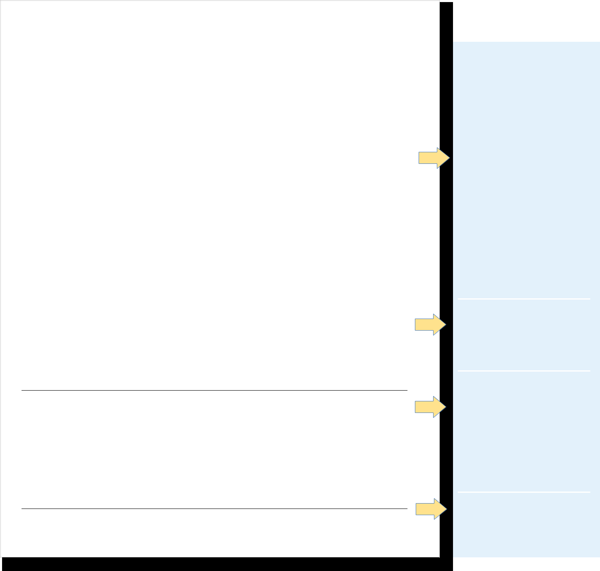

Charlie Creighton

Papillion, NE 68046 | 402-280-2722 | charliecreighton@creighton.edu | www.linkedin.com/in/charliecreighton

EDUCATION

Creighton University – Omaha, NE | May 20XX
Bachelor of Science in Psychology | GPA: 3.82
Minor in Communication Studies
University of Queensland – Brisbane, Queensland, Australia | Fall 20XX
Study Abroad Program

EXPERIENCE

LinkedIn – Omaha, NE | May 20XX – Present
Digital Marketing Intern

- Develop editorial calendar to improve rollout of more frequent and higher-quality content to website and social media platforms

- Calculate best practices for maximum engagement through email campaigns using Campaigner

- Assist in content creation for over 50 email campaigns to increase quality and quantity of sales and engagement

- Organize and maintain all digital multimedia content using Flickr, Microsoft OneDrive, and Dropbox

- Maintain all research documents for the department, including online, mobile, web, and app analytics

- Serve as an email liaison between four diverse, cross-functional teams to create revenue-generating advertising

Creighton University Admissions – Omaha, NE August 20XX – Present

Tour Guide

- Lead prospective student recruitment tours and events for more than 1,000 guests per year

- Promote Twitter, Tik Tok, and Facebook accounts, which resulted in an increase of followers

- Selected to lead more than 25 VIP and special event tours for university president meetings

Behaven Kids – Omaha, NE January 20XX – August 20XX

Child Behavioral Intern

- Partnered with Child Behavioral Specialists and therapists to provide treatment for children with behavioral health issues

- Safely transitioned a child from the classroom to time-out room when child displayed aggressive behaviors or attempted to escape from time-out

- Communicate with children’s guardians with a summary of the behavior and treatments for the day

- Praised children exhibiting positive behaviors by using a token economy to reinforce desired behaviors

RESEARCH EXPERIENCE

Identifying Colors and Words, Research Assistant to Dr. Maya Khanna, Ph.D.

- Conducted semantic priming task to determine the correlation between Color Word Associates and response times

- Created study time slots and administered semantic priming to participants

- Proficient in univariate, bivariate, and multivariate statistics using chi-square, t-test, ANOVA, and factorial
ANOVA

SERVICE

Boys & Girls Club of Omaha – Omaha, NE | January 20XX – Present
Completely Kids – Omaha, NE | February 20XX – March 20XX
Creighton University Daycare – Omaha, NE | February 20XX – August 20XX

SKILLS

Languages: Proficient in Spanish, conversational in German

Technical Skills: Microsoft Office, Mac OS, SPSS, Tableau, Adobe Creative Cloud, Campaigner

Certifications: CPR Certified

Notice that the style has changed to accommodate space needs (smaller margins, longer bullet points, personal branding, etc.)



On this version, high school information was removed. This is optional, but often done for space and relevancy. Similarly, most high school involvement has now been removed. This often happens during sophomore year—when Creighton and community involvement may replace previous involvement.

Bullet points have been expanded with more detail and focus on skills rather than duties.

Involvement sections have been expanded and separated. Here, research experience was added as a more relevant section than activities and service.

As skills grow, categories may help distinguish and organize the skills section, as seen here.

Helpful tip

Looking for a college-specific or pre-professional example? Scan here to see additional samples:

8



Senior/Recent Graduate Example


Charlie Creighton 402-280-2722 | charliecreighton@creighton.edu | linkedin.com/in/charliecreighton

EDUCATION
Creighton University – Omaha, NE | May 20XX
Bachelor of Science in Psychology; Minors in Communication Studies and Business Administration | GPA: 3.82
University of Queensland – Brisbane, Queensland, Australia | Fall 20XX
Study Abroad Program
RELEVANT EXPERIENCE
Camp Kesem – Lincoln, NE | May 20XX – Present
Development Coordinator
- Assist with grant proposals and reports to secure $15K+ annually in funding from foundation and nonprofit partners

- Create and implement donor communication and stewardship plans, including fundraising appeal letters, monthly e-newsletters, thank you letters, donor spotlights, etc.
- Maintain partnerships with local chapter community contacts, including local peer organizations, corporations, foundations, K-12 and higher-education institutions, health care institutions, and local board members
- Empower a team of 60 college students to collaborate and put together a summer camp for kids 6-18 years old, whose parents have been affected by cancer
- Moved programming to an online format during a pandemic, which resulted in active participation from kids and their families

Behaven Kids – Omaha, NE January 20XX – August 20XX

Child Behavioral Intern

- Modeled basic play skills and social interactions, which increased communication and children’s ability to socialize
- Informed caretakers of child’s progress through daily progress reports using accurate data collection

- Partnered with Child Behavioral Specialists to provide treatment for children with behavioral health issues

Identifying Colors and Words, Creighton University February 20XX – May 20XX

Research Assistant to Dr. Maya Khanna, Ph.D.

- Conducted semantic priming task to determine the correlation between Color Word Associates and response times

- Created time slots and administered semantic priming to participants for an organized data collection process

- Proficient in univariate, bivariate, and multivariate statistics using chi-square, t-test, ANOVA, and factorial

ANOVA

 | ADDITIONAL EXPERIENCE
LinkedIn – Omaha, NE | May 20XX – May 20XX
Digital Marketing Intern
- Developed editorial calendar to improve the rollout of over 80 email campaigns to increase quality and quantity of sales and engagement
- Serve as a liaison between four diverse, cross-functional teams to create revenue-generating advertising campaigns

Creighton University Admissions – Omaha, NE | August 20XX – Present
Tour Guide | SERVICE
Boys & Girls Club of Omaha – Omaha, NE | January 20XX – Present
Completely Kids – Omaha, NE | February 20XX – March 20XX
Habitat for Humanity – Omaha, NE | February 20XX – August 20XX
 | SKILLS
Languages: Proficient in Spanish, conversational in German

Technical Skills: Microsoft Office, Mac OS, SPSS, Tableau, Adobe Creative Cloud, Campaigner

Certifications: CPR Certified

While style does not need

to change with every iteration of your document, this example reflects a need for more space. For example, to condense the heading to one line, location and

LinkedIn were edited.

Here, “relevant” has been added to the experience title. This change can help readers understand your expertise in a specific area.

Bullet points have been further expanded with more detail and focus on skills rather than duties, with more bullet points written for most recent/ relevant experiences.

An additional experience section has been added to show a strong work history without requiring lengthy detail.

The biggest takeaway from this document? The content has been modified for a specific purpose—job, program, position, etc.

Remember:

There is no one way to do a resume. Feel free to borrow elements from this example throughout your career. But do keep consistent formatting a priority.

Helpful tip

Lost on how to modify your resume for a specific purpose? Check out the next page and visit the Career Center.

9


 Job vs. Graduate School?

How are they different?

The differences between a job-focused resume and a graduate program-focused resume come down to the types of experiences included and the tailored bullets.

 | RELEVANT EXPERIENCE
Camp Kesem – Lincoln, NE | May 20XX – Present
Development Coordinator
- Assist with grant proposals and reports to secure $15K+ annually in funding from foundation and nonprofit partners

- Create and implement donor communication and stewardship plans, including fundraising appeal letters, monthly e-newsletters, thank you letters, donor spotlights, etc.
- Maintain partnerships with local chapter community contacts, including local peer organizations, corporations, foundations, K-12 and higher-education institutions, health care institutions, and local board members
- Empower a team of 60 college students to collaborate and put together a summer camp for kids 6-18 years old,

whose parents have been affected by cancer |  |  |  | Job description Ex: Social Services Coordinator
• Moved programming to an online format during a pandemic, which resulted in active participation from kids and
their families
their families |  |  |  | RELEVANT EXPERIENCE
Behaven Kids – Omaha, NE | January 20XX – August 20XX
Child Behavioral Intern |  |  | Camp Kesem – Lincoln, NE | May 20XX – Present
- Modeled basic play skills and social interactions, which increased communication and children’sDevelopmentabilityto Coordinator

socialize | • Assist in grant proposals and reports to secure $15K+ annual in funding from foundation and nonprofit partners
- Informed caretakers of child’s progress through daily progress reports using accurate data collection• Create and implement donor communication and balanced budgets, including fundraising appeal letters, monthly
- Partnered with Child Behavioral Specialists to provide treatment for children with behavioral health issues-newsletters, thank you letters, donor spotlights, etc.

  - Build and maintain strategic relationships and partnerships with local chapter community contacts, including a
Identifying Colors and Words, Creighton University February 20XX –networkMay20XXoflocal peer organizations, corporations, foundations, K-12 and higher-education institutions, health care

Research Assistant to Dr. Maya Khanna, Ph.D. institutions, and local board members

- Conducted semantic priming task to determine the correlation between Color Word Associates and• responseMentortimaesam of 60 college students to collaborate and develop a successful, free summer camp for kids 6-18 years
- Created time slots and administered semantic priming to participants for an organized data collection processold,whose parents have been affected by cancer

- Proficient in univariate, bivariate, and multivariate statistics using chi-square, t-test, ANOVA, and•factorialOversee programming for children, which promotes a safe and enjoyable environment for over 500 children weekly

ANOVA | Behaven Kids – Omaha, NE |  | January 20XX – August 20XX
ADDITIONAL EXPERIENCE | Child Behavioral Intern
 | • Promoted emotional health and physical well-being, by increasing independence, and facilitated participation
LinkedIn – Omaha, NE
LinkedIn – Omaha, NE | May 20XX – May 20XX
Digital Marketing Intern |  | through behavior modeling, psychoeducation, and intervention
 | • Exemplified basic play skills and social interactions, which raised childrens’ ability to socialize and communicate
• Developed editorial calendar to improve the rollout of over 80 email campaigns to increase quality and quantity of
sales and engagement | • | Informed caretakers of child’s progress through daily progress reports by maintaining accurate documentation
- Serve as a liaison between four diverse, cross-functional teams to create revenue-generating advertising•Partnered with Child Behavioral Specialists to develop treatment plans for children with behavioral health issues using case files, best practices, and crisis counselingcampaigns

Creighton University Admissions – Omaha, NE |  |  |  |  | Identifying Colors and Words, Creighton University | February 20XX – May 20XX
 |  |  |  | August 20XX – Present
Tour Guide |  |  |  |  | Research Assistant to Dr. Maya Khanna, Ph.D.
 |  |  |  |  | • Created a flexible schedule for volunteers and administered semantic priming for study participants to ensure
 |  |  |  |  | proper compliance with data collection and standards
Graduate School Example Ex: Research-based Psychology |  |  |  |  | • Conducted semantic priming task to determine the correlation between Color Word Associates and response times
 |  |  |  |  | ADDITIONAL EXPERIENCE
 |  |  |  |  | LinkedIn – Omaha, NE | May 20XX – May 20XX
 | RESEARCH AND TEACHING EXPERIENCE |  |  |  | Digital Marketing Intern
 | RESEARCH AND TEACHING EXPERIENCE |  |  |  | • Developed editorial calendar to improve rollout of over 80 email campaigns to increase quality and quantity of
 | Department of Psychological Science, Creighton University | February 20XX – May 20XX
 | Teaching Assistant |  |  |  | sales and engagement
 | Teaching Assistant |  |  |  | • Coordinate meetings between four diverse, cross-functional teams to assist in the creation of revenue-generating
 | • Assessed student examinations, quizzes, and weekly discussion boards pertaining to introductory psychological
 |  |  |  |  | advertising campaigns
 | topics, such as scientific methods, the history of psychology, memory and learning, and psychological theories
 | • Corresponded daily via Canvas to students while answering questions, clarifying assignments, and updating courses |  |  |  |  | August 20XX – Present
 |  |  |  |  | Creighton University Admissions – Omaha, NE
 | • Prepared PowerPoint presentations, lesson plans, and assignments for two sections of Introduction to Psychology
 | course to over 100 students a semester |  |  |  | Tour Guide

10

Identifying Colors and Words, Creighton University February 20XX – May 20XX

Research Assistant to Dr. Maya Khanna, Ph.D.

- Conducted semantic priming task to determine the correlation between Color Word Associates and response times

- Created time slots and administered semantic priming to participants for an organized data collection process

- Assisted professors by using Excel, Access, and ArcMAP to process a raw spreadsheet of over 250,000 records to create a usable, aggregated data set for their research project
- Proficient in univariate, bivariate, and multivariate statistics using chi-square, t-test, ANOVA, and factorial
ANOVA

 | ADDITIONAL EXPERIENCE
Camp Kesem – Lincoln, NE | May 20XX – Present
Development Coordinator
- Empower a team of 60 college students to collaborate and organize a summer camp for kids 6-18 years old, whose parents have been affected by cancer
- Moved small-group programming to an online format during a pandemic, which resulted in active participation from kids and their families

Behaven Kids – Omaha, NE January 20XX – August 20XX

Child Behavioral Intern

- Partnered with Child Behavioral Specialists to provide treatment for children with behavioral health issues

- Modeled basic play skills and social interactions, which increased communication and children’s ability to socialize

- Informed caretakers of child’s progress through daily progress reports using accurate data collection

LinkedIn – Omaha, NE May 20XX – May 20XX

Digital Marketing Intern

- Developed editorial calendar to improve rollout of over 80 email campaigns to increase quality and quantity of sales and engagement, while also serving on four diverse, cross-functional teams

When you compare the original

document’s experience sections to those of the more tailored versions, you see a more specific emphasis on skills (which should be based on the job description for the position) in the job example, compared to more academic and research experiences in the graduate program example.

Ex: Research-based Psychology

Ex: Social Services Coordinator

What Is a Cover Letter? 

The purpose of a cover letter is to provide more detail on why you are the best candidate and what you have to offer the organization. It is not a reiteration of your resume, instead, it narratively emphasizes your most relevant experiences and connects it to the position description.

CONTENT

The key to a good cover letter is keeping your content focused on the job description. Review the job description, and for each job requirement and responsibility, reflect on a time you did something similar. Remember, this is not a formal essay, but rather, a formal letter written in a professional tone.

STRUCTURE

Helpful tips

Rather than the ol’ standby, “To Whom It May Concern,” always try to address the specific person you are writing to. This title may vary based on the position or organization you’re applying to. Can’t find a contact? Reach out to the Career Center for assistance.

Even though you have this information in your header, it is customary to include your contact information in

the conclusion. Think of it like an in-person interaction— if you plan to talk again, you usually end with exchanging information (and a solid handshake)!

First Last Name
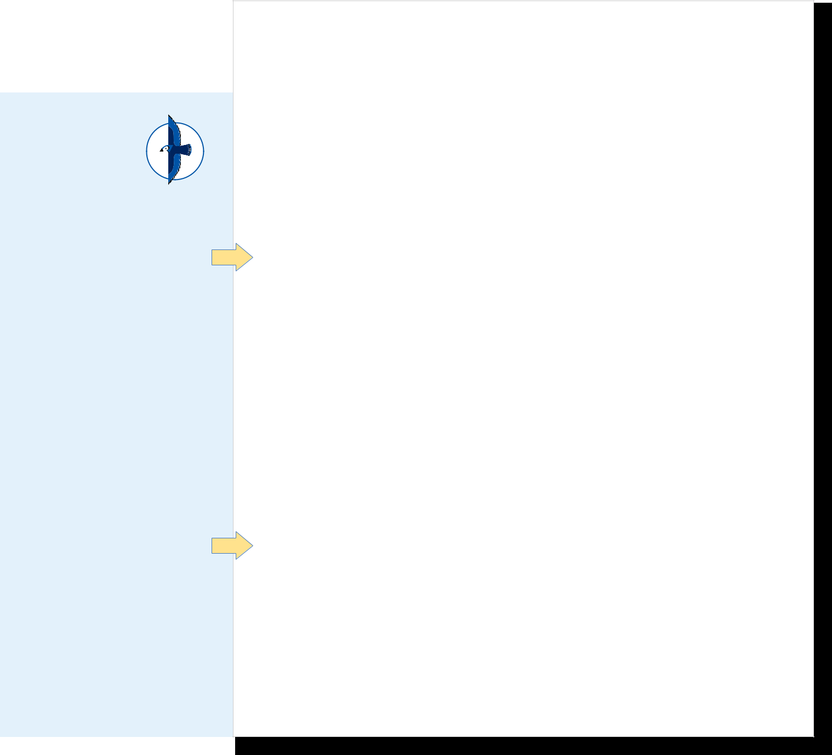
Contact info: email, phone number, optional mail address, LinkedIn URL

Date

Recipient’s Name (if known), Title

Organization Name

Organization Address

City, State Zip

Dear First Last Name (or Hiring Manager),

Section 1: Introduce who you are, what position you are applying for, why you are interested, how you heard about the job (could be a personal connection or a job board other than just their website) and provide a brief preview of why you are a good candidate.

Section 2: Emphasize why you are interested in the position and how you

meet their qualifications. Focus on your experiences in academics, previous

jobs, volunteer opportunities or extracurricular experiences. Give two or

three examples of your accomplishments or abilities to make your case stronger.

You can integrate key words or phrases from the job description into your examples. If possible, quantify by giving specific numbers or percentages. Be specific and brief, focusing on the match between what the employer is looking for and what you have to offer.

Section 3: Reiterate your interest in the position and organization and the key points about why you are a good candidate. Mention a fact about the organization or why you admire their work. Thank the employer for their consideration and identify how you can be contacted. Include a final well wish —something like “best of luck with your search” or “looking forward to hearing from you soon.”
YourSincerely,Signature (optional)

Your Name (printed)

11


Cover Letter Examples

Example A

Cover letters are best executed when they speak to the skills an employer is looking for.

The underlined points in the job description correlate to a specific example in the letter.

Marcus Jordan

3245 Shirley Street • Omaha, NE 68106 • marcusjordan@creighton.edu • 402.111.1111

September 10, 20XX

Ms. Jennifer Tyler, Director of Events and Outreach

Ronald McDonald House Charities in Omaha

620 S. 38th Avenue

Omaha, NE 68105

Dear Ms. Tyler:

I am writing to express my interest in the Media Intern position with Ronald McDonald House Charities in Omaha, posted on Handshake. I am a junior at Creighton University pursuing a Bachelor of Science in Business Administration with a major in Marketing and am looking forward to continuing to work in marketing for a nonprofit organization. I believe my experience working at a nonprofit, in addition to my coordination skills and creativity, make me a great fit for this position.

For the past year, I have worked as a Communications & Event Management Intern with the Down Syndrome Alliance of the Midlands, managing the marketing of the program.
I strengthened my creative skills by creating a successful marketing campaign, which included print, web, and social media. In particular, the social media portion of the campaign resulted in a 57% increase in web traffic to the organization’s Facebook and Twitter accounts. I also managed databases of donors, volunteers, and media. In this role, I developed program coordination and budget management skills, in addition to learning about the unique advantages and challenges of working for a nonprofit organization. My extracurricular activities have also provided me with opportunities to utilize my creativity and planning skills. As Vice President of Service for Student Activities at Creighton University, I collaborate with a team of five board members to provide events that support our community. Over the past year, I have planned the marketing and execution of five events, including working with community partners and supervising a committee of 10 students.

I have a passion for working at nonprofits and would be excited to contribute to the fundraising effort for Ronald McDonald House Charities in Omaha, an organization that raises over 80% of its budget from donors. As a member of the Ronald McDonald House team, I would contribute my hands- on experience in the nonprofit field and my skills in marketing and program coordination to help better people’s lives. Thank you for your time and consideration. I can

be reached by email at marcusjordan@creighton.edu or phone at 402.111.1111. I look forward to hearing from you.

Sincerely,

Marcus Jordan

Example

Job Description:

- Assist Director of Events and Outreach with marketing and promotion of events and programs; website development and social media; and creation of print materials for volunteer programs at nonprofit

- Improve social media presence to promote events, programs, news, donations, volunteers, etc.

- Create and maintain media database

- Promote fundraising events on Omaha-area community calendars

- Write and design electronic newsletter, press releases, and distribute local media calendars

- Develop marketing materials related to special events; save the dates, fliers, invitations

- Identify and pitch feature stories to local media

Helpful tips

By using the job description as your “road map” for the cover letter, you are speaking to readers in their own language. Utilizing their own keywords and preferred skills in your documents helps readers to see you as a fit for their organization.

And, unlike the resume, this document is written in first person. This gives you the opportunity to showcase your voice through your letter.

Feeling a little writer’s block when it comes to cover letters? You’re not alone! Reach out to the Career Center for resources and advising!

12

Example B

Helpful tips

It may be tempting to reuse a cover letter you’ve previously written, but each letter should be specific to each position.

By starting fresh, you also avoid the risk of sending a letter with the wrong company/reader addressed.

Including a signature on your cover letter creates a professional look and adds a personal touch. There are two simple ways to include

- signature:

  - Print your cover letter, sign the copy, and scan the signed copy for upload and submission

  - Use a mobile app, such as Genius Scan, to create an electronic signature JPEG file to be inserted into the digital copy

Billy Bluejay


111 N. 74th Street • Omaha, NE 68124

555.555.555 • billybluejay@creighton.edu

February 21, 20XX

BlueCross BlueShield of Nebraska

1919 Aksarben Drive

P.O. Box 3248

Omaha, NE 68180

Dear Hiring Manager,

As a junior at Creighton University pursuing a Bachelor of Science with a major in Health Administration and Policy and a minor in Applied Information Technology, I strive to pair my educational interests with my passion for service to others. I am excited to apply for the IS Intern position with BlueCross BlueShield of Nebraska after learning more about it from Alex Aegis at Creighton’s Spring Career Fair. I am impressed with BlueCross BlueShield of Nebraska’s role as a leader in providing health care coverage to over 700,000 people; this resonated with me as I, one day, aspire to join an organization that provides peace of mind to individuals in the form of patient-focused health care. I believe I would be a valuable asset for BlueCross BlueShield of Nebraska with my solid familiarity with analytical data platforms and passion for compassionate, holistic health care.

Over the past two semesters, I had the opportunity to develop skills in database management, business intelligence analytics platform structuring, and web design. Through courses such as Database Design, Systems Analysis and Design, and BIA-Seminar in Decision Making,

I have acquired hands-on experience coding in SQL, analyzing data in Excel, and visualizing big statistical data in Tableau. From closely collaborating with clients to analyzing existing gaps in technology and providing a data- driven decision-making power, I assisted in producing solid outcomes, such as an interactive web interface and new applications. By shadowing the CFO of Nebraska Orthopedic Hospital, I gained a keen insight into organizational structure, health care finance, and the daily operation of the clinic. Witnessing the board meeting and Finance Committee discussions first-hand, I learned about the unique benefits and challenges of working for a health care organization in a leadership role. This experience inspired me and reaffirmed my passion for health care.

My interest for compassionate and holistic health care is grounded in serving those who need health care the most. For the past year, I have volunteered with local organizations, as well as participated in a service trip to Lincoln, Nebraska. Active volunteering has helped me to live out my passion for meeting the needs of vulnerable communities; now I am aspiring to bring this passion, along with the aforementioned skills, to serve your clients and add value to your organizational mission of leading the way in supporting patient-focused care.

As a member of the BlueCross BlueShield of Nebraska team, I would be proud to support your organization’s mission of leading the way in supporting patient-focused care with drive and passion. Thank you for providing valuable opportunities like this to Creighton University students. I can be reached at 555.555.555 or by email at billybluejay@creighton.edu. I look forward to hearing from you soon, and best of luck with your search.

BillySincerely,Bluejay

Billy Bluejay

13

 References

Most references (people to speak on our behalf from previous experiences) are requested on application forms and should not be listed in your resume or cover letter. There are a few occasions, however, where a paper document of references may be necessary or requested. References can be checked in several ways: some Human Resources departments will call or email the reference directly, others will send an online form or rubric and others will request a reference letter. Letters are common in graduate program applications.


First Last Name

Contact info: email, phone number, optional mail address, LinkedIn URL

References:

First Name Last Name

Title

Organization

Physical Address

Phone number

Email

Relationship (i.e., supervisor, coach, professor, etc.)

Ex: Dr. Cocoa Creighton

Professor of Psychology

Creighton University

2500 California Plaza

Omaha, NE 68178

402.280.0000

ccreighton@creighton.edu

Relationship: Research Supervisor

Ex: Mr. Bob Bluejay

General Manager

Old Chicago

Omaha, NE 68116

402.000.0000

bbluejay@oldchicago.com

Relationship: Summer Job Supervisor

Who should you ask?
Choosing a reference writer can be confusing, so feel free to ask the organization you’re applying to if they have a preference.
They may want to hear from supervisors or someone you have worked with in the last year.

Regardless of the opportunity, readers prefer to speak to references who have firsthand experience with your work. This may mean that your reference’s title isn’t as prestigious as you may like. But firsthand knowledge of your skills will take you much further than vague comments from someone with a fancy title.

Finally, be sure to ask for a positive reference—the only thing worse than a vague reference is a bad one!

And when?
You should always ask a contact to provide a reference BEFORE submitting their name to an application. You can ask for references in advance (sort of like having them on “standby”), but still be sure to ask when submitting forms.

Helpful tip

Not sure how or when to ask for a

reference or reference letter? Reach out

to your Career Advisor for assistance!

14

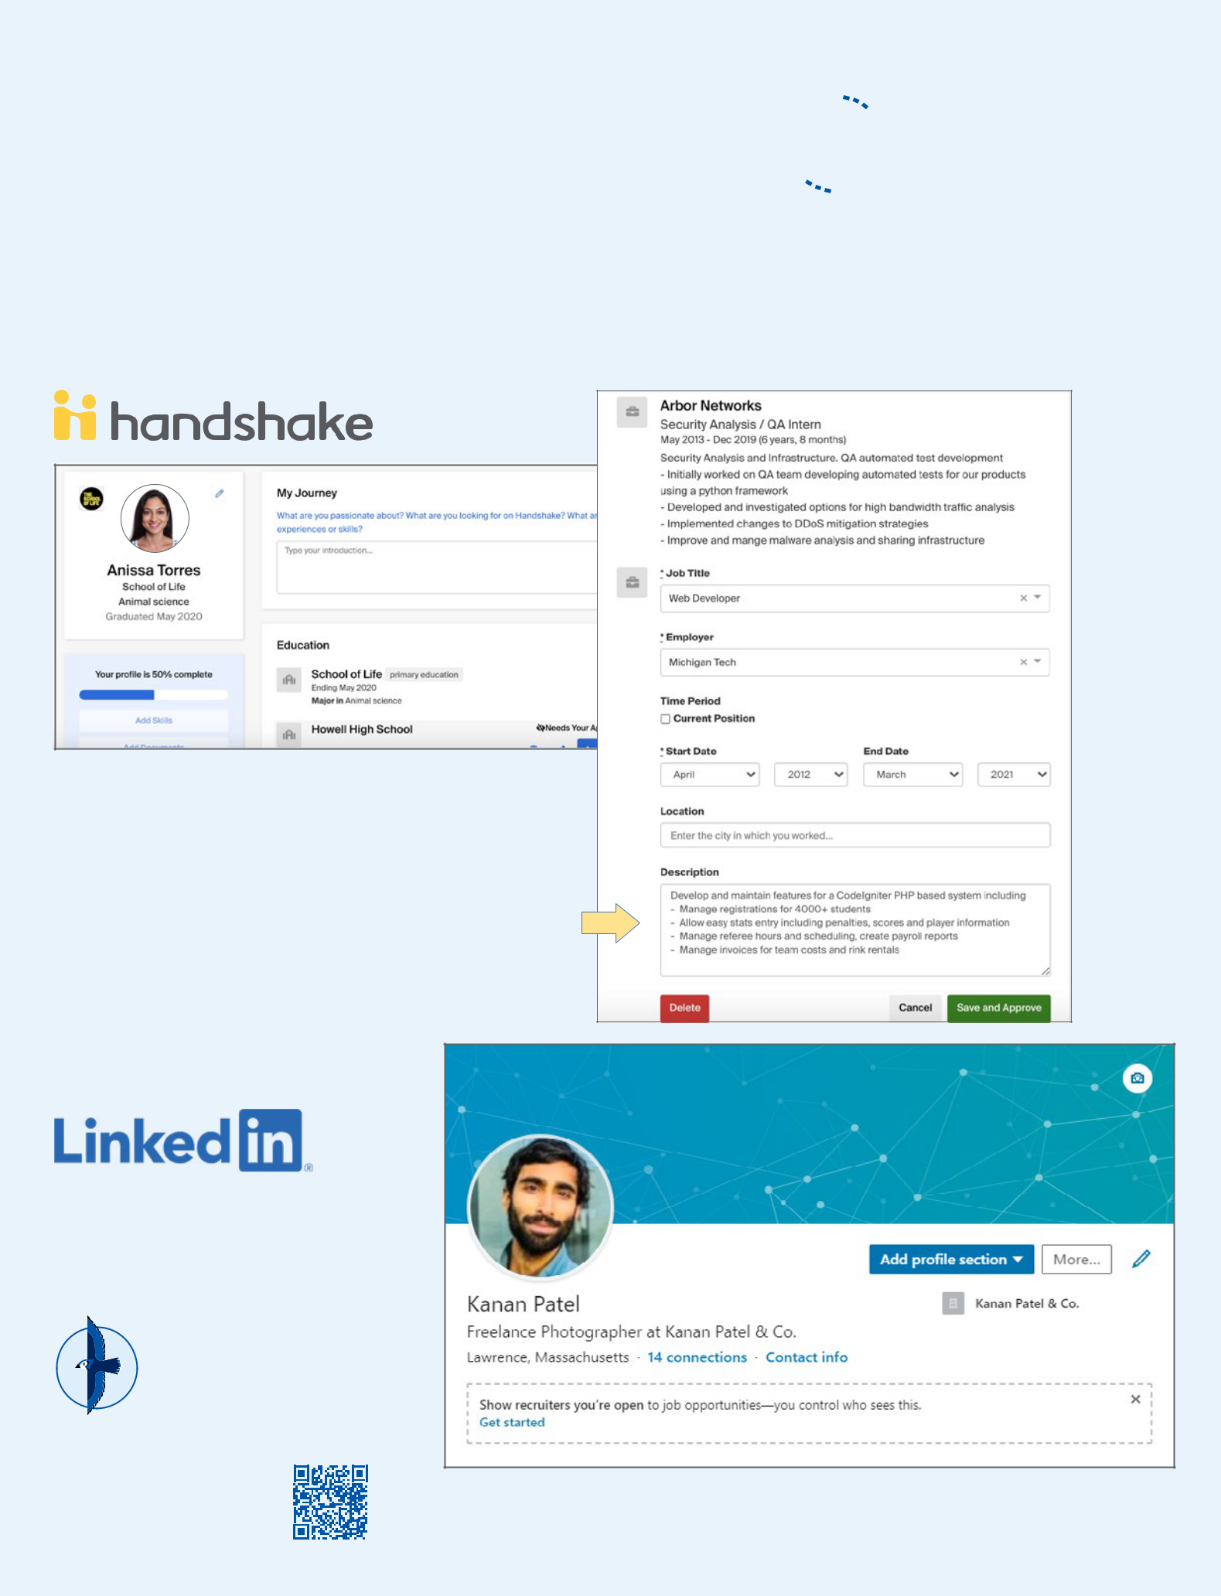
Professional Profiles 

Professional profiles are a place to showcase your skills and experiences online, which is why many students think of them as an online version of a resume. LinkedIn and Handshake are the “bread and butter” profiles for Creighton students. These platforms are also used to network with industry professionals, peers and alumni. These sites additionally include job boards for full-time and internship opportunities. And—once your resume is looking sharp—it’s an easy next step to translate this information to these profiles.

Handshake and LinkedIn use similar sections with only minor differences. Handshake even has a feature to transfer information to your profile after uploading a resume, as seen here.

Having a LinkedIn profile can be very helpful in your search for opportunities, as many recruiters use LinkedIn to not only promote jobs, but also search for candidates.

Helpful tip

Check out our Networking resources here for more information about creating professional profiles online.

Images provided by Handshake and LinkedIn Help Centers.

15



The John P. Fahey Career Center, as part of the Creighton EDGE, is committed to assisting students and alumni in exploring purpose and opportunities, developing career-related skills, and implementing goals that reflect their unique roles in the world of work and their commitment to a life of service to others.

Mike and Josie Harper Center, Suite 1088

2500 California Plaza | Omaha, Nebraska 68178

Office: 402.280.2722

careercenter@creighton.edu | creighton.edu/careercenter

Office Hours: Monday–Friday, 8 a.m.–4:30 p.m. CST

Drop-in Hours: Monday–Friday, 2–4:30 p.m. CST

(when classes are in session)

