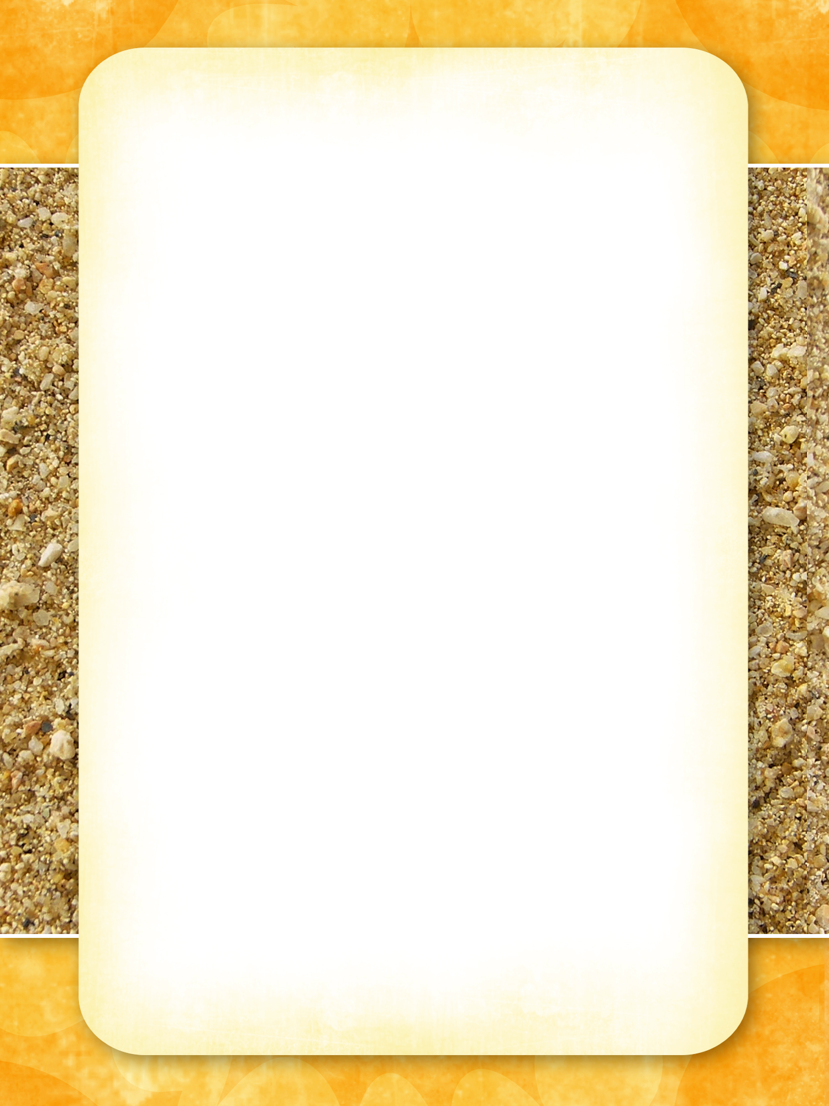Enter letterhead text here.
Primary Address
Contact

