OWNER OPERATORS

COLLECTIVE AGREEMENT

BETWEEN

Loomis EXPRESS (CANADA), LTD.
NOVA SCOTIA
(HERINAFTER REFERED TO AS THE "COMPANY")

AND

NATIONAL AUTOMOBILE, AEROSPACE, TRANSPORTATION

AND GENERAL WORKERS OF CA~ADA (CAW CANADA)
LOCAL4005
IN THE PROVINCE OF NOVA SCOTIA

(HEREINAFTER REFEREED TO AS THE "UNION")

Nova Scotia CBA Aug 1, 2009 to March 31, 2013

May 26, 2011

14412 (01)

TABLE OF CONTENTS FOR OWNER OPERATOR

ARTICLE 1: | UNION RECOGNITION............................................................................................................................. |  |  | 34
ARTICLE 2: | MANAGEMENT RIGHTS.......................................................................................................................... |  |  | 36
ARTICLE 3: | GRIEVANCE PROCEDURE ...................................................................................................................... |  |  | 36
ARTICLE4: | ARBITRATION........................................................................................................................................... |  |  | 37
ARTICLES: | HEALTH AND WELFARE INSURANCE ................................................................................................. |  |  | 38
ARTICLE6: | OWNER OPERATOR SENIORITY, BIDDING, REDUCTIONS .............................................................. |  |  | 39
ARTICLE 7: | EQUIPMENT .............................................................................................................................................. |  |  | 40
ARTICLE 8: | UNIFORMS ................................................................................................................................................. |  |  | 41
ARTICLE9: | TRAINING .................................................................................................................................................. |  |  | 42
ARTICLE 10: | MISCELLANEOUS..................................................................................................................................... |  |  | 43
ARTICLE 11: | HARASSMENT........................................................................................................................................... |  |  | 45
ARTICLE 12: | EXTRA WORK ........................................................................................................................................... |  |  | 47
ARTICLE 13: | REPLACEMENT DRIVERS ........................................................................................ |  | •... | .47
ARTICLE 14: | VEHICLE SECURITY.......... | :........................................................................................ |  | .48
ARTICLE 15: | INCORPORATION OF OWNER OPERATORS................................................................... |  |  | .48
ARTICLE 16: | RATE SCALE OWNER OPERATOR ............................................................................... |  |  | .49
ARTICLE 17: | DURATION OF AGREEMENT....................................................................................... |  |  | 50
LOU- COST OF NEGOTIATIONS........................................................................................................... |  |  |  | 51
LOU- COMMITMENT TO WORKING TOGETHER..................................................................................... |  |  |  | 52
LOU- OWNER OPERATOR HANDHELD DEVICES..................................................................................... |  |  |  | 53
LOU- FUEL ESCALATION ................................................................................................................... |  |  |  | .54
LOU- FUEL DISCOUNT....................................................................................................................... |  |  |  | 56
LOU-PAYMENT FROM PULSE............................................................................................................ |  |  |  | 57
LOU- NON BILLABLES.............................................................................. |  |  | _. ....................................... | 58
LOU- BUSINESS AGREEMENT............................................................................................................ |  |  |  | 59
APPENDIX A- LIABILITY INSURANCE ................................................................................................. |  |  |  | 62
LOU- RE-ROUTE ................................................................................................................................ |  |  |  | 63
LOU- MAJOR CENTRE PARAMETERS.................................................................................................. |  |  |  | 64
BC ACCORD | ..................................................................................................................................... |  |  | 65
NOVA SCOTIA CORE ZONE TABLES ..................................................................................................... |  |  |  | 73
LOU- RE-BRANDING.......................................................................................................................... |  |  |  | 81
THIS AGREEMENT entered into this 26 day ofMay, 2011.

Nova Scotia CBA Aug 1, 2009 to March 31, 2013
May 26, 2011 | -32-

BETWEEN: Loomis EXPRESS (CANADA), LTD., in the Province ofNova Scotia

(Hereinafter referred to as the "Company")

AND:

NATIONAL AUTOMOBILE, AEROSPACE, TRANSPORTATION AND

GENERAL WORKERS OF CANADA (CAW CANADA) in the Province oJ

Nova Scotia (Hereinafter referred to as the "Union")

WHEREAS it is the desire of the Company and the Union to enter into an agreement to prevent strikes, lockouts, and other work stoppages and/or slowdowns during the term of the Agreement.

WHEREAS the parties to the Agreement desire to cooperate in establishing and maintaining conditions which will promote harmonious relations and provides methods for a fair and amicable adjustment of disputes which may arise between them.

AND WHEREAS both parties are pledged to cooperate and assist to the fullest extent in promoting safety and efficiency within business operations.

Nova Scotia CBA Aug 1, 2009 to March 31, 2013
May 26, 2011 ⁻ ³³ ⁻

ARTICLE 1: UNION RECOGNITION

1.01 a) The Company recognizes the Union as the sole and exclusive bargaining agent for all Owner Operators in the Province ofNova Scotia, save and except supervisors, those above the rank of supervisors, office and clerical staff, sales stafi, dispatchers and mechanics.

- Properly qualified officers of the Union shall be recognized by the Company in discussing any and all matters affecting the Collective Agreement between the Company and the Owner Operator who are members of the Union.

1.02 The provisions of part I, Chapter L-2, Sections 44, 45, and 47 or as amended from time to time of the Canada Labour Code dealing with successor rights and obligations is recognized by the parties.

1.03 The Company shall not discriminate against any Owner Operator who is a Union steward and who, from time to time, represents other Owner Operators.

1.04 The Union shall promptly notify the Company in writing of the names of the Owner Operators comprising the Union's stewards and any changes in personnel thereof. The Company shall inform the Union, in writing, of the supervisors with who said accredited representatives shall deal and any changes in personnel thereof.

1.05 The Union agrees that there will be no Union activities carried out during working hours, except those necessary in connection with the administration of this Agreement, and/or grievable matters. Accredited representatives of the Union shall have access to the Company's premises during working hours for the purpose of adjusting disputes, investigating working conditions and ascertaining that the Agreement is being adhered to, provided, however, that there is no interruption of the Company's working schedule.

In a situation which requires a Union representative's attention during working hours, he/she shall not leave his/her regular duties without first obtaining permission to do so from their immediate Supervisor. It is understood that the taking of such time away from their regular duties shall be kept to a minimum, and that permission will not be unreasonably withheld. The Union representative shall return to their regular duties as expeditiously as possible. The Employer reserves the right to limit such time, if the time requested is unreasonable.

1.06 It is hereby agreed that all Owner Operators shall become members of the Union and shall as a condition of employment become and remain members of the Union.

Nova Scotia CBA Aug 1, 2009 to March 31, 2013

May 26, 2011 - 34 -
1.07 The Company agrees to deduct from the pay of each Owner Operator who is a member of the Union or covered by this Agreement, and amount of Union dues or their equivalent as specified by the Secretary-Treasurer and forward the full amount so deducted to him/her or such other person as may be officially designated. Said deductions to be made from the last pay in each and every month. Deductions so made will be forwarded to the Secretary-Treasurer of the Union or such person as that official may designate. The monthly dues remittance shall be accompanied by a list of Owner Operators on the payroll for the pay period in which the deductions were made. The Company will note on the remittance why any Owner Operator is not paying dues.

1.08 The Company shall furnish to the Union a list of all new Owner Operators contracted by the Company. The Union will supply the Company with deduction authorization forms and membership applications, which shall be signed by all new Owner Operators on the date of hire. It will be the responsibility of the Company to ensure that all forms and membership fees are forwarded to the Union Treasurer within fourteen (14) calendar days from the date of hire. The Company shall, at the time ofhiring, inform the Owner Operators as to his/her status regarding whether they are a full time or part time Owner Operator.

1.09 The Company shall not require any Owner Operator covered by this Agreement to cross a legal picket line or to accept any product or goods from any person or persons with whom a Union has a legal picket or placard line around or against, or to deliver any products or goods to any person with whom a Union has a picket or placard line around or against. This article does not prevent any Employee or Owner Operator from accepting or delivering freight that arrives at their home facility so long as they do not have to cross a legal picket line.

1.10 The Company shall grant a leave of absence without remuneration to an Owner Operator who is a steward attending essential Union business, not to exceed two (2) weeks, the Union will give a minimum of fifteen (15) days notice of such requirement.

1.11 It is understood that the Company's officer, managers, supervisors, dispatchers, sales and office staff shall not perform the work of the regular Owner Operators except in an emergency or overload situation where no Owner Operators are readily available to be called to perform such work.

1.12 Any Owner Operator elected or appointed to a full time position with the CAW - Canada shall be granted an indefinite leave of absence without pay provided that thirty (30) days notice is given to the Company prior to the beginning of such leave. During such leave, the Owner Operator's seniority shall accumulate, welfare benefits shall be suspended thirty (30) days after such leave commences, and annual vacation benefits shall be suspended immediately. They will both again be in effect the first day the Owner Operator returns to work.

Nova Scotia CBA Aug 1, 2009 to March 31, 2013
May 26, 2011 - 35 -
ARTICLE 2: MANAGEMENT RIGHTS

2.01 The Union recognizes that it is the Company's right and exclusive function to manage and generally direct and operate its business activities to include:

(i.) The right to enter a Business Agreement with or terminate the Business

Agreement in accordance with the Owner Operator Collective Agreement or for breach of contract;

(ii.) The right to maintain order, establish and reasonably enforce service standards

governing the conduct of Owner Operators;

(iii.) The right to determine the products to be handled and the methods ofhandling

and processing and related scheduling of operations.

2.02 The Company agrees that these functions will be exercised in a manner consistent with the provisions of this Agreement.

2.03 The above clauses shall not deprive Owner Operators of the right to exercise the grievance procedures as outlined in this Agreement.

ARTICLE 3: GRIEVANCE PROCEDURE

3.01 It is the intention of the parties that this procedure provide a just and peaceful method of

adjusting grievances and the parties agree to act in good faith in settlement of the grievances in accordance with the provisions of this Article.

3.02 Any complaint, disagreement, or difference of opinion between the Company and the Union or the Owner Operators covered by this agreement which concerns the application or interpretation of the terms and provisions of this Agreement, shall be considered a grievance.

3.03 a) Any Owner Operator, the Union or the Company may present a grievance.

- Any grievance concerning a dismissal shall be submitted at Step 2.

- Any grievance which is not presented within seven (7) working days following the event giving rise to such grievance shall be forfeited and waived by the aggrieved parties.

- A policy grievance filed on behalf of the Union or the Company shall be submitted at Step 2 of the grievance procedure.

3.04 Any Owner Operator having a complaint must first orally discuss the matter with a supervisor.

Nova Scotia CBA Aug 1, 2009 to March 31, 2013
May 26, 2011 | -36-

Step 1:

The Owner Operator and his/her shop steward shall submit his/her formal grievance in writing to the Service Centre Manager, who shall give his/her reply in writing within five (5) working days. If a satisfactory settlement cannot be reached, then;

Step 2:

Within four ( 4) working days of receiving the decision under Step 1, the Owner Operator with his/her shop steward shall submit the grievance in writing to the Area Service Manager. Within twenty-one (21) calendar days of submitting the grievance in writing, a meeting shall beheld between the grievor, the steward and an accredited representative of the Union or his/her designated business agent and the Area Service Manager or the designated officer of the Labour Relations Office ofthe Company. The Company shall give its reply within fourteen (14) calendar days of the meeting and failing a satisfactory settlement, the grievance may then be referred to a single arbitrator as established in Article 4 of this Agreement.

3.05 The time limitations prescribed in this Article may be extended, but only by mutual consent of both parties, in writing.

3.06 Any Owner Operator shall be allowed to inspect his/her own file held by the Company, in the presence of the Company, during normal business hours. Any officer ofthe Union, on the behalf of the Owner Operator, may accompany the Owner Operator to inspect his/her own file. Any officer of the Union shall be allowed to inspect an Owner Operator's file with the prior written authorization ofthe Owner Operator.

3.07 A copy of all corrective action letters to any Owner Operator covered by this Agreement shall be forwarded to the Union chief steward.

3.08 Any corrective action notices will be withdrawn from the Owner Operator's file after one

- year except if there is a reoccurrence of a same or similar infraction within that year. Any violation concerning a criminal or civil offence or matters affecting driving records will remain on corrective notice records indefinitely.

ARTICLE 4: ARBITRATION

4.01 Failing a satisfactory settlement of a grievance at Step 2 of the grievance procedure, either party may request that the matter be referred to an Arbitrator. Such notification must be made in writing within twenty-one (21) days of the date of the reply at Step 2 ought to have been given.

4.02 The Arbitrator shall be mutually agreed upon by the Company and the Union

4.03 Failing agreement on the selection of an Arbitrator within seven (7) calendar days, the matter shall be referred to the Department of Labour, who shall appoint an Arbitrator.

Nova Scotia CBA Aug 1, 2009 to March 31, 2013
May 26, 2011 - 37 -
4.04 The Arbitrator shall receive and consider such material evidence and contentions as the parties may offer, and shall make such independent investigation as he/she deems essential to a full understanding and determination of the issues involved. In reaching his/her decision, the Arbitrator shall be governed by the provisions of this Agreement. The Arbitrator shall not be vested with the power to change, modify, or alter any of the terms of this Agreement.

4.05 The findings and decision of the Arbitrator on all arbitrable questions shall be binding and enforceable on all parties.

4.06 The expense of the Arbitrator shall be borne equally by the Company and the Union.

4.07 All monetary grievances that are mutually agreed upon, shall be paid the following deposit period, whether by separate cheque or, in the alternative, the Owner Operator's regular cheque shall be accompanied by a written statement outlining the amount and the grievance settlement involved.

ARTICLE 5: HEALTH AND WELFARE INSURANCE

5.01 The Company will provide each eligible Owner Operator with the option of participating in the following insurance to be administered in accordance with the terms, conditions, rules and regulations of the respective plans:

Major Medical (extended health benefit)

Dental Plan

Life Insurance

Accidental Death and Dismemberment

Voluntary Personal

Vision Care- $150.00 per Owner Operator every 24 months

The parties agree that the Company is not the insurer and said insurance is provided on a

voluntary basis. The Owner Operator shall pay 100% of the premium costs, which are

subject to change without notice by the Insurer. On receipt of a change in rates from the Insurer, the Company shall notify the Union. The Company will deduct the premium costs of the insurance selected from the Owner Operator's invoice.

5.02 RETIREMENT

The retirement date for all Owner Operators will be the first day of the month following the Owner Operator's sixty-fifth (65¹h) birthday unless the Owner Operator was born on the first day of the month, in which case his/her retirement date is the sixth-fifth (65th) birthday.

Nova Scotia CBA Aug 1, 2009 to March 31, 2013
May 26, 2011 | -38-

ARTICLE 6: OWNER OPERATORS' SENIORITY, BIDDING, REDUCTIONS

6.01 The purpose is to provide a policy governing bidding, reductions and recalls. Each Owner Operator will establish a Company service date (seniority), using the greater of:

- Date of signing Business Agreement, and continuously working since then; or

- Hourly rate seniority date ifhe is a transfer from an hourly rated position.

6.02 The Company shall post onthe Union bulletin board, an up-to-date seniority list showing name, initials of the Owner Operator, date of service and will ensure that this list is maintained and kept up-to-date. The seniority list will be posted on or about March 31 ⁵\ June 30th, September 30th, and December 31st of each year.

6.03 \ When reducing Owner Operators at any location, the Company will replace the junior Owner Operator with the displaced senior Owner Operator, provided said senior Owner Operator fulfills the requirements of the route in question to the satisfaction ofthe management within fourteen (14) calendar days. In the event this is not possible, it is recognized bumping is not permitted.

6.04 For a period not to exceed twelve (12) months, a laid off Owner Operator, who is qualified and has the required vehicle, will be offered any vacancy that arises, in order of Company service date (seniority).

6.05 a) When a vacancy occurs for any reason, the Company will post within five (5) days at the appropriate depot or branch, the said vacancy for five ( 5) working days, in order that the Owner Operators may bid for the vacancy in writing. Such notice shall provide information regarding the classification, route number if applicable, service area and scheduled hours. Selection will be on the basis of the Owner Operator seniority. Seniority will be by branch or depot only.

- Should the vacancy not be filled from the Owner Operators in the classification posted, employees outside the classification in the particular branch or depot may apply

- No Owner Operator shall voluntarily and successfully apply for more than one (1) vacancy in a six ( 6) month period.

- The above provisions will apply to the filling of the original vacancy created and the

next vacancy thus created. ·

6.06 An Owner Operator's service date (seniority) shall be forfeited and his service shall be deemed to be terminated and there shall be no obligation to rehire under the following conditions:

- His contract is terminated for just cause; or

- He voluntarily resigns or quits; or

- He retires or is retired; or

- He is discharged and not reinstated through the Grievance Procedure; or

Nova Scotia CBA Aug 1, 2009 to March 31, 2013
May 26, 2011 - 39 -
e) He is laid off for a period of the lesser of twelve (12) months or the length of the Owner Operator's service; or

- He fails to respond to return to work within five (5) calendar days of his recall to his last known address or phone number on the Company's records or does not in fact return to work within fourteen (14) calendar days from the date of his response to the Company. The onus is on the Owner Operator to inform the Company of his current address and telephone number; or

- Subject to legislation, he is absent from work for two (2) years as a result of an injury or until the Owner Operator reaches age 65, whichever occurs first.

ARTICLE 7: EQUIPMENT

7.01 All Owner Operators shall be required to submit a security deposit for use of Loomis owned communication equipment or other equipment required in the performance of their services in the amount oftwo hundred dollars ($200.00).

Such security deposit shall be forfeited in the event of loss or damage to such equipment resulting from the negligence of the Owner Operator. A further security deposit shall be required with respect to any replacement equipment.

The security deposit shall not apply to Owner Operators who have a contract for service with Loomis Express (Canada), Ltd. as of January 14th, 2001.

7.02 All Owner Operators shall be required to submit a security deposit for use of Loomis owned scanning equipment required in the performance of their services in the amount of eight hundred dollars ($800.00).

Such security deposit shall be forfeited in the event of loss or damage to such equipment resulting from the negligence ofthe Owner Operator. A further security deposit shall be required with respect to any replacement equipment.

The security deposit shall not apply to Owner Operators who have a contract for service with Loomis Express (Canada), Ltd. as of January 14th, 2001.

7.03 An Owner Operator who feels he has been unjustly accused of negligence shall have recourse through the grievance procedure contained herein.

7.04 The Company assumes responsibility for the supply and installation of the decal kit. Where the Company is changing the required colour scheme, the Company assumes the full cost of painting in accordance with the painting price available at an accredited auto body shop.

7.05 All violations involving the Owner Operator's vehicle moving or parked must be reported, within 24 hours of the incident, to the Service Centre Manager.

Nova Scotia CBA Aug 1, 2009 to March 31, 2013

May 26, 2011 - 40 -
7.06 Communication allowance; Company to pay $15.00 per month as communication

allowance per owner operator for business communication between owner operators and Loomis management. It is understood that in the event Loomis introduces alternate communication technologies at no cost to owner operators then this communication allowance shall cease. Communication to an owner operator cell phone should only be for emergencies, C.O.S. shipments and narcotics shipments. All other communications to an owner operator must be through the paging system.

7.07 All affected owner operators that are required on a regular basis to use either toll bridge as part of their route shall receive a monthly Toll Bridge allowance in the amount of twenty five (25) dollars.

ARTICLE 8: UNIFORMS

8.01 Where required for Owner Operators, the wearing of Company-issued uniforms is mandatory while on duty only and a condition of maintaining a business agreement. The Company will pay for new uniforms when such are required. The Company shall also pay for uniforms when required for one company approved relief driver. All alterations, other than those required at issue to ensure fit, shall be the responsibility of the Owner Operator. All uniforms are and will remain the sole property of the Company, and the Owner Operator shall be required to maintain at their expense, care and good repair of said uniforms. All uniforms shall be returned to the Company for replacement when required, or upon termination of employment.

8.02 a) The Company will provide uniform and additional items as required by season.

GENERAL ISSUE

- Winter parka or bomber style jacket

- Summer Coat

  - Shirts

  - Trousers

  - Cap (if employee wishes)

  - Pair shorts (if employee wishes)

- When shorts are worn, the following apparel must accompany the shorts:

      - Black or brown safety shoes must be worn.

      - Loomis issue short sleeved shirt must be worn.

      - No running shoes or sandals may be worn in conjunction with this mode of summer dress.

c) Upon request, cloth name tags will be provided to each Owner Operator

Nova Scotia CBA Aug 1, 2009 to March 31, 2013
May 26, 2011 - 41 -
8.03 a) Safety footwear is mandatory for all Owner Operators while on duty. The company will provide an annual lump sum maximum payment of one hundred and twenty dollars ($120.00) for an equipment refund on the first of January each year. Safety footwear is mandatory and a condition of employment. Said footwear must be black or brown.

- During the probationary period, Owner Operators will be provided safety footwear as in Article 8.03(a). In the event the employee does not successfully complete the probationary period, advances forwarded as per Article 8.03(a) will be deducted from the final pay on a pro rated basis.

8.04 As a condition of the Business Agreement, it is agreed that the prescribed uniforms will be worn whilst on duty, but the Owner Operator must cover Company identification at any other time.

8.05 Women Owner Operators will be provided women's clothing.

ARTICLE 9: TRAINING

9.01 From time to time, Owner Operators will be required to attend training and/or educational meetings outside their schedule and these hours shall be paid at straight time at the Owner Operator special rate. Two (2) weeks advance notice will be given. A guaranteed minimum of four (4) hours pay for attending. If the owner operator is unable to attend the training session they will be required to attend at an alternative time, at the discretion of the Company, within two weeks of the original training date. The owner operator will be held out of service until the training is completed if the owner operator fails to attend the second training session. Further the training required shall be at the owner operator's expense.

9.02 The company will ensure that all Owner operators are properly trained as to their full responsibilities and duties.

9.03 The Company may require an Owner operator to attend a defensive driving course at the Company's expense.

9.04 The cost for the company approved training and upgradingthe skills or qualifications of one replacement driver per Owner Operator, approved by the Company, to comply with the requirements of the employer will be borne by the employer. Relief or Replacement drivers shall be paid at the hourly driver rate for the classification.

9.05 When adding to the Owner operator group and or when any individual is on what to them is a new Owner operator route, they shall receive a maximum of 2 days training on the route for experienced Owner operators and a maximum of 5 days training for new Owner operators. During training the trainer will be paid the hourly special rate per hour and the new owner operator will receive full route revenue.

Nova Scotia CBA Aug 1, 2009 to March 31, 2013
May 26, 2011 | -42-

ARTICLE 10: MISCELLANEOUS

10.01 During the period oflayover, the vehicle will be parked/secured in a designated secure parking area.

10.02 The Company agrees to provide a bulletin board at each of its terminals for the use by the Union for posting matters relating to Union meetings and other Union business, provided that they are authorized and signed by an officer ofthe Union. The said bulletin board shall not be located in any place the general public has access.

10.03 It shall be the responsibility of every Owner Operator to keep the Company and the Union informed of any and all changes of address or telephone numbers. Such information will be supplied in writing within three (3) working days of such change.

10.04 Owner Operators whose contracts are terminated for cause will have reasons for same confirmed in writing. Those Owner Operator who terminate their contract voluntarily shall have all monies owing them paid no later than the next scheduled payment day.

10.05 The Company shall not be responsible for the loss, damage or destruction of the Owner Operator's personal property while such property is on the Company's premises, in vehicles or equipment, or in use on Company business.

10.06 The Company will provide each Owner Operator a copy of the Collective Agreement, at the time of service commencement.

10.07 Converting Owner Operator to Hourly

In the event that the Company decides to convert any Owner Operator route(s) to hourly, the following shall apply:

- The Company will provide at least 90 days notice ofthe conversion to the Union and the affected Owner-Operator(s).

- The Company will meet with the Union, and the affected Owner Operator(s) to discuss any issues of mutual concern relating to the conversion.

- The affected Owner Operator(s) will be given the first opportunity to accept any hourly route(s) resulting from the conversion or may exercise their seniority to any junior owner operator route or may elect to resign and accept a severance payment equivalent to one

(1) week per year of service at the prevailing hourly driver rate. These options will also be available to any Owner Operator who is bumped by another Owner Operator as a direct result of the conversion. An Owner Operator who, by accepting an hourly route or otherwise exercising his/her seniority rights to bump into an hourly position, will be given credit for all continuous service since his/her original date of service for the purposes of the collective agreement.

Nova Scotia CBA Aug 1, 2009 to March 31, 2013
May 26, 2011 | -43-

- If the Owner Operator requests, the Company will either assume responsibility for the vehicle leases of affected Owner Operator(s), or, if the Owner Operator(s) owns his/her vehicle, the Company will purchase it at fair market value, established by a reputable dealer selected and agreed to by the Company and the Owner Operator, provided the vehicle was acquired or committed to by the Owner Operator prior the date of notice under paragraph 1 above.

If the vehicle is leased and there remains residual equity in the lease, the Owner Operator will be compensated accordingly.

- The Company will indemnify the affected Owner Operator(s) for any reasonable and customary business expenses already incurred or committed to for the current year which are not otherwise recoverable by the Owner Operator, including insurance, benefits, permits and cancellation fees, provided such costs were incurred prior to the date of notice under paragraph 1 above.

- The Company will indemnify the affected Owner Operator(s) for any legal or accounting fees reasonably incurred as a result of the conversion, to a maximum of $1000. per Owner Operator.

- If, as a result of conversion, an Owner Operator incurs an unexpected income tax liability because of the inability to claim a reserve under the Income Tax Act with respect to the deferred income, the company will provide the Owner Operator with reasonable financing assistance relating to such tax liability including, if necessary a loan, subject to the following conditions:

the Owner Operator must provide satisfactory proof that such loan is required for the above purpose;

the loan will be to a maximum of $20,000 for a 3/4 ton vehicle and $25,000 for a one ton vehicle.

the Owner Operator shall sign a promissory note for the loan;

the interest rate shall be 2% above the prime rate as at the date the promissory note is signed;

the repayment schedule shall be based on an equal number of monthly installments of $500. per month, unless the parties agree otherwise, provided the loan is repaid within a maximum twenty four (24) months;

the Owner Operator must have elected to become an hourly rated employee and must continue to be an employee of the company; if his/her employment is terminated prior to full repayment, the outstanding balance shall become due and payable upon termination.

Nova Scotia CBA Aug 1, 2009 to March 31, 2013
May 26, 2011 | -44-

- If, prior to the notice under paragraph 1 above, the Owner Operator has incurred indebtedness directly related to the operation of his/her vehicle which exceeds the equity in the vehicle, the Company will provide the Owner Operator with reasonable financing assistance relating to such indebtedness including, if necessary, a loan to a maximum of $5,000 subject to the conditions set out in paragraph 7) above.

- Any dispute over the application of this L.O.U. may be submitted to arbitration in accordance with Article 4 of the Collective Agreement.

  - It is understood that any Owner Operator that takes an hourly driving position as a result of these provisions will be awarded an eight (8) hour position.

10.08 The Owner Operators and the Company will be able to negotiate individual rates above and below the minimum. The Union will be present for these meetings.

10.09 The Owner Operator's Business Agreement will have a renewal date consistent with the Collective Agreement. Any Owner Operator or the Company may discuss issues of licensing, equipment, or compensation. The Union will be present at these discussions.

10.10 In the event of a major expenditure for business purposes, supported by the appropriate documentation, the Company will assist all Owner Operators by extending credit to all Owner Operators up to one thousand ($1000.00) dollars. The Owner Operator is expected to make the repayment, within 12 months of receiving the funds, through payroll deductions.

10.11 If requested by the Company and the Owner Operator agrees, the Company will reimburse the Owner Operator up to half the cost (maximum $500) for the painting of his/her vehicle.

10.12 Any medical examination requested by the Company shall promptly be complied with by the Owner Operator, provided however, that the Company shall pay for such an examination, at the hourly driver rate to a maximum of two (2) hours.

10.13 The Company shall advise the Owner Operator at least two (2) working days in advance, wherever possible, of such medical examination. The time and date of the examination to be mutually agreed upon.

ARTICLE 11: HARASSMENT

All Hourly Employees, Owner Operators, and Management Personnel are expected to treat all persons with courtesy and consideration and must not engage in discrimination, harassment, violence or bullying of any kind. Prohibited grounds for harassment are race, national or ethnic origin, colour, religion, age, sex, sexual orientation, marital status, family status, disability or conviction for an offence for which a pardon has been granted.

Nova Scotia CBA Aug 1, 2009 to March 31, 2013
May 26, 2011 ⁻ ⁴⁵ ⁻
- It is understood that both the Company and the Union shall co-operate in every way to reduce or eliminate any type of harassment, violence or bullying in the workplace and as per the Company Anti-Harassment, Violence, Bullying and Discrimination Policy.

- Harassment is in no way to be construed as Supervisory responsibilities that are properly discharged, including the delegation of work assignments, the assessment of discipline, or any conduct that does not undermine 'the dignity of the individual. Should the direction do so, then it shall be considered a violation of this Article.

- Complaint Resolution Procedure:

If an Hourly Employee or Owner Operator believes that his/her rights under the above Article have been violated the following shall apply:

- Tell the person involved, as soon as possible, how you feel, and request that he/she stops the conduct you find offensive;

- If you feel uncomfortable approaching the person, or ifthe violation of rights continues, bring the incident forming the basis of the complaint, (in writing), to the attention of the Director of Human Resources for the Company and the Local Chair of the Union, where each shall then be responsible for delegating- the individuals responsible to handle the complaint, or conduct the investigation themselves.

- The joint Committee will consist of equal members of Management and the Union. The actual composition of the joint Committee will be determined by the parties on a case-by-case basis.

  - It is the intention of the Company and the Union that, where practical, the joint investigation will begin within five (5) working days of the lodging ofthe written complaint and shall be completed within fifteen (15) calendar days after the lodging of the written complaint.

    - All matters brought before the Committee will be dealt with in a confidential manner.

    - Any complaint not resolved through this process may be taken to the Human Rights Council of Canada and/or the grievance process.

Nova Scotia CBA Aug 1, 2009 to March 31, 2013
May 26, 2011 | -46-

ARTICLE 12: EXTRA WORK

Each facility, branch, depot, & department shall post bi-weekly sign up sheets for the Union Members in their facility.

All extra work shall be awarded on the basis of seniority only, understanding that the Union Member must possess the skills or licenses required for work being offered.

All extra work shall first be offered to part-time Union Members first to supplement their hours up to eight (8) hours in a day.

Once part-time have been utilized as above, the work shall then be offered to all union members on the basis of seniority.

The additional supplemental hours offered to Union Members on the extra work roster cannot conflict with their regularly scheduled hours or shifts.

In the event that an individual that puts his/her name on the extra work roster and refuses offered work two (2) consecutive times, then the Company shall be under no obligation to call that individual in for extra work for the next sixty ( 60) days.

All extra driving work shall be awarded to on hand hourly drivers with the company reserving the right to reduce overtime hours. The extra driving work shall then be offered to owner operators on hand who have signed the extra work roster on the basis of seniority at the special hourly rate.

ARTICLE 13: REPLACEMENT DRIVERS

13.01

- When an Owner Operator must be absent for emergency purposes it will be the responsibility of the Owner Operator to supply a relief driver. If the Company must

supply a driver and a truck, the Company will retain the revenue for the relief period.

- Should an Owner Operator be absent from their route with an illness or family emergency, and not supply a relief driver he/she must supply a doctor's note or documentation to substantiate the validity of the absence, or corrective action may be taken.

- Should an Owner Operator have a vehicle breakdown while coming to work, and not supply a relief driver, she/he must supply valid documentation to substantiate that the breakdown occurred on the date of their absence.

- The death of an immediate family member will be considered a bona-fide emergency.

Nova Scotia CBA Aug 1, 2009 to March 31, 2013
May 26, 2011 | -47-

- The Company will provide a relief driver up to a maximum of four ( 4) occurrences per calendar year. Any doctor's note required by the Company will be paid for by the Company.

13.02 Should any Owner Operator receive a letter of concern for the actions of their relief driver, the relief driver shall be deemed terminated from being an approved relief driver.

ARTICLE 14: VEHICLE SECURITY

Outlined below are the vehicle security procedures that will be followed by Owner Operators and

Hourly Drivers:

- Vehicles used in the transport of shipments must have secure doors (front, side, rear and roll-up doors);

- Vehicles must be locked when shipments are being transported at all times;

- Custodial control of the shipments while on route, shall be the responsibility of the Owner Operator or Driver;

- Vehicles shall be locked at all times when unattended;

- Cargo vans require a pad lock on the back door and the Owner Operator is responsible to ensure this occurs and the lock is used;

- Cargo located on loading docks or ramps shall at no time be left unattended.

ARTICLE 15: INCORPORATION OF OWNER OPERATORS

Within six (6) months of ratification of this Agreement all Owner Operators in the bargaining unit may at their discretion, become Incorporated.

The cost of becoming Incorporated shall be borne by the Company for all Owner Operators and any Hourly Employees who are members of the Bargaining Unit as of date of ratification who in the future become Owner Operators.

All newly acquired Owner Operators after the date of ratification must be incorporated as a condition of signing the Business Agreement.

This Article in no way is to deprive any Owner Operator or Hourly Employee the rights, benefits or protections that they now or in future are entitled to in this Collective Agreement.

Nova Scotia CBA Aug 1, 2009 to March 31, 2013
May 26, 2011 | -48-

ARTICLE 16: OWNEROPERATORPAYRATES

Application of the 2.5% GWI in each year of the agreement is retroactive to August 1, 2009 and applies to pieces, core zone, stops, and quality payment.

Rates | 2008 | 2009 | 2010 | 2011 | 2012
Core Zone Rate | N/A | By Route | By Route | By Route | By Route
Stop Rate | N/A | $1.845 | $1.891 | $1.938 | $1.986
Piece Rate | N/A | $0.195 | $0.200 | $0.205 | $0.210
Quality Payment | 2008 | 2009 | 2010 | 2011 | 2012
98% to 100% | N/A | $15.000 | $15.375 | $15.759 | $16.153
AVO
95% to 97% AVO | N/A | $5.000 | $5.125 | $5.253 | $5.384
100% Pick Ups | N/A | $15.000 | $15.375 | $15.759 | $16.153
100%TOO | N/A | $15.000 | $15.375 | $15.759 | $16.153
Total Potential | N/A | $45.000 | $46.125 | $47.277 | $48.459

Minimums | 2008 | 2009 | 2010 | 2011 | 2012
City Van | $213.23 | $218.56 | $224.02 | $229.62 | $235.36
City Cube | $246.03 | $252.18 | $258.48 | $264.94 | $271.56
Rural Van | $224.51 | $230.12 | $235.87 | $241.77 | $247.81
Rural Cube | $268.59 | $275.30 | $282.18 | $289.23 | $296.46

All scannable waybills, laser way bills, shippers own bar-coded labels must be scanned, as per Company policy, in order to receive compensation outlined above. In the event of a malfunction of the handheld scanning unit there will be no reduction in the aforementioned compensation, except when the malfunction prevents a delivery scan and the Owner Operator fails to get the waybill (or sub waybill) signed, timed and dated for receipt of shipment.

Any discrepancies between an Owner Operator's invoice and the scanning information will be reviewed within forty-eight (48) hours of knowledge with the Owner Operator.

16.02 The Company will ensure that all Owner Operators are trained as to their full responsibilities and duties.

Nova Scotia CBA Aug 1, 2009 to March 31, 2013
May 26, 2011 - 49 -
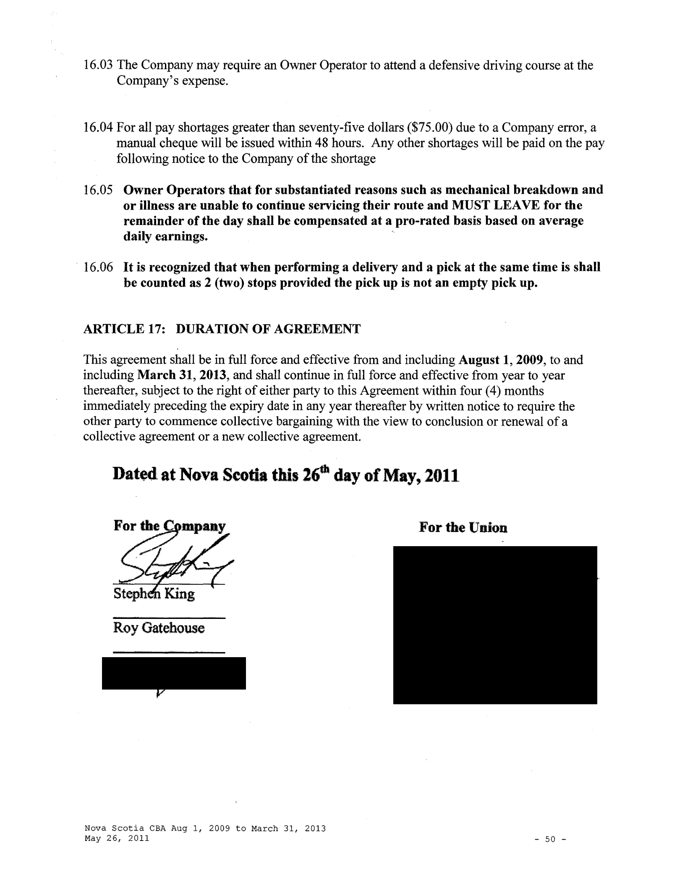
16.03 The Company may require an Owner Operator to attend a defensive driving course at the Company's expense.

16.04 For all pay shortages greater than seventy-five dollars ($75.00) due to a Company error, a manual cheque will be issued within 48 hours. Any other shortages will be paid on the pay following notice to the Company of the shortage

16.05 Owner Operators that for substantiated reasons such as mechanical breakdown and or illness are unable to continue servicing their route and MUST LEAVE for the remainder of the day shall be compensated at a pro-rated basis based on average daily earnings.

16.06 It is recognized that when performing a delivery and a pick at the same time is shall be counted as 2 (two) stops provided the pick up is not an empty pick up.

ARTICLE 17: DURATION OF AGREEMENT

This agreement shall be in full force and effective from and including August 1, 2009, to and including March 31,2013, and shall continue in full force and effective from year to year thereafter, subject to the right of either party to this Agreement within four ( 4) months immediately preceding the expiry date in any year thereafter by written notice to require the other party to commence collective bargaining with the view to conclusion or renewal of a collective agreement or a new collective agreement.

Dated at Nova Scotia this 26th day of May, 2011

For the Union

Roy Gatehouse

Nova Scotia CBA Aug 1, 2009 to March 31, 2013
May 26, 2011 | -50-

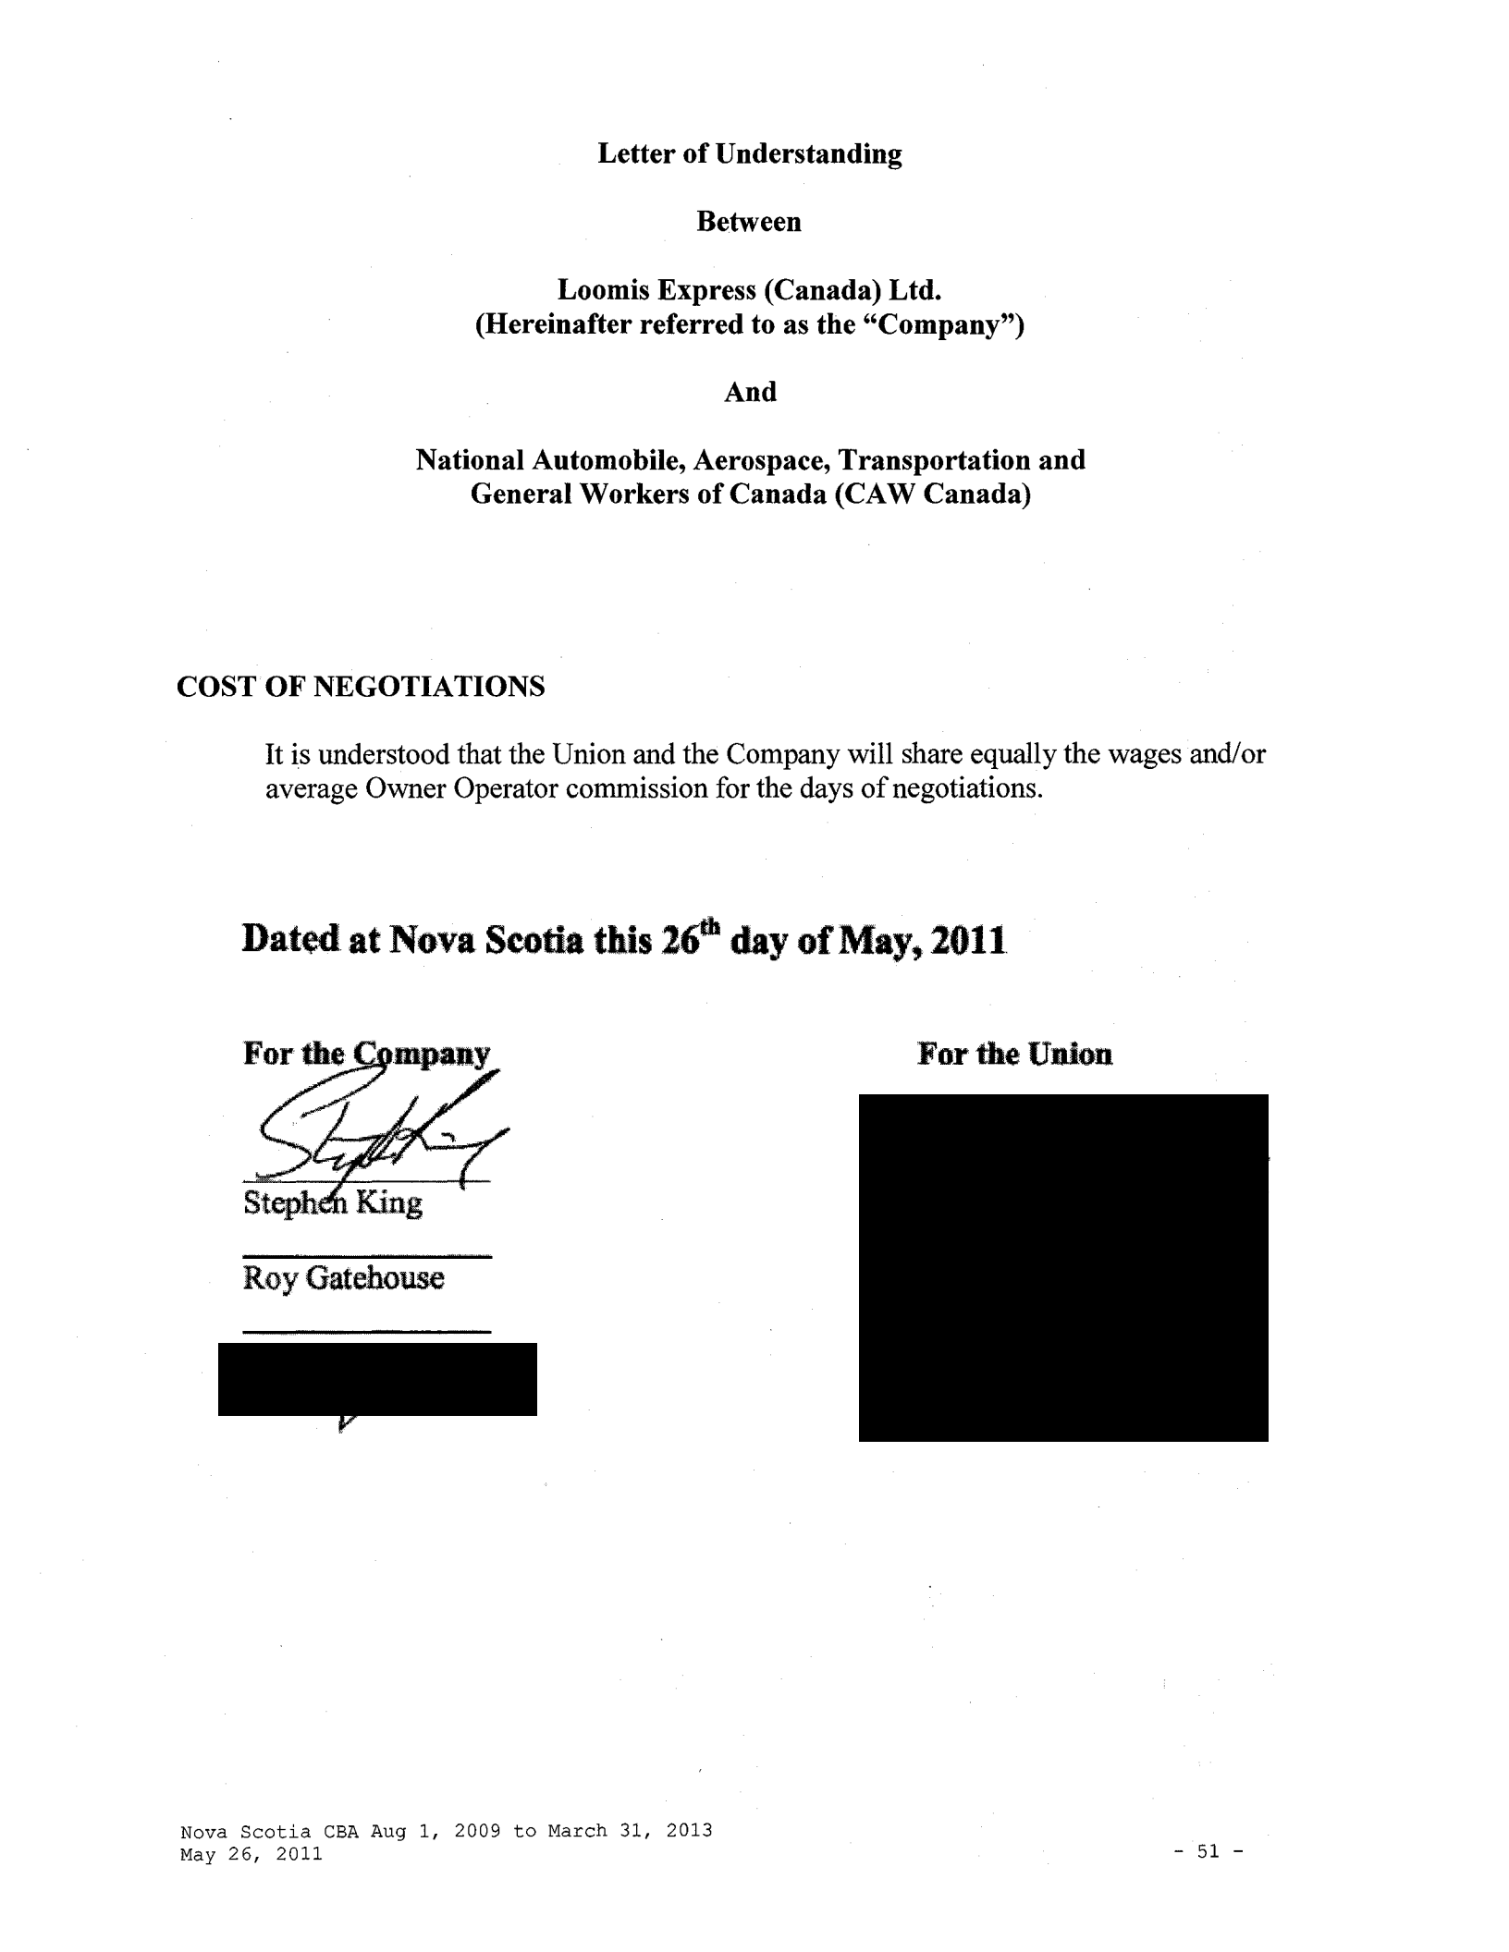
Letter of Understanding

Between

Loomis Express (Canada) Ltd.

(Hereinafter referred to as the "Company")

And

National Automobile, Aerospace, Transportation and
General Workers of Canada (CAW Canada)

COST OF NEGOTIATIONS

It is understood that the Union and the Company will share equally the wages and/or average Owner Operator commission for the days of negotiations.

Dated at Nova Scotia this 16th day of May, 2011

For the Union

Roy Gatehouse

Nova Scotia CBA Aug 1, 2009 to March 31, 2013
May 26, 2011 ⁻ ⁵¹ ⁻
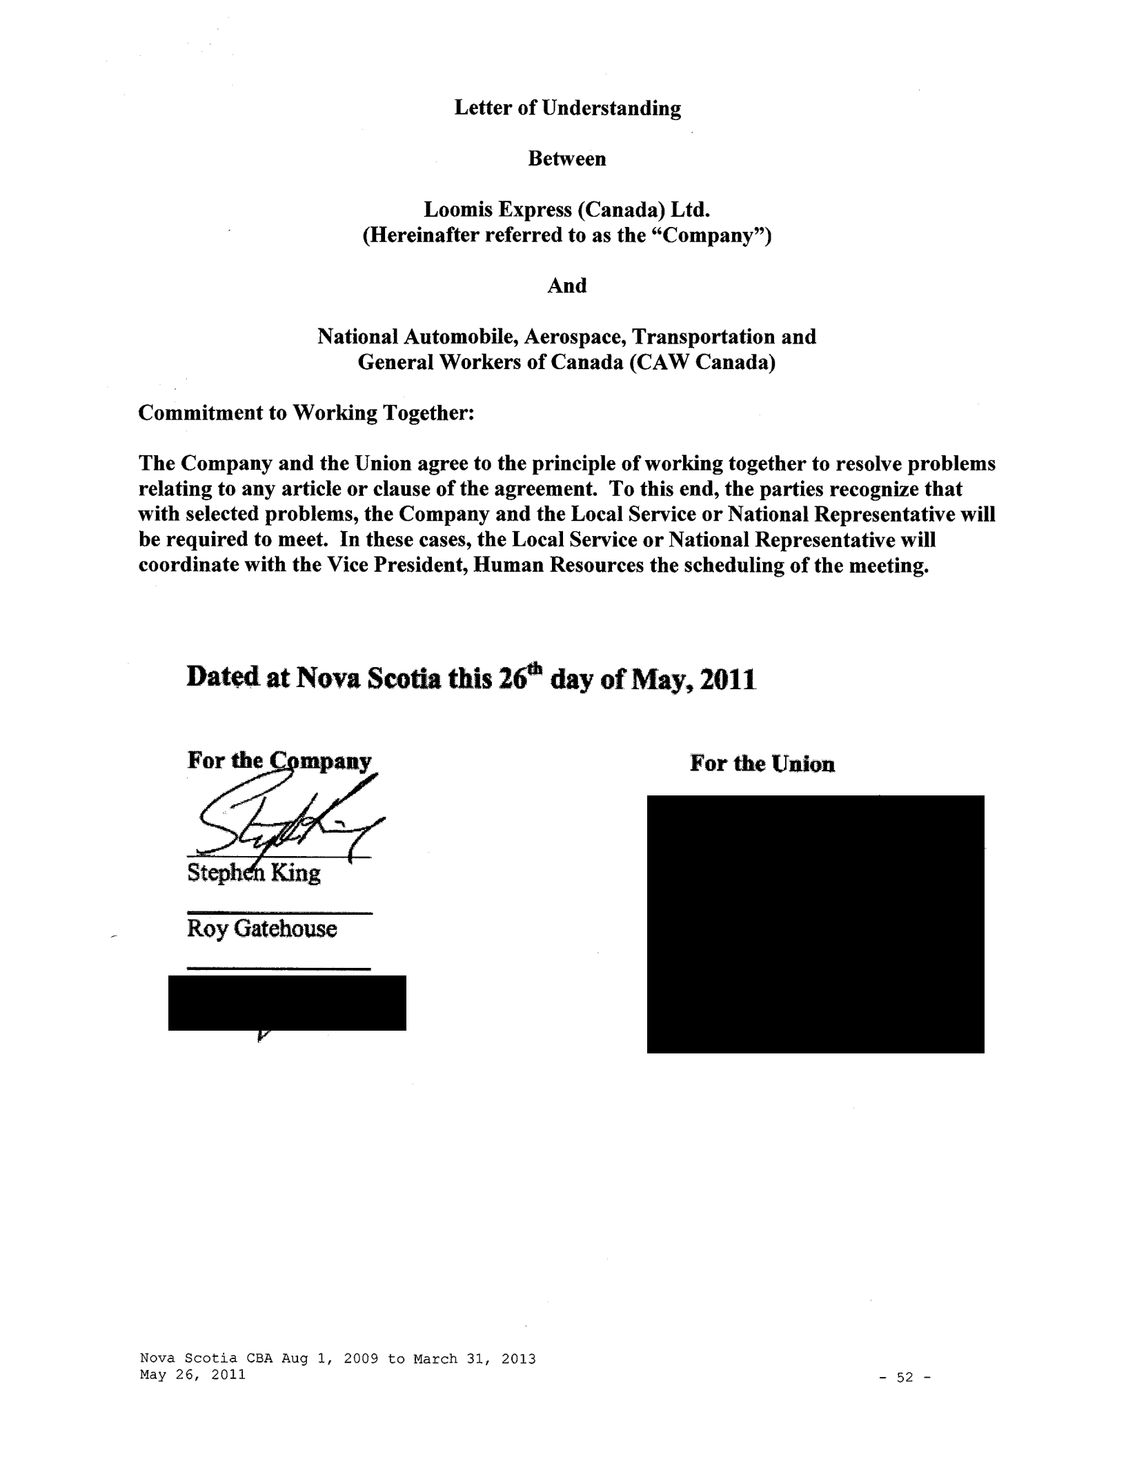
Letter of Understanding

Between

Loomis Express (Canada) Ltd.

(Hereinafter referred to as the "Company")

And

National Automobile, Aerospace, Transportation and

General Workers of Canada (CAW Canada)

Commitment to Working Together:

The Company and the Union agree to the principle of working together to resolve problems relating to any article or clause of the agreement. To this end, the parties recognize that with selected problems, the Company and the Local Service or National Representative will be required to meet. In these cases, the Local Service or National Representative will coordinate with the Vice President, Human Resources the scheduling of the meeting.

Dated at Nova Scotia this l(i*h day of May~ 2011

For the Union

Roy Gatehouse

Nova Scotia CBA Aug 1, 2009 to March 31, 2013
May 26, 2011 | -52-

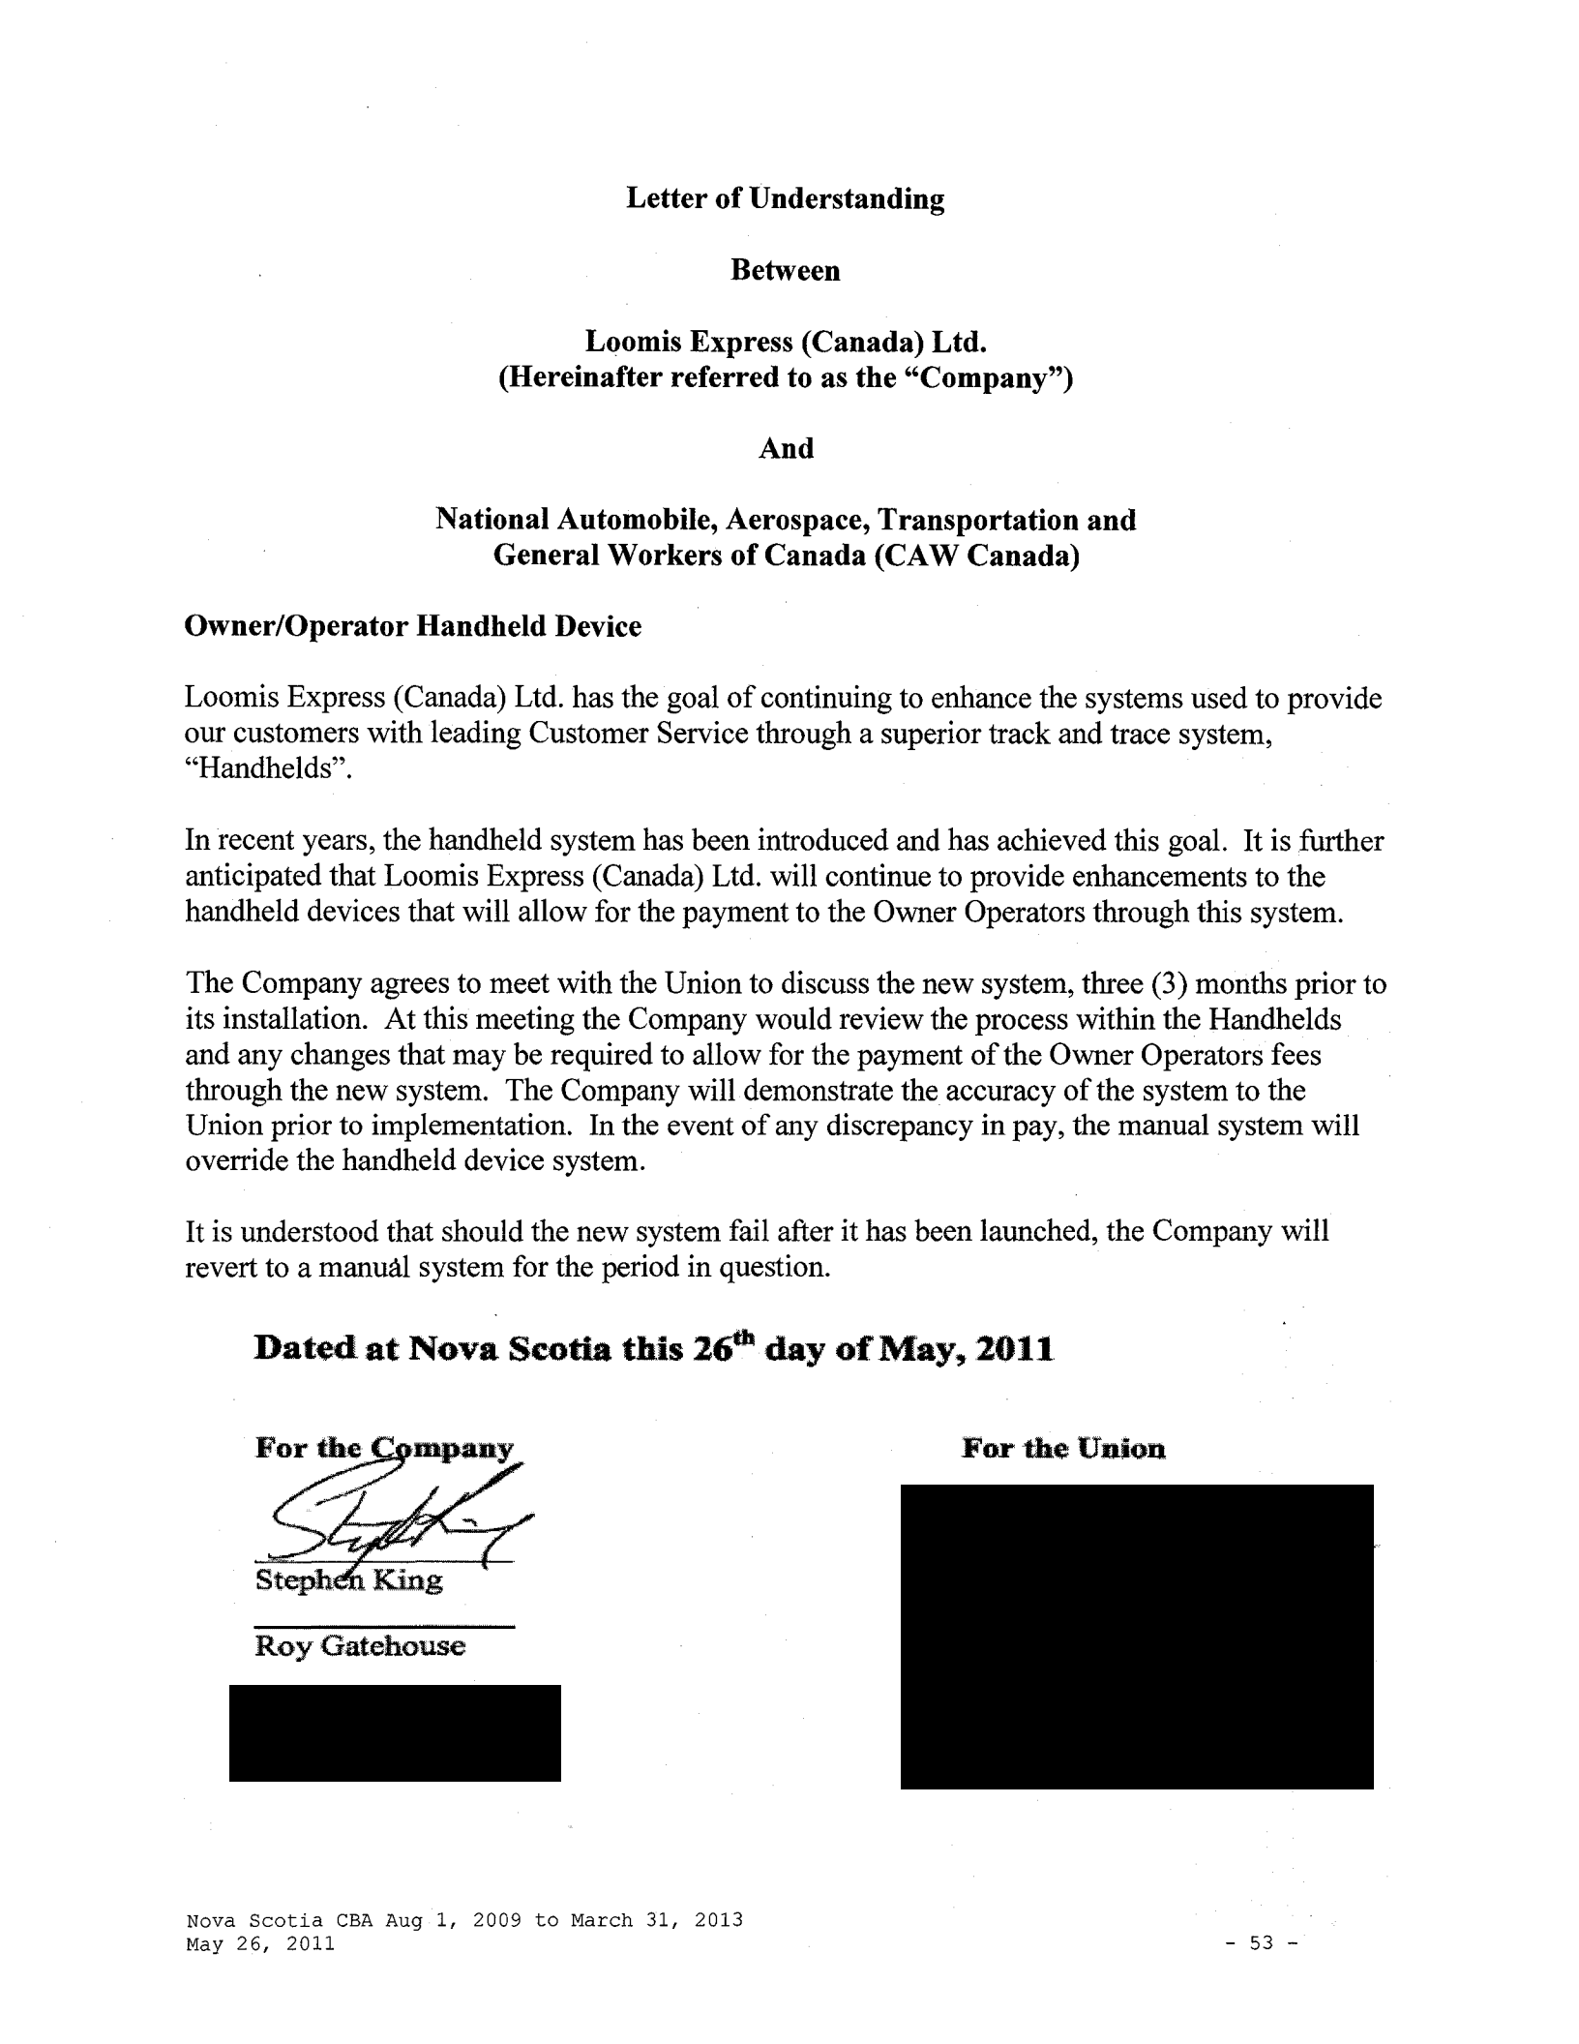
Letter of Understanding

Between

Loomis Express (Canada) Ltd.
(Hereinafter referred to as the "Company")

And

National Automobile, Aerospace, Transportation and
General Workers of Canada (CAW Canada)

Owner/Operator Handheld Device

Loomis Express (Canada) Ltd. has the goal of continuing to enhance the systems used to provide our customers with leading Customer Service through a superior track and trace system, "Handhelds".

In recent years, the handheld system has been introduced and has achieved this goal. It is further anticipated that Loomis Express (Canada) Ltd. will continue to provide enhancements to the handheld devices that will allow for the payment to the Owner Operators through this system.

The Company agrees to meet with the Union to discuss the new system, three (3) months prior to its installation. At this meeting the Company would review the process within the Handhelds and any changes that may be required to allow for the payment of the Owner Operators fees through the new system. The Company will demonstrate the accuracy of the system to the Union prior to implementation. In the event of any discrepancy in pay, the manual system will override the handheld device system.

It is understood that should the new system fail after it has been launched, the Company will revert to a manual system for the period in question.

Dated at Nova Scotia this z(j*h day of May, lOll

For the Union

Roy Gatehouse

Nova Scotia CBA Aug 1, 2009 to March 31, 2013
May 26, 2011 - 53 -
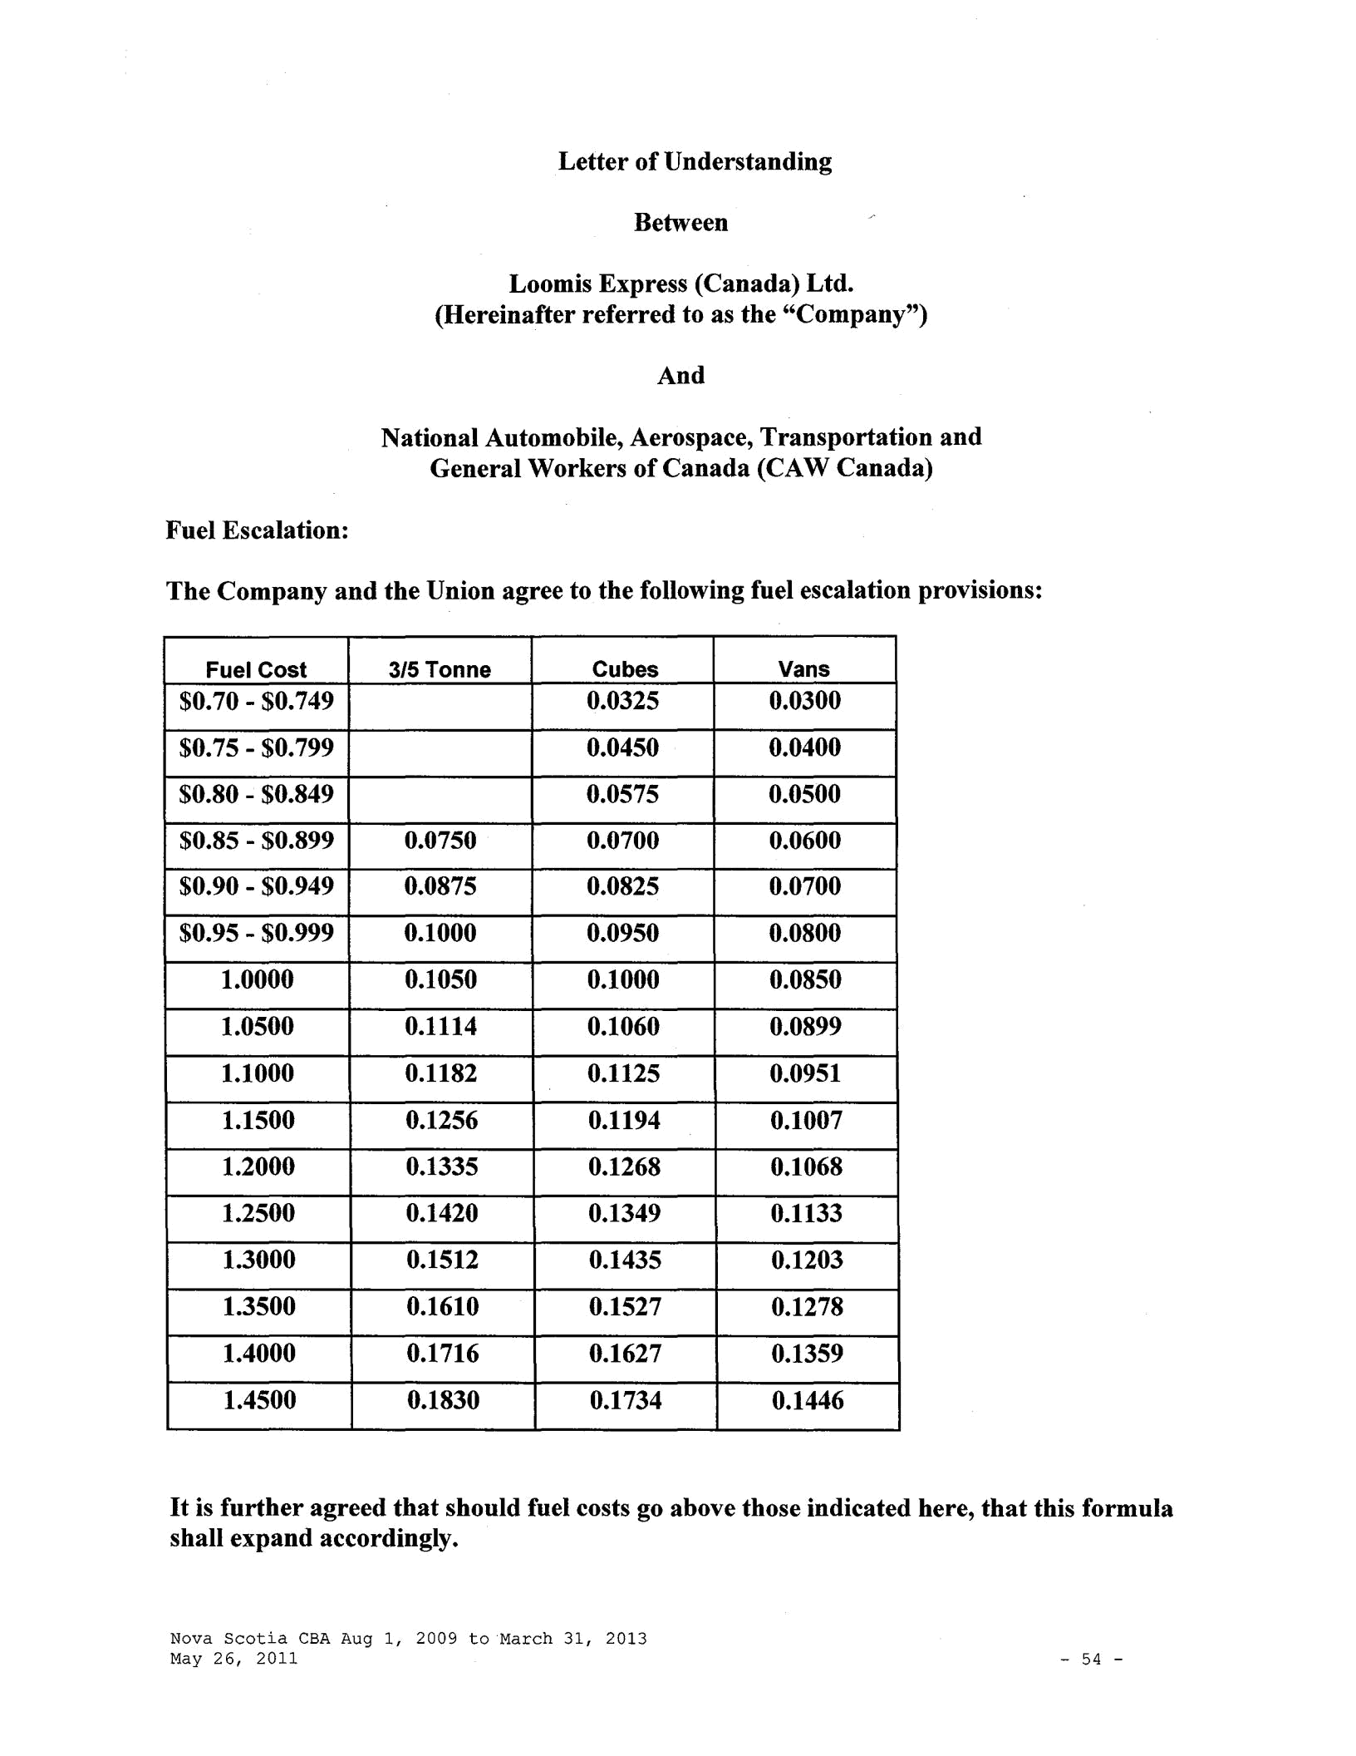
Letter of Understanding

Between

Loomis Express (Canada) Ltd.

(Hereinafter referred to as the "Company")

And

National Automobile, Aerospace, Transportation and

General Workers of Canada (CAW Canada)

Fuel Escalation:

The Company and the Union agree to the following fuel escalation provisions:

 | Fuel Cost | 3/5 Tonne | Cubes | Vans
$0.70 - $0.749 |  |  | 0.0325 | 0.0300
$0.75 - $0.799 |  |  | 0.0450 | 0.0400
$0.80- $0.849 |  |  | 0.0575 | 0.0500
$0.85 - $0.899 |  | 0.0750 | 0.0700 | 0.0600
$0.90 - $0.949 |  | 0.0875 | 0.0825 | 0.0700
$0.95 - $0.999 |  | 0.1000 | 0.0950 | 0.0800
1.0000 |  | 0.1050 | 0.1000 | 0.0850
1.0500 |  | 0.1114 | 0.1060 | 0.0899
 | 1.1000 | 0.1182 | 0.1125 | 0.0951
 | 1.1500 | 0.1256 | 0.1194 | 0.1007
 | 1.2000 | 0.1335 | 0.1268 | 0.1068
 | 1.2500 | 0.1420 | 0.1349 | 0.1133
 | 1.3000 | 0.1512 | 0.1435 | 0.1203
 | 1.3500 | 0.1610 | 0.1527 | 0.1278
 | 1.4000 | 0.1716 | 0.1627 | 0.1359
 | 1.4500 | 0.1830 | 0.1734 | 0.1446

It is further agreed that should fuel costs go above those indicated here, that this formula shall expand accordingly.

Nova Scotia CBA Aug 1, 2009 to March 31, 2013

May 26, 2011 - 54 -
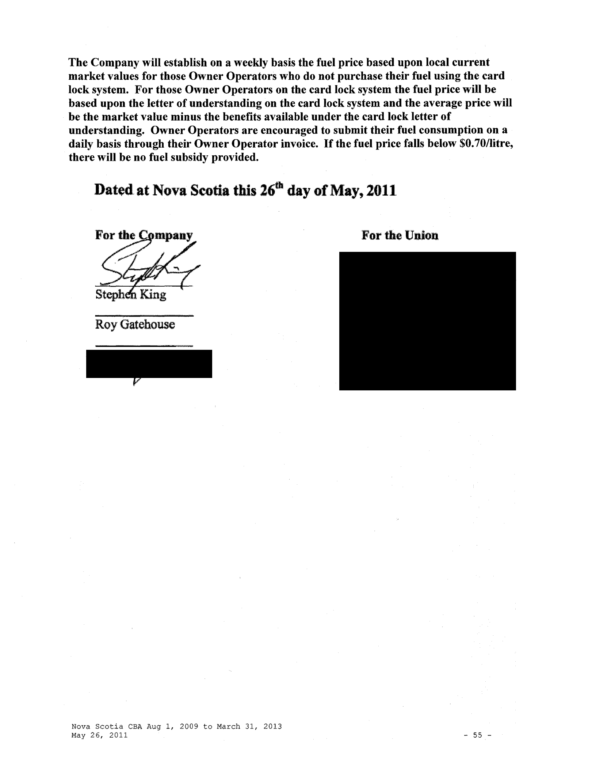
The Company will establish on a weekly basis the fuel price based upon local current market values for those Owner Operators who do not purchase their fuel using the card lock system. For those Owner Operators on the card lock system the fuel price will be based upon the letter of understanding on the card lock system and the average price will be the market value minus the benefits available under the card lock letter of understanding. Owner Operators are encouraged to submit their fuel consumption on a daily basis through their Owner Operator invoice. If the fuel price falls below $0. 70/litre, there will be no fuel subsidy provided.

Dated" at Nova Scotia this lei" day of May, 2011

For the Union

Roy Gatebouse

Nova Scotia CBA Aug 1, 2009 to March 31, 2013
May 26, 2011 | -55-

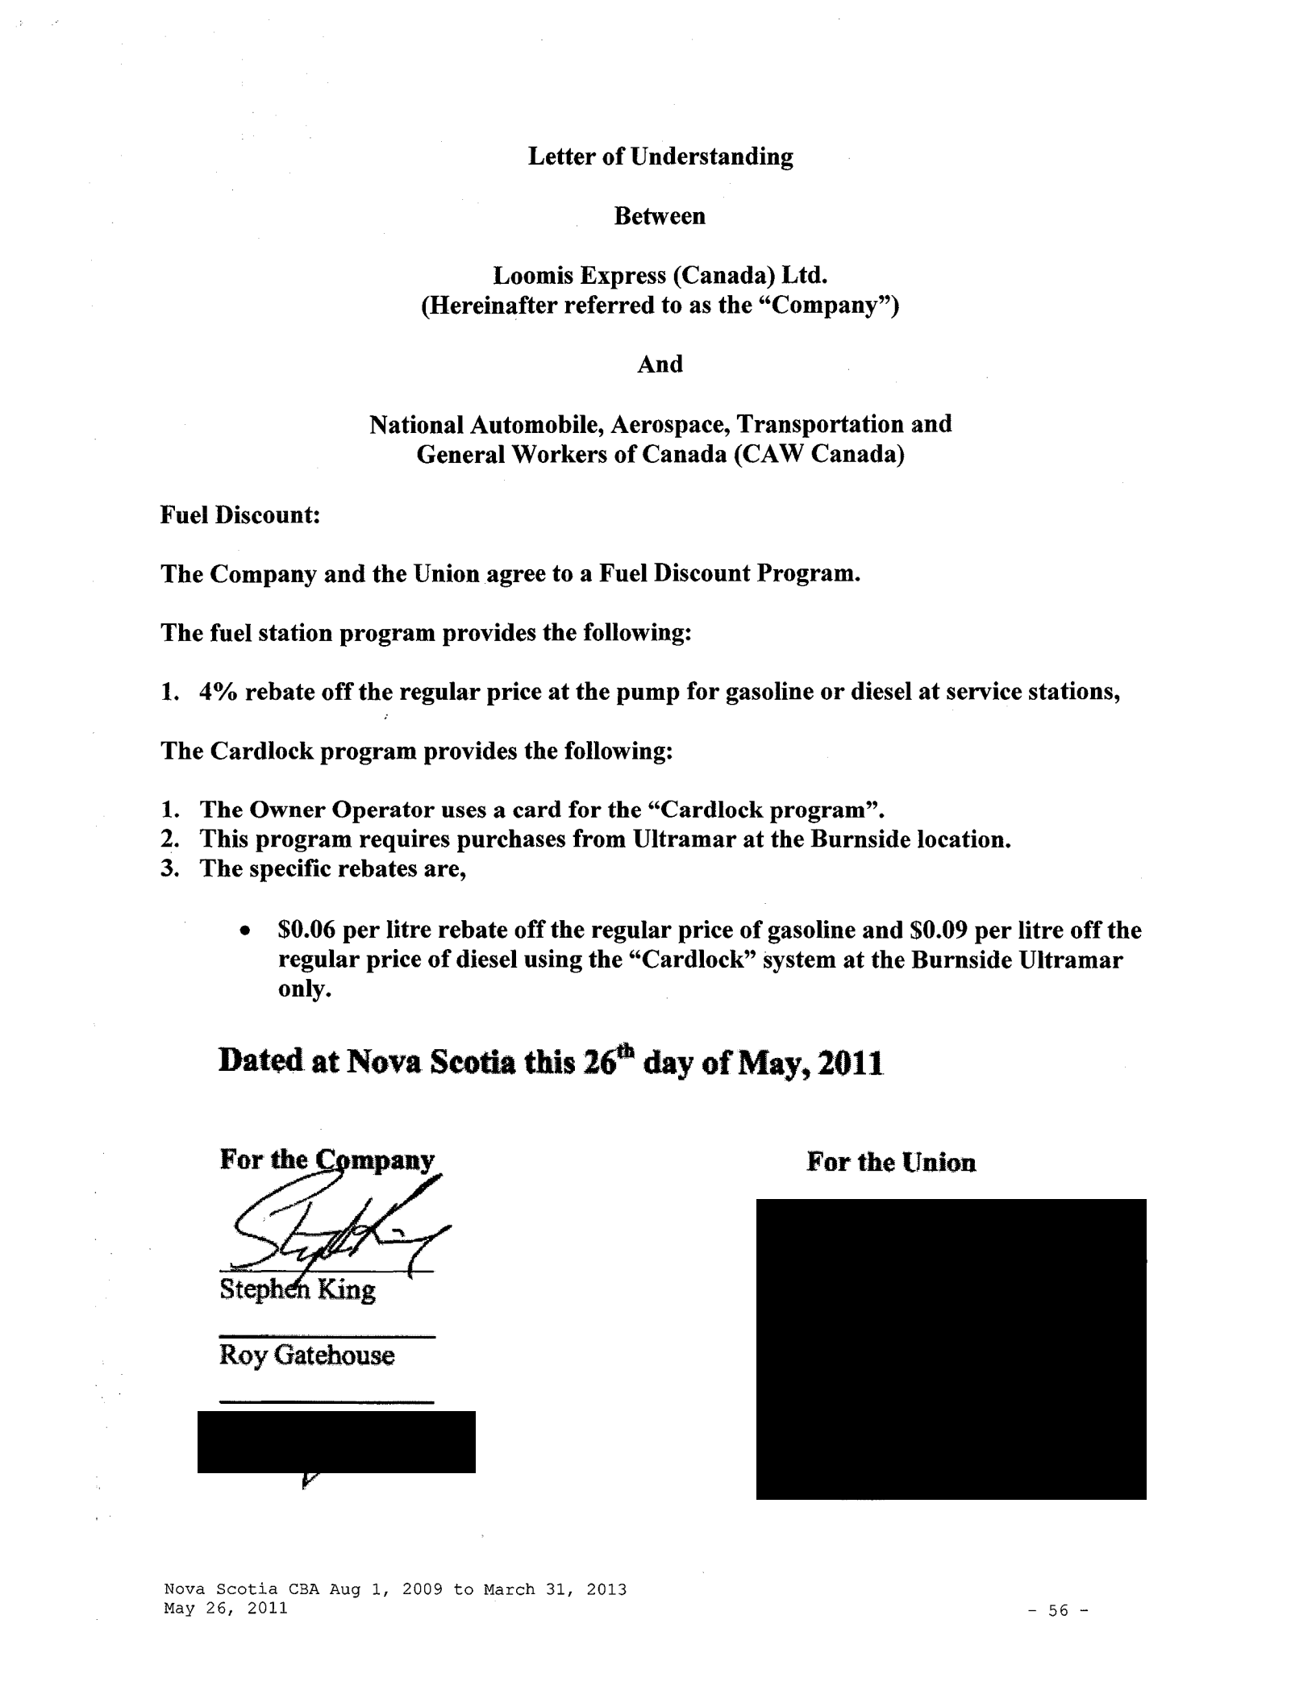
Letter of Understanding

Between

Loomis Express (Canada) Ltd.

(Hereinafter referred to as the "Company")

And

National Automobile, Aerospace, Transportation and

General Workers of Canada (CAW Canada)

Fuel Discount:

The Company and the Union agree to a Fuel Discount Program.

The fuel station program provides the following:

- 4% rebate off the regular price at the pump for gasoline or diesel at service stations, The Cardlock program provides the following:

- The Owner Operator uses a card for the "Cardlock program".
- This program requires purchases from Ultramar at the Burnside location.

- The specific rebates are,

    - $0.06 per litre rebate off the regular price of gasoline and $0.09 per litre off the regular price of diesel using the "Cardlock" system at the Burnside Ultramar only.

Dated at Nova Scotia this 16"' day of May, 2011

For the Union

Roy Gatehouse

Nova Scotia CBA Aug 1, 2009 to March 31, 2013
May 26, 2011 | -56-

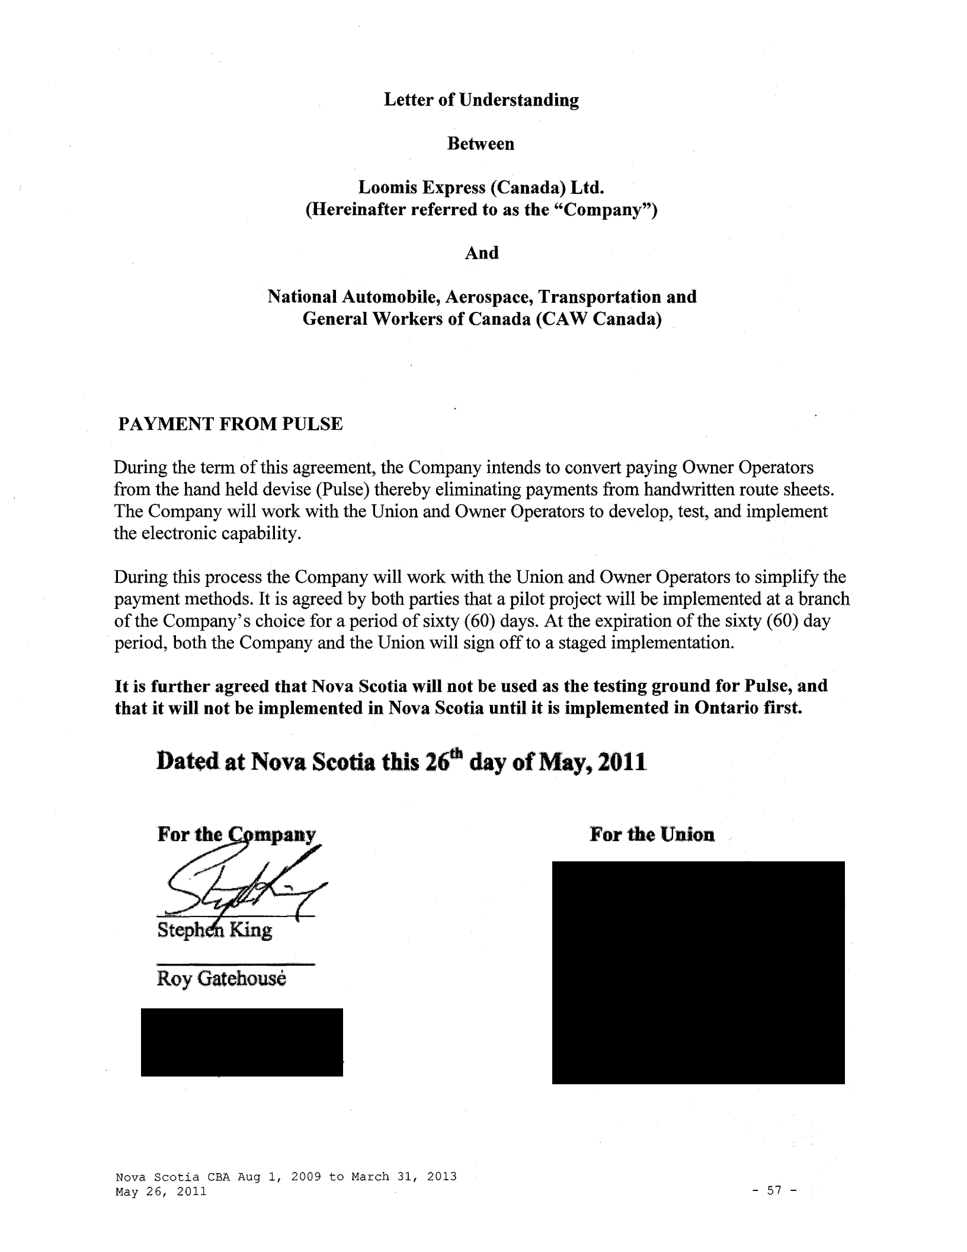
Letter of Understanding

Between

Loomis Express (Canada) Ltd.
(Hereinafter referred to as the "Company")

And

National Automobile, Aerospace, Transportation and

General Workers of Canada (CAW Canada)

PAYMENT FROM PULSE

During the term of this agreement, the Company intends to convert paying Owner Operators from the hand held devise (Pulse) thereby eliminating payments from handwritten route sheets. The Company will work with the Union and Owner Operators to develop, test, and implement the electronic capability.

During this process the Company will work with the Union and Owner Operators to simplify the payment methods. It is agreed by both parties that a pilot project will be implemented at a branch of the Company's choice for a period of sixty (60) days. At the expiration of the sixty (60) day period, both the Company and the Union will sign off to a staged implementation.

It is further agreed that Nova Scotia will not be used as the testing ground for Pulse, and that it will not be implemented in Nova Scotia until it is implemented in Ontario first.

Dated at Nova Scotia this 16• day of May, 1011

For the Union

Roy Gatehouse

Nova Scotia CBA Aug 1, 2009 to March 31, 2013
May 26, 2011 - 57 -
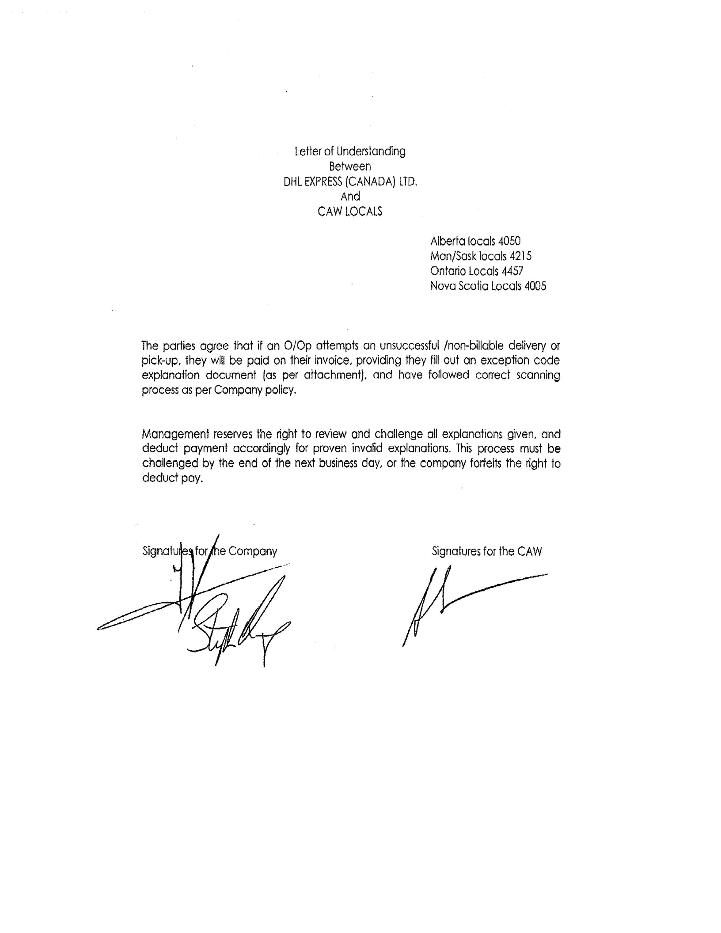

Letter of Understanding

Between

DHL EXPRESS !CANADA) LTD.

And

CAW LOCALS

Alberta locals 4050

Man/Sask locals 4215

Ontario Locals 4457

Nova Scotia Locals 4005

The parties agree that if on 0/0p attempts on unsuccessful /non-billable delivery or pick-up, they will be paid on their invoice, providing they fill out an exception code explanation document (as per attachment), and have followed correct scanning process as per Company policy.

Management reserves the right to review and challenge all explanations given, and deduct payment accordingly for proven invalid explanations. This process must be challenged by the end of the next business day, or the company forfeits the right to deduct pay.

Signatures for the CAW
BUSINESS AGREEMENT

AGREEMENT ENTERED INTO AT THE CITY OF ______ ON THIS

DAY OF ______, 20_.

BETWEEN: Loomis Express (~anada), LTD.

Having its head office at 201 Westcreek Blvd. Suite 200, Brampton. Ontario, L6T 5S6

Hereinafter called "Loomis"

AND:

(full name)

(address and postal code)

Hereinafter called the "Owner Operator"

WHEREAS Loomis, is a common carrier by motor vehicle which, in the regular course of its operations, requires the services of Owner Operators;

WHEREAS the Owner Operator has applied to Loomis to enter into an Agreement to supply transportation services with his/her own equipment on the terms and conditions hereinafter set out;

WHEREAS the Owner Operator warrants that he/she has the permits, equipment, skills and expertise necessary to operate commercial motor vehicles for the benefit of Loomis;

THE PARTIES DO MUTUALLY AGREE AS FOLLOWS:

TERM:

- This Agreement shall take effect on the date of its signature and shall continue in full force and effect until terminated by either party as a result of a breach of contract.

- This Agreement may also be terminated, at the reasonable discretion of either party, by serving a written notice to that effect, thirty (30) days in advance.

FEES:

- The schedule of fees is attached to this-Agreement as Schedule A. Deposits shall be made to the Owner Operator every two (2) weeks.

- The remuneration paid to the Owner Operators includes an indemnity for vacation, indemnity for fringe benefits, funeral leaves and statutory holidays. It is the responsibility of the Owner Operator to pay such an indemnity as required by law.

Nova Scotia CBA Aug 1, 2009 to March 31, 2013
May 26, 2011 | -59-

PURPOSE OF THE AGREEMENT:

- This Agreement outlines the terms and conditions related to the provision of services in relation to customers of Loomis, to ensure that those services will be sufficient and to the satisfaction of Loomis and its customers.

OWNER OPERATOR'S OBLIGATIONS:

- The Owner Operator agrees to:

      - Maintain at all times valid permits and licenses as required by law, and abide by and operate within the limits of all related provincial and federal laws and regulations.

      - Obtain and maintain insurance coverage, as more fully described in appendix A.

      - Promptly report any accident and any claim which could involve Loomis to the appropriate insurance carrier and to Loomis and fully cooperate with Loomis and any other person or persons appointed by or on behalf of Loomis in the investigation and settlement of any insurance claim.

        - Ensure that the best interests of Loomis and its customers are maintained through a safe, efficient and professional operation.

        - Provide, on a consistent and reliable basis, safe equipment and sufficient and satisfactory services to meet the business requirements of Loomis and its customers.

    - Make every reasonable effort to meet established delivery times unless otherwise prevented by severe weather, operational or other extraordinary circumstances beyond the control ofthe Owner Operator.

    - Where a replacement Driver is employed, provide at all times, licensed, competent, qualified personnel and make appropriate deductions and payments, as required by law, including deductions at source.

    - Recognize the right of Loomis to modify areas of service from time to time, where necessary for service or efficiency in accordance with the Bargaining unit
CBA

  - The Owner Operator agrees that, in the performance of this Agreement, especially where he/she collects monies on behalf of Loomis, he/she shall assume all the legal obligations of a person charged with administration of the property of others.

Nova Scotia CBA Aug 1, 2009 to March 31, 2013
May 26, 2011 | -60-

GENERAL:

  - It is expressly agreed between the parties that Loomis shall, in no way, be responsible to the Owner Operator or to third parties, for any services and/or supplies provided to the Owner Operator. In the event of a claim resulting from supplies or services so provided, the Owner Operator agrees to indemnify Loomis and to plead in its stead.

  - Loomis may require, from time to time, proof that the Owner Operator abides by any and all of his/her obligations. The Owner Operator will, upon demand, provide Loomis a written authorization to verify his/her status and discharge of his/her contractual obligations with any government or person.

- Loomis hereby grants to the Owner Operator a license to use its trade name, trademarks and logo types, within his/her area of service and for as long as this Agreement will remain in force. The Owner Operator recognizes that he/she has no proprietary interest in same and where the equipment is withdrawn from service for any reason, all Loomis symbols, insignias, decals or other identification will be removed, prior to the release of final payments owing

to the carrier.

- The Owner Operator agrees that, during the term of this contract and in any case on termination thereof, he/she will not solicit any of Loomis's customers, nor will he/she compete directly or indirectly with Loomis, with respect to Loomis's customers, for a period of three (3) months following termination.

      - The Owner Operator and any Employee, partner or associate of the Owner Operator, may not be entitled to any benefits or rights which would be afforded to an Employee of Loomis, including but not limited to benefits such as company pension, governmental pension contributions, dental or medical insurance, life insurance, or unemployment or disability insurance.

    - Loomis and the Owner Operator hereby acknowledge and agree that this Agreement is a Contract for Services and the Owner Operator shall, for all purposes of this Agreement, be deemed a dependent contractor, solely for the purposes of the Canada Labour Code.

This Agreement shall not be construed in any respect to create between Loomis and the Owner Operator, a legal relationship of partnership, employer and Employee, or principal and agent.

SIGNED, SEALED AND DELIVERED:

Loomis EXPRESS (CANADA), LTD.

By:

Witness:

Owner Operator:

Nova Scotia CBA Aug 1, 2009 to March 31, 2013

May 26, 2011 - 61 -
Union Representative:

APPENDIX A

Liability and Damage Insurance:

The Owner Operator shall, at their own expense and without cost or expense to Loomis Express (Canada), Ltd., obtain and maintain during the term of this Agreement the following insurance in respect to the vehicle and in relation to the performance of services under this Agreement:

- Motor vehicle third-party liability insurance in an amount of not less than two million dollars ($2,000,000) per occurrence on any vehicle utilized by the Owner Operator in providing services to Loomis Express (Canada), Ltd. under the terms of this Agreement together with any further statutory motor vehicle liability or other insurance which may be required under applicable laws or regulations.

- Comprehensive general liability insurance in an amount not less than two million dollars ($2,000,000) per occurrence against claims arising out of bodily injury or death or loss of damage to, or in the destruction of property belonging to Loomis Express (Canada), Ltd. or its customers, including the loss of use thereof covering such perils as Loomis Express (Canada), Ltd. deems necessary and in such amounts and with such terms and conditions are reasonably acceptable to Loomis Express (Canada), Ltd. The policy referenced herein shall contain an endorsement specifically covering the contractual liability ofthe Owner Operator under the terms of this Agreement.

- Cargo liability insurance on terms and conditions reasonably satisfactory to Loomis Express (Canada), Ltd. in an amount of not less than twenty-five thousand dollars ($25,000).

The foregoing insurance must be placed with an insurer reasonably acceptable to Loomis Express (Canada), Ltd. The Owner Operator must further provide Loomis Express (Canada), Ltd. with a Certificate of Insurance evidencing the foregoing insurances prior to services being commenced. Said Certificate of Insurance evidencing the coverage herein shall also contain the following provisions:

- Loomis Express (Canada), Ltd. will be added to said policies as an additional insured but only with respect to liability that may result from the performance of this Agreement.

- The Owner Operator and the insurers further agree to waive all rights of subrogation as against Loomis Express (Canada), Ltd.

- The policies shall contain severability of interest and cross liability clauses.

- The Insurers will provide Loomis Express (Canada), Ltd. with thirty (30) days prior written notice of any cancellation or material change in the policies.

Nova Scotia CBA Aug 1, 2009 to March 31, 2013
May 26, 2011 | -62-

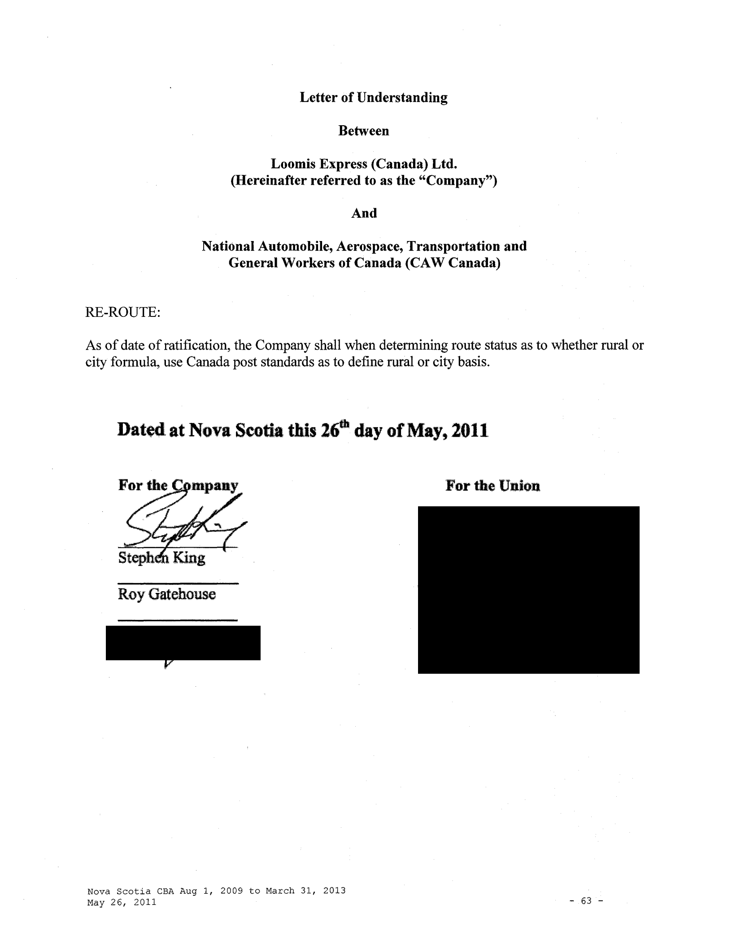
Letter of Understanding

Between

Loomis Express (Canada) Ltd.

(Hereinafter referred to as the "Company")

And

National Automobile, Aerospace, Transportation and
General Workers of Canada (CAW Canada)

RE-ROUTE:

As of date of ratification, the Company shall when determining route status as to whether rural or city formula, use Canada post standards as to define rural or city basis.

Dated at Nova Scotia this 1€? day of May, 2011

For the Union

Roy Gatehouse

Nova Scotia CBA Aug 1, 2009 to March 31, 2013
May 26, 2011 ⁻ ⁶³ ⁻
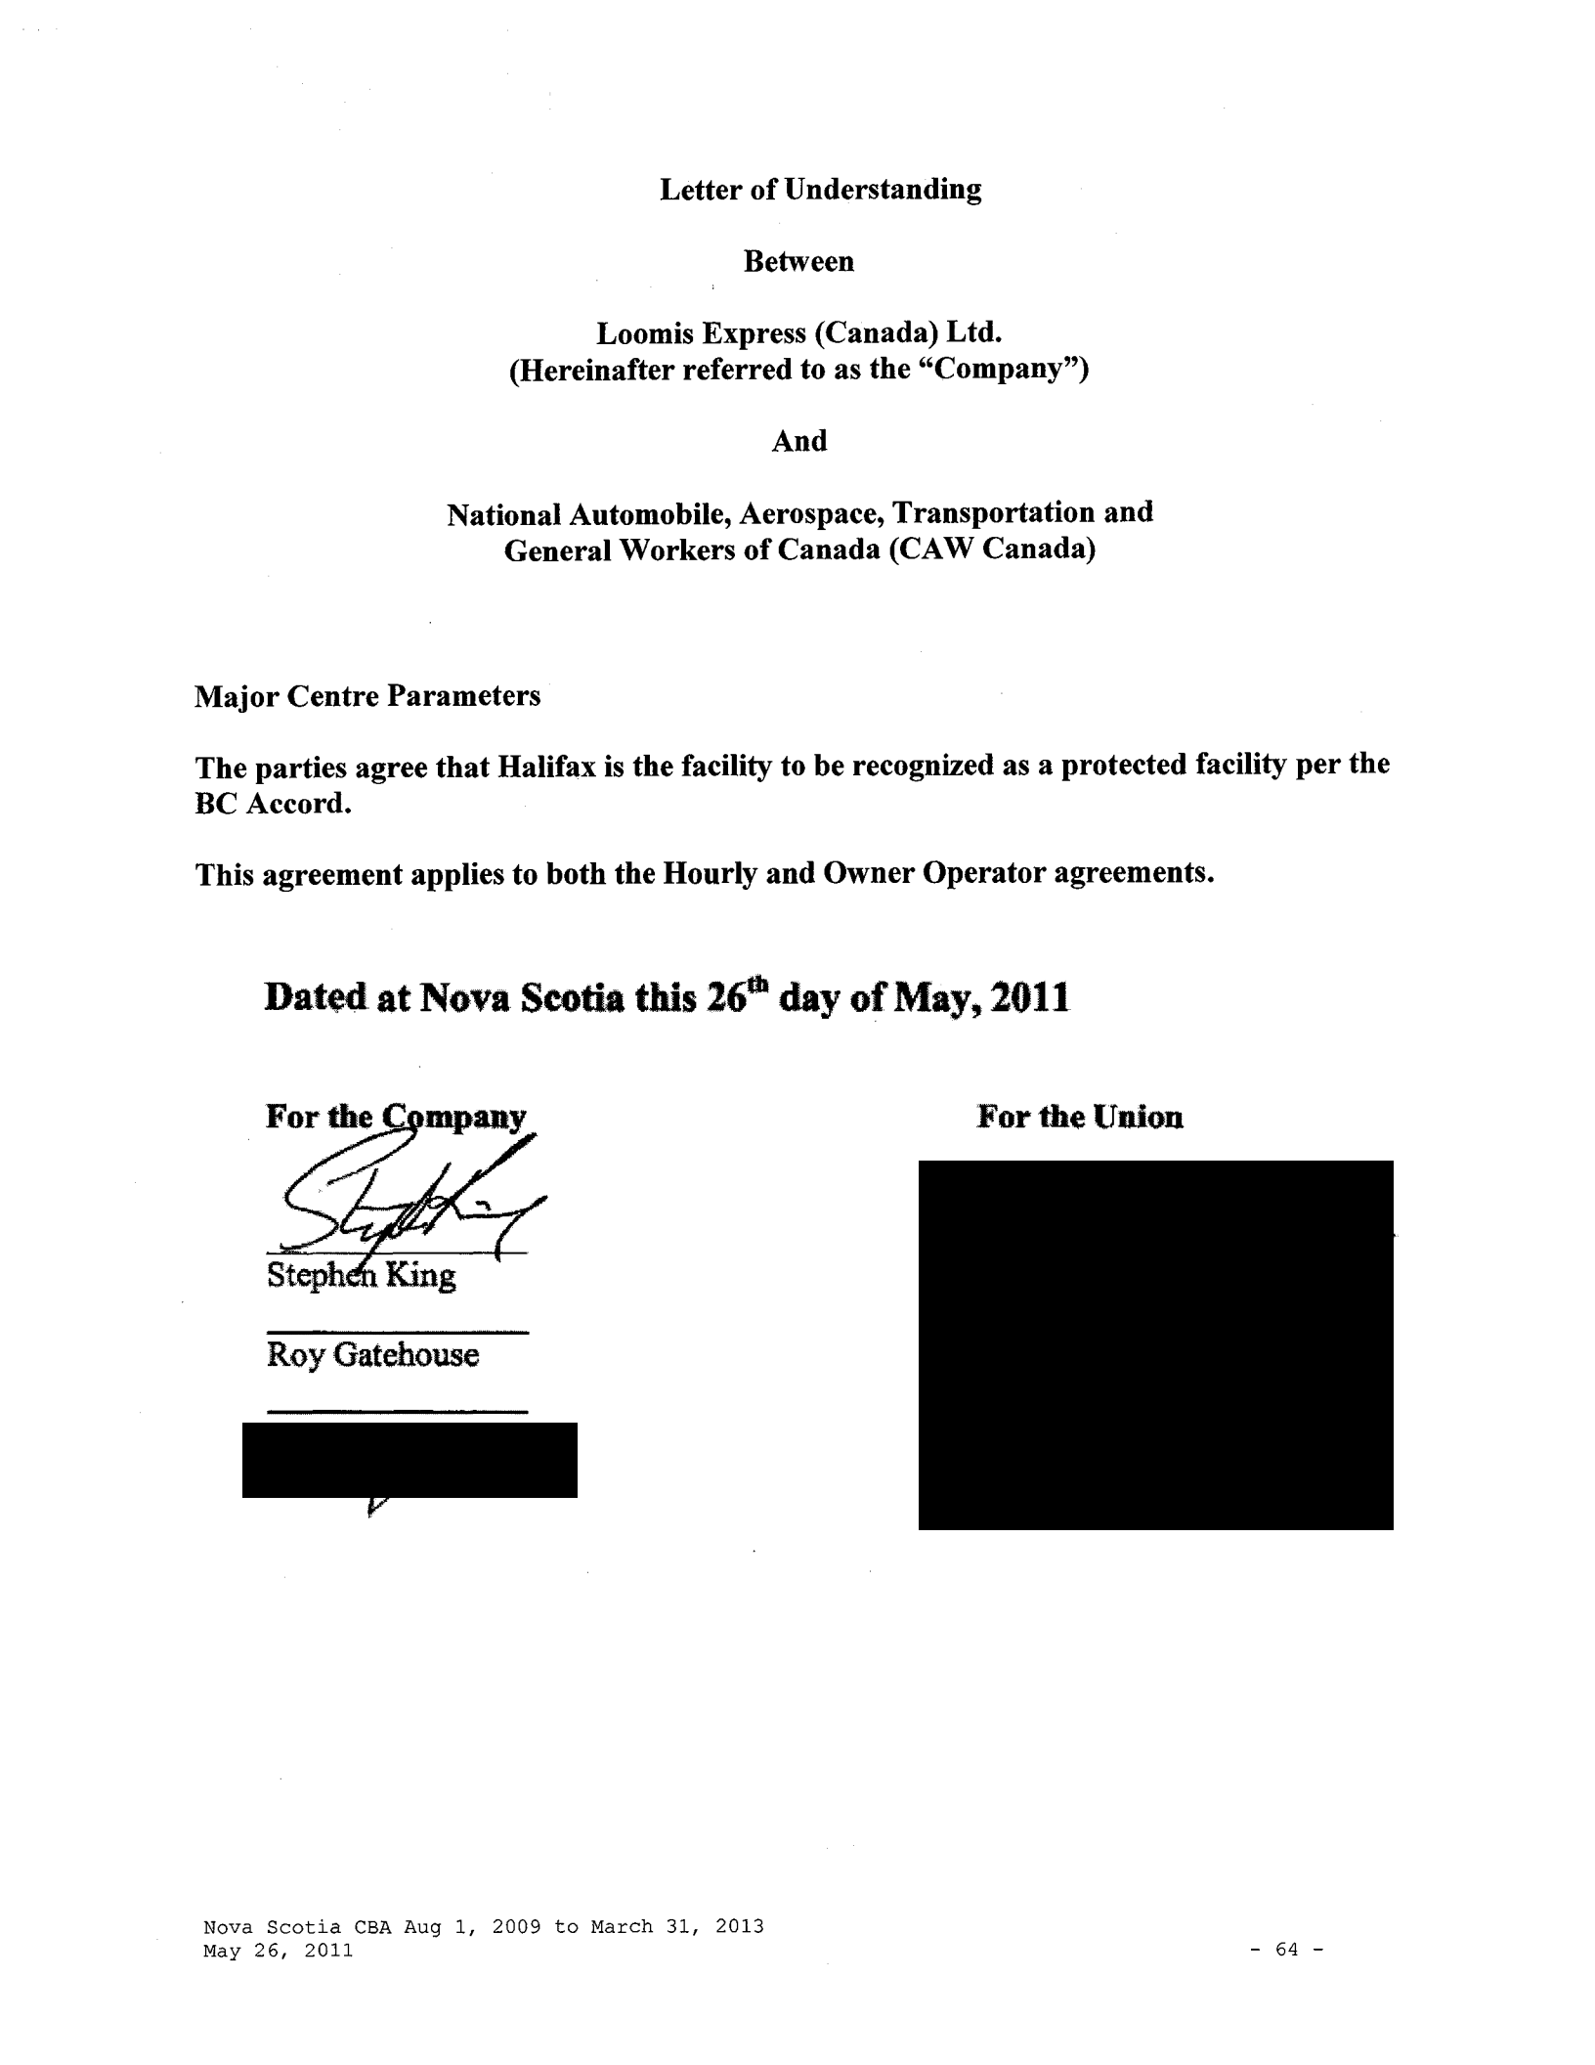
Letter of Understanding

Between

Loomis Express (Canada) Ltd.

(Hereinafter referred to as the "Company")

And

National Automobile, Aerospace, Transportation and

General Workers of Canada (CAW Canada)

Major Centre Parameters

The parties agree that Halifax is the facility to be recognized as a protected facility per the BC Accord.

This agreement applies to both the Hourly and Owner Operator agreements.

Dated at Nova Scotia this 16• day of May, 2011

For the Union

Roy Gatehouse

Nova Scotia CBA Aug 1, 2009 to March 31, 2013
May 26, 2011 - 64 -

Summary of principles between Loomis Canada and CAW Canada, British Columbia, Alberta, Manitoba, Saskatchewan, Ontario, Nova Scotia

During the latest round of negotiations in Loomis proposed a number of changes to deal with massive losses that have occurred in different parts of the business.

The Parties have spent an extensive period of time discussing these issues and looking for solutions. It is recognized that each part of the country has its own uniqueness and the Company and Union agree to the following principles to be used as a guideline when the local bargaining committees resume discussions towards reaching a collective agreement.

Therefore the following items are in general agreement and will be part of a settlement in each location when the parties have an opportunity to deal with the local issues and other items that are raised during the course of the collective bargaining process.

- Contracting Out

During the 2008 I 2009 collective bargaining, the Company advised the Union that it plans to restructure the business across Canada and tabled a list of locations that it intended to close or discontinue service with a plan to third-party I contract out these locations .
•

The Union recognizes that the express business is under severe pressure; however, any restructuring must be done ensuring that employees are fairly compensated for a layoff I termination from the Company as a result of this restructuring based on the provisions below. The Union also reserved the right to put forward an alternative strategy for future locations, and, if it can be demonstrated that such a strategy is viable, then the Company will consider such alternative.

The restructuring period will be in effect until all facilities identified to the Union have been closed down.

The following procedure will apply when a restructuring (facility closures or contracting out) is to be considered:

- The Company will notify the Unit Chair or President of the Local Union and the National Representative in writing stating the reasons for such action.

- The Company commits to continually monitor all contracted out work and agent usage to determine the economic viability of having the work transitioned back to the Loomis brand and Loomis employees and/or Owner Operators. The Company also agrees that any work formerly performed by CAW members which is again performed by a Loomis employee, or in a Loomis branded or painted truck will immediately become covered again under the collective agreement. The Company agrees to provide relevant information to the Union in writing including the financials in order to allow the Union to investigate. The Company will also provide any financial information to the Research & Benefit I National Representative of CAW to ensure an informed evaluation can be made.

Nova Scotia CBA Aug 1, 2009 to March 31, 2013 | -65-
May 26, 2011 | -65-

The Union agrees to sign any necessary confidentiality documents to receive this information.

- Within fifteen (15) days, the Company and the Union will meet to review all ofthe relevant information including the implementation of a viable strategy jointly or otherwise.

- The Company has committed that no line haul, warehouse or clerical position will be contracted out.

Major Centre Parameters

The major centres listed below (and as outlined on the attached maps) (Company needs to see maps prior to resolution) will not be contracted out in their entirety during the life of the Agreement and will be protected from contracting out as per the collective agreement and the provisions listed below.

If there is a major loss of business in a major centre listed below that requires change, the Company will first pursue its ability to reroute, abolish runs, and apply facility consolidation. If these measures are instituted and there are still problems, the Company may contract out a route or routes in each major centre up to a maximum of ten percent ( 10%) of the total province's number of Owner Operators at the time (calculated every anniversary) unless otherwise mutually agreed with the Union in writing. The Company will not use this percentage to close or contract out an entire facility identified below.

The Company will justify each move outlined above to the Union using the procedure outlined in item #1 above.

Any P&D contractor must load and unload their freight to their vehicle at a Loomis Unionized facility. The Company is in agreement with the principle that our warehouse staff will prepare the loads and unloads and the language may need to be revised for any HQ loads. The intent is that no contractor shall perform warehouse work at Loomis facilities.

Major Centres for BC

  - Victoria

  - Lower Mainland (including Vancouver, Richmond, Burnaby, Abbotsford)*

  - Kelowna

  - Kamloops

- These areas will be protected from a complete closure over the life of the Agreement.

Note: Nanaimo on list set for contracting out provided to Union in Toronto on January 19-23, 2009. Company has agreed to Union presentation on viability study.

Major Centres for Ontario

- Ottawa

- Greater Toronto Area (bordered by Oshawa, Oakville and Newmarket)*

Nova Scotia CBA Aug 1, 2009 to March 31, 2013
May 26, 2011 | -66-

  - Markham*

  - Brampton *

  - Burlington

  - Kitchener

  - London

- These areas will be protected from a complete closure over the life of the Agreement. Major Centres for Alberta

  - Calgary*

    - Edmonton*

    - Red Deer*

- These areas will be protected from a complete closure over the life of the Agreement. Major Centres for Manitoba I Saskatchewan

    - Saskatoon *

    - Regina*

    - Winnipeg*

*These areas will be protected from a complet~ closure over the life of the Agreement.

Major Centres for Nova Scotia

  - To be determined at the Local Bargaining Table .

  - Company preliminary shows a reduction in 2 hourly routes and 1 Owner Operator.

- Bumping

The Company respects the Union seniority principles as outlined in each collective agreement. The Union and the Company agree to cooperate fully in order to change areas of the collective agreement in reducing the domino effect of bumping and to hasten the process and limit it to a maximum disruption of five (5) days overall after the required information has been fully provided unless agreed to otherwise.

In restructuring initiatives and facility re-routes, the Company and Union agree to the principles noted above, as well as, working together to develop a single move of Union members (a paper bump).

- Route Flex

The Company and the Union agree to adopt the language noted below from the BC agreement and to have it written into all collective agreements:

"In the event it is determined that the Owner Operator is unable to make a delivery(s) or pickup( s) in his or her area, Management reserves the right to assign these stops to surrounding routes in order to maintain customer service."

Nova Scotia CBA Aug 1, 2009 to March 31, 2013
May 26, 2011 | -67-

"The above is not to be used on an ongoing basis but rather is intended for one-off or short term situations."

It is further understood that that the Company's position is that all hourly rated Driver positions shall be flexible, in accordance with the operational needs of the Company and the service levels to our customers. It is also understood that seniority will be respected in the application of this clause.

- Three (3) Hour Minimum

It is agreed by the parties that the application ofthe casual language regarding minimum hours of work as applied in the Alberta CBA (casual warehouse) shall be applied in all collective agreements subject to current Local practices as to type of work performed.

Work Assignments - General

In the event that employees have not finished assigned work within their scheduled shifts or volunteered for extra work, employees will be required by reverse seniority to remain on shift until all work has been completed or they have been permitted to depart the work site by the Supervisor or Manager.

- Payment Methodology for Owner Operators

The Company presented a new payment system for Owner Operators as it believes that the current system does not meet the needs of the Company or the Owner Operators.

The new payment methodology as outlined below will be implemented within sixty (60) days of ratification. The current fuel escalation formula outlined in each collective agreement shall remain in full force and effect. The Unit Chair and two (2) Owner Operator representatives selected by the Union from each province will form a Committee to be consulted on paid time on the implementation of the new methodology and to address any issues arising in an effort to make the transition as smooth as possible. In addition, the Company commits to extensive monitoring of this payment process and agrees to consult with individual Owner Operators on any and all issues that negatively impact their individual payments.

The parties will ensure that the minimum bi-weekly guarantee outlined in the BC collective agreement will continue to apply and a minimum bi-weekly guarantee of two thousand dollars ($2000) will be instituted in all other provinces provided this amount is greater than any guarantees already in place.

The Company commits to guarantee that at least eighty percent (80%) of all Owner Operator routes by district or sub-region (to be defined locally) shall earn at least the same earnings on the route compared to current methodology in each agreement.

It is understood that the Company intends each route to be completed within ten (1 0) hours excluding lunch and breaks under the new payment methodology. Once new routes are implemented, the Company will not reroute an Owner Operator unless there are verifiable

Nova Scotia CBA Aug 1, 2009 to March 31, 2013
May 26, 2011 | -68-

service failures within a route, as a result of decreased volumes, or a consistent failure to meet time definite or day definite services.

Owner Operators may request a route review at any time and these requests will be handled on an expedited basis through the following procedures:

- A Supervisor or Manager must arrange for a route ride-along or follow along within seven (7) working days of the request being received.

- Any agreed-upon adjustments to rates, volume, stops, or area will be retroactive to the date of the request for a route review.

- The Company will ensure that a team of senior Management from the Operations Department is assigned on an ongoing basis to assist in speedy resolutions of disputes arising out of requests for route review.

The new methodology ill include the following points:

(Add in items and any other language).

Laser Waybills

  - Discuss language in local bargaining related to Company's intention to have every item scanned.

- Call Centre (British Columbia)

The Company agrees that it will continue to operate a reasonable amount of staff in the British Columbia Call Center until at least June 1, 2009 to allow for an orderly transition.

The Company agrees that employees who voluntarily leave before their exit date during the transition period will be entitled to the full severance package.

- Union Office

The Company will provide the Union with a blind LOU outlining the following:

The Company will provide the Union with an office space and facilities at the main premises (define in each location) for the exclusive use of authorized Union officers and representatives. The Company will provide filing cabinets, desk, chairs, a phone line, and a secure high speed internet connection for the non-private use of the Union in this office.

- Union Representation

The Union will select and the Company shall recognize, a full-time Unit Chairperson who shall be a Loomis employee. The Unit Chairperson shall attend to Union business as required and as necessary for the administration of the collective agreement and shall be given free access to all branches and depots and the Union office for these purposes. The Unit Chairperson shall be permitted to attend all meetings related to bargaining unit members if requested. The Unit Chair shall not be laid off or have any reduction or freezing in hours, pay, seniority or any other benefit during their term of office

Nova Scotia CBA Aug 1, 2009 to March 31, 2013

May 26, 2011 - 69 -
The Company agrees that such Unit Chair shall receive all existing benefits and pension as per classification the amended agreement and shall also receive 120% of the top hourly P&D non HQ driving wage rate (as per each region's CBA) based on forty (40) hours per week.

If the Unit Chair is an Owner Operator they shall be allowed to either retain their run with a relief driver or elect to give up their run.

Employees and Owner Operators holding a the Unit Chairperson position who are away from their workstation for a minimum period of six (6) months to fulfill these functions, will receive, if needed at the time of their return to work, sufficient on the job training in line with the training requirements of their classification and position in order to be re-familiarized and to perform their tasks adequately.

Note: Manitoba I Saskatchewan and Nova Scotia will be provided with paid time for the Unit Chair as needed.

- Severance

The severance benefits outlined in this document is a one time offer to Owner Operators and hourly employees for closures, contracting out, facility consolidation, and re-routes as per severance listed.

Severance benefits identified in each region's CBA may be nullified with the acceptance of this offer based on discussions in local bargaining where it can be shown that the overall total of severance provided under this Agreement meets or exceeds the severance in each Agreement. Situations falling outside of the current restructuring I rerouting initiatives of the Company are not intended to be captured in this understanding.

All other situations remain status quo per respective CBAs.

Hourly Employees

If the termination is as a result of a closure or contracting out of an area or abolishment of hourly driver runs due to closure, facility consolidation or contracting out, then the Company agrees to offer severance pay based on the following:

- Two weeks per year of service (prorated) based on forty (40) hours per week at straight time for full time status employees on date of ratification. Severance for part-time employees shall be based on average earnings for the previous twelve (12) months active paid earnings.

- The Company has offered two (2) weeks of severance for each year of service based on fifty (50) hours (prorated) per week for BC Call Centre employees working as of the announcement of the closure of the BC Call Centre. In addition to this severance, the Company will also pay one (1) month's wages as additional severance to all BC Call Centre employees as they are transitioned out from the business.

Nova Scotia CBA Aug 1, 2009 to March 31, 2013
May 26, 2011 | -70-

- Extended benefits - Company will continue to provide benefits as per Company policy with salaried personnel for six (6) months following date of termination.

Owner Operators

Initial Restructuring and Reroutes

Under the initial major restructuring reroutes- $11,500 total for 10+ years in a reroute, $8000 total for 5-10 years in a reroute, and $4500 total for 5 years and under in a reroute.

Other Initial Restructuring

Under the current major restructuring, those Owner Operators impacted by a facility closure, contracting out, facility consolidation will be paid severance calculated at two (2) weeks per year of service (prorated) at fifty (50) hours per week based on the straight time hourly P&D driver rates per region. This formula will also be offered to any re-route in an area already listed on the restructuring lists provided to the Union during the week of January 19-23, 2009.

Further Re-Routes

Owner Operators affected by a reroute after the initial major restructuring will be paid severance of $10,000 total for 10+ years in a reroute, $7000 total for 5-10 years in a reroute, and $4000 total for 5 years and under in a reroute. This clause shall be in effect for two (2) years after the date of ratification of each collective agreement.

Further Restructuring

Those Owner Operators impacted by a facility closure, contracting out, facility consolidation will be paid severance calculated at two (2) weeks per year of service (prorated) at forty ( 40) hours per week based on the straight time hourly P&D driver rates per region.

  - Wages and Compensation

- The General Wage Increase (GWI) will be 2.5%, 2.5%, 2.5%, 2.5% in each year ofthe Agreement effective on the ratification date of each Agreement.

- The GWI outlined above will be applied to all hourly wages retroactive from the expiry date

of each collective agreement for all hours worked.

- For P&D Owner Operators, the GWI percentage increase will be applied retroactively from the expiry date of each collective agreement to all aspects of the current payment methodology as per past practise for increases to these classifications.

- For Heavy Equipment and Line Haul Owner Operators, the GWI percentage increase will be applied retroactively from the expiry date of each collective agreement as per past practise for increases to these classifications.

- For P&D Owner Operators, the GWI percentage increase applies to: Pieces, Stops, Core Zone, and Quality Payments.

  - Term of Contracts

Nova Scotia CBA Aug 1, 2009 to March 31, 2013
May 26, 2011 | -71-

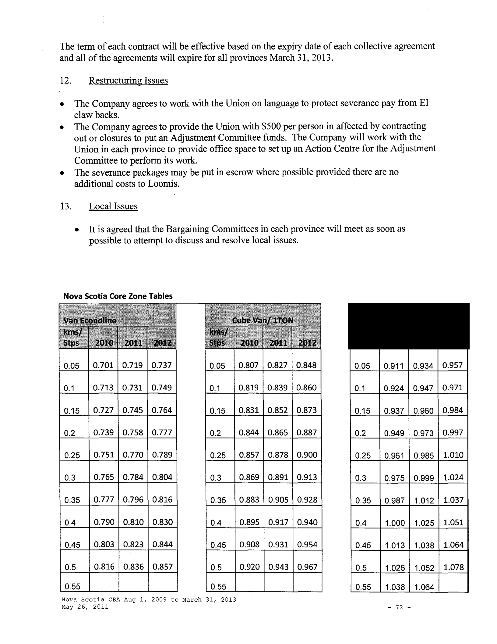
The term of each contract will be effective based on the expiry date of each collective agreement and all ofthe agreements will expire for all provinces March 31,2013.

  - Restructuring Issues

- The Company agrees to work with the Union on language to protect severance pay from EI claw backs.

- The Company agrees to provide the Union with $500 per person in affected by contracting out or closures to put an Adjustment Committee funds. The Company will work with the Union in each province to provide office space to set up an Action Centre for the Adjustment Committee to perform its work.

- The severance packages may be put in escrow where possible provided there are no additional costs to Loomis.

  - Local Issues

    - It is agreed that the Bargaining Committees in each province will meet as soon as possible to attempt to discuss and resolve local issues.

Nova Scotia Core Zone Tables

0.05 |  | 0.701 | 0.719 | 0.737 |  |  |  | 0.05 |  |  |  | 0.807 | 0.827 | 0.848 |  |  | 0.05 |  |  |  |  |  |  | 0.911 |  | 0.934 | 0.957
0.1 |  | 0.713 | 0.731 | 0.749 |  |  |  | 0.1 |  |  |  | 0.819 | 0.839 | 0.860 |  |  |  | 0.1 |  |  |  |  |  |  | 0.924 | 0.947 | 0.971
 | 0.15 | 0.727 | 0.745 | 0.764 |  |  |  |  | 0.15 |  |  | 0.831 | 0.852 | 0.873 |  |  |  |  | 0.15 |  |  |  |  | 0.937 |  | 0.960 | 0.984
 | 0.2 | 0.739 | 0.758 | 0.777 |  |  |  |  |  | 0.2 |  | 0.844 | 0.865 | 0.887 |  |  |  |  | 0.2 |  |  |  |  | 0.949 |  | 0.973 | 0.997
 | 0.25 | 0.751 | 0.770 | 0.789 |  |  |  |  |  |  | 0.25 | 0.857 | 0.878 | 0.900 |  |  |  |  |  | 0.25 |  |  |  | 0.961 |  | 0.985 | 1.010
 | 0.3 | 0.765 | 0.784 | 0.804 |  |  |  |  |  |  | 0.3 | 0.869 | 0.891 | 0.913 |  |  |  |  |  |  | 0.3 |  |  | 0.975 |  | 0.999 | 1.024
 | 0.35 | 0.777 | 0.796 | 0.816 |  |  |  |  |  |  | 0.35 | 0.883 | 0.905 | 0.928 |  |  |  |  |  |  |  | 0.35 |  | 0.987 |  | 1.012 | 1.037
 | 0.4 | 0.790 | 0.810 | 0.830 |  |  |  |  |  |  | 0.4 | 0.895 | 0.917 | 0.940 |  |  |  |  |  |  |  | 0.4 |  | 1.000 |  | 1.025 | 1.051
 | 0.45 | 0.803 | 0.823 | 0.844 |  |  |  |  |  |  | 0.45 | 0.908 | 0.931 | 0.954 |  |  |  |  |  |  |  |  | 0.45 | 1.013 |  | 1.038 | 1.064
 | 0.5 | 0.816 | 0.836 | 0.857 |  |  |  |  |  |  | 0.5 | 0.920 | 0.943 | 0.967 |  |  |  |  |  |  |  |  | 0.5 | 1.026 |  | 1.052 | 1.078
0.55 |  |  |  |  |  |  |  |  |  |  | 0.55 |  |  |  |  |  |  |  |  |  |  | 0.55 |  | 1.038 |  | 1.064

Nova Scotia CBA Aug 1, 2009 to March 31, 2013
May 26, 2011 | -72-

 |  |  |  |  | 0.828 | 0.849 |  | 0.870
 |  | 0.6 |  |  | 0.842 | 0.863 |  | 0.885
 |  | 0.65 |  |  | 0.855 | 0.876 |  | 0.898
 |  | 0.7 |  |  | 0.868 | 0.890 |  | 0.912
 |  | 0.75 |  |  | 0.880 | 0.902 |  | 0.925
 |  | 0.8 |  |  | 0.894 | 0.916 |  | 0.939
 |  | 0.85 |  |  | 0.907 | 0.930 |  | 0.953
 |  | 0.9 |  |  | 0.920 | 0.943 |  | 0.967
 |  | 0.95 |  |  | 0.934 | 0.957 |  | 0.981
 |  | 1 |  |  | 0.947 | 0.971 |  | 0.995
 |  |  |  |  | 0.960 | 0.984 |  | 1.009
1.05 |  |  |  |  | 0.960 | 0.984 |  | 1.009
 |  | 1.1 |  |  | 0.975 | 0.999 |  | 1.024
 |  |  |  | 0.988 |  | 1.013 |  | 1.038
 |  | 1.15 |  |  |  | 1.013 |  | 1.038
 |  |  |  |  | 1.001 | 1.026 |  | 1.052
1.2 |  |  |  |  | 1.001 | 1.026 |  | 1.052
 |  | 1.25 |  |  |  | 1.040 |  | 1.066
 |  | 1.25 |  |  | 1.015 | 1.040 |  | 1.066
 | 1.3 |  |  | 1.029 |  | 1.055 |  | 1.081
 |  | 1.35 |  | 1.042 |  | 1.068 |  | 1.095
 |  | 1.4 |  | 1.056 |  | 1.082 |  | 1.109
 | 1.45 |  |  | 1.070 |  | 1.097 |  | 1.124
 |  | 1.5 |  | 1.084 |  | 1.112 |  | 1.140
 |  | 1.55 |  | 1.098 |  | 1.125 |  | 1.153
 | 1.6 |  |  | 1.112 |  | 1.140 |  | 1.169
 | 1.65 |  |  | 1.125 |  | 1.154 |  | 1.183
 | 1.7 |  |  | 1.140 |  | 1.168 |  | 1.197
 | 1.75

 | 0.934 | 0.957 |  | 0.981
0.6 | 0.947 | 0.971 |  | 0.995
0.65 | 0.959 | 0.983 |  | 1.008
0.7 | 0.973 | 0.997 |  | 1.022
0.75 | 0.986 | 1.011 |  | 1.036
0.8 | 0.999 | 1.024 |  | 1.050
0.85 | 1.013 | 1.038 |  | 1.064
0.9 | 1.027 | 1.053 |  | 1.079
0.95 | 1.039 | 1.065 |  | 1.092
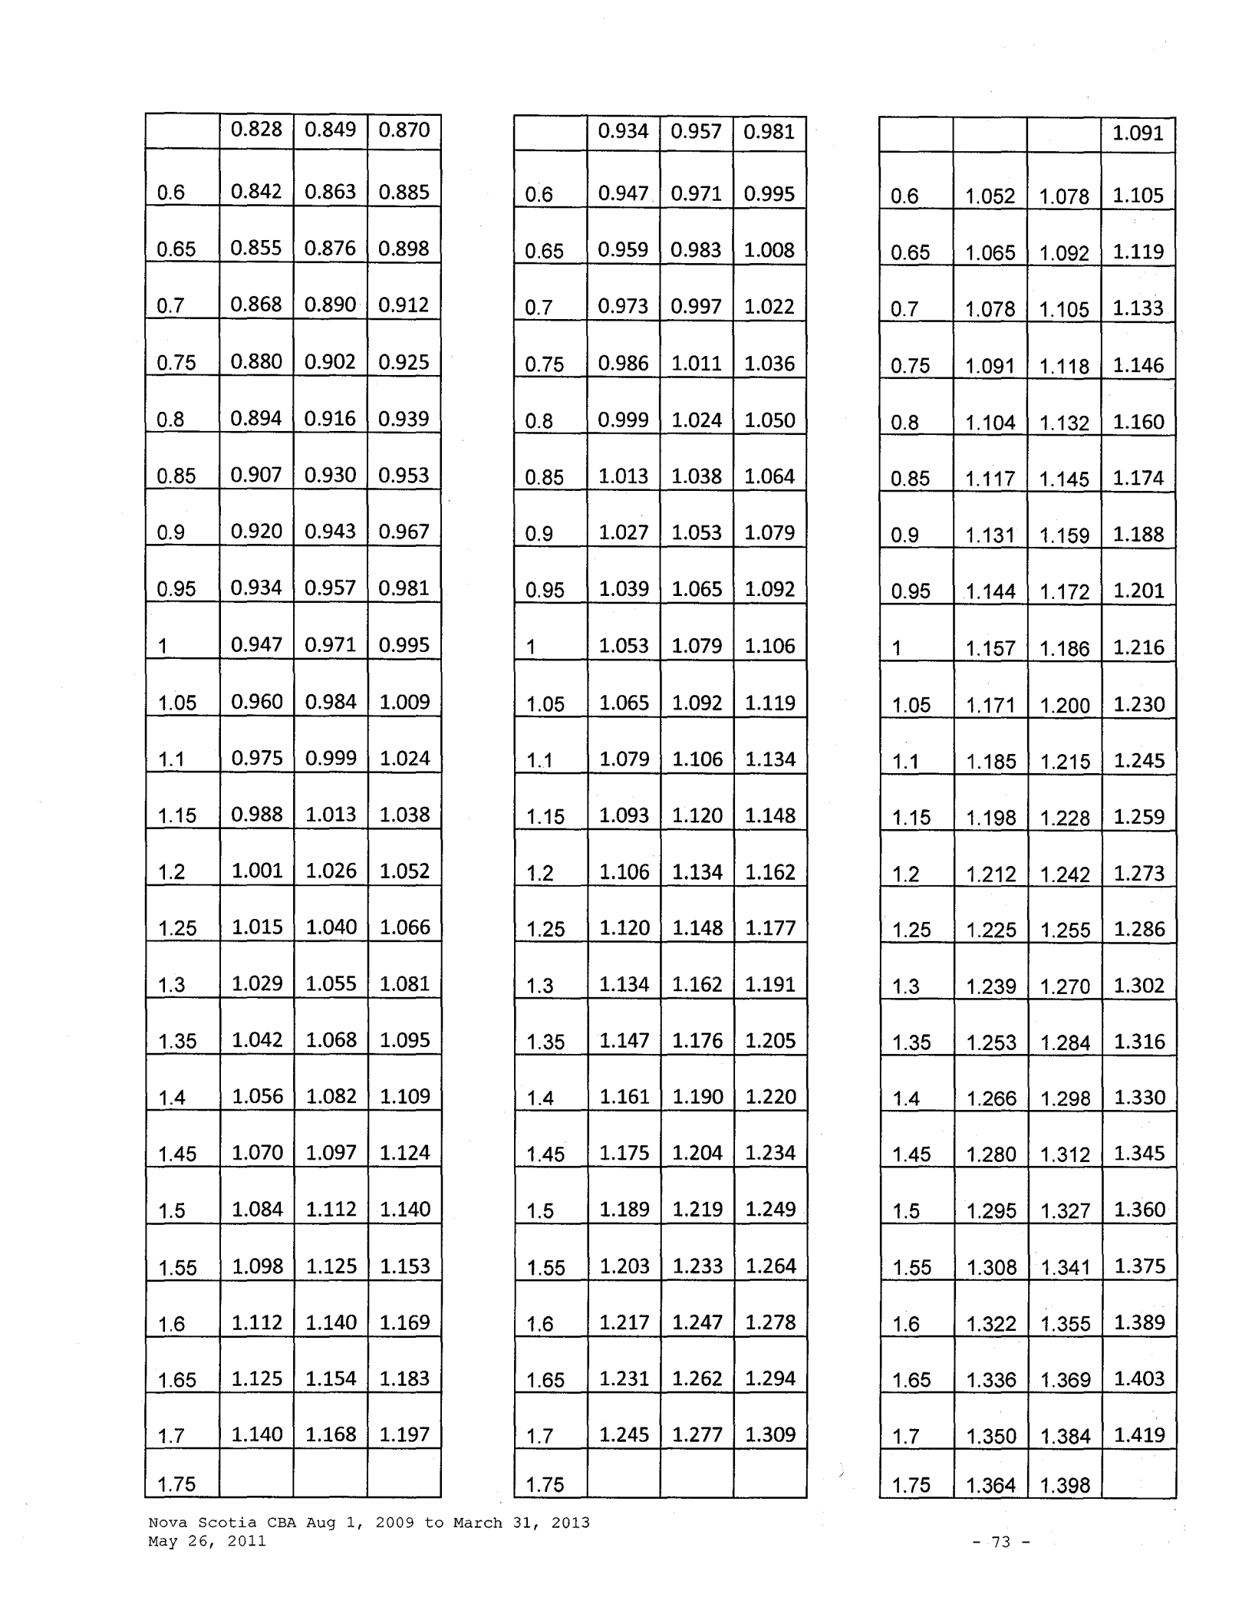

- 1.053 1.079 1.106

- 051.065 1.092 1.119

1.1 |  | 1.079 | 1.106 | 1.134
1.15 |  | 1.093 | 1.120 | 1.148
1.2 |  | 1.106 | 1.134 | 1.162
1.25 |  | 1.120 | 1.148 | 1.177
1.3 |  | 1.134 | 1.162 | 1.191
1.35 |  | 1.147 | 1.176 | 1.205
1.4 |  | 1.161 | 1.190 | 1.220
1.45 |  | 1.175 | 1.204 | 1.234
 | 1.5 | 1.189 | 1.219 | 1.249
 | 1.55 | 1.203 | 1.233 | 1.264
1.6 |  | 1.217 | 1.247 | 1.278
1.65 |  | 1.231 | 1.262 | 1.294
1.7 |  | 1.245 | 1.277 | 1.309
1.75

 |  |  | 1.091
0.6 | 1.052 | 1.078 | 1.105
0.65 | 1.065 | 1.092 | 1.119
0.7 | 1.078 | 1.105 | 1.133
0.75 | 1.091 | 1.118 | 1.146
0.8 | 1.104 | 1.132 | 1.160
0.85 | 1.117 | 1.145 | 1.174
0.9 | 1.131 | 1.159 | 1.188
0.95 | 1.144 | 1.172 | 1.201

- 1.157 1.186 1.216

- 051.171 1.200 1.230

1.1 | 1.185 |  | 1.215 | 1.245
1.15 | 1.198 |  | 1.228 | 1.259
1.2 | 1.212 |  | 1.242 | 1.273
1.25 | 1.225 |  | 1.255 | 1.286
1.3 |  | 1.239 | 1.270 | 1.302
1.35 | 1.253 |  | 1.284 | 1.316
1.4 |  | 1.266 | 1.298 | 1.330
1.45 |  |  | 1.312 | 1.345
1.45 |  | 1.280 | 1.312 | 1.345
1.5 | 1.295 |  | 1.327 | 1.360
1.55 | 1.308 |  | 1.341 | 1.375
1.6 | 1.322 |  | 1.355 | 1.389
1.65 |  | 1.336 | 1.369 | 1.403
 |  |  |  | 1.419
1.7 | 1.350 |  | 1.384 | 1.419
 |  | 1.364 | 1.398
1.75 |  | 1.364 | 1.398

Nova Scotia CBA Aug 1, 2009 to March 31, 2013 May 26, 2011

- 73 -

 |  | 1.154 | 1.183 |  | 1.213
 | 1.8 | 1.169 | 1.198 |  | 1.228
 | 1.85 | 1.183 | 1.212 |  | 1.242
 | 1.9 | 1.197 | 1.227 |  | 1.258
 | 1.95 | 1.212 | 1.242 |  | 1.273
 | 2 | 1.226 | 1.257 |  | 1.288
 | 2.05 | 1.240 | 1.271 |  | 1.303
 | 2.1 | 1.255 | 1.286 |  | 1.318
 | 2.15 | 1.269 | 1.301 |  | 1.334
 | 2.2 | 1.283 | 1.315 |  | 1.348
 | 2.25 | 1.298 | 1.330 |  | 1.363
 | 2.3 | 1.313 | 1.346 |  | 1.380
 | 2.35 | 1.327 | 1.361 |  | 1.395
 | 2.4 | 1.342 | 1.375 |  | 1.409
 | 2.45 | 1.357 | 1.391 |  | 1.426
 | 2.5 | 1.371 | 1.406 |  | 1.441
 | 2.55 | 1.387 | 1.421 |  | 1.457
 | 2.6 | 1.402 | 1.437 |  | 1.473
 | 2.65 | 1.417 | 1.452 |  | 1.488
 | 2.7 | 1.432 | 1.468 |  | 1.505
 | 2.75 | 1.447 | 1.483 |  | 1.520
 | 2.8 | 1.462 | 1.498 |  | 1.535
 | 2.85 | 1.477 | 1.514 |  | 1.552
 | 2.9 | 1.492 | 1.530 |  | 1.568
 | 2.95

 |  | 1.259 |  | 1.290 |  | 1.322
 | 1.8 | 1.273 |  | 1.305 |  | 1.338
 | 1.85 |  | 1.287 | 1.320 |  | 1.353
 | 1.9 |  | 1.302 | 1.334 |  | 1.367
 | 1.95 |  | 1.316 | 1.349 |  | 1.383
 | 2 |  | 1.330 | 1.364 |  | 1.398
 | 2.05 |  | 1.345 | 1.378 |  | 1.412
 | 2.1 |  | 1.359 | 1.393 |  | 1.428
 | 2.15 |  | 1.374 | 1.408 |  | 1.443
 | 2.2 |  | 1.389 | 1.424 |  | 1.460
 | 2.25 |  | 1.403 | 1.438 |  | 1.474
 | 2.3 |  | 1.418 | 1.453 |  | 1.489
 | 2.35 |  | 1.433 | 1.469 |  | 1.506
 | 2.4 |  | 1.447 | 1.483 |  | 1.520
 | 2.45 |  | 1.462 | 1.498 |  | 1.535
 |  |  |  | '
 | 2.5 |  | 1.477 | 1.514 |  | 1.552
 | 2.55 |  | 1.491 | 1.529 |  | 1.567
 | 2.6 |  | 1.507 | 1.544 |  | 1.583
 | 2.65 |  | 1.522 | 1.560 |  | 1.599
 | 2.7 |  | 1.536 | 1.575 |  | 1.614
 | 2.75 |  | 1.552 | 1.591 |  | 1.631
 | 2.8 |  | 1.567 | 1.606 |  | 1.646
 | 2.85 |  | 1.583 | 1.622 |  | 1.663
 | 2.9 |  | 1.598 | 1.638 |  | 1.679
 | 2.95
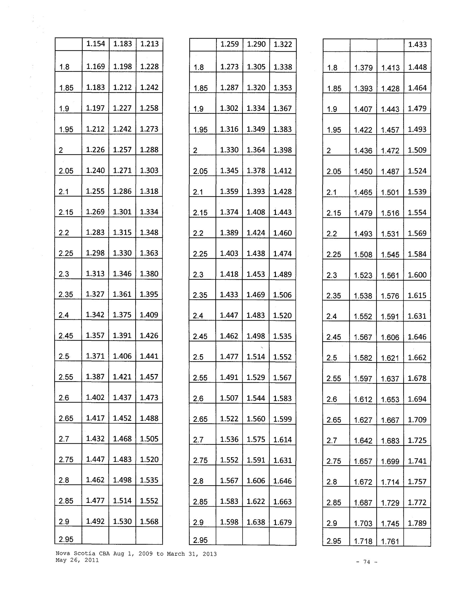

 |  |  |  |  | 1.433
 | 1.8 | 1.379 | 1.413 |  | 1.448
 | 1.85 | 1.393 | 1.428 |  | 1.464
 | 1.9 | 1.407 | 1.443 |  | 1.479
 | 1.95 | 1.422 | 1.457 |  | 1.493
 | 2 | 1.436 | 1.472 |  | 1.509
 | 2.05 | 1.450 | 1.487 |  | 1.524
 | 2.1 | 1.465 | 1.501 |  | 1.539
 | 2.15 | 1.479 | 1.516 |  | 1.554
 | 2.2 | 1.493 | 1.531 |  | 1.569
 | 2.25 | 1.508 | 1.545 |  | 1.584
 | 2.3 | 1.523 | 1.561 |  | 1.600
 | 2.35 | 1.538 | 1.576 |  | 1.615
 | 2.4 | 1.552 | 1.591 |  | 1.631
 | 2.45 | 1.567 | 1.606 |  | 1.646
 | 2.5 | 1.582 | 1.621 |  | 1.662
 | 2.55 | 1.597 | 1.637 |  | 1.678
 | 2.6 | 1.612 | 1.653 |  | 1.694
 | 2.65 | 1.627 | 1.667 |  | 1.709
 | 2.7 | 1.642 | 1.683 |  | 1.725
 | 2.75 | 1.657 | 1.699 |  | 1.741
 | 2.8 | 1.672 | 1.714 |  | 1.757
 | 2.85 | 1.687 | 1.729 |  | 1.772
 | 2.9 | 1.703 | 1.745 |  | 1.789
 | 2.95 | 1.718 | 1.761

Nova Scotia CBA Aug 1, 2009 to March 31, 2013 May 26, 2011

- 74 -

 |  | 1.508 |  | 1.545 |  |  | 1.584
 | 3 | 1.523 |  | 1.561 |  |  | 1.600
 | 3.05 | 1.539 |  | 1.577 |  |  | 1.616
 | 3.1 | 1.554 |  | 1.593 |  |  | 1.633
 | 3.15 | 1.569 |  | 1.609 |  |  | 1.649
 | 3.2 | 1.585 |  | 1.624 |  |  | 1.665
 | 3.25 | 1.601 |  | 1.641 |  |  | 1.682
 | 3.3 | 1.616 |  | 1.657 |  |  | 1.698
 | 3.35 | 1.632 |  | 1.673 |  |  | 1.715
 | 3.4 | 1.647 |  | 1.688 |  |  | 1.730
 | 3.45 | 1.664 |  | 1.705 |  |  | 1.748
 | 3.5 | 1.679 |  | 1.721 |  |  | 1.764
 | 3.55 | 1.695 |  | 1.738 |  |  | 1.781
 | 3.6 | 1.711 |  | 1.753 |  |  | 1.797
 | 3.65 | 1.727 |  | 1.770 |  |  | 1.814
 | 3.7 | 1.743 |  | 1.786 |  |  | 1.831
 | 3.75 | 1.759 |  | 1.803 |  |  | 1.848
 | 3.8 | 1.775 |  | 1.820 |  |  | 1.866
 | 3.85 | 1.792 |  | 1.836 |  |  | 1.882
 | 3.9 | 1.807 |  | 1.852 |  |  | 1.898
 | 3.95 | 1.823 |  | 1.869 |  |  | 1.916
 | 4 | 1.840 |  | 1.886 |  |  | 1.933
 | 4.05 | 1.856 |  | 1.903 |  |  | 1.951
 | 4.1 | 1.873 |  | 1.919 |  |  | 1.967
 | 4.15

 |  | 1.612 |  | 1.652 |  | 1.693
 | 3 | 1.629 |  | 1.669 |  | 1.711
 | 3.05 | 1.644 |  | 1.685 |  | 1.727
 | 3.1 | 1.659 |  | 1.701 |  | 1.744
 | 3.15 | 1.675 |  | 1.717 |  | 1.760
 | 3.2 | 1.690 |  | 1.732 |  | 1.775
 | 3.25 | 1.706 |  | 1.748 |  | 1.792
 | 3.3 | 1.721 |  | 1.764 |  | 1.808
 | 3.35 | 1.737 |  | 1.781 |  | 1.826
 | 3.4 | 1.753 |  | 1.797 |  | 1.842
 | 3.45 | 1.768 |  | 1.812 |  | 1.857
 | 3.5 | 1.785 |  | 1.829 |  | 1.875
 | 3.55 | 1.800 |  | 1.845 |  | 1.891
 | 3.6 | 1.816 |  | 1.861 |  | 1.908
 | 3.65 | 1.832 |  | 1.877 |  | 1.924
 | 3.7 | 1.848 |  | 1.894 |  | 1.941
 | 3.75 | 1.864 |  | 1.911 |  | 1.959
 | 3.8 | 1.880 |  | 1.927 |  | 1.975
 | 3.85 | 1.896 |  | 1.944 |  | 1.993
 | 3.9 | 1.913 |  | 1.960 |  | 2.009
 | 3.95 | 1.929 |  | 1.977 |  | 2.026
 | 4 | 1.945 |  | 1.994 |  | 2.044
 | 4.05 | 1.962 |  | 2.011 |  | 2.061
 | 4.1 | 1.978 |  | 2.028 |  | 2.079
 | 4.15
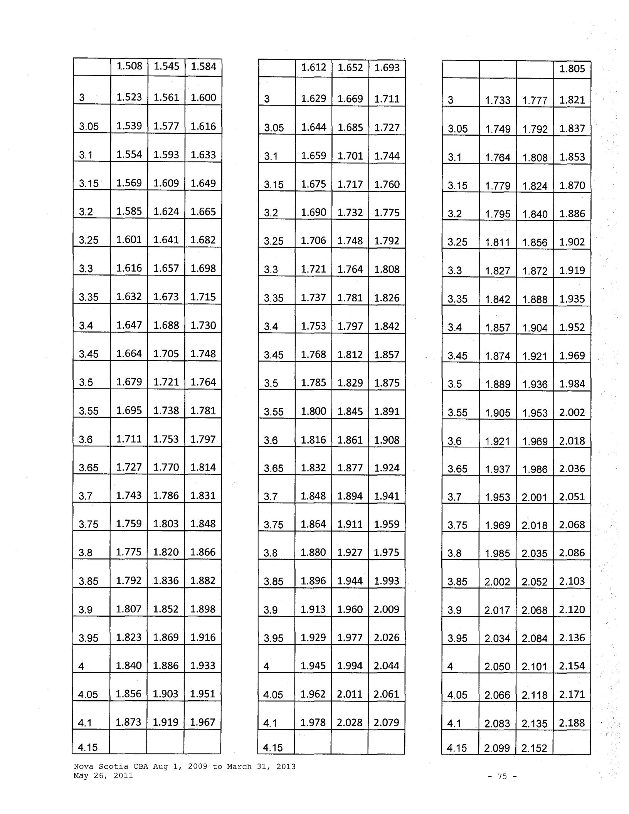

 |  |  |  |  | 1.805
3 | 1.733 |  | 1.777 |  | 1.821
3.05 | 1.749 |  | 1.792 |  | 1.837
3.1 | 1.764 |  | 1.808 |  | 1.853
3.15 | 1.779 |  | 1.824 |  | 1.870
3.2 | 1.795 |  | 1.840 |  | 1.886
3.25 | 1.811 |  | 1.856 |  | 1.902
3.3 | 1.827 |  | 1.872 |  | 1.919
3.35 | 1.842 |  | 1.888 |  | 1.935
3.4 | 1.857 |  | 1.904 |  | 1.952
3.45 | 1.874 |  | 1.921 |  | 1.969
3.5 | 1.889 |  | 1.936 |  | 1.984
3.55 | 1.905 |  | 1.953 |  | 2.002
3.6 | 1.921 |  | 1.969 |  | 2.018
3.65 | 1.937 |  | 1.986 |  | 2.036
3.7 | 1.953 |  | 2.001 |  | 2.051
3.75 | 1.969 |  | 2.018 |  | 2.068
3.8 | 1.985 |  | 2.035 |  | 2.086
3.85 | 2.002 |  | 2.052 |  | 2.103
3.9 | 2.017 |  | 2.068 |  | 2.120
3.95 | 2.034 |  | 2.084 |  | 2.136
4 | 2.050 |  | 2.101 |  | 2.154
4.05 | 2.066 |  | 2.118 |  | 2.171
4.1 | 2.083 |  | 2.135 |  | 2.188
4.15 | 2.099 |  | 2.152

Nova Scotia CBA Aug 1, 2009 to March 31, 2013 May 26, 2011

- 75 -

 |  |  | 1.889 |  | 1.936 |  |  | 1.984
 | 4.2 |  | 1.905 |  | 1.953 |  |  | 2.002
 | 4.25 |  | 1.922 |  | 1.970 |  |  | 2.019
 | 4.3 |  | 1.938 |  | 1.987 |  |  | 2.037
 | 4.35 |  | 1.956 |  | 2.005 |  |  | 2.055
 | 4.4 |  | 1.972 |  | 2.021 |  |  | 2.072
 | 4.45 |  | 1.989 |  | 2.038 |  |  | 2.089
 | 4.5 |  | 2.005 |  | 2.055 |  |  | 2.106
 | 4.55 |  | 2.022 |  | 2.073 |  |  | 2.125
 | 4.6 |  | 2.039 |  | 2.090 |  |  | 2.142
 | 4.65 |  | 2.056 |  | 2.108 |  |  | 2.161
 | 4.7 |  | 2.073 |  | 2.124 |  |  | 2.177
 | 4.75 |  | 2.090 |  | 2.142 |  |  | 2.196
 | 4.8 |  | 2.106 |  | 2.159 |  |  | 2.213
 | 4.85 |  | 2.124 |  | 2.177 |  |  | 2.231
 | 4.9 |  | 2.140 |  | 2.194 |  |  | 2.249
 | 4.95 |  | 2.158 |  | 2.212 |  |  | 2.267
 | 5 |  | 2.175 |  | 2.229 |  |  | 2.285
 | 5.05 |  | 2.191 |  | 2.246 |  |  | 2.302
 | 5.1 |  | 2.209 |  | 2.264 |  |  | 2.321
 | 5.15 |  | 2.226 |  | 2.282 |  |  | 2.339
 | 5.2 |  | 2.244 |  | 2.300 |  |  | 2.358
 | 5.25 |  | 2.261 |  | 2.318 |  |  | 2.376
 | 5.3 |  | 2.279 |  | 2.336 |  |  | 2.394
 | 5.35

 |  | 1.995 |  | 2.045 | 2.096
 | 4.2 | 2.011 |  | 2.061 | 2.113
 | 4.25 |  | 2.027 | 2.078 | 2.130
 | 4.3 |  | 2.044 | 2.095 | 2.147
 | 4.35 |  | 2.060 | 2.112 | 2.165
 | 4.4 |  | 2.077 | 2.129 | 2.182
 | 4.45 |  | 2.094 | 2.146 | 2.200
 | 4.5 |  | 2.110 | 2.163 | 2.217
 | 4.55 |  | 2.128 | 2.181 | 2.236
 | 4.6 |  | 2.144 | 2.198 | 2.253
 | 4.65 |  | 2.161 | 2.215 | 2.270
 | 4.7 |  | 2.177 | 2.232 | 2.288
 | 4.75 |  | 2.195 | 2.249 | 2.305
 | 4.8 |  | 2.212 | 2.267 | 2.324
 | 4.85 |  | 2.228 | 2.284 | 2.341
 | 4.9 |  | 2.246 | 2.302 | 2.360
 | 4.95 |  | 2.262 | 2.319 | 2.377
 | 5 | 2.280 |  | 2.337 | 2.395
 | 5.05 | 2.297 |  | 2.354 | 2.413
 | 5.1 | 2.314 |  | 2.372 | 2.431
 | 5.15 | 2.332 |  | 2.390 | 2.450
 | 5.2 | 2.348 |  | 2.407 | 2.467
 | 5.25 | 2.366 |  | 2.425 | 2.486
 | 5.3 | 2.383 |  | 2.443 | 2.504
 | 5.35
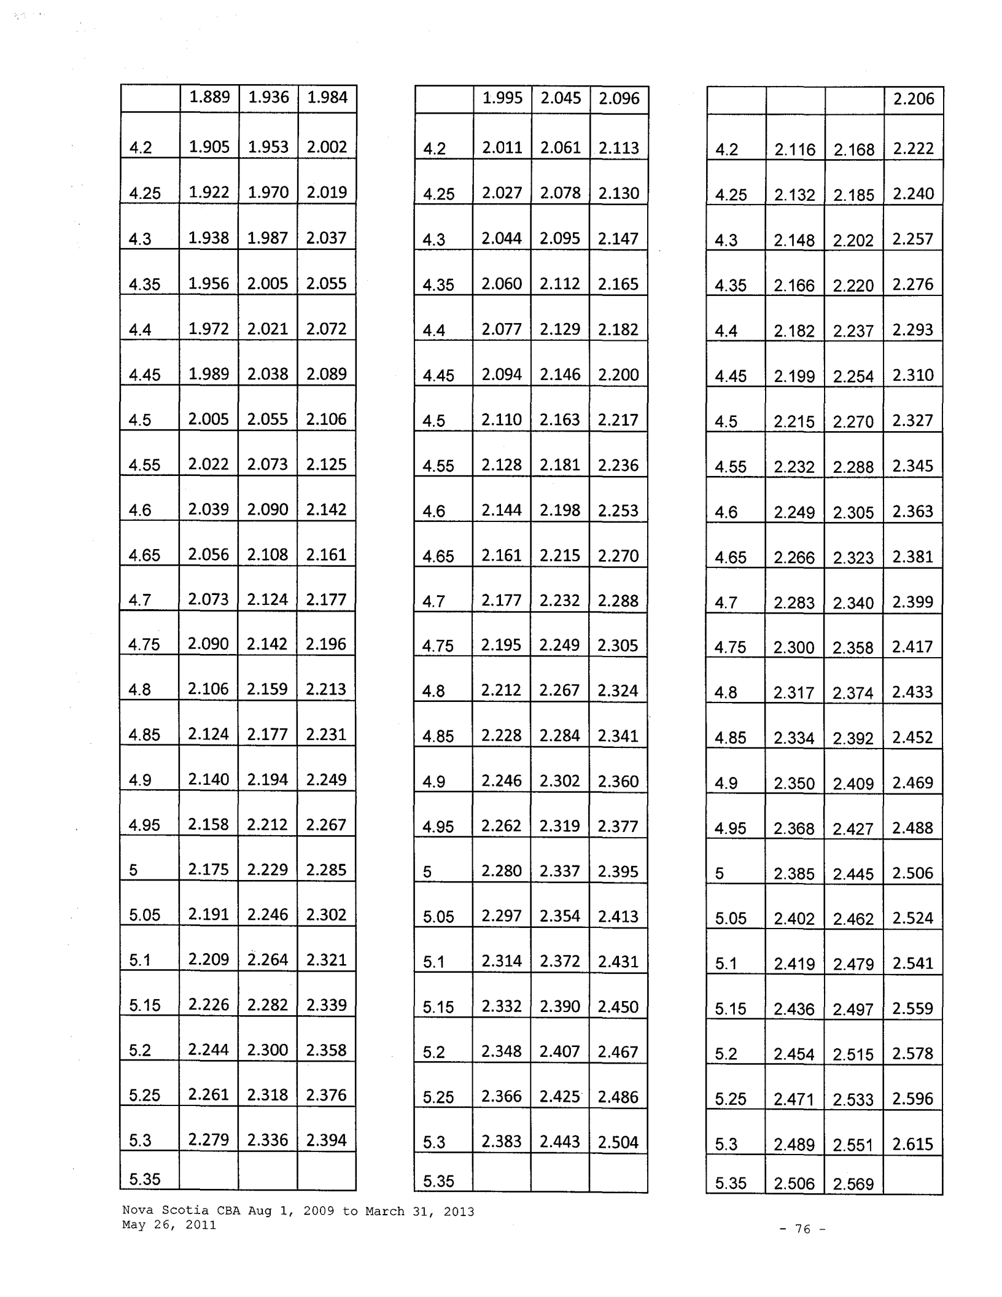

 |  |  |  |  |  |  |  |  |  | 2.206
 | 4.2 | 2.116 |  |  |  |  |  |  | 2.168 | 2.222
 | 4.25 |  |  |  | 2.132 |  |  |  | 2.185 | 2.240
 | 4.3 |  |  |  | 2.148 |  |  |  | 2.202 | 2.257
 | 4.35 |  |  |  | 2.166 |  |  |  | 2.220 | 2.276
 | 4.4 |  |  |  | 2.182 |  |  |  | 2.237 | 2.293
 | 4.45 |  |  |  | 2.199 |  |  |  | 2.254 | 2.310
 | 4.5 |  |  |  | 2.215 |  |  |  | 2.270 | 2.327
 | 4.55 |  |  |  | 2.232 |  |  |  | 2.288 | 2.345
 | 4.6 |  |  |  | 2.249 |  |  |  | 2.305 | 2.363
 | 4.65 |  |  |  | 2.266 |  |  |  | 2.323 | 2.381
 | 4.7 |  |  |  | 2.283 |  |  |  | 2.340 | 2.399
 | 4.75 |  |  |  | 2.300 |  |  |  | 2.358 | 2.417
 | 4.8 |  |  |  | 2.317 |  |  |  | 2.374 | 2.433
 | 4.85 |  |  |  | 2.334 |  |  |  | 2.392 | 2.452
 | 4.9 |  |  |  |  |  | 2.350 |  | 2.409 | 2.469
 | 4.95 |  |  |  |  | 2.368 |  |  | 2.427 | 2.488
 | 5 | 2.385 |  |  |  |  |  |  | 2.445 | 2.506
 | 5.05 | 2.402 |  |  |  |  |  |  | 2.462 | 2.524
 | 5.1 | 2.419 |  |  |  |  |  |  | 2.479 | 2.541
 | 5.15 | 2.436 |  |  |  |  |  |  | 2.497 | 2.559
 | 5.2 | 2.454 |  |  |  |  |  |  | 2.515 | 2.578
 | 5.25 | 2.471 |  |  |  |  |  |  | 2.533 | 2.596
 | 5.3 | 2.489 |  |  |  |  |  |  | 2.551 | 2.615
 | 5.35 | 2.506 |  |  |  |  |  |  | 2.569

Nova Scotia CBA Aug 1, 2009 to March 31, 2013 May 26, 2011

- 76 -

 | 2.296 | 2.353 |  | 2.412
5.4 | 2.313 | 2.371 |  | 2.430
5.45 | 2.331 | 2.389 |  | 2.449
5.5 | 2.348 | 2.407 |  | 2.467
5.55 | 2.366 | 2.425 |  | 2.486
5.6 | 2.383 | 2.443 |  | 2.504
5.65 | 2.401 | 2.461 |  | 2.523
5.7 | 2.419 | 2.479 |  | 2.541
5.75 | 2.436 | 2.497 |  | 2.559
5.8 | 2.454 | 2.515 |  | 2.578
5.85 | 2.472 | 2.534 |  | 2.597
5.9 | 2.490 | 2.552 |  | 2.616
5.95 | 2.507 | 2.570 |  | 2.634
6 | 2.526 | 2.589 |  | 2.654
6.05 | 2.543 | 2.607 |  | 2.672
6.1 | 2.561 | 2.626 |  | 2.692
6.15 | 2.579 | 2.643 |  | 2.709
6.2 | 2.597 | 2.662 |  | 2.729
6.25 | 2.615 | 2.680 |  | 2.747
6.3 | 2.633 | 2.699 |  | 2.766
6.35 | 2.652 | 2.718 |  | 2.786
6.4 | 2.669 | 2.736 |  | 2.804
6.45 | 2.688 | 2.755 |  | 2.824
6.5 | 2.706 | 2.774 |  | 2.843
6.55

 | 2.401 | 2.461 | 2.523
5.4 | 2.418 | 2.478 | 2.540
5.45 | 2.435 | 2.496 | 2.558
5.5 | 2.453 | 2.514 | 2.577
5.55 | 2.471 | 2.533 | 2.596
5.6 | 2.489 | 2.551 | 2.615
5.65 | 2.506 | 2.569 | 2.633
5.7 | 2.524 | 2.587 | 2.652
5.75 | 2.541 | 2.605 | 2.670
5.8 | 2.559 | 2.623 | 2.689
5.85 | 2.577 | 2.641 | 2.707
5.9 | 2.595 | 2.660 | 2.727
5.95 | 2.613 | 2.678 | 2.745
6 | 2.630 | 2.696 | 2.763
6.05 | 2.649 | 2.715 | 2.783
6.1 | 2.666 | 2.733 | 2.801
6.15 | 2.684 | 2.752 | 2.821
6.2 | 2.702 | 2.769 | 2.838
6.25 | 2.720 | 2.788 | 2.858
6.3 | 2.738 | 2.806 | 2.876
6.35 | 2.756 | 2.825 | 2.896
6.4 | 2.775 | 2.844 | 2.915
6.45 | 2.792 | 2.862 | 2.934
6.5 | 2.811 | 2.881 | 2.953
6.55
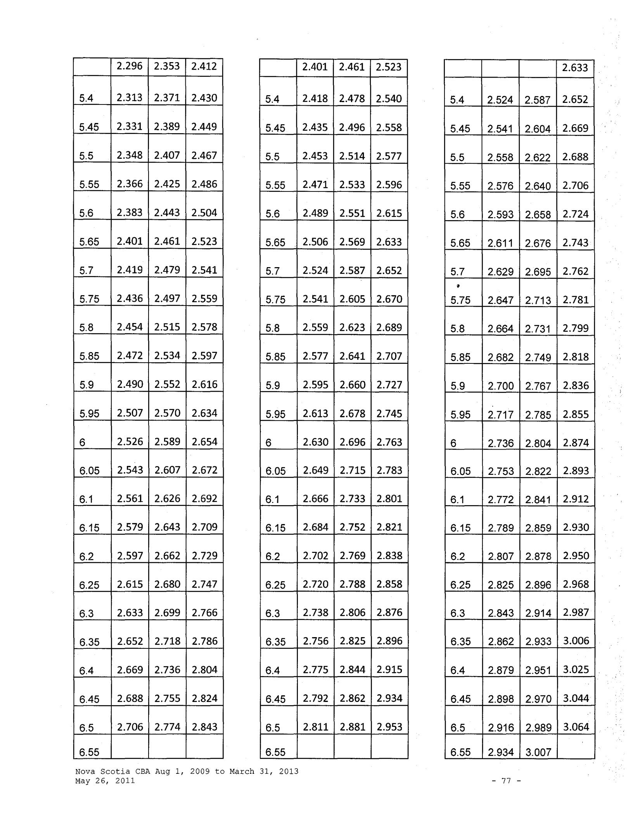

 |  |  |  |  | 2.633
5.4 |  | 2.524 |  | 2.587 | 2.652
 | 5.45 | 2.541 |  | 2.604 | 2.669
 | 5.5 | 2.558 |  | 2.622 | 2.688
 | 5.55 | 2.576 |  | 2.640 | 2.706
 | 5.6 | 2.593 |  | 2.658 | 2.724
 | 5.65 | 2.611 |  | 2.676 | 2.743
 | 5.7 | 2.629 |  | 2.695 | 2.762
 | • |  |  |  | 2.781
 | 5.75 | 2.647 |  | 2.713 | 2.781
 | 5.8 | 2.664 |  | 2.731 | 2.799
 | 5.85 | 2.682 |  | 2.749 | 2.818
 | 5.9 | 2.700 |  | 2.767 | 2.836
 | 5.95 | 2.717 |  | 2.785 | 2.855
 | 6 | 2.736 |  | 2.804 | 2.874
 | 6.05 | 2.753 |  | 2.822 | 2.893
 | 6.1 | 2.772 |  | 2.841 | 2.912
 | 6.15 | 2.789 |  | 2.859 | 2.930
 | 6.2 | 2.807 |  | 2.878 | 2.950
 | 6.25 | 2.825 |  | 2.896 | 2.968
 | 6.3 | 2.843 |  | 2.914 | 2.987
 | 6.35 | 2.862 |  | 2.933 | 3.006
 | 6.4 | 2.879 |  | 2.951 | 3.025
 | 6.45 | 2.898 |  | 2.970 | 3.044
 | 6.5 | 2.916 |  | 2.989 | 3.064
 | 6.55 | 2.934 |  | 3.007

Nova Scotia CBA Aug 1, 2009 to March 31, 2013 May 26, 2011

- 77 -

 |  | 2.723 |  | 2.792 | 2.862
 | 6.6 | 2.742 |  | 2.811 | 2.881
 | 6.65 | 2.760 |  | 2.829 | 2.900
 | 6.7 | 2.779 |  | 2.848 | 2.919
 | 6.75 | 2.797 |  | 2.867 | 2.939
 | 6.8 | 2.816 |  | 2.886 | 2.958
 | 6.85 | 2.834 |  | 2.905 | 2.978
 | 6.9 | 2.852 |  | 2.923 | 2.996
 | 6.95 | 2.870 |  | • | 3.016
 | 6.95 | 2.870 |  | 2.942 | 3.016
 | 7 | 2.888 |  | 2.961 | 3.035
 | 7.05 | 2.907 |  | 2.980 | 3.055
 | 7.1 | 2.925 |  | 2.998 | 3.073
 | 7.15 | 2.944 |  | 3.017 | 3.092
 | 7.2 | 2.963 |  | 3.037 | 3.113
 | 7.25 | 2.982 |  | 3.056 | 3.132
 | 7.3 | 3.000 |  | 3.075 | 3.152
 | 7.35 | 3.019 |  | 3.094 | 3.171
 | 7.4 | 3.037 |  | 3.113 | 3.191
 | 7.45 | 3.056 |  | 3.132 | 3.210
 | 7.5 | 3.074 |  | 3.151 | 3.230
 | 7.55 | 3.093 |  | 3.171 | 3.250
 | 7.6 | 3.112 |  | 3.190 | 3.270
 | 7.65 | 3.129 |  | 3.207 | 3.287
 | 7.7 | 3.149 |  | 3.228 | 3.309
 | 7.75

 |  |  | 2.829 |  | 2.900 |  | 2.973
 |  | 6.6 | 2.847 |  | 2.919 |  | 2.992
 |  | 6.65 |  | 2.866 | 2.938 |  | 3.011
 |  | 6.7 |  | 2.883 | 2.955 |  | 3.029
 |  | 6.75 |  | 2.902 | 2.975 |  | 3.049
 |  | 6.8 | 2.920 |  | 2.993 |  | 3.068
 |  | 6.85 |  | 2.939 | 3.012 |  | 3.087
 |  | 6.9 |  | 2.957 | 3.031 |  | 3.107
 |  | 6.95 |  | 2.976 | 3.050 |  | 3.126
 |  | 7 |  | 2.994 | 3.069 |  | 3.146
 |  | 7.05 |  | 3.012 | 3.088 |  | 3.165
 |  | 7.1 |  | 3.031 | 3.107 |  | 3.185
 |  | 7.15 |  | 3.049 | 3.126 |  | 3.204
 |  | 7.2 |  | 3.068 | 3.145 |  | 3.224
 |  | 7.25 |  | 3.086 | 3.163 |  | 3.242
 |  | 7.3 |  | 3.105 | 3.182 |  | 3.262
 |  | 7.35 |  | 3.123 | 3.201 |  | 3.281
 |  | 7.4 |  | 3.142 | 3.220 |  | 3.301
 |  | 7.45 |  | 3.161 | 3.240 |  | 3.321
 |  | 7.5 |  | 3.180 | 3.259 |  | 3.340
 |  | 7.55 | 3.198 |  | 3.278 |  | 3.360
 |  | 7.6 | 3.217 |  | 3.297 |  | 3.379
 |  | 7.65 | 3.235 |  | 3.316 |  | 3.399
 |  | 7.7 | 3.254 |  | 3.336 |  | 3.419
 |  | 7.75
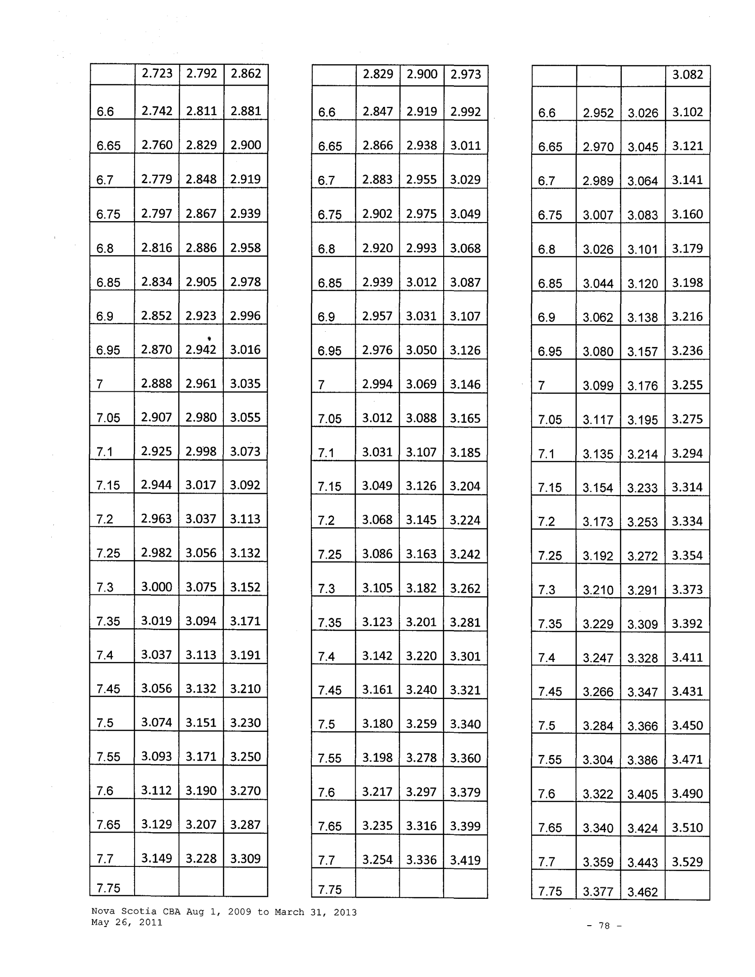

 |  |  |  |  |  |  |  | 3.082
 | 6.6 | 2.952 |  |  | 3.026 |  |  | 3.102
 | 6.65 |  | 2.970 |  | 3.045 |  |  | 3.121
 | 6.7 |  | 2.989 |  | 3.064 |  |  | 3.141
 | 6.75 |  | 3.007 |  | 3.083 |  |  | 3.160
 | 6.8 |  | 3.026 |  | 3.101 |  |  | 3.179
 | 6.85 |  | 3.044 |  | 3.120 |  |  | 3.198
 | 6.9 |  | 3.062 |  | 3.138 |  |  | 3.216
 | 6.95 |  | 3.080 |  | 3.157 |  |  | 3.236
 | 7 |  | 3.099 |  | 3.176 |  |  | 3.255
 | 7.05 |  | 3.117 |  | 3.195 |  |  | 3.275
 | 7.1 |  | 3.135 |  | 3.214 |  |  | 3.294
 | 7.15 |  | 3.154 |  | 3.233 |  |  | 3.314
 | 7.2 |  | 3.173 |  | 3.253 |  |  | 3.334
 | 7.25 |  | 3.192 |  | 3.272 |  |  | 3.354
 | 7.3 |  | 3.210 |  | 3.291 |  |  | 3.373
 | 7.35 |  | 3.229 |  | 3.309 |  |  | 3.392
 | 7.4 | 3.247 |  |  | 3.328 |  |  | 3.411
 | 7.45 | 3.266 |  |  | 3.347 |  |  | 3.431
 | 7.5 | 3.284 |  |  | 3.366 |  |  | 3.450
 | 7.55 | 3.304 |  |  | 3.386 |  |  | 3.471
 | 7.6 | 3.322 |  |  | 3.405 |  |  | 3.490
 | 7.65 | 3.340 |  |  | 3.424 |  |  | 3.510
 | 7.7 | 3.359 |  |  | 3.443 |  |  | 3.529
 | 7.75 | 3.377 |  |  | 3.462

Nova Scotia CBA Aug 1, 2009 to March 31, 2013 May 26, 2011

- 78 -

 |  | 3.167 | 3.246 | 3.327
7.8 |  | 3.187 | 3.266 | 3.348
7.85 |  | 3.205 | 3.285 | 3.367
7.9 |  | 3.224 | 3.304 | 3.387
7.95 |  | 3.243 | 3.324 | 3.407
8 |  | 3.262 | 3.343 | 3.427
 | 8.05 | 3.280 | 3.362 | 3.446
 | 8.1 | 3.299 | 3.382 | 3.467
 | 8.15 | 3.318 | 3.401 | 3.486
 | 8.2 | 3.336 | 3.420 | 3.506
 | 8.25 | 3.356 | 3.440 | 3.526
 | 8.3 | 3.374 | 3.459 | 3.545
 | 8.35 | 3.394 | 3.479 | 3.566
 | 8.4 | 3.412 | 3.498 | 3.585
 | 8.45 | 3.431 | 3.516 | 3.604
 | 8.5 | 3.450 | 3.536 | 3.624
 | 8.55 | 3.469 | 3.555 | 3.644
 | 8.6 | 3.488 | 3.575 | 3.664
 | 8.65 | 3.507 | 3.595 | 3.685
 | 8.7 | 3.526 | 3.614 | 3.704
 | 8.75 | 3.544 | 3.633 | 3.724
 | 8.8 | 3.563 | 3.652 | 3.743
 | 8.85 | 3.582 | 3.672 | 3.764
 | 8.9 | 3.601 | 3.691 | 3.783
 | 8.95

 |  | 3.273 |  |  | 3.355 |  | 3.439
 | 7.8 | 3.291 |  |  | 3.374 |  | 3.458
 | 7.85 | 3.311 |  |  | 3.394 |  | 3.479
 | 7.9 | 3.329 |  |  | 3.412 |  | 3.497
 | 7.95 | 3.348 |  |  | 3.431 |  | 3.517
 | 8 | 3.366 |  |  | 3.450 |  | 3.536
 | 8.05 | 3.386 |  |  | 3.470 |  | 3.557
 | 8.1 |  |  |  | 3.489 |  | 3.576
 | 8.1 |  | 3.404 |  |  |  | 3.576
 | 8.15 |  | 3.424 |  | 3.509 |  | 3.597
 | 8.2 |  | 3.442 |  | 3.528 |  | 3.616
 | 8.25 |  | 3.460 |  |  |  | 3.636
 | 8.25 |  | 3.460 |  |  | 3.547 | 3.636
 | 8.3 |  | 3.480 |  |  | 3.567 | 3.656
 | 8.35 |  | 3.498 |  |  | 3.586 | 3.676
 | 8.4 |  | 3.517 |  |  | 3.605 | 3.695
 | 8.45 |  | 3.536 |  |  | 3.625 | 3.716
 | 8.5 |  | 3.555 |  |  | 3.644 | 3.735
 | 8.55 |  | 3.574 |  |  | 3.664 | 3.756
 | 8.6 |  | 3.593 |  |  | 3.682 | 3.774
 | 8.65 |  | 3.612 |  |  | 3.702 | 3.795
 | 8.7 |  | 3.631 |  |  | 3.721 | 3.814
 | 8.75 |  | 3.649 |  |  | 3.740 | 3.834
 | 8.8 |  | 3.668 |  |  | 3.760 | 3.854
 | 8.85 |  | 3.687 |  |  | 3.779 | 3.873
 | 8.9 |  | 3.706 |  |  | 3.799 | 3.894
 | 8.95
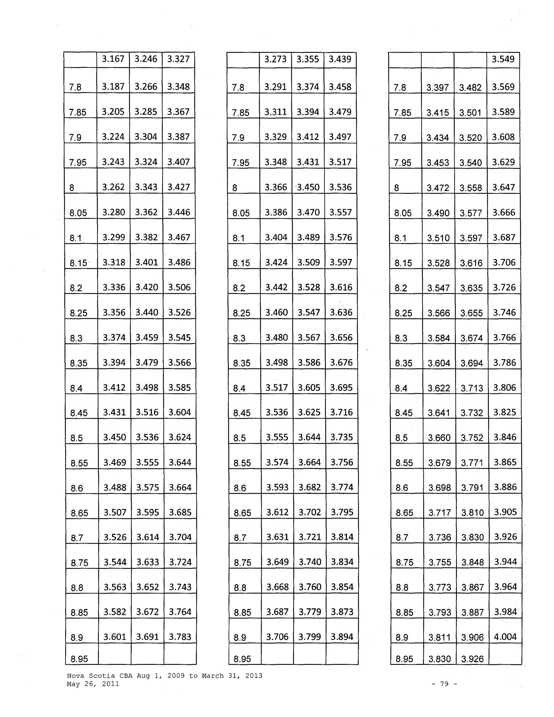

 |  |  |  |  |  |  |  | 3.549
 |  | 7.8 |  | 3.397 |  | 3.482 |  | 3.569
 |  | 7.85 |  | 3.415 |  | 3.501 |  | 3.589
 |  | 7.9 |  | 3.434 |  | 3.520 |  | 3.608
 |  | 7.95 |  | 3.453 |  |  | 3.540 | 3.629
 |  | 8 |  | 3.472 |  |  | 3.558 | 3.647
 |  | 8.05 |  | 3.490 |  |  | 3.577 | 3.666
 |  | 8.1 |  | 3.510 |  |  | 3.597 | 3.687
 |  | 8.15 |  | 3.528 |  |  | 3.616 | 3.706
 |  | 8.2 |  | 3.547 |  |  | 3.635 | 3.726
 |  | 8.25 |  | 3.566 |  |  | 3.655 | 3.746
 |  | 8.3 |  | 3.584 |  |  | 3.674 | 3.766
 |  | 8.35 |  | 3.604 |  |  | 3.694 | 3.786
 |  |  | 8.4 | 3.622 |  |  | 3.713 | 3.806
 |  |  | 8.45 | 3.641 |  |  | 3.732 | 3.825
 |  |  | 8.5 | 3.660 |  |  | 3.752 | 3.846
 |  |  | 8.55 | 3.679 |  |  | 3.771 | 3.865
 |  |  | 8.6 |  | 3.698 |  | 3.791 | 3.886
 |  |  | 8.65 |  | 3.717 |  | 3.810 | 3.905
 |  |  |  |  |  |  | 3.830 | 3.926
 |  |  | 8.7 | 3.736 |  |  | 3.830 | 3.926
 |  |  |  |  |  |  | 3.848 | 3.944
 |  |  | 8.75 | 3.755 |  |  | 3.848 | 3.944
 |  |  | 8.8 |  |  |  | 3.867 | 3.964
 |  |  | 8.8 |  | 3.773 |  | 3.867 | 3.964
 |  |  | 8.85 |  | 3.793 |  | 3.887 | 3.984
 |  |  | 8.9 |  | 3.811 |  | 3.906 | 4.004
 |  |  | 8.95 |  | 3.830 |  | 3.926

Nova Scotia CBA Aug 1, 2009 to March 31, 2013 May 26, 2011

- 79 -

 |  | 3.620 | 3.711 | 3.804
 | 9 | 3.639 | 3.730 | 3.823
9.05 |  | 3.658 | 3.750 | 3.844
9.1 |  | 3.677 | 3.769 | 3.863
9.15 |  | 3.696 | 3.789 | 3.884
9.2 |  | 3.715 | 3.807 | 3.902
9.25 |  | 3.733 | 3.826 | 3.922
9.3 |  | 3.753 | 3.846 | 3.942
9.35 |  | 3.771 | 3.865 | 3.962
9.4 |  | 3.790 | 3.885 | 3.982
9.45 |  | 3.809 | 3.904 | 4.002
9.5 |  | 3.828 | 3.924 | 4.022
9.55 |  | 3.847 | 3.943 | 4.042
9.6 |  | 3.865 | 3.962 | 4.061
9.65 |  | 3.885 | 3.982 | 4.082
9.7 |  | 3.903 | 4.001 | 4.101
9.75 |  | 3.923 | 4.021 | 4.122
9.8 |  | 3.941 | 4.040 | 4.141
9.85 |  | 3.960 | 4.059 | 4.160
9.9 |  | 3.979 | 4.079 | 4.181
9.95 |  | 3.998 | 4.097 | 4.199

- 4.016 4.116 4.219

- 05 4.035 4.136 4.239

10.1 4.054 4.155 4.259

10.15

 | 3.725 | 3.818 |  | 3.913
9 | 3.744 | 3.838 |  | 3.934
9.05 | 3.763 | 3.857 |  | 3.953
9.1 | 3.782 | 3.877 |  | 3.974
9.15 | 3.801 | 3.896 |  | 3.993
9.2 | 3.819 | 3.915 |  | 4.013
9.25 | 3.839 | 3.935 |  | 4.033
9.3 | 3.857 | 3.954 |  | 4.053
9.35 | 3.877 | 3.974 |  | 4.073
9.4 | 3.895 | 3.992 |  | 4.092
9.45 | 3.914 | 4.012 |  | 4.112
9.5 | 3.933 | 4.031 |  | 4.132
9.55 | 3.952 | 4.051 |  | 4.152
9.6 | 3.971 | 4.070 |  | 4.172
9.65 | 3.989 | 4.089 |  | 4.191
9.7 | 4.009 | 4.109 |  | 4.212
9.75 | 4.027 | 4.128 |  | 4.231
9.8 | 4.046 | 4.147 |  | 4.251
9.85 | 4.065 | 4.167 |  | 4.271
9.9 | 4.084 | 4.186 |  | 4.291
9.95 | 4.103 | 4.206 |  | 4.311
10 | 4.122 | 4.225 |  | 4.331
10.05 | 4.140 | 4.243 |  | 4.349
10.1 | 4.159 | 4.263 |  | 4.370
10.15
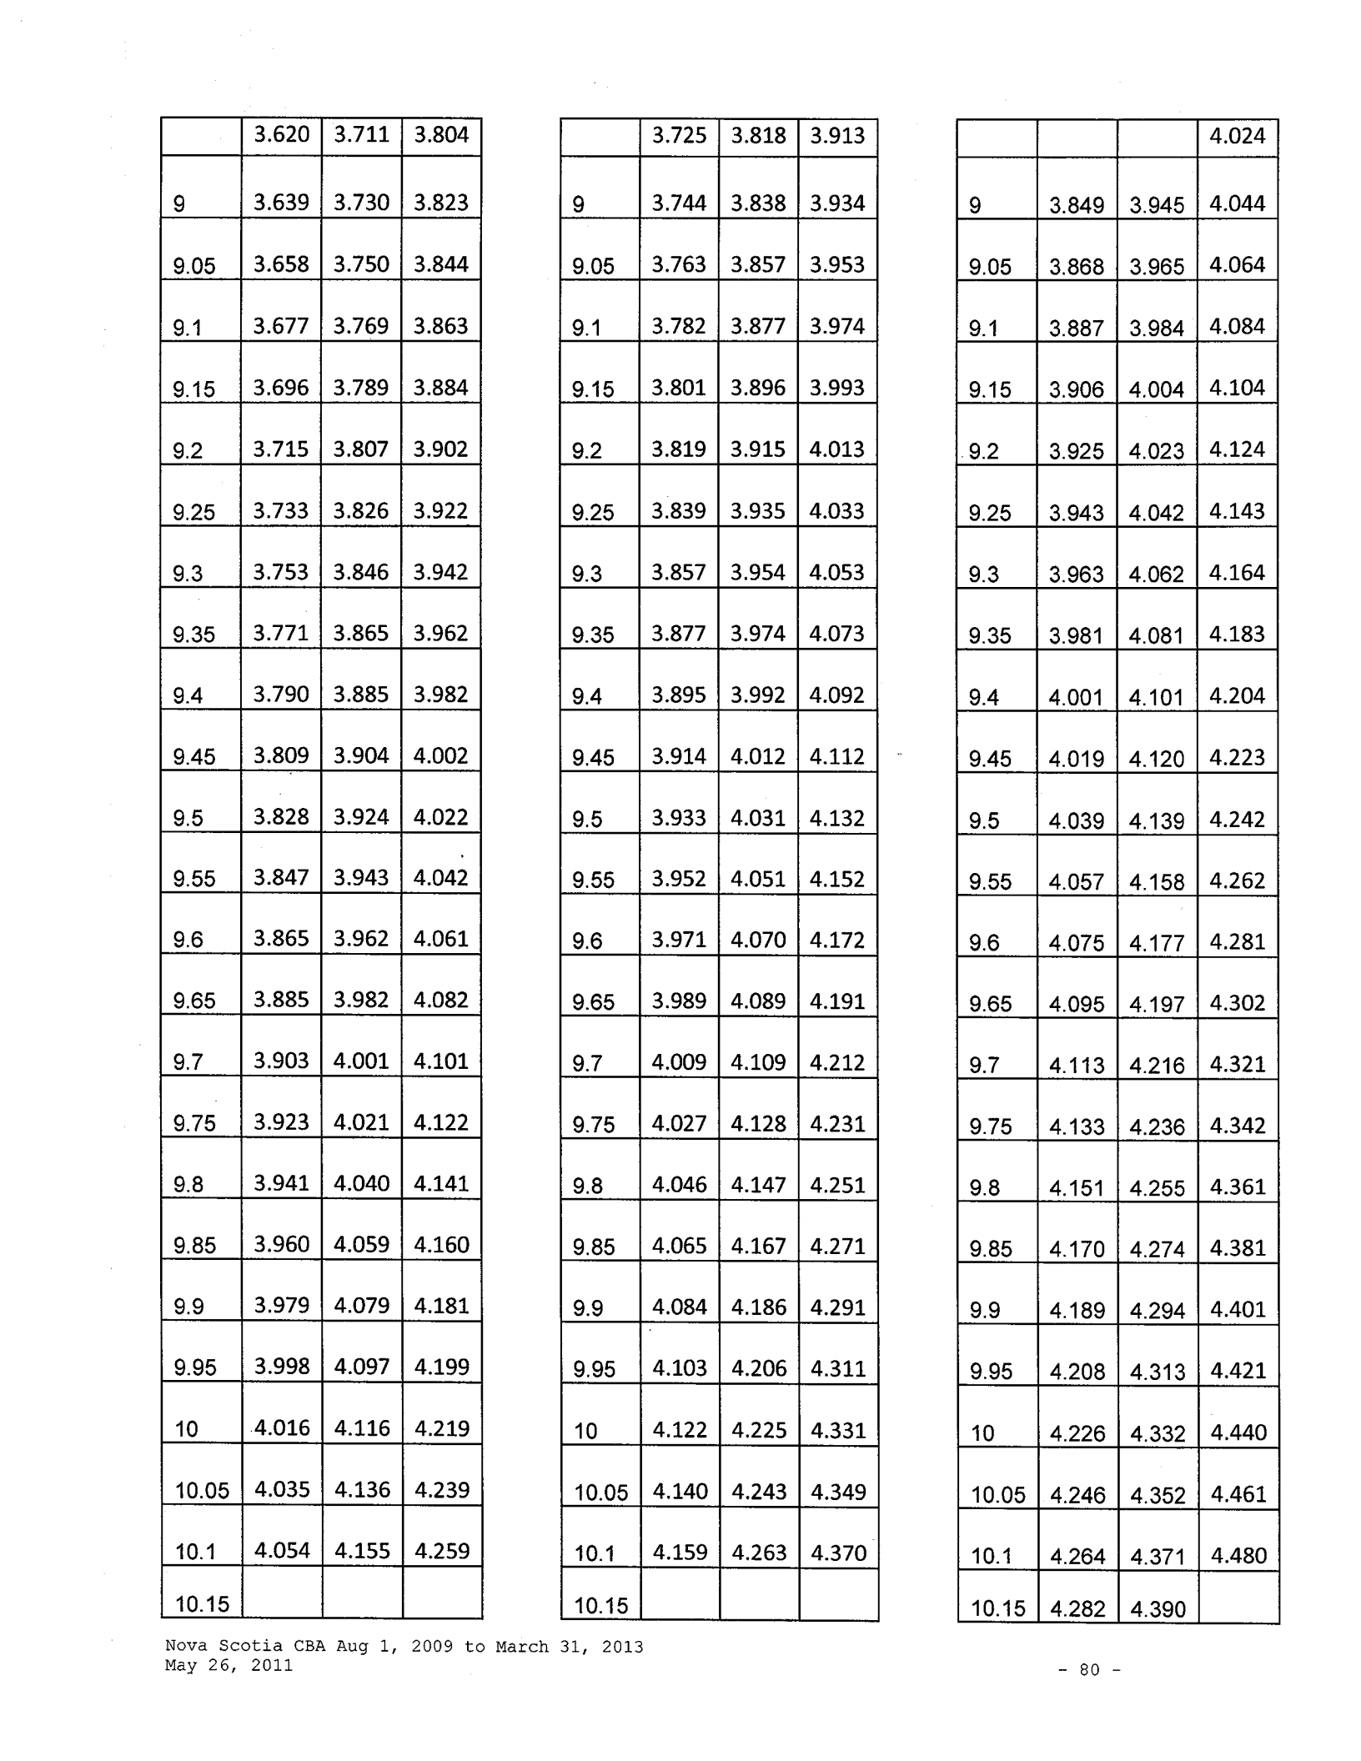

 |  |  | 4.024
9 | 3.849 | 3.945 | 4.044
9.05 | 3.868 | 3.965 | 4.064
9.1 | 3.887 | 3.984 | 4.084
9.15 | 3.906 | 4.004 | 4.104
9.2 | 3.925 | 4.023 | 4.124
9.25 | 3.943 | 4.042 | 4.143
9.3 | 3.963 | 4.062 | 4.164
9.35 | 3.981 | 4.081 | 4.183
9.4 | 4.001 | 4.101 | 4.204
9.45 | 4.019 | 4.120 | 4.223
9.5 | 4.039 | 4.139 | 4.242
9.55 | 4.057 | 4.158 | 4.262
9.6 | 4.075 | 4.177 | 4.281
9.65 | 4.095 | 4.197 | 4.302
9.7 | 4.113 | 4.216 | 4.321
9.75 | 4.133 | 4.236 | 4.342
9.8 | 4.151 | 4.255 | 4.361
9.85 | 4.170 | 4.274 | 4.381
9.9 | 4.189 | 4.294 | 4.401
9.95 |  |  | 4.421
9.95 | 4.208 | 4.313 | 4.421

- 4.226 4.332 4.440

- 05 4.246 4.352 4.461

10.1 4.264 4.371 4.480

10.15 4.282 4.390

Nova Scotia CBA Aug 1, 2009 to March 31, 2013 May 26, 2011

- 80 -

 |  |  | 4.072 |  | 4.174 |  |  | 4.278
 |  | 10.2 | 4.092 |  | 4.194 |  |  | 4.299
 |  | 10.25 | 4.110 |  | 4.213 |  |  | 4.318
 |  | 10.3 | 4.129 |  | 4.232 |  |  | 4.338
 |  | 10.35 | 4.147 |  | 4.251 |  |  | 4.357
 |  | 10.4 | 4.167 |  | 4.271 |  |  | 4.378
 |  | 10.45 | 4.185 |  | 4.290 |  |  | 4.397
 |  | 10.5 | 4.204 |  | 4.309 |  |  | 4.417
 |  | 10.55 | 4.222 |  | 4.328 |  |  | 4.436
 |  | 10.6 | 4.240 |  | 4.346 |  |  | 4.455
 |  | 10.65 | 4.260 |  | 4.366 |  |  | 4.475
 |  | 10.7 | 4.278 |  | 4.385 |  |  | 4.495
 |  | 10.75 | 4.297 |  | 4.404 |  |  | 4.514
 |  | 10.8 | 4.315 |  | 4.423 |  |  | 4.534
 |  | 10.85 | 4.334 |  | 4.442 |  |  | 4.553
 |  | 10.9 | 4.352 |  | 4.461 |  |  | 4.573
 |  | 10.95 | 4.371 |  | 4.480 |  |  | 4.592
 |  | 11 | 4.389 |  | 4.499 |  |  | 4.611
 |  | 11.05 | 4.408 |  | 4.518 |  |  | 4.631
 |  | 11.1 | 4.426 |  | 4.537 |  |  | 4.650
 |  | 11.15 | 4.444 |  | 4.556 |  |  | 4.670
 |  | 11.2 | 4.463 |  | 4.574 |  |  | 4.688
 |  | 11.25 | 4.481 |  | 4.593 |  |  | 4.708
 |  | 11.3 | 4.500 |  | 4.612 |  |  | 4.727
 |  | 11.35

 |  |  |  | 4.178 |  | 4.282 |  | 4.389
 |  | 10.2 |  | 4.196 |  | 4.301 |  | 4.409
 |  | 10.25 |  | 4.215 |  | 4.320 |  | 4.428
 |  | 10.3 |  | 4.234 |  | 4.340 |  | 4.449
 |  | 10.35 |  | 4.253 |  | 4.359 |  | 4.468
 |  | 10.4 |  | 4.271 |  | 4.378 |  | 4.487
 |  | 10.45 |  | 4.290 |  | 4.397 |  | 4.507
 |  | 10.5 |  | 4.309 |  | 4.417 |  | 4.527
 |  | 10.55 |  | 4.328 |  | 4.436 |  | 4.547
 |  | 10.6 |  | 4.346 |  | 4.455 |  | 4.566
 |  | 10.65 |  | 4.364 |  | 4.474 |  | 4.586
 |  | 10.7 |  | 4.383 |  | 4.492 |  | 4.604
 |  | 10.75 |  | 4.401 |  | 4.511 |  | 4.624
 |  | 10.8 |  | 4.420 |  | 4.530 |  | 4.643
 |  | 10.85 |  | 4.438 |  | 4.549 |  | 4.663
 |  | 10.9 |  | 4.457 |  | 4.568 |  | 4.682
 |  | 10.95 |  | 4.475 |  | 4.587 |  | 4.702
 |  | 11 |  | 4.494 |  | 4.606 |  | 4.721
 |  | 11.05 |  | 4.512 |  | 4.625 |  | 4.741
 |  | 11.1 |  | 4.531 |  | 4.644 |  | 4.760
 |  | 11.15 |  | 4.549 |  | 4.663 |  | 4.780
 |  | 11.2 |  | 4.567 |  | 4.682 |  | 4.799
 |  |  | " | 4.586 |  | 4.700 |  | 4.818
 |  | 11.3 |  | 4.604 |  | 4.719 |  | 4.837
 |  | 11.35
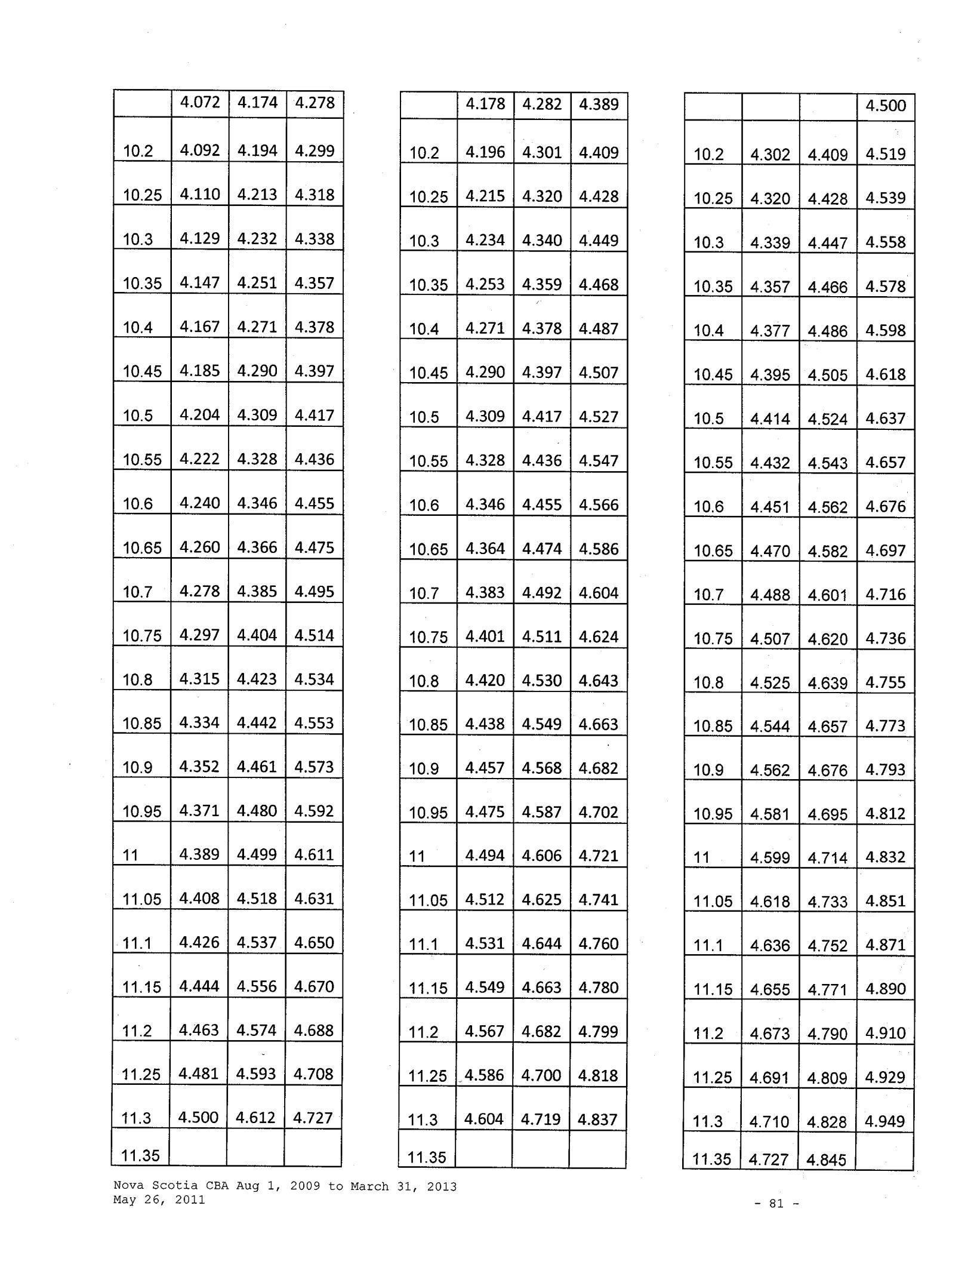

 |  |  |  |  |  |  | 4.500
 | 10.2 | 4.302 |  | 4.409 |  |  | 4.519
 | 10.25 | 4.320 |  | 4.428 |  |  | 4.539
 | 10.3 | 4.339 |  | 4.447 |  |  | 4.558
 | 10.35 | 4.357 |  | 4.466 |  |  | 4.578
 | 10.4 | 4.377 |  | 4.486 |  |  | 4.598
 |  |  |  |  |  |  | 4.618
 | 10.45 | 4.395 |  | 4.505 |  |  | 4.618
 | 10.5 | 4.414 |  | 4.524 |  |  | 4.637
 | 10.55 | 4.432 |  | 4.543 |  |  | 4.657
 | 10.6 | 4.451 |  | 4.562 |  |  | 4.676
 | 10.65 | 4.470 |  | 4.582 |  |  | 4.697
 | 10.7 | 4.488 |  | 4.601 |  |  | 4.716
 | 10.75 | 4.507 |  | 4.620 |  |  | 4.736
 | 10.8 | 4.525 |  | 4.639 |  |  | 4.755
 | 10.85 | 4.544 |  | 4.657 |  |  | 4.773
 | 10.9 | 4.562 |  | 4.676 |  |  | 4.793
 | 10.95 | 4.581 |  | 4.695 |  |  | 4.812
 | 11 | 4.599 |  | 4.714 |  |  | 4.832
 | 11.05 | 4.618 |  | 4.733 |  |  | 4.851
 | 11.1 | 4.636 |  | 4.752 |  |  | 4.871
 | 11.15 | 4.655 |  | 4.771 |  |  | 4.890
 | 11.2 | 4.673 |  | 4.790 |  |  | 4.910
 | 11.25 | 4.691 |  | 4.809 |  |  | 4.929
 | 11.3 | 4.710 |  | 4.828 |  |  | 4.949
 | 11.35 | 4.727 |  | 4.845

Nova Scotia CBA Aug 1, 2009 to March 31, 2013 May 26, 2011

- 81 -

 |  | 4.517 | 4.630 | 4.746
 | 11.4 | 4.536 | 4.649 | 4.765
 | 11.45 | 4.554 | 4.668 | 4.785
 | 11.5 | 4.573 | 4.687 | 4.804
 | 11.55 | 4.590 | 4.705 | 4.823
 | 11.6 | 4.608 | 4.724 | 4.842
 | 11.65 | 4.627 | 4.743 | 4.862
 | 11.7 | 4.644 | 4.760 | 4.879
 | 11.75 | 4.663 | 4.779 | 4.898
 | 11.8 | 4.681 | 4.798 | 4.918
 | 11.85 | 4.699 | 4.816 | 4.936
 | 11.9 | 4.717 | 4.835 | 4.956
 | 11.95 | 4.734 | 4.853 | 4.974
 | 12 | 4.753 | 4.872 | 4.994
 | 12.05 | 4.770 | 4.890 | 5.012
 | 12.1 | 4.788 | 4.907 | 5.030
 | 12.15 | 4.806 | 4.926 | 5.049
 | 12.2 | 4.824 | 4.944 | 5.068
 | 12.25 | 4.841 | 4.962 | 5.086
 | 12.3 | 4.860 | 4.981 | 5.106
 | 12.35 | 4.877 | 4.999 | 5.124
 |  | '
 | 12.4 | 4.894 | 5.017 | 5.142
 | 12.45 | 4.912 | 5.035 | 5.161
 | 12.5 | 4.929 | 5.052 | 5.178
 | 12.55

 | 4.623 |  | 4.738 |  | 4.856
11.4 | 4.641 |  | 4.757 |  | 4.876
11.45 |  |  | 4.775 |  | 4.894
11.45 | 4.659 |  | 4.775
11.5 | 4.677 |  | 4.794 |  | 4.914
11.55 | 4.696 |  | 4.813 |  | 4.933
11.6 | 4.714 |  | 4.832 |  | 4.953
11.65 | 4.731 |  | 4.850 |  | 4.971
11.7 | 4.750 |  | 4.869 |  | 4.991
11.75 | 4.768 |  | 4.888 |  | 5.010
11.8 | 4.786 |  | 4.905 |  | 5.028
11.85 | 4.804 |  | 4.924 |  | 5.047
11.9 | 4.822 |  | 4.942 |  | 5.066
11.95 | 4.840 |  | 4.961 |  | 5.085
12 | 4.857 |  | 4.979 |  | 5.103
12.05 | 4.876 |  | 4.998 |  | 5.123
12.1 | 4.893 |  | 5.01fl |  | 5.141
 |  |  | '
12.15 | 4.911 |  | 5.034 |  | 5.160
12.2 | 4.929 |  | 5.052 |  | 5.178
12.25 | 4.947 |  | 5.070 |  | 5.197
12.3 | 4.964 |  | 5.088 |  | 5.215
12.35 | 4.982 |  | 5.106 |  | 5.234
12.4 | 5.000 |  | 5.125 |  | 5.253
12.45 | 5.017 |  | 5.143 |  | 5.272
12.5 | 5.035 |  | 5.161 |  | 5.290
12.55
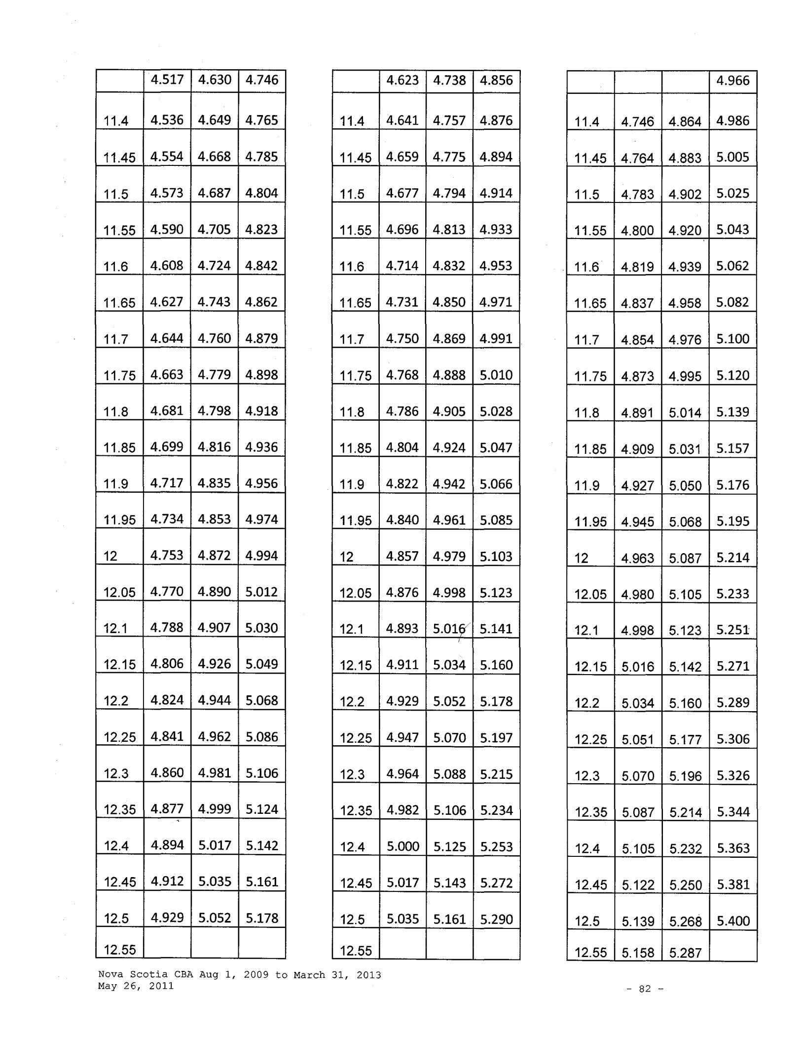

 |  |  |  | 4.966
 | 11.4 | 4.746 | 4.864 | 4.986
 | 11.45 | 4.764 | 4.883 | 5.005
 | 11.5 | 4.783 | 4.902 | 5.025
 | 11.55 | 4.800 | 4.920 | 5.043
 | 11.6 | 4.819 | 4.939 | 5.062
 | 11.65 | 4.837 | 4.958 | 5.082
 | 11.7 | 4.854 | 4.976
 | 11.7 | 4.854 | 4.976 | 5.100
 | 11.75 | 4.873 | 4.995 | 5.120
 | 11.8 | 4.891 | 5.014 | 5.139
 | 11.85 | 4.909 | 5.031 | 5.157
 | 11.9 | 4.927 | 5.050 | 5.176
 | 11.95 | 4.945 | 5.068 | 5.195
 | 12 | 4.963 | 5.087 | 5.214
 | 12.05 | 4.980 | 5.105 | 5.233
 | 12.1 | 4.998 | 5.123 | 5.251
 | 12.15 | 5.016 | 5.142 | 5.271
 | 12.2 | 5.034 | 5.160 | 5.289
 | 12.25 | 5.051 | 5.177 | 5.306
 | 12.3 | 5.070 | 5.196 | 5.326
 | 12.35 | 5.087 | 5.214 | 5.344
 | 12.4 | 5.105 | 5.232 | 5.363
 | 12.45 | 5.122 | 5.250 | 5.381
 | 12.5 | 5.139 | 5.268 | 5.400
 | 12.55 | 5.158 | 5.287

Nova Scotia CBA Aug 1, 2009 to March 31, 2013 May 26, 2011

- 82 -

 |  |  | 4.948 | 5.071 | 5.198
 |  | 12.6 | 4.965 | 5.089 | 5.216
 |  | 12.65 | 4.983 | 5.107 | 5.235
 |  | 12.7 | 5.000 | 5.125 | 5.253
 |  | 12.75 | 5.017 | 5.143 | 5.272
 |  | 12.8 | 5.034 | 5.160 | 5.289
 |  | 12.85 | 5.051 | 5.177 | 5.306
 |  | 12.9 | 5.069 | 5.195 | 5.325
 |  | 12.95 | 5.086 | 5.213 | 5.343
 |  | 13 | 5.103 | 5.231 | 5.362
 |  | 13.05 | 5.120 | 5.248 | 5.379
 |  | 13.1 | 5.137 | 5.266 | 5.398
 |  | 13.15 | 5.155 | 5.284 | 5.416
 |  | 13.2 | 5.171 | 5.300 | 5.433
 |  | 13.25 | 5.189 | 5.318 | 5.451
 |  | 13.3 | 5.205 | 5.335 | 5.468
 |  | 13.35 | 5.222 | 5.353 | 5.487
 |  | 13.4 | 5.239 | 5.370 | 5.504
 |  | 13.45 | 5.256 | 5.388 | 5.523
 |  | 13.5 | 5.273 | 5.404 | 5.539
 |  | 13.55 | 5.289 | 5.421 | 5.557
 | 13.6 |  | 5.306 | 5.439 | 5.575
 | 13.65 |  | 5.323 | 5.456 | 5.592
 | 13.7 |  | 5.339 | 5.473 | 5.610
 | 13.75

 |  | 5.052 |  |  | 5.179 |  | 5.308
12.6 |  | 5.070 |  |  | 5.196 |  | 5.326
12.65 |  | 5.087 |  |  | 5.214 |  | 5.344
12.7 |  | 5.105 |  |  | 5.232 |  | 5.363
12.75 |  | 5.122 |  |  | 5.250 |  | 5.381
12.8 |  | 5.139 |  |  | 5.268 |  | 5.400
12.85 |  |  | 5.157 |  | 5.286 |  | 5.418
12.9 |  |  | 5.174 |  | 5.304 |  | 5.437
12.95 |  |  | 5.191 |  | 5.320 |  | 5.453
13 |  |  | 5.208 |  | 5.338 |  | 5.471
13.05 |  |  | 5.225 |  | 5.356 |  | 5.490
13.1 |  |  | 5.243 |  | 5.374 |  | 5.508
13.15 |  |  | 5.259 |  | 5.391 |  | 5.526
13.2 |  |  | 5.277 |  | 5.409 |  | 5.544
13.25 |  |  | 5.293 |  | 5.425 |  | 5.561
13.3 |  |  | 5.311 |  | 5.443 |  | 5.579
13.35 |  |  | 5.327 |  | 5.460 |  | 5.597
13.4 |  |  | 5.344 |  | 5.478 |  | 5.615
13.45 |  |  | 5.361 |  | 5.495 |  | 5.632
13.5 |  |  | 5.378 |  | 5.513 |  | 5.651
13.55 |  |  | 5.395 |  | 5.529 |  | 5.667
13.6 |  | 5.411 |  |  | 5.546 |  | 5.685
13.65 |  |  |  |  | 5.563 |  | 5.702
13.65 |  | 5.427 |  |  |  |  | 5.702
13.7 |  | 5.445 |  |  | 5.581 |  | 5.721
13.75
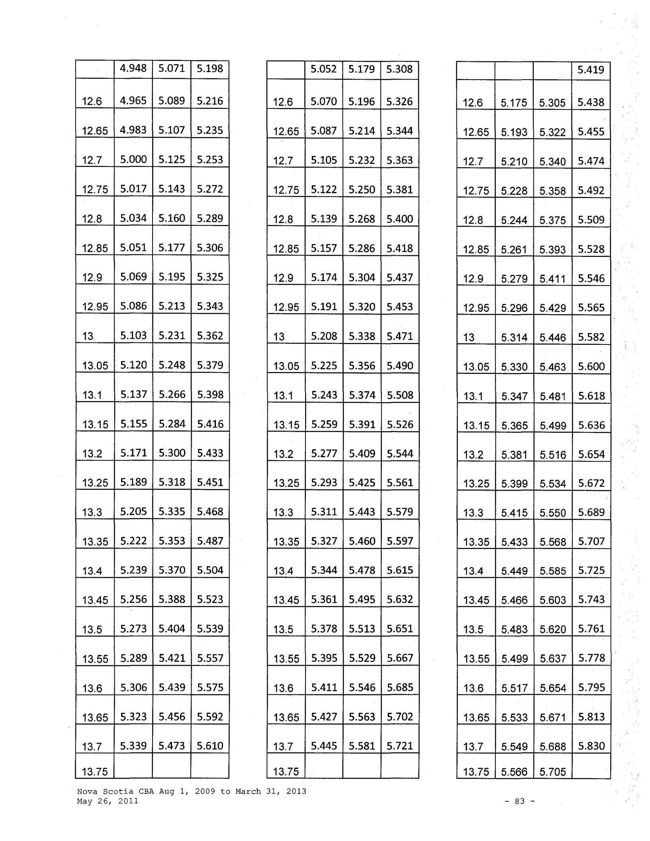

 |  |  |  |  | 5.419
 |  | 12.6 | 5.175 | 5.305 | 5.438
 |  | 12.65 | 5.193 | 5.322 | 5.455
 |  | 12.7 | 5.210 | 5.340 | 5.474
 |  | 12.75 | 5.228 | 5.358 | 5.492
 |  | 12.8 | 5.244 | 5.375 | 5.509
 |  | 12.85 | 5.261 | 5.393 | 5.528
 |  | 12.9 | 5.279 | 5.411 | 5.546
 |  | 12.95 | 5.296 | 5.429 | 5.565
 |  | 13 | 5.314 | 5.446 | 5.582
 |  | 13.05 | 5.330 | 5.463 | 5.600
 |  | 13.1 | 5.347 | 5.481 | 5.618
 |  | 13.15 | 5.365 | 5.499 | 5.636
 |  | 13.2 | 5.381 | 5.516 | 5.654
 |  | 13.25 | 5.399 | 5.534 | 5.672
 |  | 13.3 | 5.415 | 5.550 | 5.689
 |  | 13.35 | 5.433 | 5.568 | 5.707
 |  | 13.4 | 5.449 | 5.585 | 5.725
 |  | 13.45 | 5.466 | 5.603 | 5.743
 |  | 13.5 | 5.483 | 5.620 | 5.761
 |  | 13.55 | 5.499 | 5.637 | 5.778
 |  | 13.6 | 5.517 | 5.654 | 5.795
 | 13.65 |  | 5.533 | 5.671 | 5.813
 |  | 13.7 | 5.549 | 5.688 | 5.830
 |  | 13.75 | 5.566 | 5.705

Nova Scotia CBA Aug 1, 2009 to March 31, 2013 May 26, 2011

- 83 -

 | 5.356 | 5.490 | 5.627
13.8 | 5.372 | 5.506 | 5.644
13.85 | 5.388 | 5.523 | 5.661
13.9 | 5.405 | 5.540 | 5.679
13.95 | 5.421 | 5.557 | 5.696
14 | 5.438 | 5.574 | 5.713
14.05 | 5.454 | 5.590 | 5.730
14.1 | 5.470 | 5.607 | 5.747
14.15 | 5.487 | 5.624 | 5.765
14.2 | 5.503 | 5.641 | 5.782
14.25 | 5.519 | 5.657 | 5.798
14.3 | 5.535 | 5.673 | 5.815
14.35 | 5.551 | 5.690 | 5.832
14.4 | 5.567 | 5.706 | 5.849
14.45 | 5.583 | 5.723 | 5.866
14.5 | 5.599 | 5.739 | 5.882
14.55 | 5.615 | 5.755 | 5.899
14.6 | 5.630 | 5.771 | 5.915
14.65 | 5.646 | 5.787 | 5.932
14.7 | 5.662 | 5.804 | 5.949
14.75 | 5.677 | 5.819 | 5.964
14.8 | 5.693 | 5.835 | 5.981
14.85 | 5.708 | 5.851 | 5.997
14.9 | 5.724 | 5.867 | 6.014
14.95

 |  | 5.461 |  | 5.598 |  | 5.738
 | 13.8 | 5.478 |  | 5.615 |  | 5.755
 | 13.85 | 5.494 |  | 5.631 |  | 5.772
 | 13.9 | 5.510 |  | 5.648 |  | 5.789
 | 13.95 | 5.527 |  | 5.665 |  | 5.807
 | 14 | 5.543 |  | 5.682 |  | 5.824
 | 14.05 | 5.560 |  | 5.699 |  | 5.841
 | 14.1 | 5.576 |  | 5.715 |  | 5.858
 | 14.15 | 5.591 |  | 5.731 |  | 5.874
 | 14.2 | 5.608 |  | 5.748 |  | 5.892
 | 14.25 | 5.624 |  | 5.765 |  | 5.909
 | 14.3 | 5.640 |  | 5.781 |  | 5.926
 | 14.35 | 5.656 |  | 5.797 |  | 5.942
 | 14.4 | 5.672 |  | 5.814 |  | 5.959
 | 14.45 | 5.688 |  | 5.830 |  | 5.976
 | 14.5 | 5.704 |  | 5.847 |  | 5.993
 | 14.55 | 5.720 |  | 5.862 |  | 6.009
 | 14.6 | 5.735 |  | 5.878 |  | 6.025
 | 14.65 | 5.751 |  | 5.895 |  | 6.042
 | 14.7 | 5.767 |  | 5.911 |  | 6.059
 | 14.75 | 5.782 |  | '5.927 |  | 6.075
 | 14.8 | 5.798 |  | 5.943 |  | 6.092
 | 14.85 | 5.814 |  | 5.959 |  | 6.108
 | 14.9 | 5.829 |  | 5.975 |  | 6.124
 | 14.95
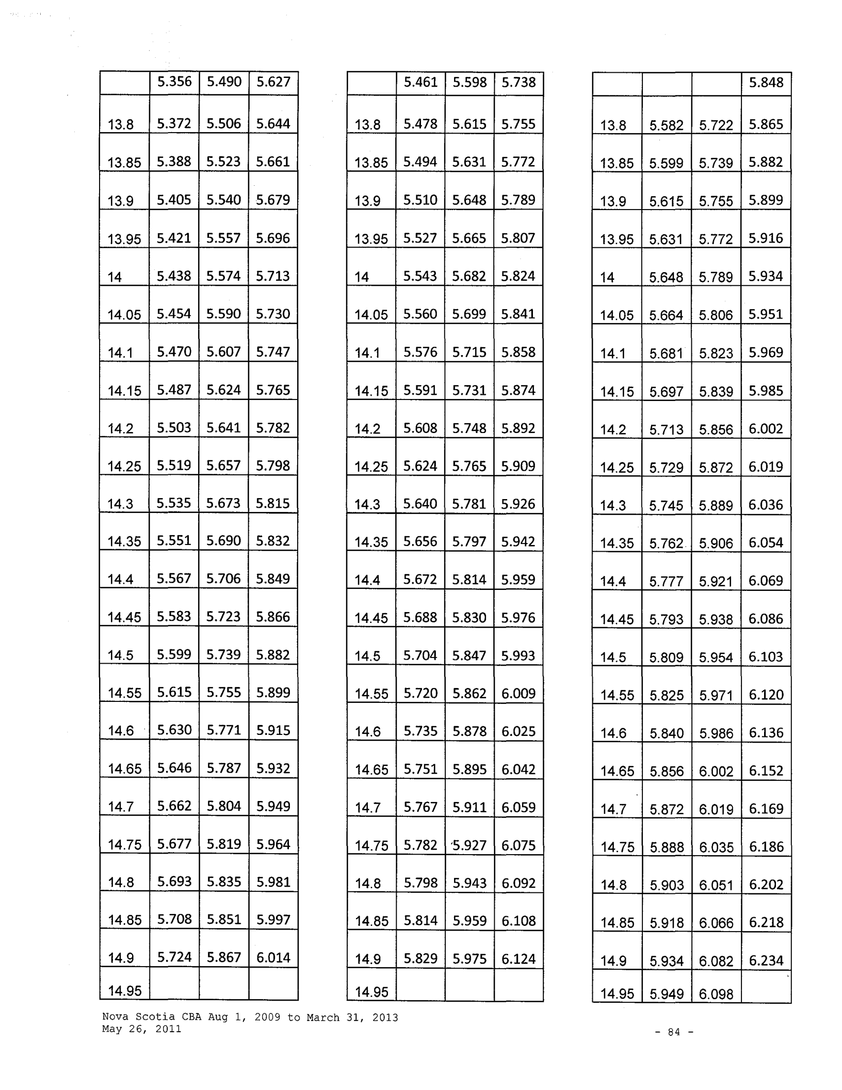

 |  |  |  |  |  | 5.848
 | 13.8 | 5.582 |  | 5.722 |  | 5.865
 | 13.85 | 5.599 |  | 5.739 |  | 5.882
 | 13.9 | 5.615 |  | 5.755 |  | 5.899
 | 13.95 | 5.631 |  | 5.772 |  | 5.916
 | 14 | 5.648 |  | 5.789 |  | 5.934
 | 14.05 | 5.664 |  | 5.806 |  | 5.951
 | 14.1 | 5.681 |  | 5.823 |  | 5.969
 | 14.15 | 5.697 |  | 5.839 |  | 5.985
 | 14.2 | 5.713 |  | 5.856 |  | 6.002
 | 14.25 | 5.729 |  | 5.872 |  | 6.019
 | 14.3 | 5.745 |  | 5.889 |  | 6.036
 | 14.35 | 5.762 |  | 5.906 |  | 6.054
 | 14.4 | 5.777 |  | 5.921 |  | 6.069
 | 14.45 | 5.793 |  | 5.938 |  | 6.086
 | 14.5 | 5.809 |  | 5.954 |  | 6.103
 | 14.55 | 5.825 |  | 5.971 |  | 6.120
 | 14.6 | 5.840 |  | 5.986 |  | 6.136
 | 14.65 | 5.856 |  | 6.002 |  | 6.152
 | 14.7 | 5.872 |  | 6.019 |  | 6.169
 | 14.75 | 5.888 |  | 6.035 |  | 6.186
 | 14.8 | 5.903 |  | 6.051 |  | 6.202
 | 14.85 | 5.918 |  | 6.066 |  | 6.218
 | 14.9 | 5.934 |  | 6.082 |  | 6.234
 | 14.95 | 5.949 |  | 6.098

Nova Scotia CBA Aug 1, 2009 to March 31, 2013 May 26, 2011

- 84 -

 | 5.739 | 5.882 |  | 6.029
15 | 5.754 | 5.898 |  | 6.045
15.05 | 5.770 | 5.914 |  | 6.062
15.1 | 5.785 | 5.930 |  | 6.078
15.15 | 5.800 | 5.945 |  | 6.094
15.2 | 5.816 | 5.961 |  | 6.110
15.25 | 5.831 | 5.977 |  | 6.126
15.3 | 5.847 | 5.993 |  | 6.143
15.35 | 5.861 | 6.007 |  | 6.157
15.4 | 5.876 | 6.023 |  | 6.174
15.45 | 5.891 | 6.038 |  | 6.189
15.5 | 5.906 | 6.054 |  | 6.205
15.55 | 5.920 | 6.068 |  | 6.220
15.6 | 5.936 | 6.084 |  | 6.236
15.65 | 5.950 | 6.099 |  | 6.251
15.7 | 5.966 | 6.115 |  | 6.268
15.75 | 5.980 | 6.129 |  | 6.282
15.8 | 5.994 | 6.144 |  | 6.298
15.85 | 6.009 | 6.159 |  | 6.313
15.9 | 6.024 | 6.175 |  | 6.329
15.95 | 6.038 | 6.189 |  | 6.344
16 | 6.053 | 6.204 |  | 6.359
16.05 | 6.067 | 6.219 |  | 6.374
16.1 | 6.081 | 6.233 |  | 6.389
16.15

 | 5.845 |  | 5.991 | 6.141
15 | 5.860 |  | 6.006 | 6.156
15.05 | 5.875 |  | 6.022 | 6.173
15.1 | 5.891 |  | 6.038 | 6.189
15.15 | 5.906 |  | 6.054 | 6.205
15.2 | 5.920 |  | 6.068 | 6.220
15.25 | 5.936 |  | 6.084 | 6.236
15.3 | 5.951 |  | 6.100 | 6.253
15.35 | 5.967 |  | 6.116 | 6.269
15.4 | 5.981 |  | 6.130 | 6.283
15.45 | 5.996 |  | 6.146 | 6.300
15.5 | 6.011 |  | 6.161 | 6.315
15.55 | 6.026 |  | 6.177 | 6.331
15.6 | 6.040 |  | 6.191 | 6.346
15.65 | 6.056 |  | 6.207 | 6.362
15.7 | 6.070 |  | 6.222 | 6.378
15.75 | 6.084 |  | 6.237 | 6.393
15.8 | 6.100 |  | 6.252 | 6.408
15.85 | 6.114 |  | 6.267 | 6.424
15.9 | 6.128 |  | 6.282 | 6.439
15.95 | 6.143 |  | 6.296 | 6.453
16 | 6.157 |  | 6.311 | 6.469
16.05 | 6.172 |  | 6.326 | 6.484
16.1 | 6.186 |  | 6.341 | 6.500
16.15
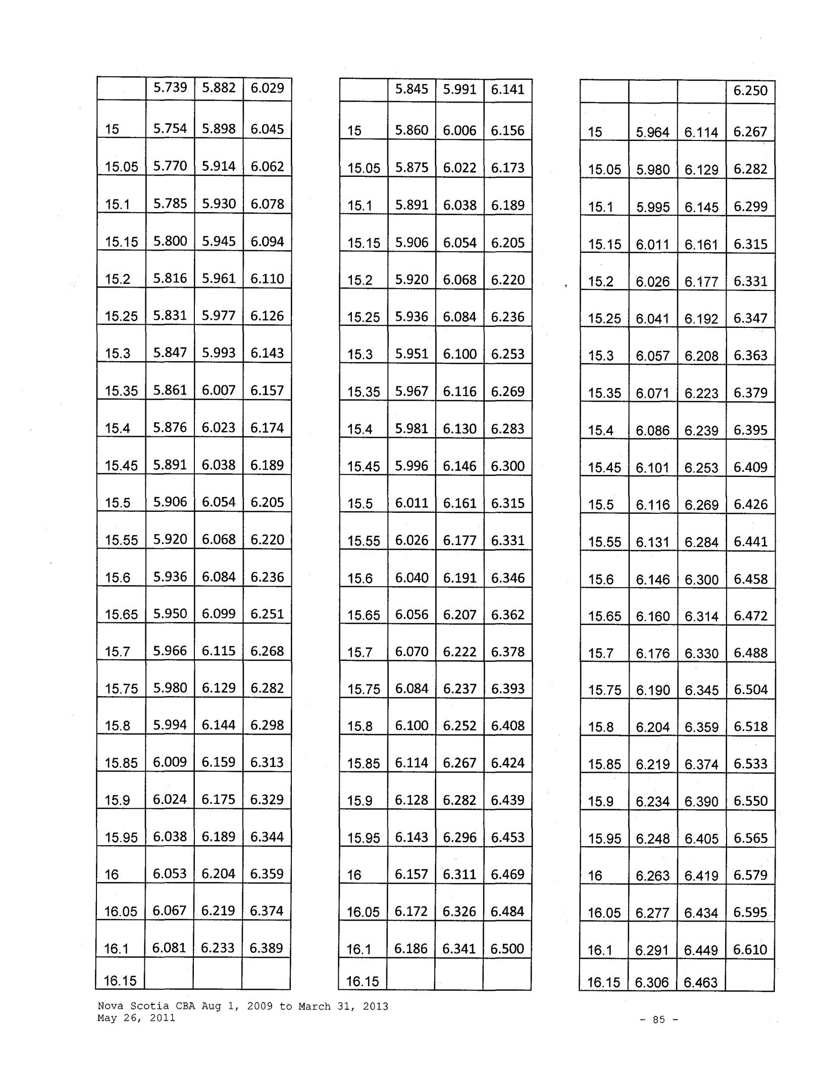

 |  |  |  | 6.250
15 | 5.964 | 6.114 |  | 6.267
15.05 | 5.980 | 6.129 |  | 6.282
15.1 | 5.995 | 6.145 |  | 6.299
15.15 | 6.011 | 6.161 |  | 6.315
15.2 | 6.026 | 6.177 |  | 6.331
15.25 | 6.041 | 6.192 |  | 6.347
15.3 | 6.057 | 6.208 |  | 6.363
15.35 | 6.071 | 6.223 |  | 6.379
15.4 | 6.086 | 6.239 |  | 6.395
15.45 | 6.101 | 6.253 |  | 6.409
15.5 | 6.116 | 6.269 |  | 6.426
15.55 | 6.131 | 6.284 |  | 6.441
15.6 | 6.146 | 6.300 |  | 6.458
15.65 | 6.160 | 6.314 |  | 6.472
15.7 | 6.176 | 6.330 |  | 6.488
15.75 | 6.190 | 6.345 |  | 6.504
15.8 | 6.204 | 6.359 |  | 6.518
15.85 | 6.219 | 6.374 |  | 6.533
15.9 | 6.234 | 6.390 |  | 6.550
15.95 | 6.248 | 6.405 |  | 6.565
16 | 6.263 | 6.419 |  | 6.579
16.05 | 6.277 | 6.434 |  | 6.595
16.1 | 6.291 | 6.449 |  | 6.610
16.15 | 6.306 | 6.463

Nova Scotia CBA Aug 1, 2009 to March 31, 2013 May 26, 2011

- 85 -

 | 6.096 | 6.248 |  | 6.404
16.2 | 6.110 | 6.263 |  | 6.420
16.25 | 6.123 | 6.276 |  | 6.433
16.3 | 6.138 | 6.291 |  | 6.448
16.35 | 6.152 | 6.306 |  | 6.464
16.4 | 6.166 | 6.321 |  | 6.479
16.45 | 6.180 | 6.334 |  | 6.492
16.5 | 6.194 | 6.349 |  | 6.508
16.55 | 6.207 | 6.363 |  | 6.522
16.6 | 6.222 | 6.377 |  | 6.536
16.65 | 6.235 | 6.391 |  | 6.551
16.7 | 6.249 | 6.406 |  | 6.566
16.75 | 6.263 | 6.419 |  | 6.579
16.8 | 6.276 | 6.433 |  | 6.594
16.85 | 6.290 | 6.448 |  | 6.609
16.9 | 6.304 | 6.461 |  | 6.623
16.95 | 6.317 | 6.475 |  | 6.637
17 | 6.330 | 6.489 |  | 6.651
17.05 | 6.344 | 6.502 |  | 6.665
17.1 | 6.357 | 6.516 |  | 6.679
17.15 | 6.370 | 6.530 |  | 6.693
17.2 | 6.384 | 6.543 |  | 6.707
17.25 | 6.397 | 6.557 |  | 6.721
17.3 | 6.410 | 6.571 |  | 6.735
17.35

 |  |  | 6.200 |  | 6.355 |  |  | 6.514
 | 16.2 |  | 6.215 |  | 6.370 |  |  | 6.529
 | 16.25 |  | 6.229 |  | 6.385 |  |  | 6.545
 | 16.3 |  |  | 6.243 | 6.399 |  |  | 6.559
 | 16.35 |  |  | 6.257 | 6.413 |  |  | 6.573
 | 16.4 |  |  | 6.271 | 6.428 |  |  | 6.589
 | 16.45 |  |  | 6.285 | 6.442 |  |  | 6.603
 | 16.5 |  |  | 6.299 | 6.456 |  |  | 6.617
 | 16.55 |  |  | 6.313 | 6.471 |  |  | 6.633
 | 16.6 |  |  | 6.326 | 6.484 |  |  | 6.646
 | 16.65 |  |  | 6.341 | 6.499 |  |  | 6.661
 | 16.7 |  |  | 6.354 | 6.513 |  |  | 6.676
 | 16.75 |  |  | 6.368 | 6.528 |  |  | 6.691
 | 16.8 |  |  | 6.382 | 6.541 |  |  | 6.705
 | 16.85 |  |  | 6.395 | 6.555 |  |  | 6.719
 | 16.9 |  | 6.408 |  | 6.569 |  |  | 6.733
 | 16.95 |  | 6.423 |  | 6.583 |  |  | 6.748
 | 17 |  | 6.436 |  | 6.597 |  |  | 6.762
 | 17.05 |  | 6.449 |  | 6.611 |  |  | 6.776
 | 17.1 |  | 6.463 |  | 6.624 |  |  | 6.790
 | 17.15 |  | 6.476 |  | 6.638 |  |  | 6.804
 | 17.2 |  | 6.489 |  | 6.652 |  |  | 6.818
 | 17.25 |  | 6.503 |  | 6.665 |  |  | 6.832
 | 17.3 |  | 6.515 |  | 6.678 |  |  | 6.845
 | 17.35
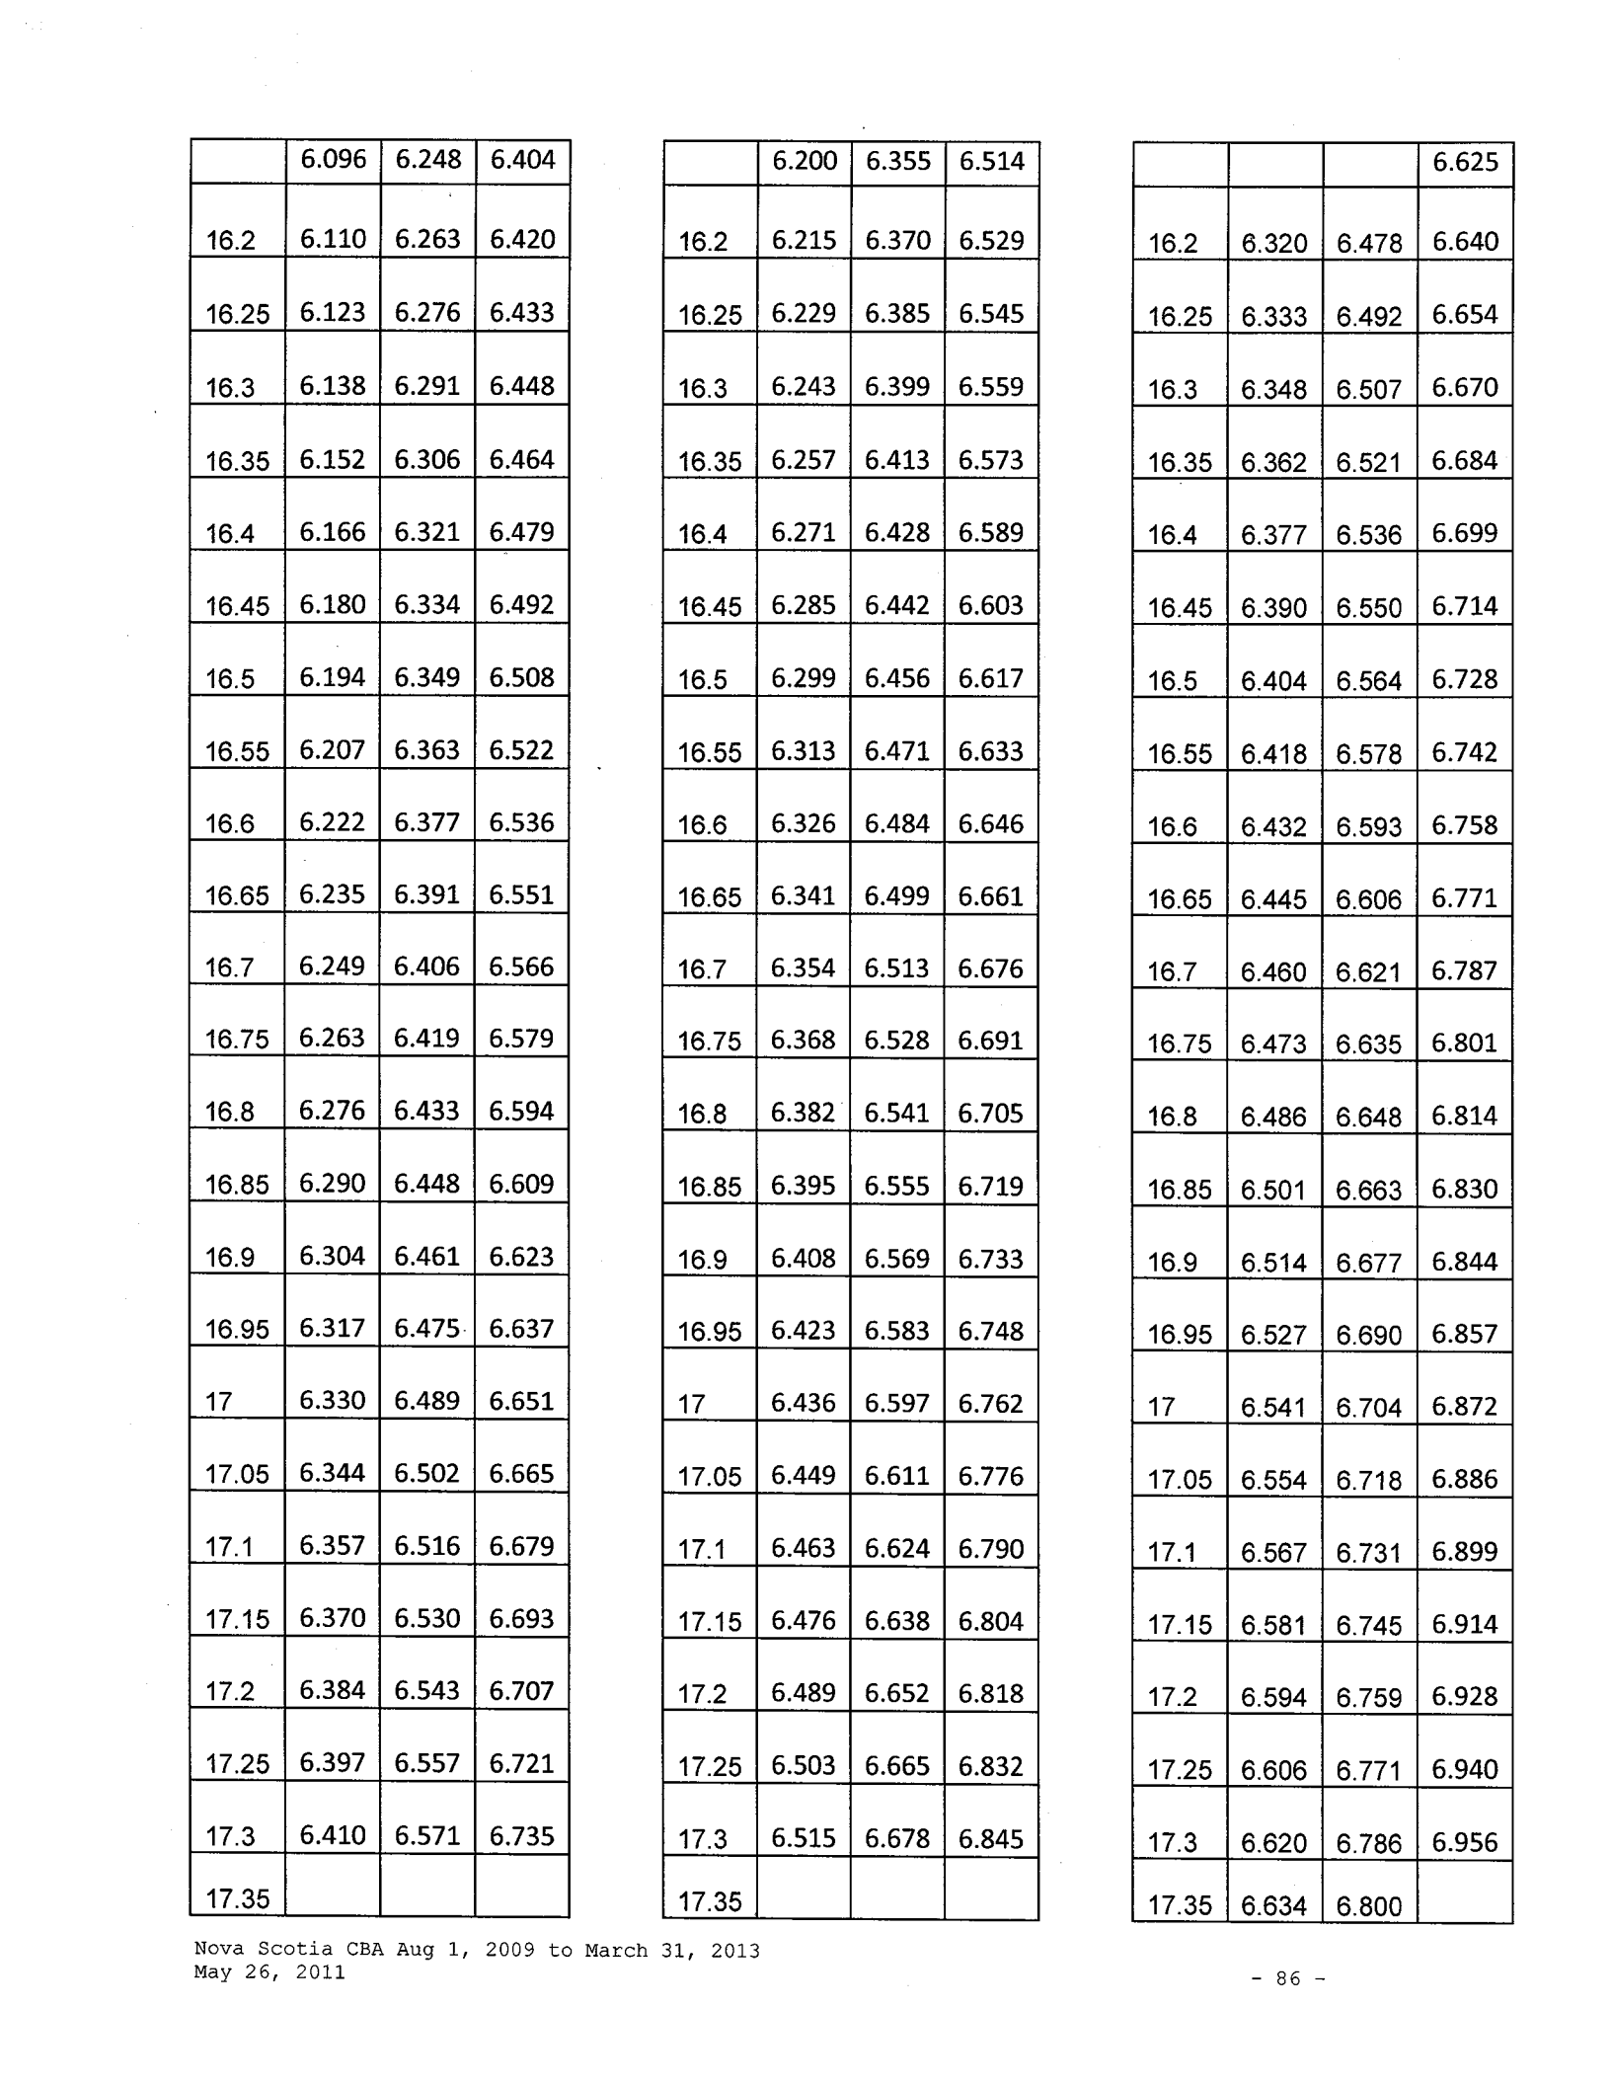

 |  |  |  | 6.625
16.2 | 6.320 | 6.478 |  | 6.640
16.25 | 6.333 | 6.492 |  | 6.654
16.3 | 6.348 | 6.507 |  | 6.670
16.35 | 6.362 | 6.521 |  | 6.684
16.4 | 6.377 | 6.536 |  | 6.699
16.45 | 6.390 | 6.550 |  | 6.714
16.5 | 6.404 | 6.564 |  | 6.728
16.55 | 6.418 | 6.578 |  | 6.742
16.6 | 6.432 | 6.593 |  | 6.758
16.65 | 6.445 | 6.606 |  | 6.771
16.7 | 6.460 | 6.621 |  | 6.787
16.75 | 6.473 | 6.635 |  | 6.801
16.8 | 6.486 | 6.648 |  | 6.814
16.85 | 6.501 | 6.663 |  | 6.830
16.9 | 6.514 | 6.677 |  | 6.844
16.95 | 6.527 | 6.690 |  | 6.857
17 | 6.541 | 6.704 |  | 6.872
17.05 | 6.554 | 6.718 |  | 6.886
17.1 | 6.567 | 6.731 |  | 6.899
17.15 | 6.581 | 6.745 |  | 6.914
17.2 | 6.594 | 6.759 |  | 6.928
17.25 | 6.606 | 6.771 |  | 6.940
17.3 | 6.620 | 6.786 |  | 6.956
17.35 | 6.634 | 6.800

Nova Scotia CBA Aug 1, 2009 to March 31, 2013 May 26, 2011

- 86 -

 | 6.424 | 6.584 |  | 6.749
17.4 | 6.436 | 6.597 |  | 6.762
17.45 | 6.449 | 6.611 |  | 6.776
17.5 | 6.463 | 6.624 |  | 6.790
17.55 | 6.475 | 6.637 |  | 6.803
17.6 | 6.488 | 6.650 |  | 6.816
17.65 | 6.501 | 6.663 |  | 6.830
17.7 | 6.514 | 6.677 |  | 6.844
17.75 | 6.526 | 6.689 |  | 6.856
17.8 | 6.540 | 6.703 |  | 6.871
17.85 | 6.552 | 6.716 |  | 6.884
17.9 | 6.564 | 6.728 |  | 6.896
17.95 | 6.576 | 6.741 |  | 6.910
18 | 6.590 | 6.754 |  | 6.923
18.05 | 6.602 | 6.767 |  | 6.936
18.1 | 6.614 | 6.780 |  | 6.950
18.15 | 6.627 | 6.792 |  | 6.962
18.2 | 6.639 | 6.805 |  | 6.975
18.25 | 6.651 | 6.818 |  | 6.988
18.3 | 6.664 | 6.830 |  | 7.001
18.35 | 6.675 | 6.842 |  | 7.013
18.4 | 6.687 | 6.854 |  | 7.025
18.45 | 6.699 | 6.867 |  | 7.039
18.5 | 6.712 | 6.879 |  | 7.051
18.55

 | 6.528 | 6.691 |  | 6.858
17.4 | 6.542 | 6.705 |  | 6.873
17.45 | 6.555 | 6.719 |  | 6.887
17.5 | 6.567 | 6.731 |  | 6.899
17.55 | 6.581 | 6.745 |  | 6.914
17.6 | 6.593 | 6.758 |  | 6.927
17.65 | 6.606 | 6.771 |  | 6.940
17.7 | 6.618 | 6.784 |  | 6.954
17.75 | 6.632 | 6.798 |  | 6.968
17.8 | 6.644 | 6.810 |  | 6.980
17.85 | 6.656 | 6.823 |  | 6.994
17.9 | 6.670 | 6.836 |  | 7.007
17.95 | 6.682 | 6.849 |  | 7.020
18 | 6.694 | 6.862 |  | 7.034
18.05 | 6.707 | 6.874 |  | 7.046
18.1 | 6.719 | 6.887 |  | 7.059
18.15 | 6.731 | 6.899 |  | 7.071
18.2 | 6.743 | 6.912 |  | 7.085
18.25 | 6.756 | 6.925 |  | 7.098
18.3 | 6.768 | 6.937 |  | 7.110
 | 6.780 | 6.950 |  | 7.124
18.35 | 6.780 | 6.950 |  | 7.124
18.4 | 6.793 | 6.962 |  | 7.136
18.45 | 6.805 | 6.975 |  | 7.149
18.5 | 6.816 | 6.987 |  | 7.162
18.55
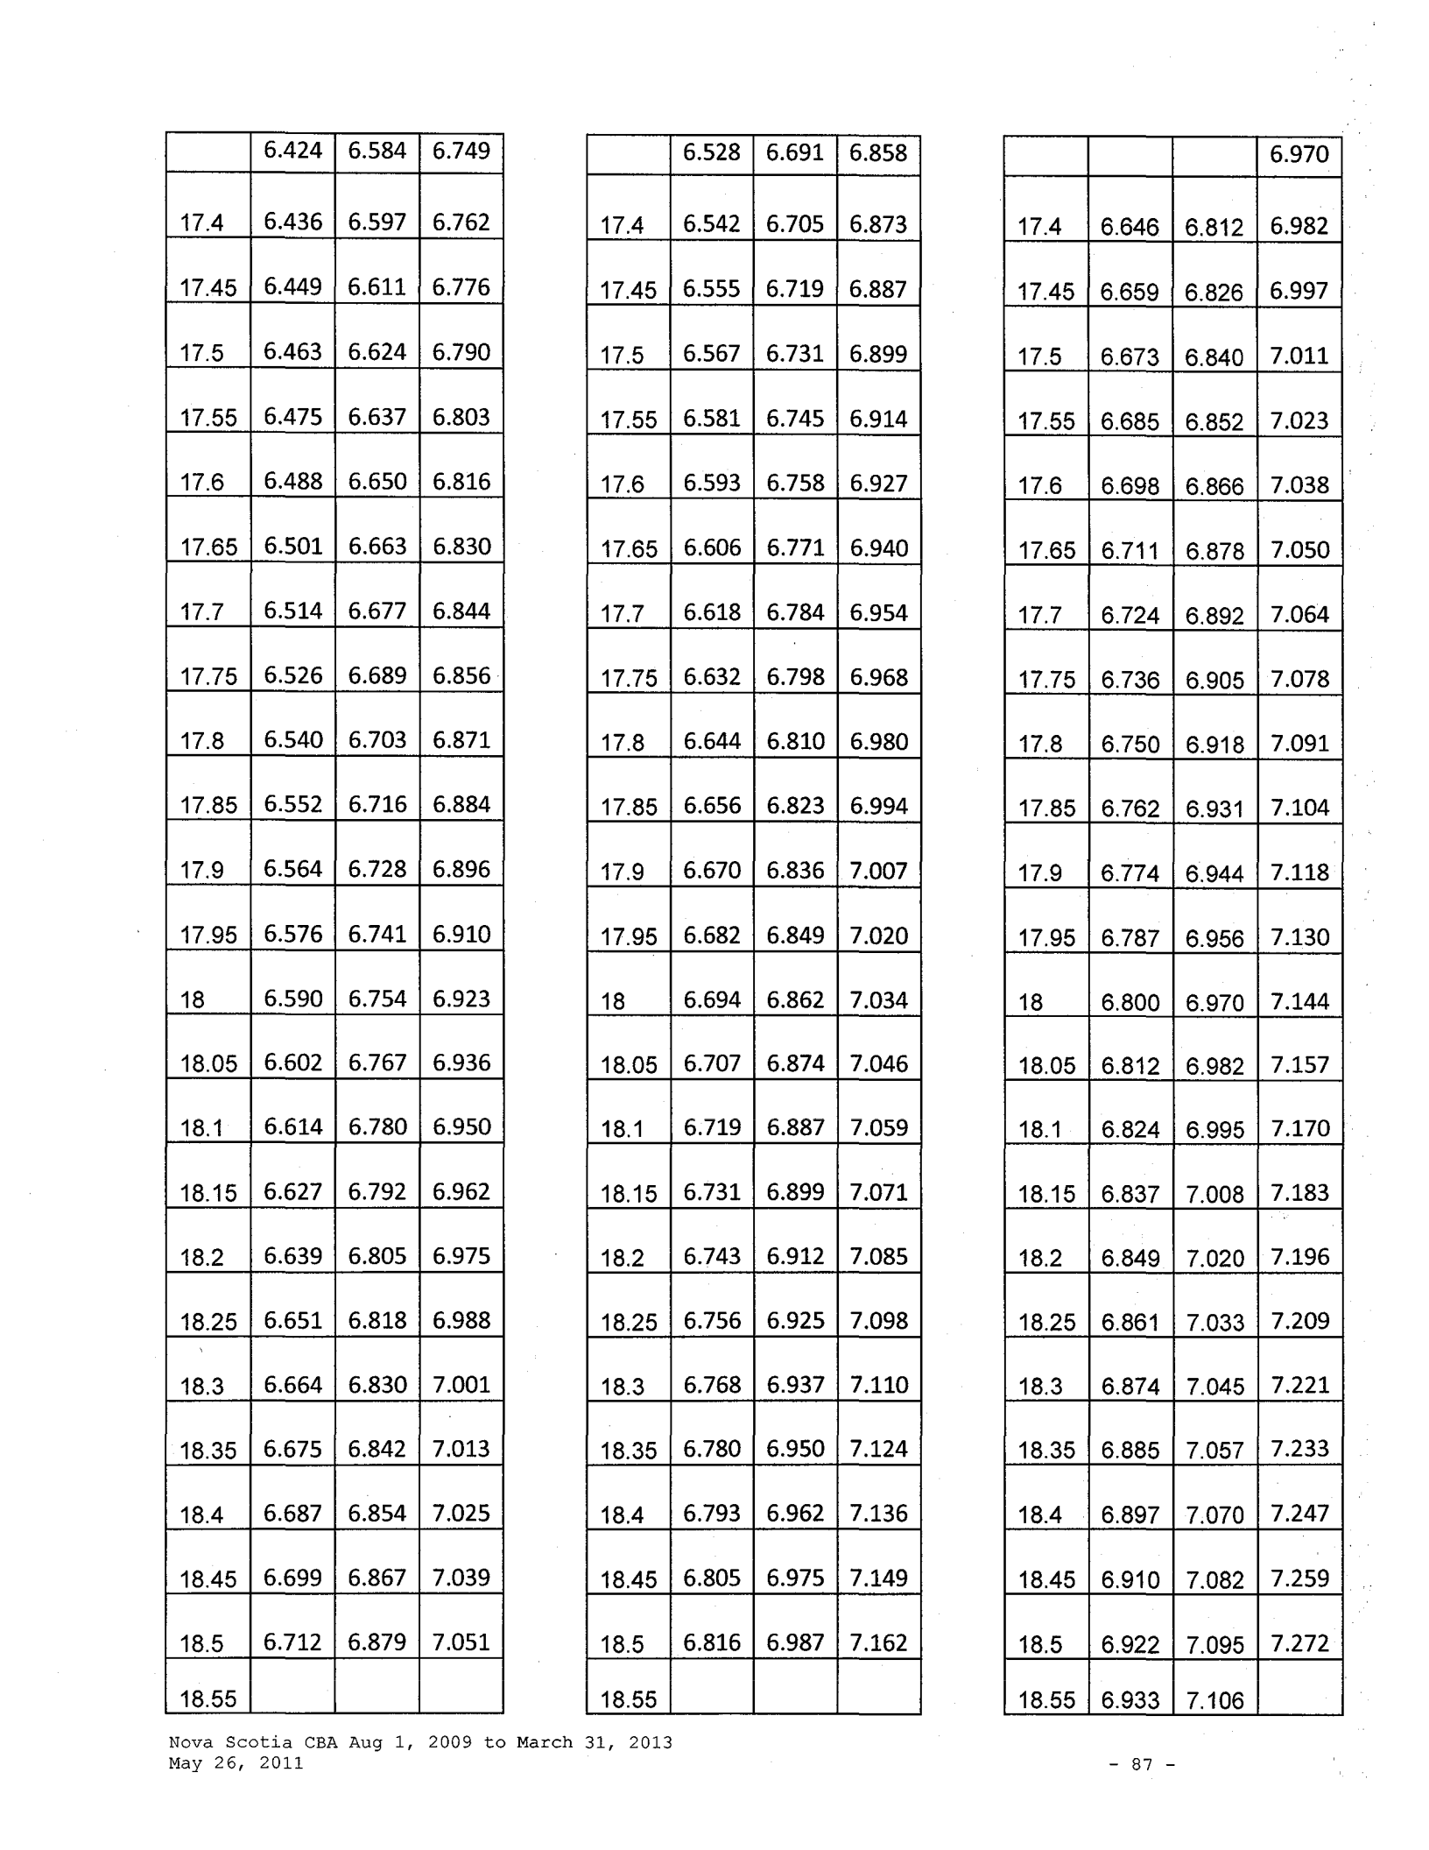

 |  |  |  |  | 6.970
 | 17.4 | 6.646 |  | 6.812 | 6.982
 | 17.45 | 6.659 |  | 6.826 | 6.997
 | 17.5 | 6.673 |  | 6.840 | 7.011
 | 17.55 | 6.685 |  | 6.852 | 7.023
 | 17.6 | 6.698 |  | 6.866 | 7.038
 | 17.65 | 6.711 |  | 6.878 | 7.050
 | 17.7 | 6.724 |  | 6.892 | 7.064
 | 17.75 | 6.736 |  | 6.905 | 7.078
 | 17.8 | 6.750 |  | 6.918 | 7.091
 | 17.85 | 6.762 |  | 6.931 | 7.104
 | 17.9 | 6.774 |  | 6.944 | 7.118
 | 17.95 | 6.787 |  | 6.956 | 7.130
 | 18 | 6.800 |  | 6.970 | 7.144
 | 18.05 | 6.812 |  | 6.982 | 7.157
 | 18.1 | 6.824 |  | 6.995 | 7.170
 | 18.15 | 6.837 |  | 7.008 | 7.183
 | 18.2 | 6.849 |  | 7.020 | 7.196
 | 18.25 | 6.861 |  | 7.033 | 7.209
 | 18.3 | 6.874 |  | 7.045 | 7.221
 | 18.35 | 6.885 |  | 7.057 | 7.233
 | 18.4 | 6.897 |  | 7.070 | 7.247
 | 18.45 | 6.910 |  | 7.082 | 7.259
 | 18.5 | 6.922 |  | 7.095 | 7.272
 | 18.55 | 6.933 |  | 7.106

Nova Scotia CBA Aug 1, 2009 to March 31, 2013 May 26, 2011

- 87 -

 |  |  |  | 6.723 | 6.891 | 7.063
18.6 |  |  |  | 6.735 | 6.904 | 7.077
18.65 |  |  |  | 6.748 | 6.916 | 7.089
18.7 |  |  |  | 6.759 | 6.928 | 7.101
18.75 |  |  |  | 6.771 | 6.940 | 7.114
18.8 |  |  |  | 6.782 | 6.952 | 7.126
18.85 |  |  |  | 6.794 | 6.964 | 7.138
18.9 |  |  |  | 6.806 | 6.976 | 7.150
18.95 |  |  |  | 6.817 | 6.988 | 7.163
19 |  |  |  | 6.829 | 6.999 | 7.174
19.05 |  |  |  | 6.841 | 7.012 | 7.187
19.1 |  |  |  | 6.852 | 7.023 | 7.199
19.15 |  |  |  | 6.863 | 7.035 | 7.211
19.2 |  |  |  | 6.875 | 7.047 | 7.223
19.25 |  |  |  | 6.886 | 7.058 | 7.234
19.3 |  |  |  | 6.897 | 7.070 | 7.247
19.35 |  |  |  | 6.909 | 7.081 | 7.258
19.4 |  |  | 6.920 |  | 7.093 | 7.270
19.45 |  |  | 6.931 |  | 7.104 | 7.282
19.5 |  |  | 6.942 |  | 7.116 | 7.294
19.55 |  |  | 6.954 |  | 7.127 | 7.305
19.6 |  |  |  | 6.964 | 7.138 | 7.316
19.65 | 6.975 |  |  |  | 7.150 | 7.329
19.7 |  |  |  |  | 7.161 | 7.340
19.7 |  |  |  | 6.986 | 7.161 | 7.340
19.75

 |  | 6.829 | 6.999 | 7.174
 | 18.6 | 6.841 | 7.012 | 7.187
 | 18.65 | 6.852 | 7.023 | 7.199
 | 18.7 | 6.864 | 7.036 | 7.212
 | 18.75 | 6.876 | 7.048 | 7.224
 | 18.8 | 6.888 | 7.060 | 7.237
 | 18.85 | 6.899 | 7.072 | 7.249
 | 18.9 | 6.911 | 7.083 | 7.260
 | 18.95 | 6.923 | 7.096 | 7.273
 | 19 | 6.934 | 7.107 | 7.285
 | 19.05 | 6.945 | 7.119 | 7.297
 | 19.1 | 6.957 | 7.131 | 7.309
 | 19.15 | 6.968 | 7.142 | 7.321
 | 19.2 | 6.980 | 7.155 | 7.334
 | 19.25 | 6.992 | 7.166 | 7.345
 | 19.3 | 7.003 | 7.178 | 7.357
 | 19.35 | 7.014 | 7.189 | 7.369
 | 19.4 | 7.025 | 7.201 | 7.381
 | 19.45 | 7.036 | 7.211 | 7.391
 | 19.5 | 7.047 | 7.223 | 7.404
 | 19.55 | 7.058 | 7.235 | 7.416
19.6 |  | 7.069 | 7.246 | 7.427
 | 19.65 | 7.081 | 7.258 | 7.439
 | 19.7 | 7.091 | 7.268 | 7.450
 | 19.75
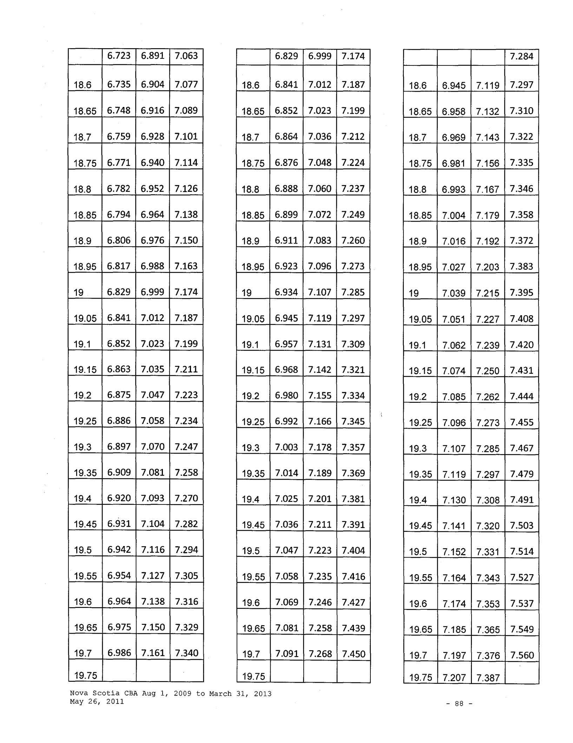

 |  |  |  |  | 7.284
 | 18.6 | 6.945 | 7.119 |  | 7.297
 | 18.65 | 6.958 | 7.132 |  | 7.310
 | 18.7 | 6.969 | 7.143 |  | 7.322
 | 18.75 | 6.981 | 7.156 |  | 7.335
 | 18.8 | 6.993 | 7.167 |  | 7.346
 | 18.85 | 7.004 | 7.179 |  | 7.358
 | 18.9 | 7.016 | 7.192 |  | 7.372
 | 18.95 | 7.027 | 7.203 |  | 7.383
 | 19 | 7.039 | 7.215 |  | 7.395
 | 19.05 | 7.051 | 7.227 |  | 7.408
 | 19.1 | 7.062 | 7.239 |  | 7.420
 | 19.15 | 7.074 | 7.250 |  | 7.431
 | 19.2 | 7.085 | 7.262 |  | 7.444
 | 19.25 | 7.096 | 7.273 |  | 7.455
 | 19.3 | 7.107 | 7.285 |  | 7.467
 | 19.35 | 7.119 | 7.297 |  | 7.479
 | 19.4 | 7.130 | 7.308 |  | 7.491
 | 19.45 | 7.141 | 7.320 |  | 7.503
 | 19.5 | 7.152 | 7.331 |  | 7.514
 | 19.55 | 7.164 | 7.343 |  | 7.527
 | 19.6 | 7.174 | 7.353 |  | 7.537
 | 19.65 | 7.185 | 7.365 |  | 7.549
 | 19.7 | 7.197 | 7.376 |  | 7.560
 | 19.75 | 7.207 | 7.387

Nova Scotia CBA Aug 1, 2009 to March 31, 2013 May 26, 2011

- 88 -

 |  | 6.997 | 7.172 | 7.351
 | 19.8 | 7.008 | 7.183 | 7.363
 | 19.85 | 7.018 | 7.194 | 7.374
 | 19.9 | 7.029 | 7.205 | 7.385
 | 19.95 | 7.040 | 7.216 | 7.396
 | 20 | 7.051 | 7.227 | 7.408
 | 20.05 | 7.061 | 7.238 | 7.419
 | 20.1 | 7.073 | 7.249 | 7.430
 | 20.15 | 7.083 | 7.260 | 7.442
 | 20.2 | 7.093 | 7.270 | 7.452
 | 20.25 | 7.103 | 7.281 | 7.463
 | 20.3 | 7.114 | 7.291 | 7.473
 | 20.35 | 7.125 | 7.303 | 7.486
 | 20.4 | 7.135 | 7.313 | 7.496
 | 20.45 | 7.145 | 7.324 | 7.507
 | 20.5 | 7.156 | 7.334 | 7.517
 | 20.55 | 7.166 | 7.345 | 7.529
 | 20.6 | 7.176 | 7.355 | 7.539
 | 20.65 | 7.186 | 7.366 | 7.550
 | 20.7 | 7.196 | 7.375 | 7.559
 | 20.75 | 7.206 | 7.386 | 7.571
 | 20.8 | 7.216 | 7.396 | 7.581
 | 20.85 | 7.226 | 7.407 | 7.592
 | 20.9 | 7.235 | 7.416 | 7.601
 | 20.95

 |  |  |  | 7.102 | 7.280 | 7.462
 | 19.8 |  |  | 7.112 | 7.290 | 7.472
 | 19.85 |  |  | 7.124 | 7.302 | 7.485
 | 19.9 |  |  | 7.134 | 7.312 | 7.495
 | 19.95 |  |  | 7.145 | 7.324 | 7.507
 | 20 |  |  | 7.156 | 7.334 | 7.517
 | 20.05 |  |  | 7.167 | 7.346 | 7.530
 | 20.1 |  |  | 7.177 | 7.356 | 7.540
 | 20.15 |  |  | 7.187 | 7.367 | 7.551
 | 20.2 |  |  | 7.199 | 7.379 | 7.563
 | 20.25 |  |  | 7.209 | 7.389 | 7.574
 | 20.3 |  |  | 7.219 | 7.400 | 7.585
 | 20.35 |  |  | 7.229 | 7.410 | 7.595
 | 20.4 |  |  | 7.240 | 7.421 | 7.607
 | 20.45 |  |  | 7.250 | 7.431 | 7.617
 | 20.5 |  |  | 7.260 | 7.442 | 7.628
 | 20.55 |  |  | 7.270 | 7.452 | 7.638
 | 20.6 |  |  | 7.281 | 7.463 | 7.650
 | 20.65 |  |  | 7.291 | 7.473 | 7.660
 | 20.7 |  |  | 7.301 | 7.484 | 7.671
 | 20.75 |  |  | 7.311 | 7.494 | 7.681
 | 20.8 |  |  | 7.322 | 7.505 | 7.693
 | 20.85 |  |  | 7.331 | 7.514 | 7.702
 | 20.9 |  |  | 7.341 | 7.525 | 7.713
 | 20.95
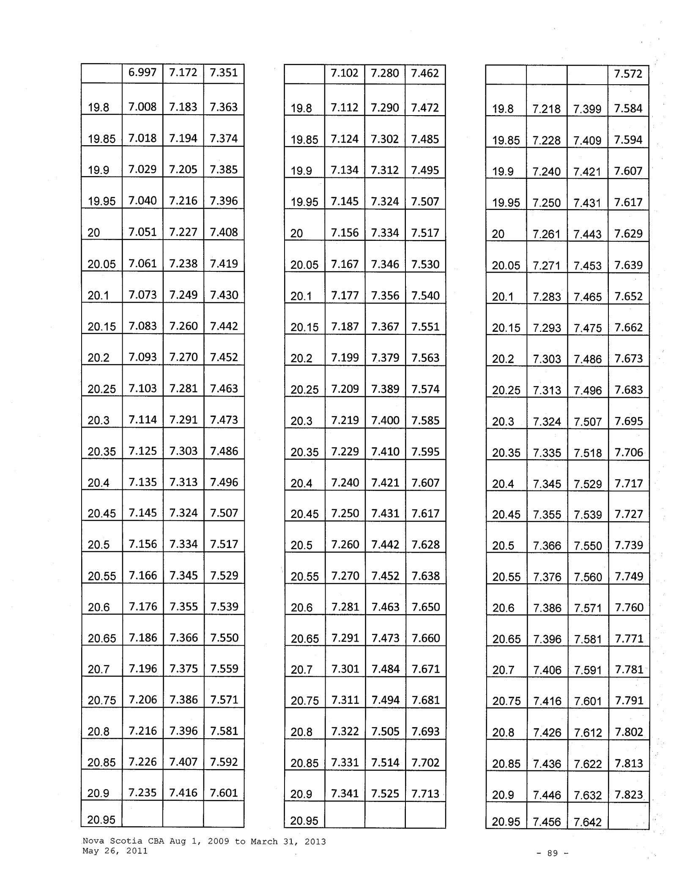

 |  |  |  | 7.572
 | 19.8 | 7.218 | 7.399 | 7.584
 | 19.85 | 7.228 | 7.409 | 7.594
 | 19.9 | 7.240 | 7.421 | 7.607
 | 19.95 | 7.250 | 7.431 | 7.617
 | 20 | 7.261 | 7.443 | 7.629
 | 20.05 | 7.271 | 7.453 | 7.639
 | 20.1 | 7.283 | 7.465 | 7.652
 | 20.15 | 7.293 | 7.475 | 7.662
 | 20.2 | 7.303 | 7.486 | 7.673
 | 20.25 | 7.313 | 7.496 | 7.683
 | 20.3 | 7.324 | 7.507 | 7.695
 | 20.35 | 7.335 | 7.518 | 7.706
 | 20.4 | 7.345 | 7.529 | 7.717
 | 20.45 | 7.355 | 7.539 | 7.727
 | 20.5 | 7.366 | 7.550 | 7.739
 | 20.55 | 7.376 | 7.560 | 7.749
 | 20.6 | 7.386 | 7.571 | 7.760
 | 20.65 | 7.396 | 7.581 | 7.771
 | 20.7 | 7.406 | 7.591 | 7.781
 | 20.75 | 7.416 | 7.601 | 7.791
 | 20.8 | 7.426 | 7.612 | 7.802
 | 20.85 | 7.436 | 7.622 | 7.813
 | 20.9 | 7.446 | 7.632 | 7.823
 | 20.95 | 7.456 | 7.642

Nova Scotia CBA Aug 1, 2009 to March 31, 2013 May 26, 2011

- 89 -

 | 7.246 | 7.427 |  | 7.613
21 | 7.256 | 7.437 |  | 7.623
21.05 | 7.265 | 7.447 |  | 7.633
21.1 | 7.275 | 7.457 |  | 7.643
21.15 | 7.285 | 7.467 |  | 7.654
21.2 | 7.295 | 7.477 |  | 7.664
21.25 | 7.304 | 7.487 |  | 7.674
21.3 | 7.314 | 7.497 |  | 7.684
21.35 | 7.324 | 7.507 |  | 7.695
21.4 | 7.333 | 7.516 |  | 7.704
21.45 | 7.343 | 7.527 |  | 7.715
21.5 | 7.352 | 7.536 |  | 7.724
21.55 | 7.362 | 7.546 |  | 7.735
21.6 | 7.371 | 7.555 |  | 7.744
21.65 | 7.380 | 7.565 |  | 7.754
21.7 | 7.389 | 7.574 |  | 7.763
21.75 | 7.399 | 7.584 |  | 7.774
21.8 | 7.409 | 7.594 |  | 7.784
21.85 | 7.418 | 7.603 |  | 7.793
21.9 | 7.426 | 7.612 |  | 7.802
21.95 | 7.435 | 7.621 |  | 7.812
22 | 7.445 | 7.631 |  | 7.822
22.05 | 7.453 | 7.639 |  | 7.830
22.1 | 7.463 | 7.650 |  | 7.841
22.15

 | 7.351 | 7.535 |  | 7.723
21 | 7.361 | 7.545 |  | 7.734
21.05 | 7.371 | 7.555 |  | 7.744
21.1 | 7.380 | 7.565 |  | 7.754
21.15 | 7.390 | 7.575 |  | 7.764
21.2 | 7.399 | 7.584 |  | 7.774
21.25 | 7.410 | 7.595 |  | 7.785
21.3 | 7.419 | 7.604 |  | 7.794
21.35 | 7.429 | 7.615 |  | 7.805
21.4 | 7.438 | 7.624 |  | 7.815
21.45 | 7.448 | 7.634 |  | 7.825
21.5 | 7.457 | 7.643 |  | 7.834
21.55 | 7.467 | 7.654 |  | 7.845
 | 7.476 | 7.663 |  | 7.855
21.6 | 7.476 | 7.663 |  | 7.855
21.65 | 7.486 | 7.673 |  | 7.865
21.7 | 7.495 | 7.682 |  | 7.874
21.75 | 7.504 | 7.692 |  | 7.884
21.8 | 7.513 | 7.701 |  | 7.894
21.85 | 7.522 | 7.711 |  | 7.904
21.9 | 7.532 | 7.720 |  | 7.913
21.95 | 7.541 | 7.729 |  | 7.922
22 | 7.550 | 7.739 |  | 7.932
22.05 | 7.559 | 7.748 |  | 7.942
22.1 | 7.568 | 7.757 |  | 7.951
22.15
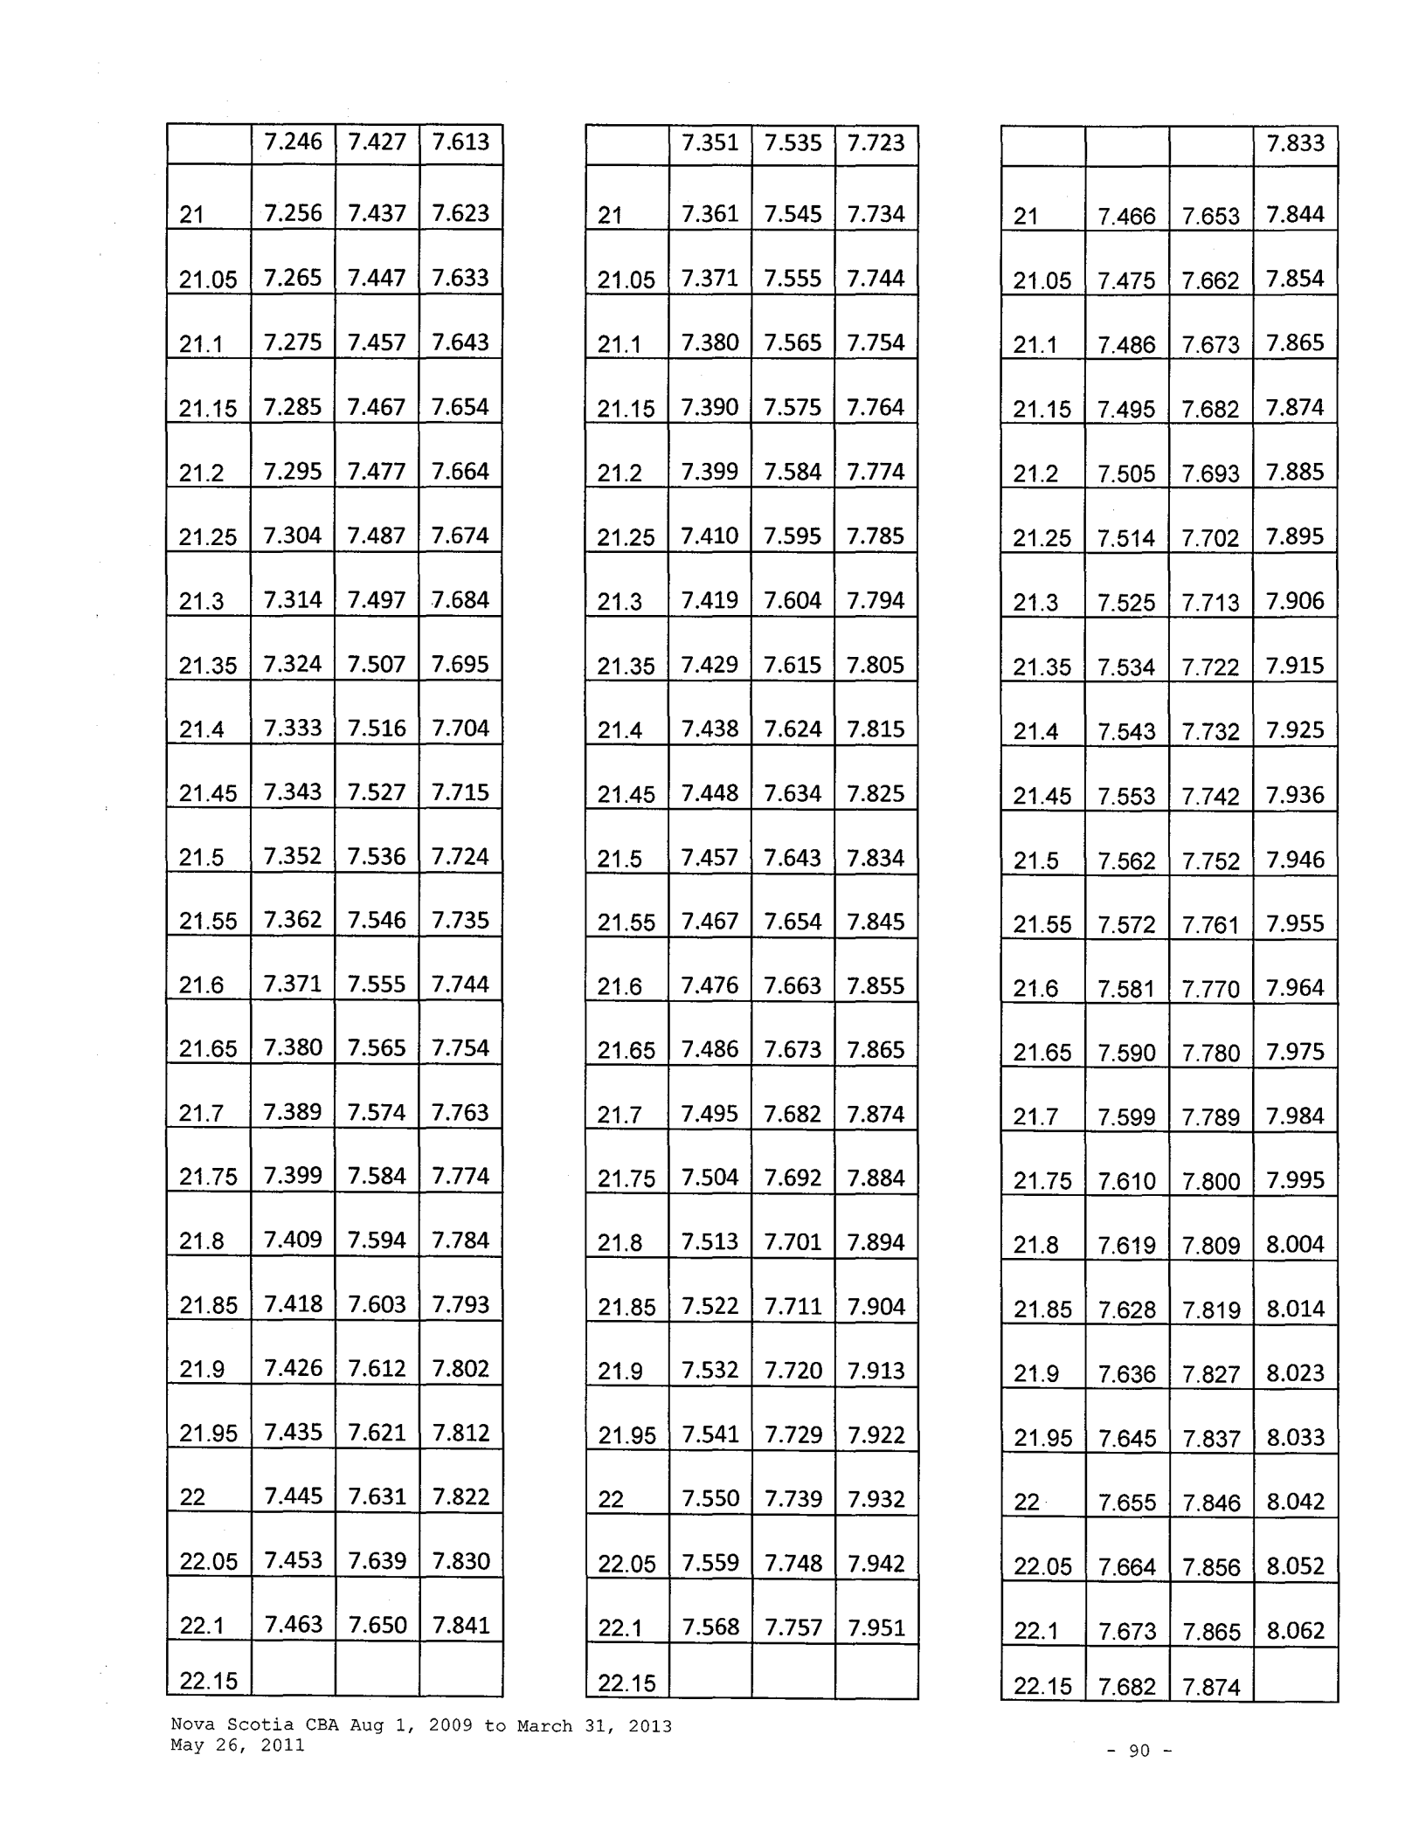

 |  |  |  | 7.833
21 | 7.466 |  | 7.653 | 7.844
21.05 | 7.475 |  | 7.662 | 7.854
21.1 | 7.486 |  | 7.673 | 7.865
21.15 | 7.495 |  | 7.682 | 7.874
21.2 | 7.505 |  | 7.693 | 7.885
21.25 | 7.514 |  | 7.702 | 7.895
21.3 | 7.525 |  | 7.713 | 7.906
21.35 | 7.534 |  | 7.722 | 7.915
21.4 | 7.543 |  | 7.732 | 7.925
21.45 | 7.553 |  | 7.742 | 7.936
21.5 | 7.562 |  | 7.752 | 7.946
21.55 | 7.572 |  | 7.761 | 7.955
21.6 | 7.581 |  | 7.770 | 7.964
21.65 | 7.590 |  | 7.780 | 7.975
21.7 | 7.599 |  | 7.789 | 7.984
21.75 | 7.610 |  | 7.800 | 7.995
21.8 | 7.619 |  | 7.809 | 8.004
21.85 | 7.628 |  | 7.819 | 8.014
21.9 | 7.636 |  | 7.827 | 8.023
21.95 | 7.645 |  | 7.837 | 8.033
22 | 7.655 |  | 7.846 | 8.042
22.05 | 7.664 |  | 7.856 | 8.052
22.1 | 7.673 |  | 7.865 | 8.062
22.15 | 7.682 |  | 7.874

Nova Scotia CBA Aug 1, 2009 to March 31, 2013 May 26, 2011

- 90 -

 | 7.472 | 7.659 | 7.850
22.2 | 7.480 | 7.667 | 7.859
22.25 | 7.490 | 7.677 | 7.869
22.3 | 7.499 | 7.686 | 7.878
22.35 | 7.507 | 7.695 | 7.887
22.4 | 7.516 | 7.704 | 7.897
22.45 | 7.526 | 7.714 | 7.907
22.5 | 7.534 | 7.722 | 7.915

7.577 7.766 7.960
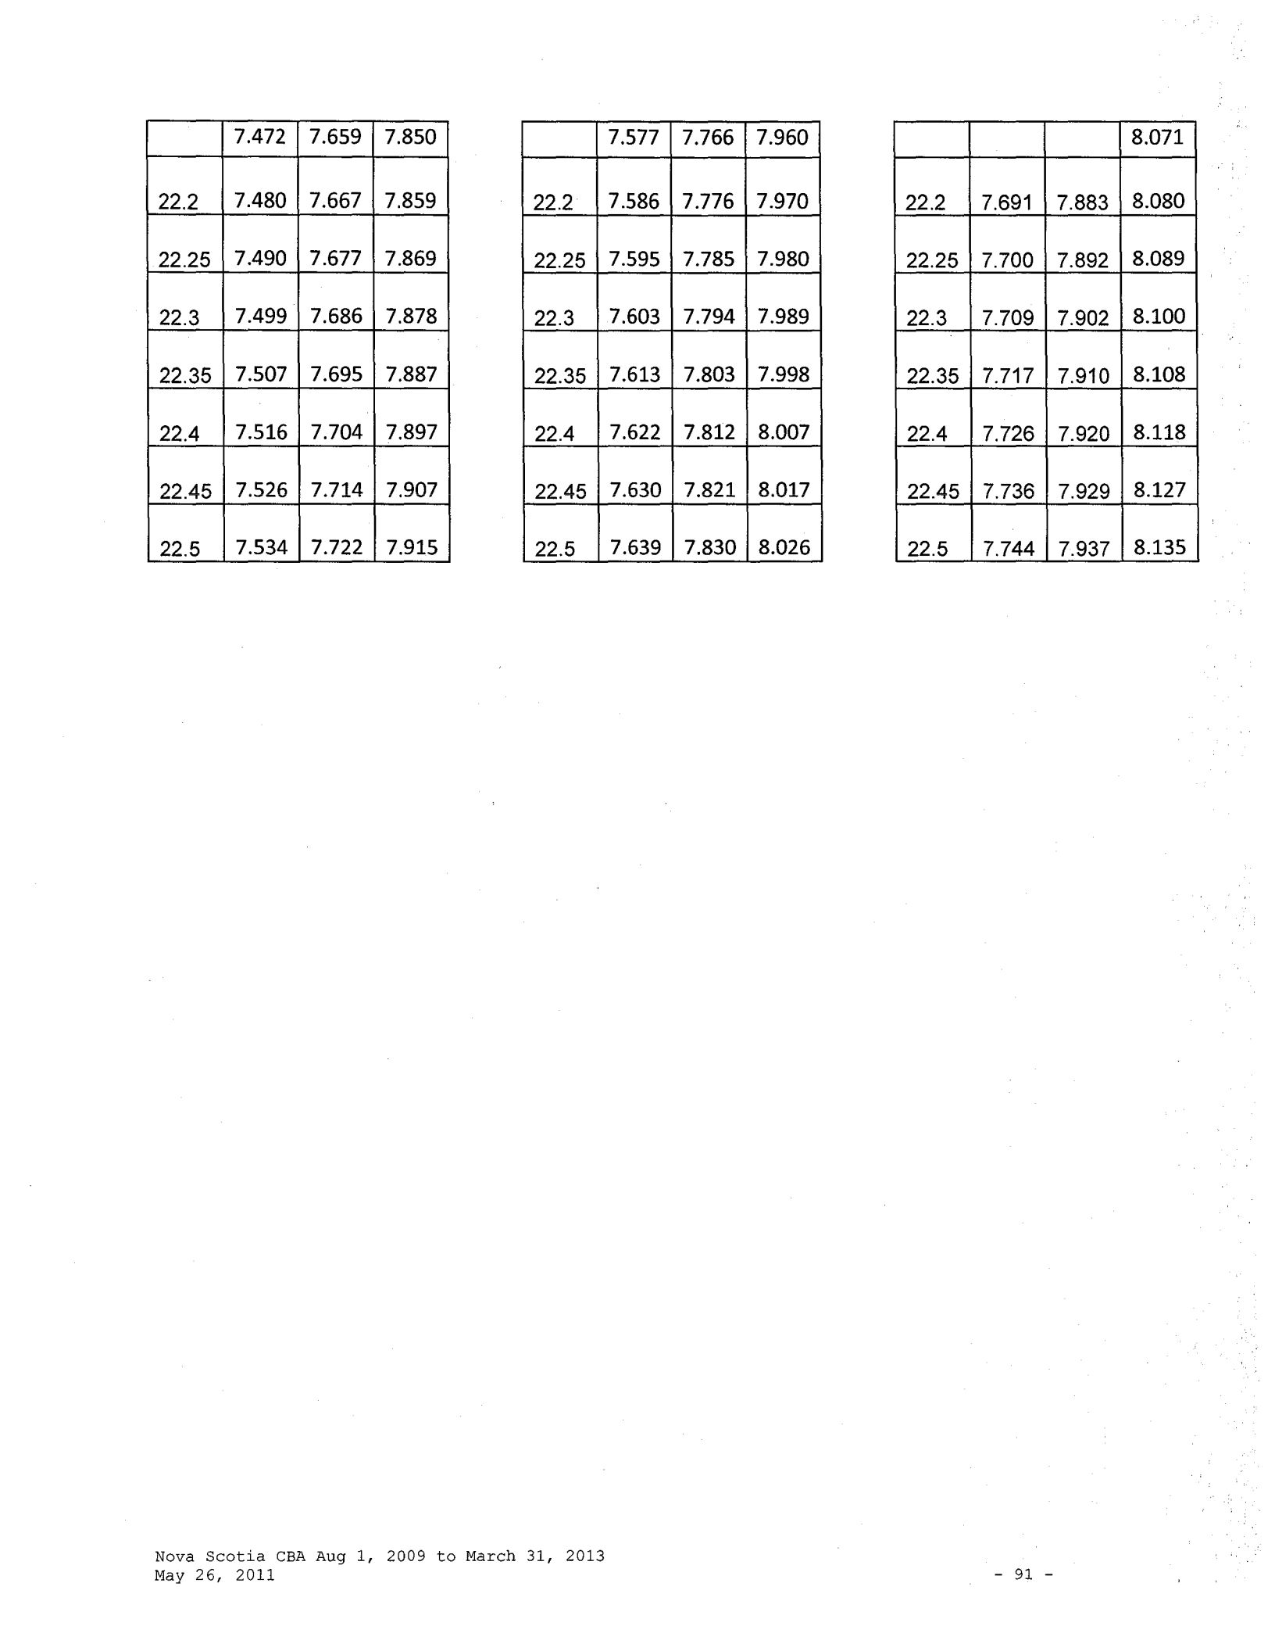

22.2 7.586 7.776 7.970

22.25 7.595 7.785 7.980

22.3 7.603 7.794 7.989

22.35 7.613 7.803 7.998

22.4 7.622 7.812 8.007

22.45 7.630 7.821 8.017

22.5 7.639 7.830 8.026

8.071

22.2 7.691 7.883 8.080

22.25 7.700 7.892 8.089

22.3 7.709 7.902 8.100

22.35 7.717 7.910 8.108

22.4 7.726 7.920 8.118

22.45 7.736 7.929 8.127

22.5 7.744 7.937 8.135

Nova Scotia CBA Aug 1, 2009 to March 31, 2013
May 26, 2011 - 91 -

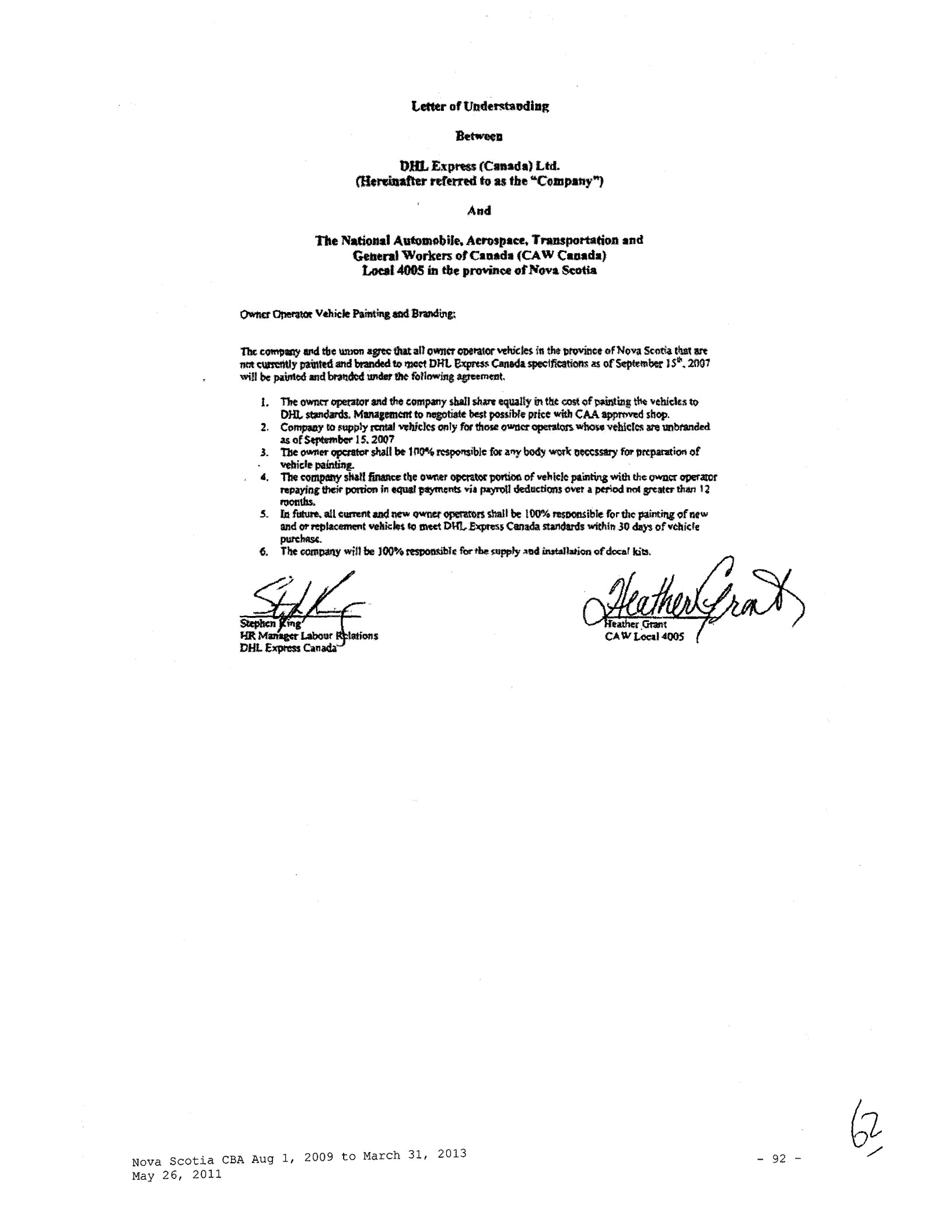

bHL Express (Cauda) Ltd.
C'Hemn.netrd'etnd to as the "(:'(lmpany"')

And

The Natio.na1 Automobile. Aerospace, Transportation and
Gebtnl Workers otCaaada (CAW Cuada)
Loea14005 mt!Je p~ otJ'IlovaSeotia

The comt~IWl)' ll!ld tbe wmm ap that all owncr ODei'Ulr \/dUcks !11 thit \ltOVinct of Nova St11tia tim art
nat tlllftlitly l)a1rlted l!l'ld branded tD 12l0r:t DRL ~Canada s:pe.;'lfic:atiam as of~l:JI:r JS"'. :2001
will be p~.illttd and btalt®d IUider !he ((lllDWing apernmt,

  - The Ollt'lltt opetator and the eompany shall 51ll1Tf equally in tll,t (:.05( oJ ~~~~!! ~ Yeh!'CkstQ DHl.. ~. MlllliJnnatfto ~e best pouible price with CAA ~shop.

- Compacy to ~ply muaJ vdlitks 0111): for tf!OR owner~ wl\oie vth!<:l~ liTtlll:lhfanded asof~berlS.2007
- 'tlle owner~ sM!I bt 111~ ~blc for arty ooey WQI'\:n~SS&I)' fo:r lntp.atation of' veflic;lepeln!ill~
- The complii!Y sltatt finance t!te OWI\tr ~t« ~of veillek pamtina with tltc QWDCr operaror repayillf tfleit ponion in equal \llt)'lftents via payr'Otl dedru:tiQM ovet a ptl'iod 1101 ~Iller tlti111 ! l root~ths.

- fQ ~all cumnt and MW owner opemtlrUhalt be 100% resoonsible for the painting of new
and Of'!'elllacemer>t vehic~ to m«t Dt-I'L151(JJI'eS5 Canada standards within 30 days ohchic!e
plii'Clmsc.
- The t:0111patty will be JOO'Vo mpomiblc lOr t~ supply ~lld itut#lbtion of&cc-ar kits.

Nova | scotia CBA Aug 1, 2009 to March 31, 2013 | -92-
May | 26, 2011

