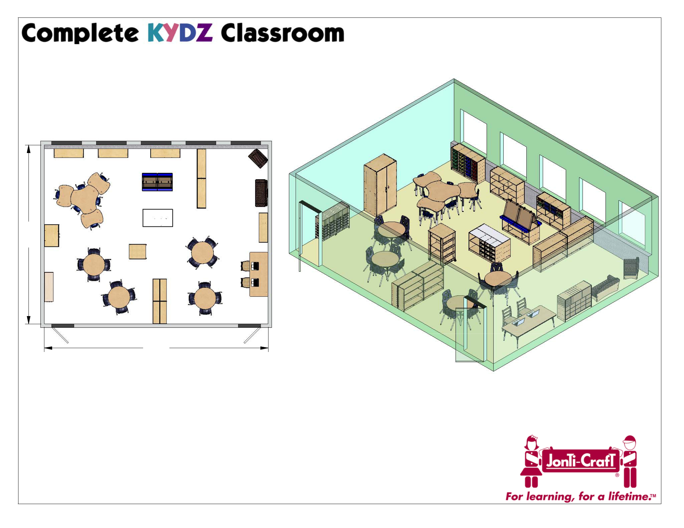

TYPICAL CLASSROOM / PHILADELPHIA PUBLIC SCHOOLS
REALLY GOOD STUFF

24'-0"

30'-0"

Useable Square Footage: 708 sq. ft.

Questions? Scale Info: 1:100
Call: 800-543-4149
Click: www.jonti-craft.com
Email: sales@jonti-craft.com
Co
py
gri
ht
©2
01
5.
Jo
nti
C-
ar
ft,
nI
c.
All
rgi
hts
re
se
vr
ed
1.
80
7A
-1
12
01
5-H
WL
-1

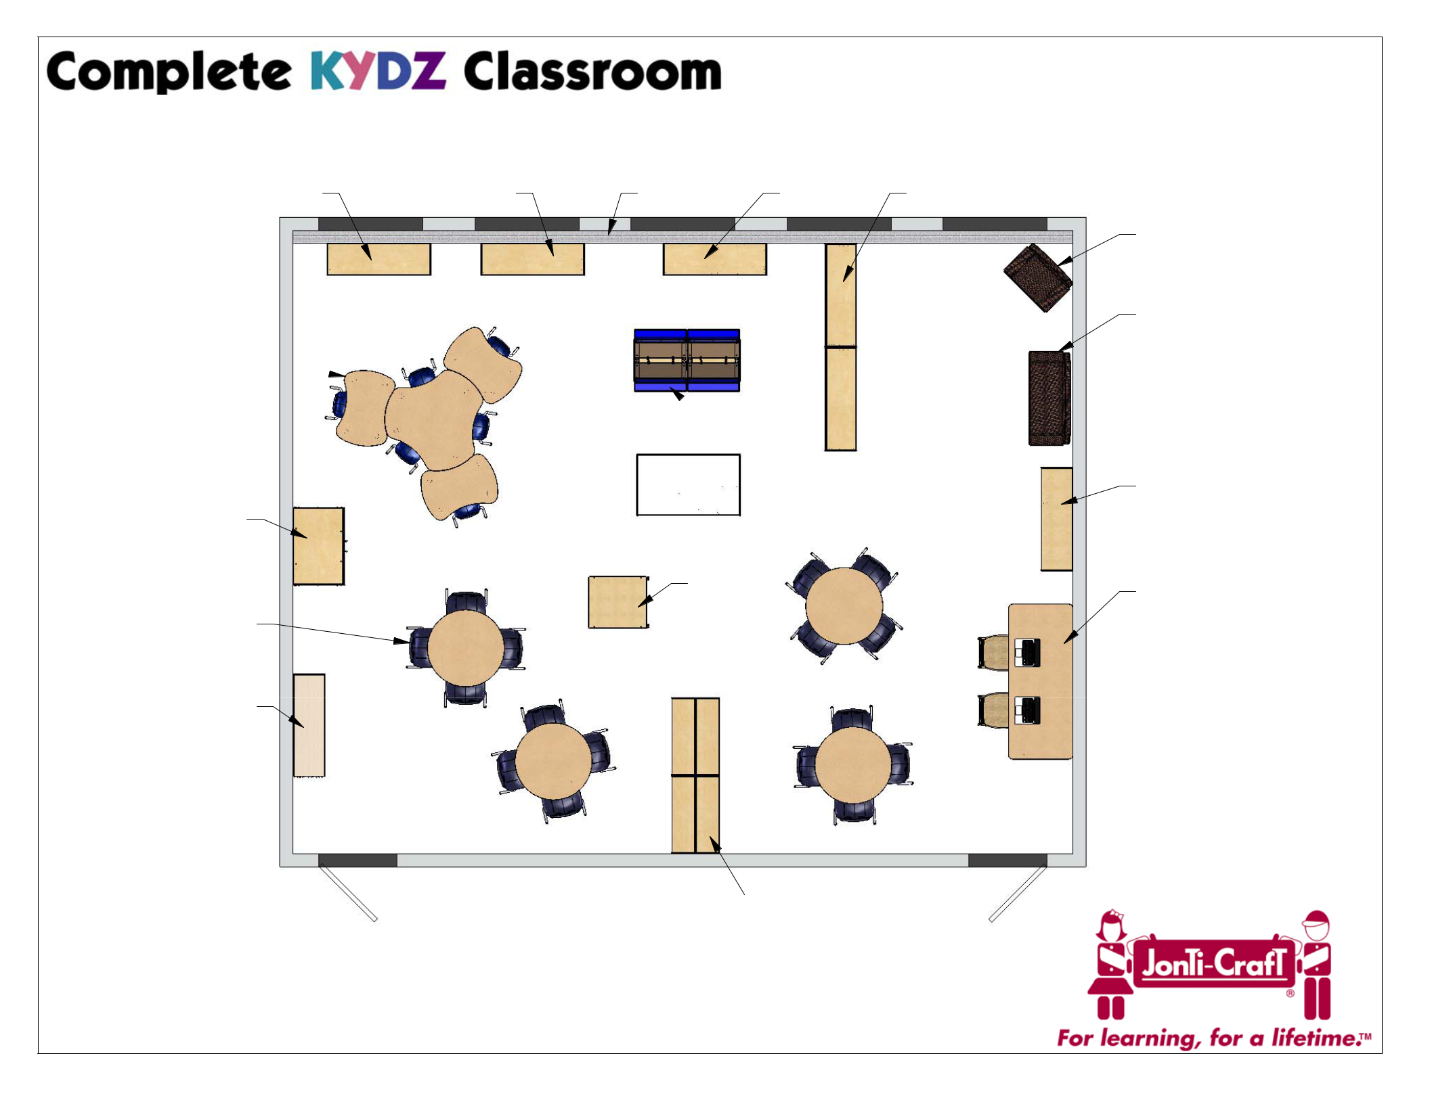

TYPICAL CLASSROOM SEATING

06250JC 2691JC HEATER 0726JC 0782JC (x2)

6310JC5410 (x3)
6311JC5410

8144JC1112 (x6)

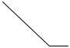0294JC

04400JC

5950JC

0539JC
6488JCE011 (x2)
8146JC1112 (x16)

78240JC

Questions? |  |  | 0960JC (x4)
Call: 800-543-4149
Click: www.jonti-craft.com
Email: sales@jonti-craft.com | Scale Info: 1:60

3771JC

3770JC

04160JC

6413JCE011
5918JC2
Co
py
gri
ht
©2
01
5.
Jo
nti
C-
ar
ft,
nI
c.
All
rgi
hts
re
se
vr
ed
1.
80
7A
-1
12
01
5-H
WL
-2

