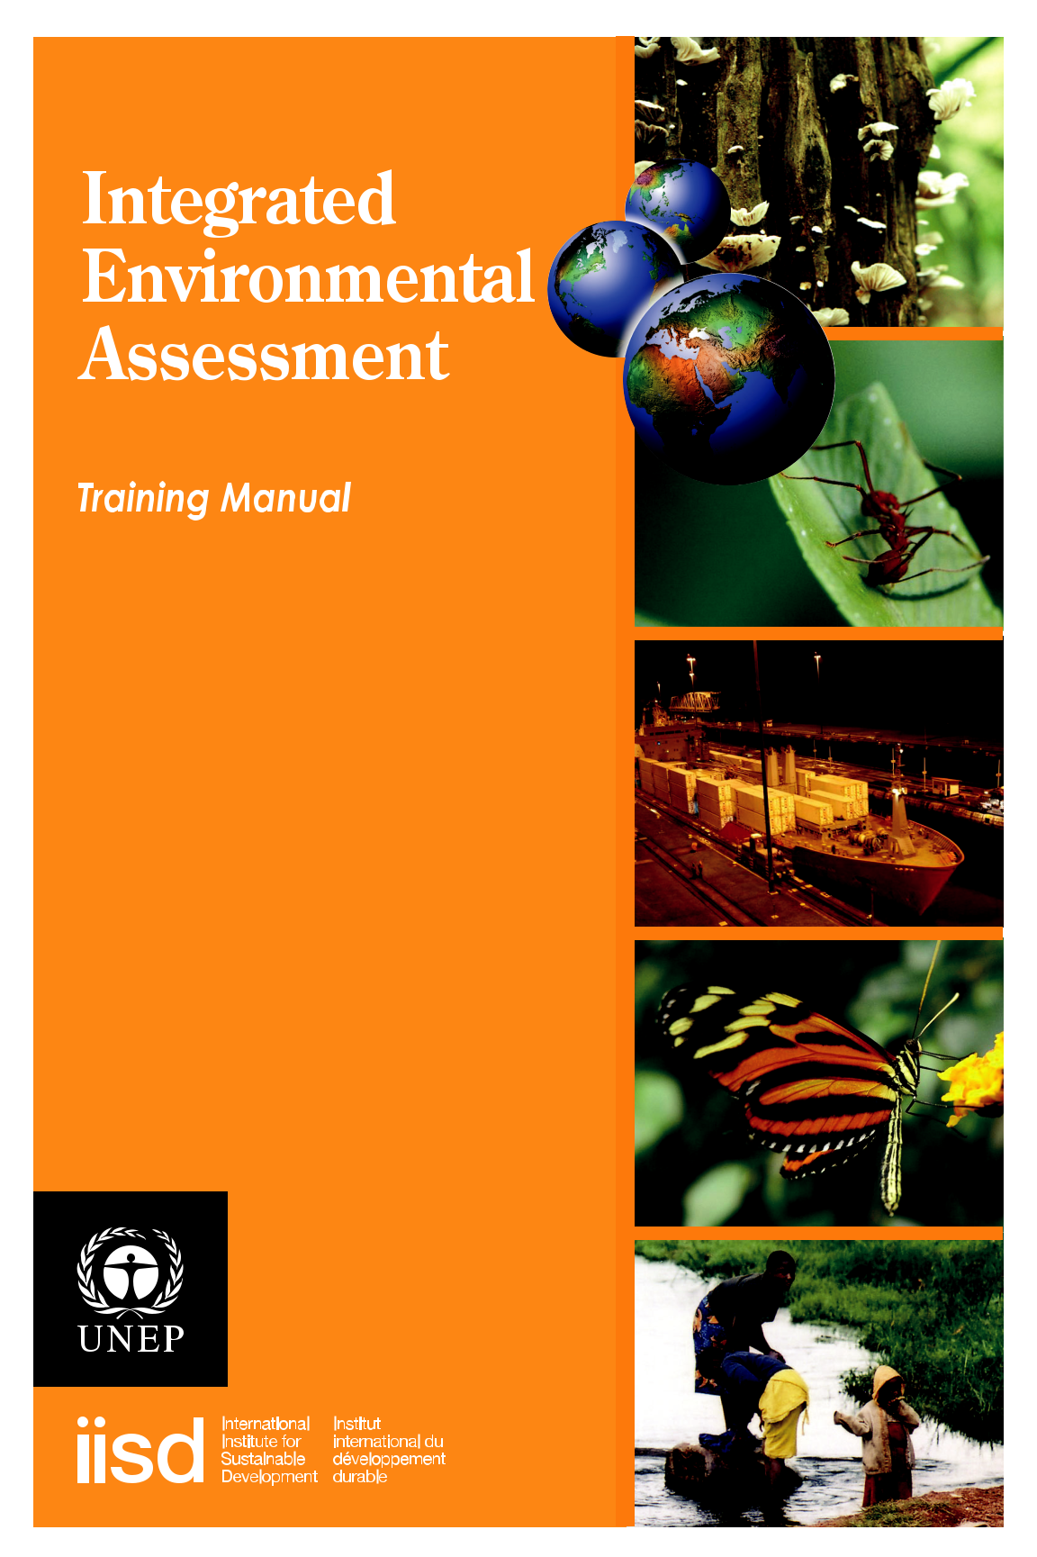

Copyright ©2009 United Nations Environment Programme (UNEP)

Disclaimers

The contents of this publication do not necessarily reflect the views or policies of UNEP or contributory organisations.

While reasonable efforts have been made to ensure that the contents of this publication are factually correct and properly referenced, UNEP does not accept responsibility for the accuracy or completeness of the contents, and shall not be liable for any loss or damage that may be occasioned directly or indirectly through the use of, or reliance upon, the contents of this publication, including its translation into languages other than English.

Reproduction

This publication may be reproduced in whole or in part and in any form for educational or non-profit purposes without special permission of the copyright holder, provided acknowledgement of the source is made. UNEP would appreciate receiving a copy of any publication that uses this document as a source.

This booklet summarises the contents of the IEA Training Manual: A Training Manual on Integrated Environmental Assessment and Reporting, developed through a collaborative initiative among the United Nations Environment Programme (UNEP), the International Institute for Sustainable Development (IISD) and more than 40 experts from around the world.

In order to emphasise the generic applicability of the methodology at the global, regional, national, ecosystem and local levels, the original title, GEO Resource Book, has been changed to IEA Training Manual.

The manual consists of two volumes. Volume 1 includes eight core methodological modules, while Volume 2 currently includes one thematic module, as follows:

VOLUME 1: Core methodological modules

Module 1: The GEO approach to integrated environmental assessment

Module 2: National IEA process design and organisation

Module 3: Developing an impact strategy for your IEA

Module 4: Monitoring, data and indicators

Module 5: Integrated analysis of environmental trends and policies

Module 6: Scenario development and analysis

Module 7: Creating communication outputs from the assessment

Module 8: Improving the IEA process and increasing impact through monitoring, evaluation and learning

VOLUME 2: Thematic modules

Module VIA: Vulnerability and Impact assessment for Adaptation to Climate Change

IEA Training Manual: A Training Manual on Integrated Environmental Assessment and Reporting can be downloaded from www.unep.org/ieacp or www.iisd.org/measure.

Keeping to the original idea of a continuously evolving capacity-development approach and materials, the IEA Training Manual is distributed only in electronic form. It can be accessed at www.unep.org/ieacp or http://hqweb.unep.org/ieacp. Hard copies are printed on demand for specific workshops. This summary booklet is available through UNEP in hard copy, or can be downloaded from the same website. UNEP is proceeding with the translation of the manual into all six official UN languages (Arabic, Chinese, English, French, Russian and Spanish) and the development of regionally customised versions.

iii


Acknowledgements

The IEA Training Manual was edited by László Pintér (IISD), Darren Swanson (IISD) and Jacquie Chenje (UNEP).

The language edit and proofreading was performed by Michelle French, Michael Keating and Stu Slayen.

Lead and contributing authors to the IEA Training Manual included the following:

Ibrahim Abdel-Jelil, AGU, Bahrain; Ahmed Abdelrehim, CEDARE, Egypt; Chris Anastasi, British Energy Group, United Kingdom; Maria Eugenia Arreola, UNEP-ROLAC, Mexico; Johara Bellali, UNEP Headquarters; Preeti Bhandari, TERI, India; Livia Bizikova, IISD, Canada (Lead Author, Module A); Philip Bubb, UNEP-WCMC, United Kingdom; Jacquie Chenje, UNEP Headquarters; Munyaradzi Chenje, UNEP Headquarters; Heather Creech, IISD, Canada (Lead Author, Module 3); Andrea Déri, LEAD International, United Kingdom (Lead Author, Module 8); Elsa Galarza, CIUP, Peru; Rosario Gómez, CIUP, Peru (Lead Author, Module 2); Richard Grosshans, IISD, Canada; Edgar Gutierrez-Espeleta, University of Costa Rica, Costa Rica; Zerisenay Habtezion, UNITAR, Switzerland; Jill Jäger, SERI, Austria (Lead Author, Modules 1 and 6); Sivan Kartha, SEI, United States; Marcel Kok, MNP, Netherlands; Karen Landmark, UNEP/GRID-Arendal, Norway; Nicolas Lucas, WRI, United States; Clever Mafuta, SARDC, Zimbabwe; Kakuko Nagatani-Yoshida, UNEP-ROLAC, Mexico; László Pintér, IISD, Canada (Lead Author, Module 5); Atiq Rahman, BCAS, Bangladesh; Purna Chandra Lall Rajbhandari, UNEP RRC.AP, Thailand; Dale Rothman, IISD, Canada; Ieva Rucevska, UNEP/GRID-Arendal, Norway (Lead Author, Module 7); Joni Seager, York University, Canada; Charles Sebukeera, UNEP Headquarters; Nalini Sharma, UNEP Headquarters; Darren Swanson, IISD, Canada; Philip van Notten, Independent Scholar, Netherlands; Jaap van Woerden, UNEP/GRID-Geneva, Switzerland (Lead Author, Module 4); Morten Wasstøl, UNEP/GRID-Arendal, Norway; Carissa Wieler, IISD, Canada; Kaveh Zahedi, UNEP-WCMC, United Kingdom.

Instructor guidance was provided by Gillian Martin Mehers, LEAD International, United Kingdom; James A. Perry, University of Minnesota, United States.

The design and layout was completed by Don Berg.

Cover photos by Stefan Schwarzer except: Bird: Volodymyr Demkine/UNEP; Buffalo:
Christian Lambrechts/UNEP; Buildings: Christian Lambrechts/UNEP; Women washing
clothes: Jo-Ellen Parry; Woman with child: Frédéric Gagnon-Lebrun.

iv


IEA Training Manual: A Training Manual on Integrated Environmental Assessment and Reporting

The need for an IEA training manual

The need to build environmental considerations into decision-making, a central theme in Our Common Future (commonly known as the Brundtland Report), is no longer a bold proposition, but a basic necessity.¹ Without the ability to monitor and assess changing environmental trends and their interactions with human development, navigating the sea of global change would be reduced to reactive crisis management—hardly an effective way to tackle policy issues with such profound relevance for the planet.

Brundtland called not only for attention to the interactions between environment and development but also for the need to consider the interests of future generations. This requires an ongoing effort to substantially strengthen our capacity to assess the range of possible futures and to create policies that take this knowledge into account. Addressing these needs is at the heart of this training manual.

The purpose of the IEA Training Manual is to help build capacity for forward-looking integrated environmental assessment (IEA) and reporting at the subglobal level. Users of the IEA Training Manual will:

- Understand the rationale for undertaking forward-looking, integrated environmental assessment (IEA) using the Global Environment Outlook (GEO) approach of the United Nations Environment Programme (UNEP).

- Understand the importance of a mandate for an IEA, its participatory process and options for its governance structure, and be able to construct an impact strategy.

- Be familiar with the conceptual and methodological aspects of carrying out the assessment, including the analysis of environmental trends and policies and the study of policy options in the context of future scenarios.

- Be capable of organising the process for producing physical and electronic outputs from the IEA.

- Have the knowledge and skills to set up a monitoring and evaluation process focused on the IEA itself as part of a continuous learning process to improve the assessment.

For the purposes of this publication we defined integrated environmental assessment as “the process of producing and communicating future-oriented, policy-relevant information on key interactions between the natural environment and human society.” The methodology underlying IEA has been pioneered and championed by the Global Environment Outlook (GEO), UNEP’s flagship assessment and reporting process on the status and direction of the global environment. GEO is a consultative, participatory, capacity-building process as well as a series of reports analysing environmental change, causes and impacts, and policy responses, providing information for decision-making at global and subglobal levels. The GEO series aims to keep the state of the world’s environment under review, identify emerging issues that require international attention and provide options for policy-making and action planning.

- World Commission on Environment and Development. (1987). Our common future. Oxford: Oxford University Press.

1


Since the publication of the first global report in 1996, the GEO approach has been adopted by an increasing number of organisations at the regional, national and subnational level. The IEA Training Manual draws on the growing body of experience gained through these initiatives.

Capacity building has been a key element of the GEO process, and training activities carried out by UNEP and its partners since the late nineties contributed to the wider adoption of IEA methods. In 2000 UNEP and IISD, a UNEP Collaborating Centre, jointly published a training manual that served as the basis for many training activities and for developing other regionalised training curricula.²

The need for updating the earlier IEA training manual became obvious for a number of reasons, including the evolution of the GEO methods, the need for more detailed and more easily customisable information on the environment and its interaction with human well-being, and the need to increase the effectiveness of capacity building. A 2004 meeting of the GEO Capacity Building Working Group discussed the criteria for more effective capacity-building efforts, shown in Box 1, and these criteria, along with additional guidance from UNEP and the GEO Capacity Building Working Group, inspired the development of the IEA Training Manual.

Box 1: Criteria for improving the effectiveness of IEA capacity building, as identified at the March 2004 meeting of the GEO Capacity Building Working Group in Geneva, Switzerland.

- Improve coordination. Identify, monitor and, where possible, improve coordination and cooperation with similar capacity-building initiatives, including other initiatives of UNEP.

- Utilise existing capacity. Identify and improve the utilisation of capacity that exists in current partner organisations and the GEO network.

- Promote innovation and diversity. Embrace the diversity of capacity-building and training approaches to assessment and reporting while maintaining the coherence and integrity of the GEO approach.

- Introduce innovative tools and methods. Increase the effectiveness of capacity building by introducing novel tools and innovative, experiential and participatory training methods successfully used by partner organisations.

- Promote multi-level engagement. Increase sustainability of impact by engaging capacity-building audiences on both an individual as well as an organisational level.

- Link capacity building to actual assessment and reporting. Search for and create opportunities to connect capacity building and the actual production of GEO-compatible assessments and reports.

- Provide incentives. Provide incentives to eligible organisations and experts where possible and warranted to maintain their interest in GEO assessment and reporting beyond training.

- Strengthen capacity to effectively communicate assessments. Ensure capacity building strengthens the ability to design and implement communication strategies.

- Improve monitoring, evaluation and learning. Ensure methods and mechanisms are in place to monitor, measure and, as required, report on the short- and long-term impacts of capacity-building efforts.

- Pintér, L., Zahedi, K., & Cressman, D. (2000). Capacity building for integrated environmental assessment and
- reporting. Training manual. Winnipeg: IISD for UNEP. Retrieved from http://www.iisd.org/pdf/geo_manual_2.pdf

Capacity is multi-dimensional, particularly in an area as complex as an IEA, which requires a multi-pronged approach. This may include a training component (face-to-face, distance learning, training-by-doing), but also may include additional measures such as staff exchanges, technical support or providing easy access to data. Therefore, the IEA Training Manual has to be seen in a broader context, as a key—but not the only—element in UNEP’s IEA capacity-building efforts.

Capacity development accompanying the IEA process comes in the form of a well-developed training package, which includes:

- The IEA Training Manual, to help build capacity for IEA and reporting at the subglobal level (available in all six UN official languages).

- IEA Community Platform, a web-based tool for access to and sharing of resources on IEA, developed through the GEO/IEA process and other related assessment processes at subglobal levels.

- Development of an e-learning version of the IEA Training Manual that responds to the need to increase the reach and effectiveness of existing and future training materials (available at http://moodle.iisd.org).

- IEA Trainers’ Database, which includes all IEA-certified trainers who support the delivery of the IEA training package.

The audience

The target audience for the IEA Training Manual includes facilitators who construct IEA training curricula and, ultimately, the participants in capacity-building programs. The latter include primarily mid-level leaders and practitioners in public agencies, with overall responsibility for initiating and managing assessment and reporting processes. They may work on different scales, from national governments to states and provinces, municipalities or ecoregions. Many of them would have prior assessment or state-of-the environment reporting experience. Based on experience with previous training endeavours, IEA practitioners may also include representatives of non-governmental organisations, academics, students, media and experts from the private sector.

While a variety of technical specialists have a key role to play in IEAs, the IEA Training Manual, even with its extended content, provides only introductory coverage of some methods that would require extensive academic training. The emphasis is on the IEA system as a whole and on helping participants realise when and where to bring in specialist knowledge for maximum effect.

Contents

The IEA Training Manual builds on elements of the earlier IEA training manual, other teaching resources and experience with previous IEA initiatives, but there are also several significant differences.

Content is organised into nine modules, as shown in Box 2. A modular design was chosen because capacity-building needs vary, and often it is necessary and more effective to concentrate efforts on one or a few topics rather than on the entire IEA package. The intention is to provide maximum flexibility to audiences and facilitators in deciding what content is most relevant. The IEA Training Manual is the IEA “source code” that can be freely used as a library of ideas and materials that, over time, can evolve and integrate new concepts and ideas that arise either from GEO or from the many other assessments that will be undertaken in the future at the global or subglobal level.

3


Box 2: IEA Training Manual

VOLUME 1: Core methodological modules

Module 1: The GEO approach to integrated environmental assessment

Module 2: National IEA process design and organisation

Module 3: Developing an impact strategy for your IEA

Module 4: Monitoring, data and indicators

Module 5: Integrated analysis of environmental trends and policies

Module 6: Scenario development and analysis

Module 7: Creating communication outputs from the assessment

Module 8: Improving the IEA process and increasing impact through monitoring, evaluation and learning

VOLUME 2: Thematic module

Module A: Vulnerability and Impact assessment for Adaptation to Climate Change (VIA)

The modules take participants through the IEA process, essentially treating IEA as an institution that organisations in charge of assessment and reporting processes need to build. This will take the reader through questions related to setting up a process and securing the mandate to build an impact strategy, carry out the actual assessment, prepare information products and close the loop by reflecting on lessons learned throughout the process.

Thematic modules that will provide guidance for IEAs focused on a particular scale, sector or issue are being developed and will represent Volume 2 of the training manual. The first currently available thematic module is focused on vulnerability assessment and adaptation to climate change. This module is based on the IEA methodology and integrates the perspectives of vulnerability and impact assessments to explore adaptation responses.

Each module is accompanied by a set of PowerPoint slides on a CD, along with sample agendas that are intended to help course designers construct and run sessions of an

overview or comprehensive nature, or somewhere in-between. Course designers are encouraged to modify and enrich the slide decks with regional case studies and other, more locally relevant information.

Course design and delivery

Generally, a course based on the entire IEA Training Manual will not be offered (that is, all modules in full detail), as it would require much more time in one block than a typical participant could devote to the program. The modules are cross-referenced and are designed to be delivered as individual modules or as a package. As a result, some key graphics and concepts repeat across modules.

Figure 1 illustrates the relationship between the IEA Training Manual and the participant workbook. A participant workbook is a customised set of training materials based on the IEA Training Manual, selected by the facilitator and possibly enriched with regional case studies. A participant workbook includes detailed agendas, core content and PowerPoint slides for delivery of the modules. Other modules not covered need not be included. Most course participants thus do not receive the entire IEA Training Manual, only the sections selected by the facilitator.

4

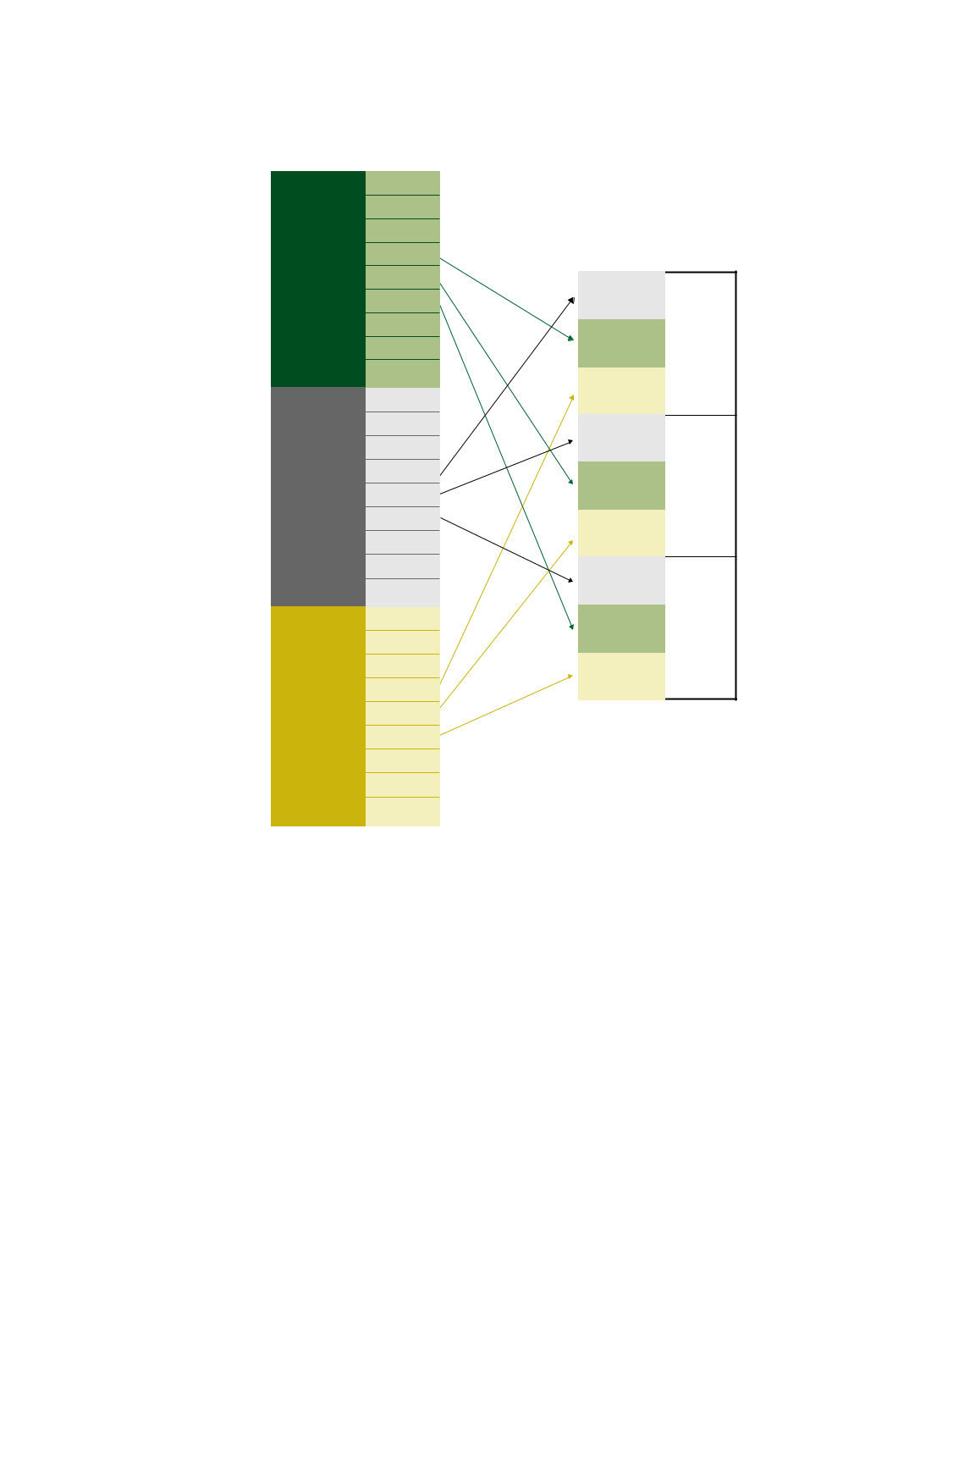
Figure 1: The relationship between the training manual and the participant workbook

TRAINING MANUAL

Module 1

Module 2

Module 3

Module 4
Modules
Module 5

Module 6

Module 7

Module 8

Thematic

VIA module

Module 1

Module 2

Module 3
_{Sample} Module 4

agendas
Module 5

Module 6

Module 7

Module 8

Thematic

VIA module

Module 1

Module 2

Module 3

PowerPoint ^{Module 4}
slides
Module 5

Module 6

Module 7

Module 8

Thematic

VIA module

PARTICIPANT WORKBOOK

Agenda

Module and
regional Module 4

case studies

Slides

Agenda

Module and
regional ^{Module 5}
case studies

Slides

Agenda

Module and

regional Module 6
case studies

Slides

Effective IEA capacity building, as emphasised by some of the criteria shown in Box 1, should be an interactive process. The modules, therefore, are set up to include a series of didactic elements:

- Concept presentations

- Discussion questions in breakout groups or plenary sessions

- Case studies

- Role plays

- Problem-solving group exercises

- Plenary sessions at the end of the days to review key lessons learned and any outstanding questions and to explore concrete opportunities for practical application of the topics covered

In some cases the facilitator may ask participants to read selected papers prior to or during the workshop.

Included with the sample agendas and PowerPoint slides is a guide for interactive course design and delivery.

5



The margins of each module contain symbols for the facilitator and participants to more readily identify discussion questions, participatory exercises and information for which a specific PowerPoint slide has been created.

– discussion question

- – PowerPoint slide and number  – participatory exercise

Course facilitators should formally and informally gather participant feedback throughout a course. In order to help the process, a sample evaluation form is included on the CD for daily and overall course evaluations.

Module 1 Overview: The GEO Approach to Integrated Environmental Assessment

Module 1 Content

- UNEP assessment mandate

- GEO rationale and IEA framework

- The GEO process

- The GEO-4 process

- GEO products

- Assessment and reporting related to IEA

Module 1 introduces the IEA and reporting process based on the GEO of UNEP. It demonstrates that the IEA approach is an effective way of developing policy-relevant recommendations about the state of the environment and its interaction with human development.

The module describes UNEP, its mandate to keep the global environment under review and how the GEO process fulfils this mandate. The goal of the GEO process is to ensure that environmental problems and significant emerging issues receive appropriate, adequate and timely consideration by governments and other stakeholders. As part of the GEO initiative, UNEP helps practitioners learn how to carry out integrated environmental assessments at regional and national levels.

IEA undertakes a critical, objective evaluation and analysis of data and information designed to support decision-making. It applies expert judgment to existing knowledge to provide scientifically credible answers to policy-relevant questions, indicating, where possible, the level of confidence. IEA provides a participatory, structured approach to linking knowledge and action. Over time, GEO has developed an increasingly integrated approach to environmental assessment and reporting. It asks the questions shown in Figure 2.

For GEO-1, GEO-2000 and GEO-3, UNEP’s IEA was carried out using the DPSIR (drivers, pressures, state, impacts, response) framework. In GEO-4 the conceptual framework has been modified. Module 1 describes the differences between this new framework and the
- original DPSIR framework.

GEO products include:

- Global assessments (GEO-1, GEO-2000 and GEO-3)

- Regional and subregional reports

- Technical reports

- Educational products

Figure 2: Key questions to be answered within the IEA framework

  - What actions could be taken for a more sustainable future?

        - Where are we heading?

      - What is being done and how effective is it?

- What are the consequences for the environment and humanity?

    - What is happening to the environment and why?

The module concludes by providing examples of three subglobal GEO assessments: the Africa Environment Outlook (a regional assessment); the Bhutan national environmental assessment and the assessment carried out for Mexico City. These examples show how the processes started and were carried out, their main results and how they have been followed up.

Module 2 Overview: National IEA Process

Module 2 Content

- IEA process features

- Overview of the IEA process

– Objectives and importance

– Basic conditions for initiating an IEA process

– General structure of the IEA process

– The role of participation in the IEA process

– Stages of the IEA process

IEA is a way of analysing and communicating environment-society interactions.³ A national IEA is complex and dynamic, and it requires careful planning. Module 2 provides the rationale for and describes the process, gives advice on the allocation of resources, and explains the stages involved in setting up and implementing a GEO-based IEA (see Figure 3). The user’s role in participating or managing the IEA process is explained, along with how other modules in the training manual fit into that role.
3 For more details regarding GEO and the integrated environmental assessment, see Modules 1 and 5. | 7

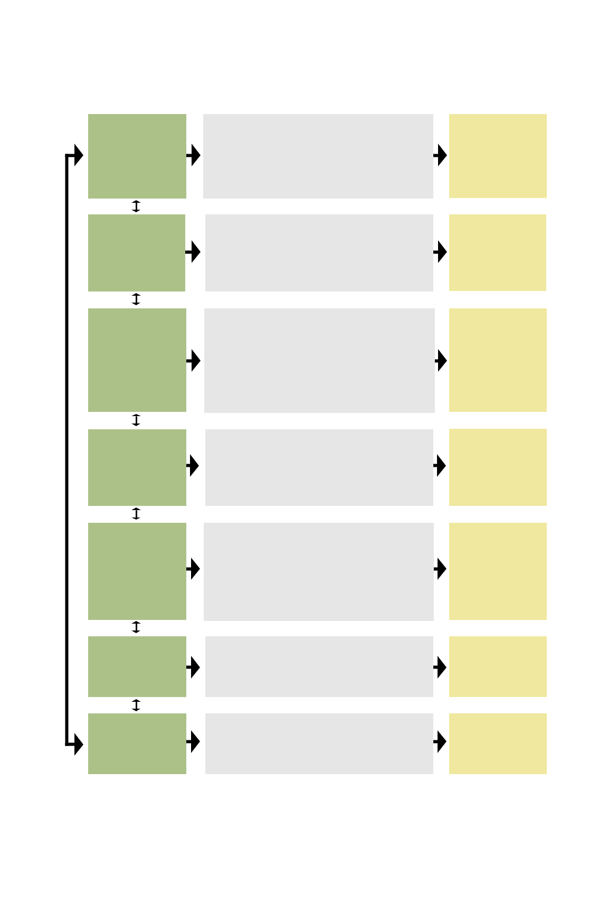
Figure 3: Stages of the subglobal IEA process. For more information, see Module 2.

PROCESS MONITORING, EVALUATION AND LEARNING

STAGES

Stage 1
Start-up
(4–6 weeks)

Stage 2
Institutional set-up
(1–3 months)

Stage 3
Scoping and
design
(2–4 weeks)

Stage 4
Planning
(4–6 weeks)

Stage 5
Implementation

(10–12 months)

Stage 6

Communication of results and outreach (1–2 months)

Stage 7

Monitoring, evaluation

and learning
(1–2 months)

ACTIVITIES

Secure legal mandate for environmental assessment and reporting.

Identify a local technical team within the lead agency. Develop a basic outline for a conceptual framework and the process, capacity, time and resources required. Hold start-up meetings to discuss, adjust, and finalise the process and institutional arrangements.

Secure commitment for resources and in-kind contributions.

Define roles and responsibilities of the political and technical partners.

Establish mechanisms of coordination among partners and

collaborating institutions.
Define an institutional framework.
Discuss the elements for the impact strategy.
Prepare a stakeholder map.

Clarify methodological issues.

Establish a geographic boundary and a detailed timeline

for producing the report.
Identify key environmental issues.
Identify indicators, data requirements and sources of information.

Draft an outline of the report.
Identify the target audience.
Develop the impact strategy.
Discuss the elements for a communication and outreach strategy.

Define activities in the process, assign responsibilities

and identify expected outputs.
Allocate financial and human resources.
Review and adjust the impact strategy and define indicators of impact.

Develop a communication and outreach strategy.
Establish a monitoring and evaluation system.

Validate priority environment and development issues and their

connection according to the IEA framework.
Collect, process and analyse data and information. Present and discuss preliminary results with relevant partner organisations.
Write the draft report, organise peer review and finalise

the report based on feedback.
Arrange for translation and publication (hard copy, CD, website, etc.).

Promote different IEA products and messages.
Organise interviews with the media.
Organise presentations for stakeholders.

Evaluate the process.
Identify lessons learned.
Evaluate the impact of the process in terms of the contribution to

policy planning, capacity building and public awareness.

OUTPUTS

MOUs reviewed.
Conceptual
framework

MOUs signed.
Institutional
framework.

Stakeholders' map.

Design document

(including
annotated structure
or outline).
Impact strategy.

Implementation plan.

Adjusted impact
strategy.
Communication
and outreach
strategy.

Publish the report and complementary results in different media.

Publish the report and complementary products in the public domain.

IEA impacts and recomendations for the future.

8


Module 2 is useful not only for IEA managers but also for professionals in private or public sectors who are responsible for conducting environmental assessments in an integrated and participatory manner.

Module 2 will describe the following aspects of the IEA process:

- Securing institutional commitment

- Identification of stakeholders and definition of their roles

- Instruments for conducting the process

- Allocation of required resources (time, human, financial)

- Interactive process design and its benefits

A key feature of IEAs is the participation and interaction of different experts and stakeholders. This module will show how to identify relevant stakeholders and their roles. Additionally, it outlines approaches for participation, which will enhance the capacities of the stakeholders to lead similar processes elsewhere.

Module 3 Overview: Developing an Impact Strategy for your Integrated Environmental Assessment

Module 3 Content

- Understanding impact

– What is an impact strategy?

– When do you prepare an impact strategy, and who is responsible for it?

– Why do you need an impact strategy?

– Understanding issue attention cycles

- Model for an impact strategy

– Attributes of impact strategies and traditional communications activities

– Steps in building an impact strategy

– Case studies of assessments that had impact

Module 3 focuses on methods to position and deliver a national IEA so that it can have real impact on environmental policy and practice, not only at the national level, but also at a regional level.

Why bother with developing an impact strategy?

In 1997 David Shenk coined the phrase “data smog,” referring to the over 3,000 information messages an average person in the United States received on a daily basis.⁴ Imagine now, 10 years later, the volume of information the average person must process, and what decision-makers must sort through each day. Simply providing yet another report to your senior bureaucrats and political leaders won’t be enough to ensure they read your findings, let alone act upon them.

4 Shenk, D. (1997). Data smog: Surviving the information glut. New York: HarperCollins.

9

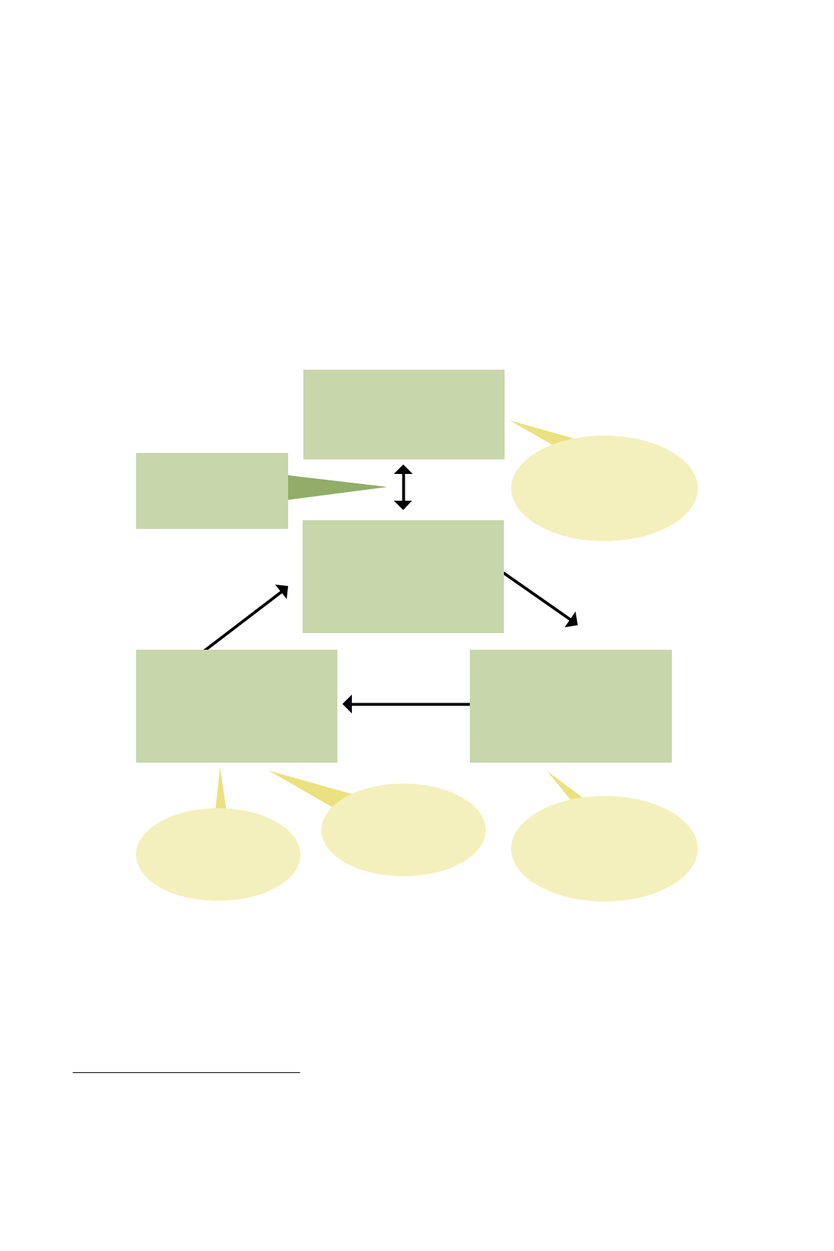
Module 3 describes the steps to engage the right people to respond to your work. This impact process takes time and involves a real emphasis on being clear and strategic in identifying the changes that should occur as a result of your assessment. The process focuses on building relationships with key people, finding out what they know already and what they need to know. That understanding is the basis to seek out and create the opportunities to get your messages across, generate dialogue, and gain the attention and support of those who may have appeared unresponsive to your work in the past.

The primary output of this module should be an outline of an impact strategy for the IEA report. At the end of this module you will have a good understanding of how to have a real impact on decision-making.

Figure 4: Model for an impact strategy.⁵ For more information, see Module 3.

Step 1

Changes you want to

influence with your work

Step 5 | External political
Step 5 | environment
Monitoring, evaluation, | environment
Monitoring, evaluation, | Other influences on decisions
improvement | Other influences on decisions
improvement | and decision-makers

Step 2

Who?

Identify relationships:

Decision-makers, influencers,

media, people who work

for NGOs, etc.

Step 4

How?

What are the opportunities? Publishing, conferences and workshops, news articles, etc.

What are your

key messages?

Step 3

What?

Knowledge to be gathered

through the assessment

and how it is to be gathered

Timing | Who is involved in the
What is the current | Who is involved in the
What is the current | process itself? Are they adding
"issue cycle"? | process itself? Are they adding
"issue cycle"? | legitimacy, credibility and
 | salient information to the
 | knowledge base?

- Source: International Institute for Sustainable Development (IISD). (2004). Securing influence and impact.
Winnipeg: IISD.

10


Module 4 Overview: Monitoring, Data and Indicators

Module 4 Content

- Developing data for integrated environmental assessment

- Information systems

– Data

– Monitoring and data collection of environmental trends and conditions

– Data compilation

– GEO Data Portal

- Indicators and indices

- Data analysis

– Non-spatial analysis

– Spatial analysis

A steady increase in reporting on environmental trends and performance during the past decade reflects the need to strengthen the evidence base for policy-making. Despite efforts to compile and analyse environmental information more systematically, important data gaps remain. Interest in fine-tuning monitoring and data-collection systems to reflect the real needs of society and decision-makers is now part of the mainstream.

Module 4 addresses how to collect, process, store and analyse data, with a particular focus on spatial data collection and the GEO Data Portal.

With data in hand, the next step will be to convert the data so it can be used in decision-making. Indicators and indices help us package data into a form that speaks to a relevant policy issue (see Figure 5). The module offers the basic building blocks of indicators and indices, including frameworks, selection criteria and elements of a participatory indicator-selection process. It also provides examples of indicators, including the GEO core indicator set.

Once you have developed indicators, you will need to derive meaning from them. What trends, correlations or spatial relationships do the data reveal? To answer these questions, it is important to be familiar with various non-spatial and spatial analysis techniques.

Reliable data and appropriate indicators are critical to the process, because poor information can lead to poor decisions. At the same time, information needs to speak to the intended audience in a relevant way. Otherwise, the most well-developed indicators could have limited impact.

11

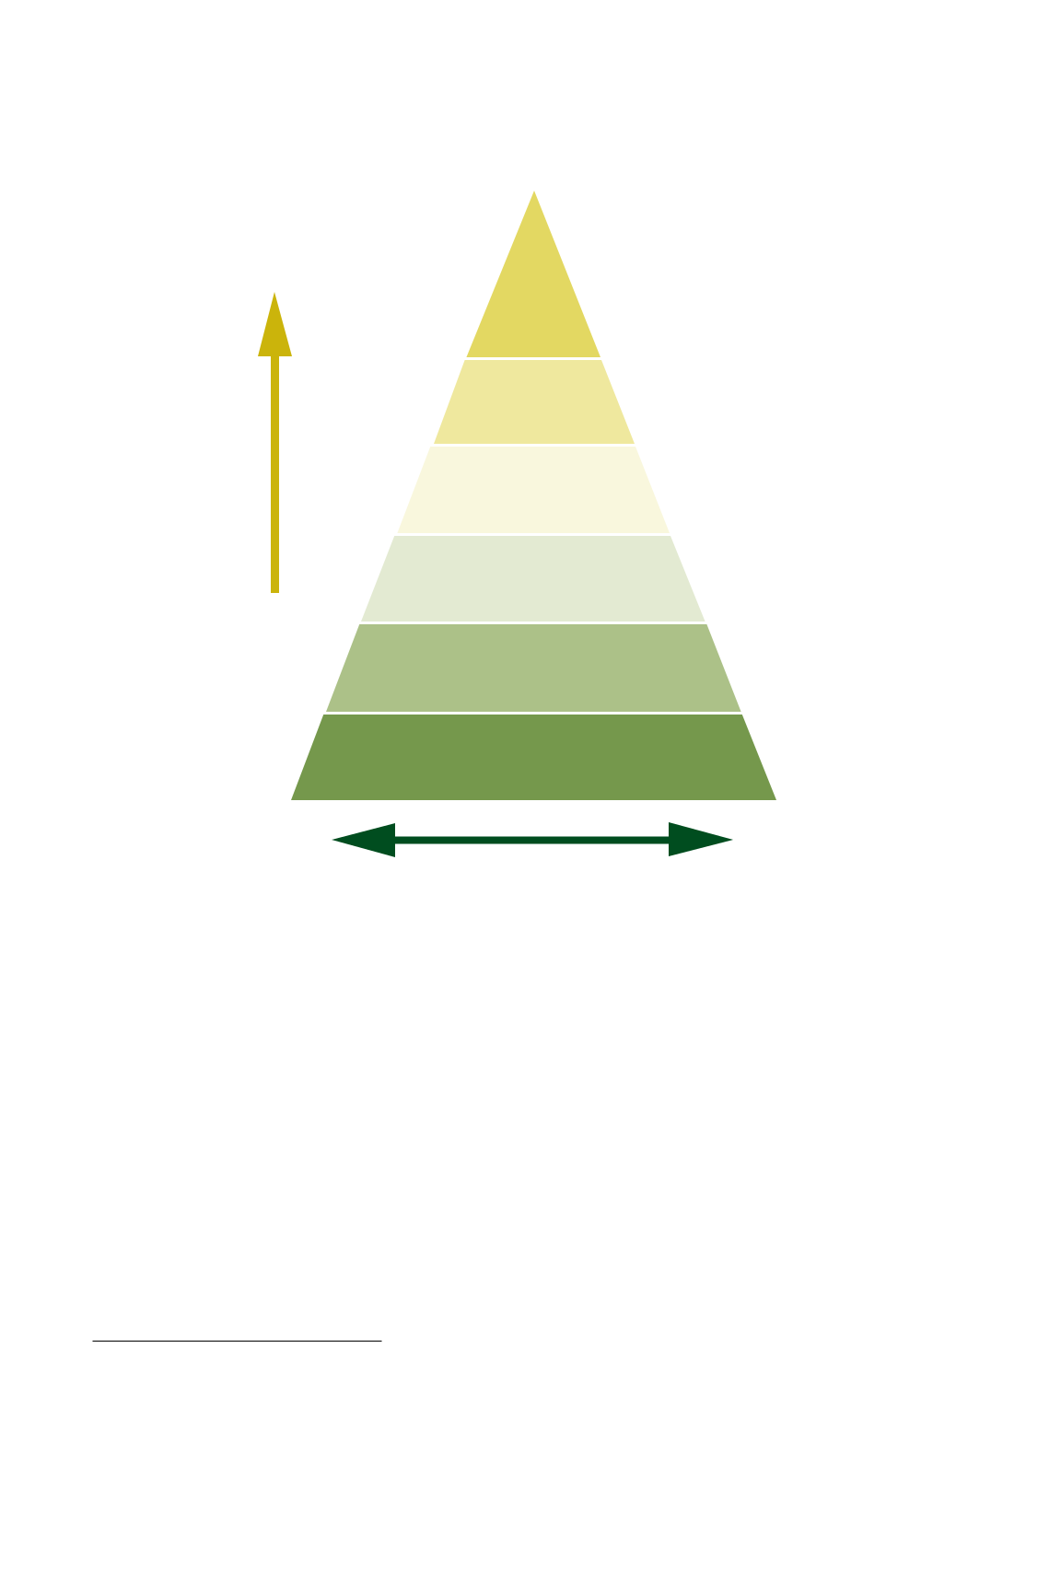
Figure 5: Relationship among data, indicators and indices.⁶ For more information, see Module 4.

Composite

indices

Simple indices

Indicators

Disaggregated indicators

Increasing

synopsis

and

integration Integrated databases

Disaggregated data and statistics

Total quantity of information

- Source: Adapted from Braat, L. (1991). The predictive meaning of sustainability indicators. Pp. 57–70 in O.

Kuik and H. Verbruggen (Eds.). In search of indicators of sustainable development. Dordrecht: Kluwer Academic Publishers.

12


Module 5 Overview: Integrated Analysis of Environmental Trends and Policies

Module 5 Content

- Spatial, temporal and thematic context

- Analytic framework for state-of-the-environment and policy analysis

- Step 1: What is happening to the environment and why?

- Step 2: What are the consequences for the environment and humanity?

- Step 3: What is being done and how effective is it?

Integrated analysis of environmental trends and policies is core to IEA. The integrated analysis described in Module 5 helps answer the following three questions:

- What is happening to the environment and why?

- What are the consequences for the environment and humanity?

- What is being done and how effective is it?

Using the GEO-4 analytic approach to the DPSIR framework (see Figure 6), Module 5 walks you through IEA, starting with an assessment of the state and trends of various aspects of the environment. The DPSIR framework will help you understand the direct pressures on the environment from human activities and natural processes, and also the higher-level drivers of these pressures via human development. Through this analysis you will see that changes in the state of the environment lead to impacts on specific ecosystem services, which can affect human well-being. In order to assess the effectiveness of society’s responses to these problems, IEA analyses policies directed at the mitigation and restoration of the environment and adaptation by humans to the environmental impacts that do take place.

You will see in Module 5 that the above analysis is a participatory process leveraging the array of perspectives offered by stakeholders. This process includes identifying priority environmental and sustainability issues, specific indicators representing these issues and relevant policy targets for their improvement.

In the analysis of impacts, Module 5 goes beyond what was conveyed in the earlier IEA training manual. Insights are also gleaned from the Millennium Ecosystem Assessment on how changes in the state of the environment can impact the services provided by ecosystems and how changes in these services impact human well-being. The module provides a glimpse into the emerging field of environmental valuation, which provides advanced techniques for quantifying the economic costs and benefits of changes in ecosystem services and human well-being.

The analysis of policy responses focuses on identifying existing policies and analysing them for their effects and their effectiveness. This involves the following steps:

- Understanding the issue to see what is happening to the environment and why, and how this is impacting human well-being and the economy.

- Conducting a policy-instrument scan to identify the mix of policies influencing the environmental issue and how effective the mix has been.

- Performing a policy gap-and-coherence analysis to determine if relevant policies are in place and are focused on the most important drivers and pressures.

13

Figure 6: Simplified analytic framework for integrated environmental assessment and reporting. For more information, see Module 5.
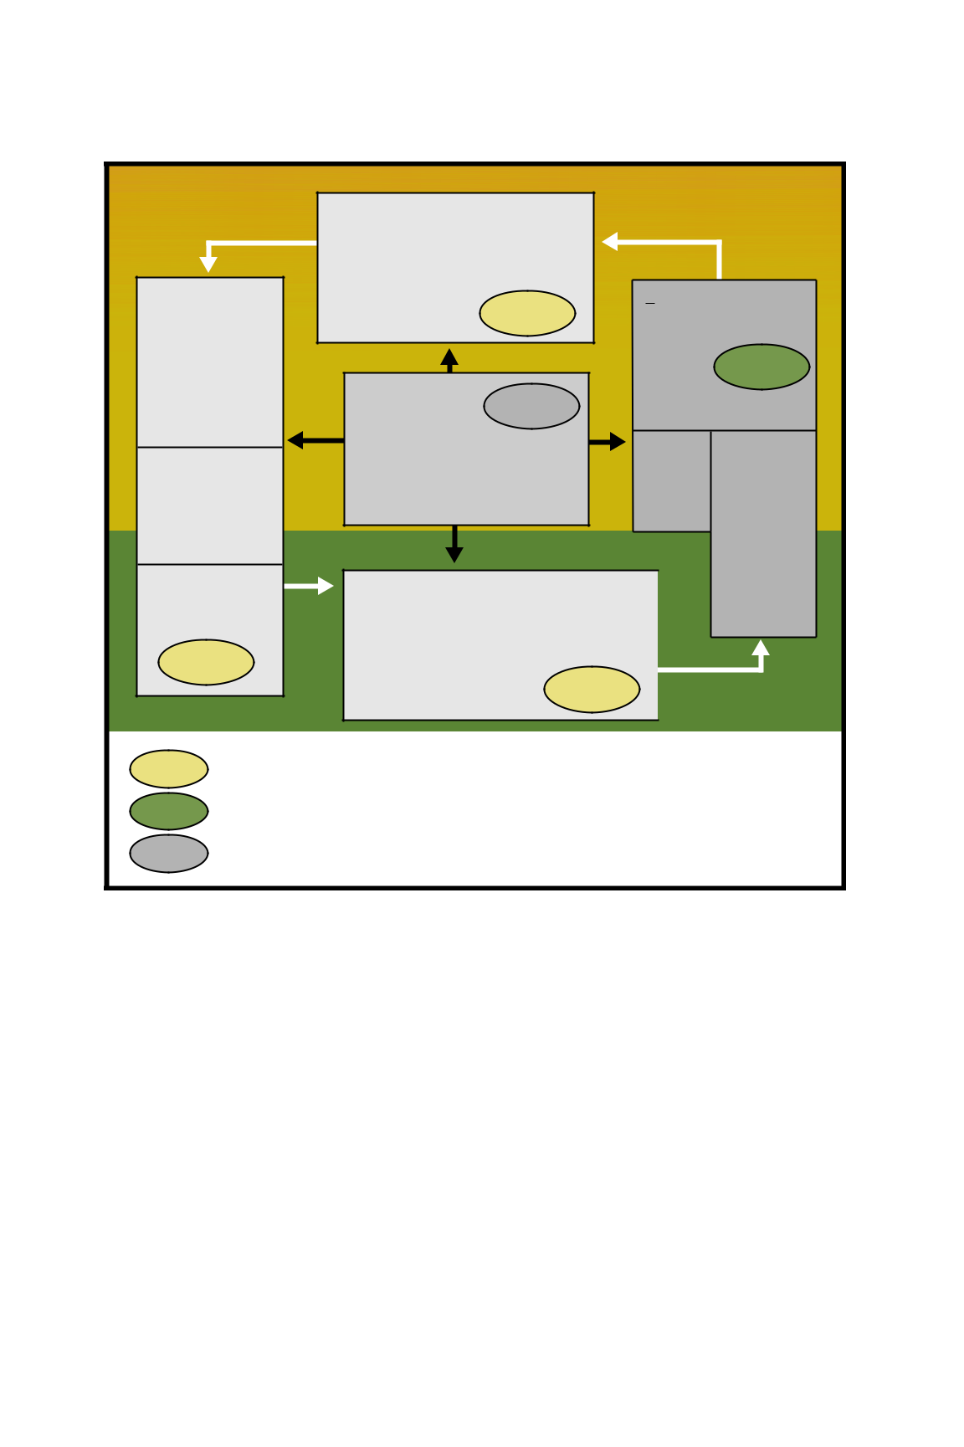Step 1
Step 1
Step 3

HUMAN SOCIETY

P – PRESSURES

Sectors:

- Agriculture, fisheries and forestry
- Transport and housing

- Finance and trade

- Energy and industry

- Security and defence

- Science and education

- Culture

Human influences:

- Emissions (pollution)

- Land use

- Resource extraction

- Modification and movement of organisms

Natural processes:

- Solar radiation

- Volcanic eruptions

- Earthquakes

Step 1

ENVIRONMENT

D – DRIVERS

- Consumption and production patterns

- Population demographics

- Scientific and technological innovation

- Economic demand, markets and trade

- Institutional and social-political frameworks

- Distribution patterns

R – RESPONSES

(Interventions)

Formal and informal

adaptation and mitigation

to environmental change by altering human behaviour within and between the D, P and I boxes, e.g., through science and technology, policy, laws and institutions, and coping capacity.

S – STATE (Environmental Change)

State of atmosphere, land and water, and trends such as:

- Climate change (also referred to as a direct driver)

- Desertification and land degradation

- Loss of biodiversity

- Pollution and degradation of air,

land and water

I – IMPACTS

- Human well-being (International goals and targets)
- Material needs

- Health
- Security Step 2
- Freedom of choice

- Vulnerability to change in:

Economic |  | Environmental:
and social: |  | - Provisioning
- Goals |  | services (goods)
- Services |  | - Regulating
- Stress |  | services
 |  | - Cultural
 |  | services
 |  | - Supporting
 |  | services
 |  | - Stress (e.g.,
 |  | diseases and
 |  | hazards)

Step 1 What is happening to the environment and why?

Step 2 What are the consequences for the environment and humanity?

Step 3 What is being done and how effective is it?

14


Module 6 Overview: Scenario Development

Module 6 Content

- What is a scenario?

- A very short history of scenario development

- Examples of scenario exercises

- The purpose, process and substance of scenarios and scenario exercises

- Policy analysis

- Developing scenarios: A complete process

Module 6 will help you develop scenarios and analyse them, either in terms of the impact they would have on existing policies or of the kinds of policies that would be needed in order for a particular scenario to unfold. The module provides the basis for an entire process for developing and analysing scenarios.

A scenario is not a prediction of what the future will be. Rather, it is a description of how the future might unfold. Scenarios explore the possible, not just the probable, and challenge users to think beyond conventional wisdom. They support informed action by providing insights into the scope of the possible. They also can illustrate the role of human activities in shaping the future, as well as the links among issues, such as consumption patterns, environmental change and human impacts.

Scenarios were first used formally after World War II as a method for war game analysis. Their value was quickly recognised, and the use of scenarios for a number of other strategic-planning applications developed. Today, scenario development is used in a wide variety of different contexts, ranging from political decision-making to business planning and from global environmental assessments to local community management.

There are hundreds of examples of scenarios developed during the last 30 years or so. A small number are selected in this module to illustrate the range of scenarios that have been developed, from specific country or regional exercises to global visions of the future, covering a range of time frames from 10 to 100 years. The illustrations in this module are the Mont Fleur scenarios for South Africa, the GEO-3 scenarios and the Intergovernmental Panel on Climate Change scenarios.

A range of processes has been used to produce scenarios. We can distinguish among these according to three overarching themes: project goal, process design and scenario content. Goals might include raising awareness, stimulating creative thinking and gaining insight into the way societal processes influence one another. A usual overriding goal is to support decision-making, either directly or indirectly. Process design addresses aspects such as the scope and depth of the analysis, the degree of quantitative and qualitative data used, and choices among stakeholder workshops, expert interviews or desk research. Scenario content focuses on composition of the scenarios (that is, on the variables and dynamics in a scenario and how they interconnect).

While many different processes have been used to develop and analyse scenarios, most involve steps similar to ones used in this module, although emphasis on particular steps varies. Figure 7 shows the steps used in this module.

15


Figure 7. A snapshot of the scenario process. For more information, see Module 6.

Establishing the nature and Identifying and selecting
scope of the scenarios (a) stakeholders/participants (b)

Identifying themes, targets, indicators
and potential policies (c)

Clarifying the purpose and structure of the scenario exercise

Identifying driving forces (d) Selecting critical uncertainties (e)

Creating a scenario framework (f)

Laying the foundation for the scenarios

Elaborating the scenario narratives (g) Undertaking quantitative analysis (h)

Exploring policy (i)

Developing and testing the actual scenarios

Communication and outreach

A full scenario process would ideally involve going through each of the above steps. In many cases, however, the scenario development will be nested within an overall IEA and reporting process. Thus, to the extent possible, the scenario development should be pursued in concert with the other components of this process, such as those described in Modules 4 and 5. Furthermore, we often avoid developing completely new scenarios, particularly in a national-scale IEA process. Instead, scenarios at the national level or below are developed based on existing scenarios at a higher level (for example, global and regional scenarios developed for GEO).

GEO-4 considers four plausible futures looking out to the year 2050: Markets First, Policy First, Security First and Sustainability First. These scenarios explore how current social, economic and environmental trends may unfold and the implications for the environment and human well-being. The scenarios are defined by different policy approaches and societal choices. In Markets First, the private sector, with active government support, pursues maximum economic growth as the best path to improve the environment and human well-being. Policy First assumes government, with active private and civic sector support, initiates and implements strong policies to improve the environment and human well-being, while still emphasising economic development. In Security First, government and the private sector compete for control in efforts to improve, or at least maintain, human well-being for mainly the rich and powerful in society. Sustainability First presumes that government, civil society and the private sector work collaboratively to improve the environment and human well-being, with a strong emphasis on equity.

16


Module 7 Overview: Creating Communication Outputs from the Assessment

Module 7 Content

- Choosing what to produce

– Target group(s)

– Content

– Budget

– Formats

– Consider your channels

- How do we do it?

– Print products

– Electronic/digital products

– Visual presentation of data in the IEA

- Reaching out with the outputs of the IEA

– Dissemination

– Approach the media

– Communicating sustainability: Long-term approaches

There are many techniques and products to communicate the results of an IEA. Module 7 guides you through the communication process, showing how to get the messages to the audiences you want to reach.

Before producing the main report and other products, a series of important decisions need to be made. Identify the target audiences to be better able to shape your message and select the right content and, later, the right presentation format. By carefully considering available resources, including budget, you can make better decisions about which products will be most beneficial.

Decide what kinds of information products best suit your message and target audience. Materials can be printed (such as popular reports, flyers, posters and brochures), electronic (for example, websites and CD-ROMs) or visual (such as photos, graphics and maps), and each type has its advantages and disadvantages. Module 7 discusses the strengths and weaknesses of different channels. It also provides guidance on how to go about approaching the media.

In addition to written materials, this module gives concrete suggestions about ways to express your message visually.

Effective production and dissemination require good planning and organisation. You need to evaluate internal and external resources to best meet your needs. Not everything can be produced in-house; often it is best to use external providers for services such as cartography, web design, editing and printing.

Finally, the module provides advice on building long-term communication strategies.

17

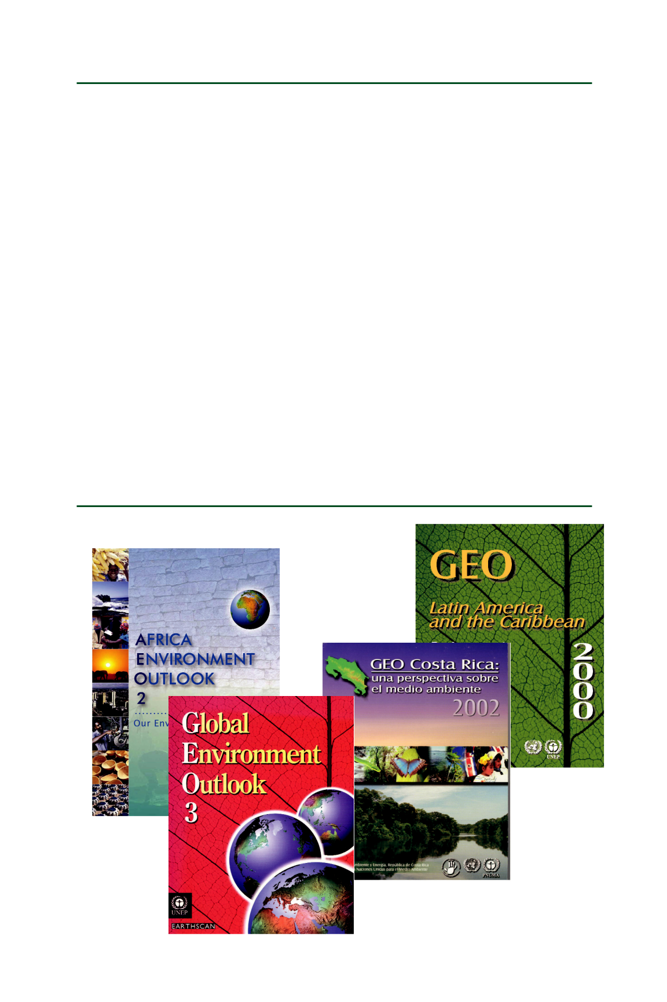
Box 3: Common steps in the production of a printed IEA report.

The following list summarises common steps in the production of a printed IEA report.

- Specifications. Provide rough specifications on the organisation of the publication, its size and your design guidelines. In some cases, provide a dummy report.

- Contents. Produce text and choose graphics and pictures. At this stage it is important not to forget any elements such as picture text, references and headings.

- Translation. Arrange for translation if needed.

- Predesign. It can be useful to test the design in order to be able to make revisions before developing all the contents.

- Layout. Wrap all the content in the design chosen.

- Proofreading. This is the last chance to make revisions before the report goes to the printer.

- Test print. You should always ask for a test print in order to get rid of any last mistakes, correct colours, identify missing elements and so on.

- Print. Now your major concern is to make sure the printed report is ready on time, meets quality expectations and is within budget.

- Quality control. Quality control should occur throughout the whole production process.

Figure 8. Covers from a variety of GEO reports.

18


Module 8 Overview: Improving the IEA Process and Increasing Impact through Monitoring, Evaluation and Learning

Module 8 Content

- Foundation of effective monitoring and evaluation

- Framework, attributes and measures

- Self-assessment matrix

- Improvement opportunities

How do we know whether an assessment is useful and used, rather than just sitting on a shelf? Module 8 offers tools to help you monitor and evaluate the effectiveness of your IEA.

In Module 8 you will learn to develop a monitoring and evaluation plan, based on seven questions:

- What is the purpose of the evaluation?

- Who will use the evaluation results?

- Who will do the evaluation?

- What evaluation framework is practical?

- What needs to be monitored and evaluated?

- What are the steps to developing a self-assessment matrix?

- How can you use the evaluation to enhance a learning culture that keeps improving your IEA process?

Module 8 promotes an improvement-oriented evaluation that aims to increase the effectiveness of your IEA process by feeding lessons learned into the next cycle. Learning plays a central role. It shapes the monitoring and evaluation process and connects knowledge creation to policy-making.

Module 8 will help you to make sure that your IEA has an evaluation component and will show you a way to design an effective evaluation that keeps improving your IEA process.

As part of designing an effective evaluation, you will develop measures to monitor and evaluate key outcomes from your IEA (see Figure 9), relating to the change statement from your impact strategy and the important relationships you need to manage to achieve impact (see Module 3). You will also develop measures to monitor the timely completion of key activities and outputs of your IEA process, relating to the important knowledge you will generate in your IEA and the opportunities you need to leverage in order to effectively communicate the results of your IEA to your target audiences.

For Module 8, you need to be familiar with the stages for developing an IEA (see Module 2) and your impact strategy (see Module 3).

19


Figure 9. Framework for monitoring and evaluating the national IEA process. For more information, see Module 8.

OUTCOMES

Improvements in policies

and policy processes

Measuring changes in policies and policy processes both

during and after the IEA process and comparing with the desired

impacts from your impact strategy (refer to Module 3).

Effective relationship management:

Measuring changes in the thinking and actions of

policy- and decision-makers

Measuring aspects of effective relationship management

(e.g., stakeholder identification and engagement)

ACTIVITIES and OUTPUTS

Timely completion

Measuring the timely completion of

key activities and outputs

Effective knowledge management

Measuring saliency, credibility and legitimacy

of the IEA report

Effective opportunity management

Measuring communication opportunities

that are being leveraged

Volume 2:

Module VIA: Vulnerability and Impact assessment for Adaptation to Climate Change

Module A Content

- Characteristics of vulnerability and scope of the assessment

– Defining vulnerability

– Vulnerability to climate change

- Vulnerability assessments and the DPSIR framework

- Monitoring vulnerability

- Impacts of climate change and their assessment

- Creating responses—determining the adaptation options

– Mainstreaming climate change into development decisions

– Developing adaptation responses

- Prioritising adaptation responses

- Developing a basic implementation plan and a communication strategy

– Implementing adaptation responses

– Communicating climate change and adaptation

20


This module focuses on key approaches to help in the assessment of vulnerability to and impacts of climate change in the context of non-climatic stresses and their integration with other drivers and pressures. The module further outlines the key elements of an implementation and communication strategy.

Supported by examples and exercises, the module describes the process for addressing climate change in the context of other development priorities to help in moving toward a more sustainable and resilient development pathway.

Box 4: Steps in assessing vulnerability and adaptation to climate change

The following lists the steps used in the module:

- Initiating the work on climate change and adaptation

– Making climate change relevant

– Building a stakeholder team to address climate change

- Addressing climatic and non-climatic vulnerabilities

– Defining vulnerability

– Specifying vulnerability to climate change

– Defining criteria for climate change vulnerability assessments

- Identifying linkages between climate change and other development challenges

– Integrating climate change with other local and regional pressures and drivers

– Identifying adaptation options

- Prioritising and implementing responses

– Assessing adaptation options

– Developing an implementation strategy

– Creating a communication strategy

IEA Community Platform

In order to support the growing community of IEA trainers worldwide and to encourage continuous improvement of the training materials, the IEA Community Platform (www.unep.org/ieacp) was developed in 2008 through collaboration among UNEP, GRID Arendal and IISD. The Community Platform provides access to the entire IEA Training Manual and all associated materials. It also serves as a tool for exchanging comments and suggestions related to individual modules and their use and has a built-in discussion forum for IEA trainers and a databank for IEA case studies.

The Community Platform aims to support and encourage collaboration among practitioners, experts and educators who are involved in IEA capacity-development activities by:

- Providing broad access to the tools, methods and results of IEA capacity development and training

21

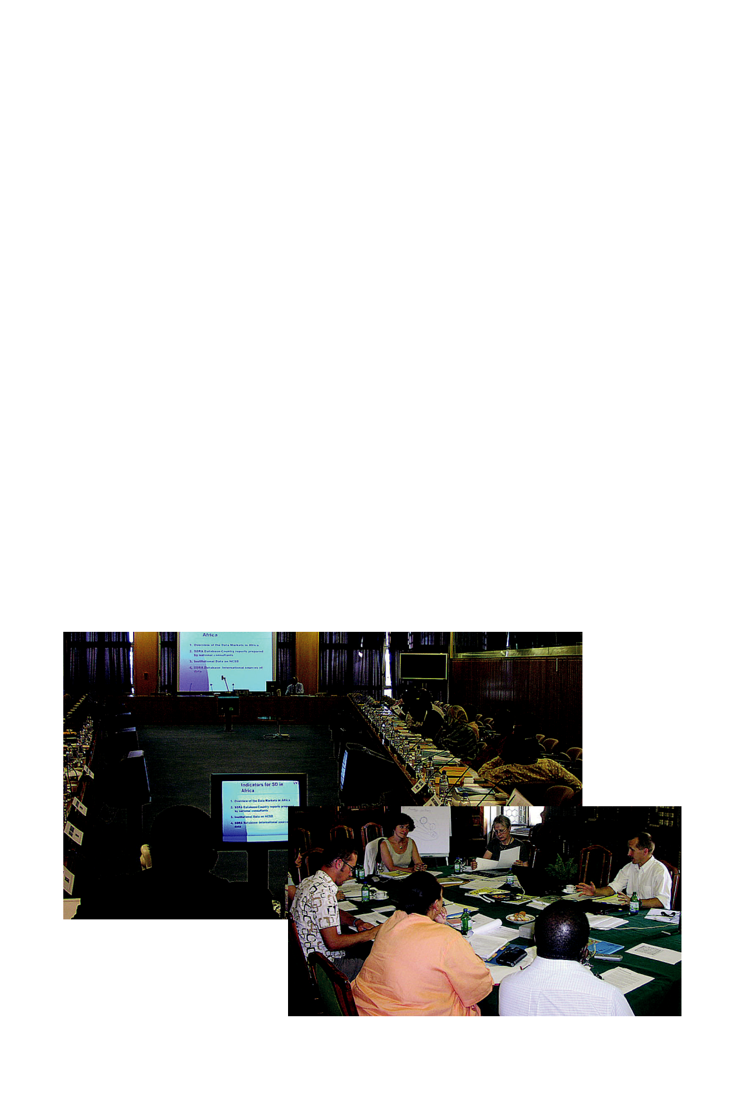
- Facilitating exchange of experiences, tools and lessons learned through IEA capacity-development activities

- Facilitating online training and discussions to encourage development of new IEA resources and their efficient use.

Who will benefit?

IEA practitioners, educators, representatives of national and regional authorities, technical experts and consultants interested in more efficient use of IEAs and professional development.

What are the benefits?

- Access to resources

- Opportunity for faster learning and a higher level of knowledge

- Access to IEA experts, practitioners and experienced trainers

- Promotion of your ideas and practices related to IEA

- Possibility to improve your training skills and skills in IEA

- Information on UNEP Division of Early Warning and Assessment IEA-related training events globally and regionally

The Community Platform includes an IEA trainers and practitioners database, which includes all IEA-certified trainers who support the delivery of the IEA training package. The database includes information on each trainer and expert, including, at minimum:

- The name of the trainer

- The region where she or he is based

- The languages he or she speaks

- His or her area of expertise

22


E-learning modules

In order to broaden the reach of IEA training, in 2008 UNEP and IISD started to develop an e-learning program based on the training manual. This e-learning is viewed as an additional and important part of the IEA capacity-development toolkit that can usefully complement face-to-face training activities and offer a different learning experience. All modules in the manual are being adapted for e-learning and will be available by late 2009 at www.unep.org/mentor.

A Final Thought

As this quick journey through the IEA Training Manual illustrates, integrated environmental assessment requires continuous learning and improvement. Ideally, IEAs are not one-off exercises but integrated, ongoing elements of environmental and sustainable development governance. That is how real learning can take place.

IEAs can play several roles in governance. They can:

- Help realise past successes and failures and their underlying causes.

- Improve our understanding of the interlinkages between the environment and human well-being and anchor policy-making in facts on the ground.

- Increase awareness of interactions among the many global and local forces of environmental change and facilitate cross-scale coordination.

- Build capacity to recognise the challenges ahead and help articulate key environmental targets and policy options to achieve them.

Realising the potential of IEAs in improving governance and decision-making requires not only effective assessment tools but also meaningful engagement with audiences through a participatory assessment process. The duality of process and products is an essential feature of the GEO approach to IEA.

While capacity can be built through training exercises, true capacity will emerge through the process and practice of actually conducting an IEA. The practitioner community is already large, built through UNEP’s comprehensive GEO process, its many subglobal applications and other related assessment initiatives. UNEP, along with its other partners in IEA capacity building, will continue to support and maintain a network of practitioners to share experiences and to learn together.

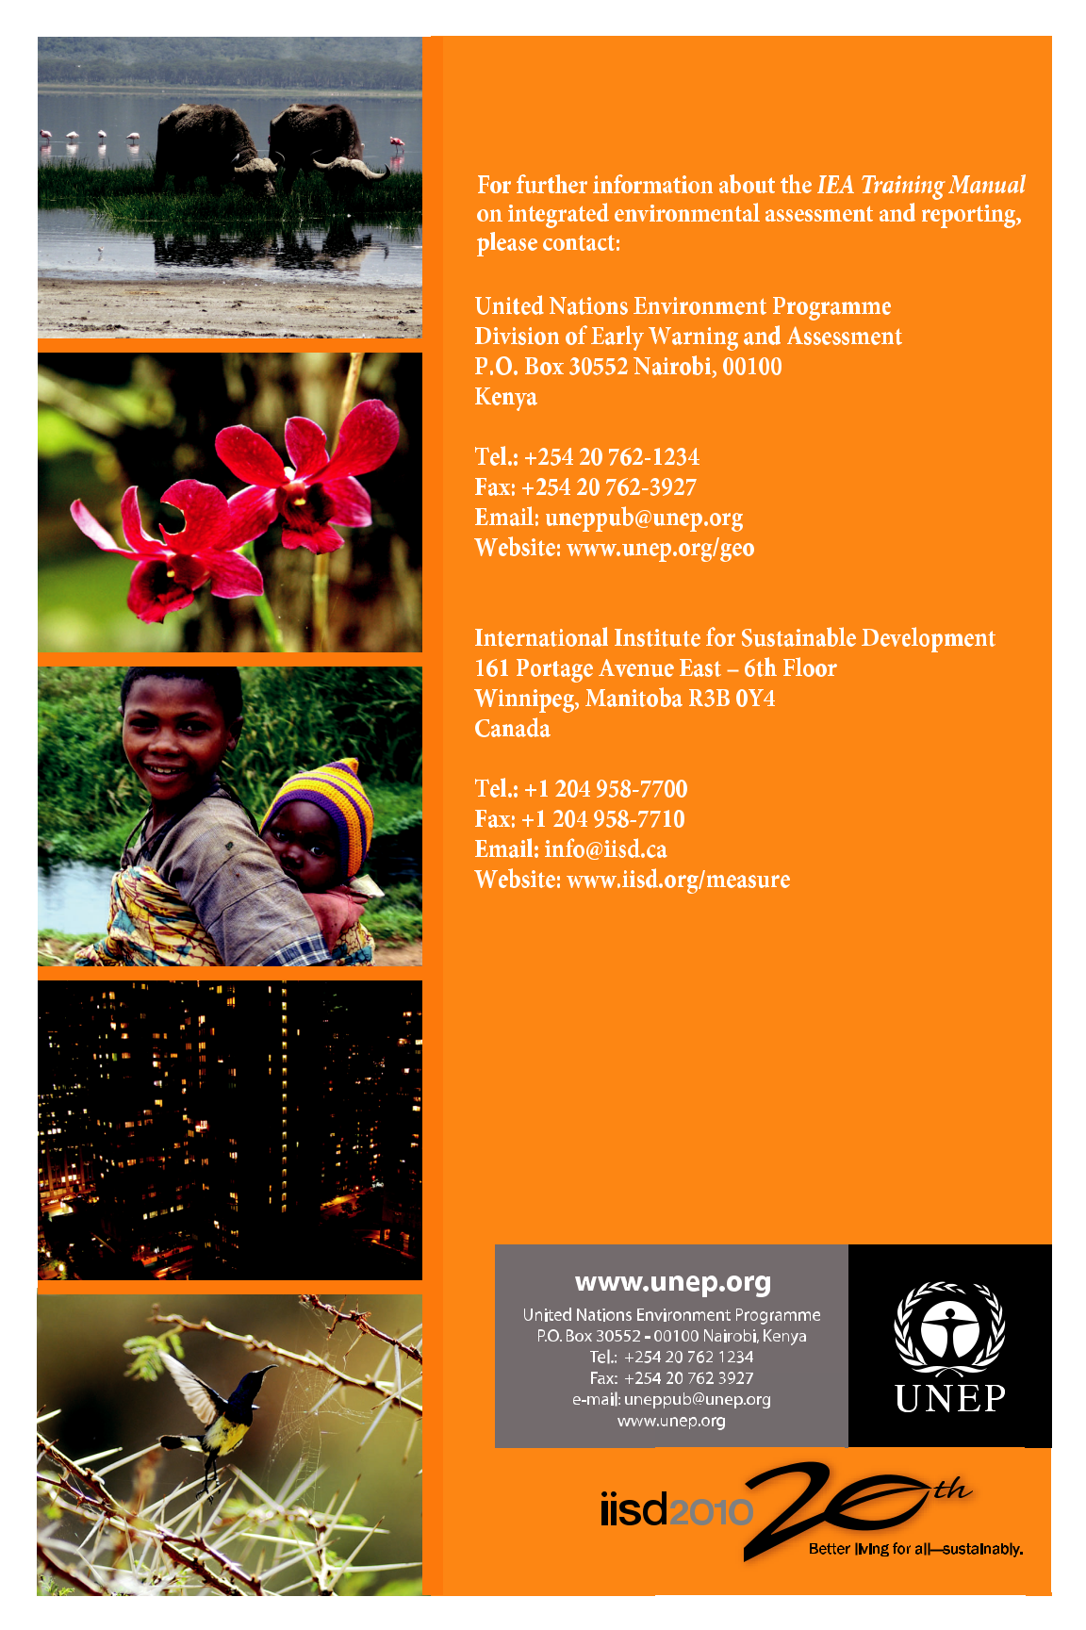
23

