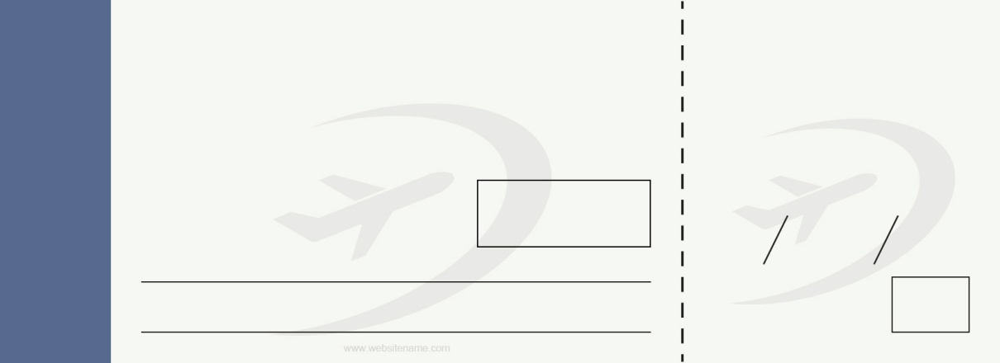Untitled-1.pngUntitled-1.png

08 B

18-45

18-45

Boarding Till

B 54321

6 jan 2020

07

08 B

B 54321

6 jan 2020

07

lorem ipsum

lorem ipsum

lorem ipsum

lorem ipsum

lorem ipsum

lorem ipsum

Seat

Flight

Date

Gate

To

From

Name of passenger

Boarding Till

Seat

Flight

Date

Gate

Name of passenger

From

To

AIRLINE NAME

BOARDING PASS

AIRLINE NAME