Text Description for Poster Sample

TAN AND BLACK

TERRIER MIX

Last seen near Main St. and Secondary St. in

Yourtown on 2/5/15. Was wearing a black collar with white bones and tags. Medium size, about 40lbs. He is friendly with people and dogs.

If spotted or caught please call

908-526-3330

Template for Handout Flyer Example

REWARD

INSERT CLEAR

PET PHOTO HERE

LOST DOG/CAT

BRIEF DESCRIPTION/MEDICAL NEEDS

Description of lost pet including: general height/weight, nature of pet (friendly/timid/etc.), detailed coloring, any distinguishing markings or characteristics. Also include where the pet was lost and phone numbers where you can be reached at. Make sure all phone numbers are correct and current and number is bolded.

Please call (111) 111-1111

SOCIAL MEDIA TIPS

Using Social Media:

Social media sites such as Facebook and Craigslist offer a quick and effective way to spread the word about a lost/found pet. While Facebook is more prevalent in our daily lives, Craigslist can also be an effective way to check for or alert your community to your lost pet. Anyone using the sites will be able to easily share the information with friends and family. There are many pages on Facebook for lost and found pets in that are specific to counties and regions, towns and state-wide. In addition to the lost and found groups, be sure to check town websites, veterinarian office/hospital pages, local shelters or rescues and other animal based pages. While every group/page may differ in what they require for a post they tend to share many core requirements.

Information Typically Needed:

Photo(s) of your pet Type, gender, age

Important information including if pet has clipped wings, declawed, needs medication, etc. Microchip # or if pet is not chipped

Location pet went missing from and place of last sighting

Information such as if the animal knows the area, if pet is skittish or friendly, dog /friendly

Avoiding Scams:

If someone contacts you claiming to have found your pet, there are a few measures you can take to ensure they actually have your pet. If your pet has any traits or characteristics that you have not shared yet do not address them as facts. Rather than asking “Does he have a kink in his tail?” you can either ask for a general description of the body or even “Can you describe his tail?” This will help with determining who actually has your pet and who is deceitful.

General Tips:

Share on multiple platforms – do not limit your search to one audience.

Check every lead as not everyone will know the names for coloring and breeds while size and length of fur may be relative to what the finder is accustomed to. Just as a Belgian Malinois may be listed as a German Shepherd Mix or a brown and black dog, a 30lb mix may seem like a large dog to someone with a 10lb dog. A tortoiseshell cat may be listed as a black and brown or black and orange cat.

It is also advisable to meet somewhere public such as a police station or a veterinary hospital and also speak with someone at your choice location about your situation and to verify that meeting someone there is allowed and will not interfere with daily operations.

Never use social media as a sole form of searching for your lost pet.

Helpful Links on Facebook:
St. Hubert’s Pet Retention | facebook.com/StHubertsPetRetention
Lost and Found Pets New Jersey | facebook.com/pages/Lost-and-Found-Pets-New-
 | Jersey/165544503515421
Helping NJ Animals | facebook.com/HelpingNJAnimals
Lost & Found Dogs and Cats of Northern NJ | facebook.com/LostFoundDogsAndCatsOfNorthernNj
Middlesex County NJ Lost and Found Pets | facebook.com/MiddlesexCountyLostPets
Lost and Found Pets in South Jersey | facebook.com/groups/lostandfoundpetsinsj/
Lost Dogs of South Jersey | https://www.facebook.com/LostDogsofSouthJersey

Poster Explanation Sample

THIS IS AN EXAMPLE OF

WHAT A MISSING PET

POSTER SHOULD LOOK

LIKE

All too often flyers go unseen because they blend in! Ensure everyone sees your posters by following this model.
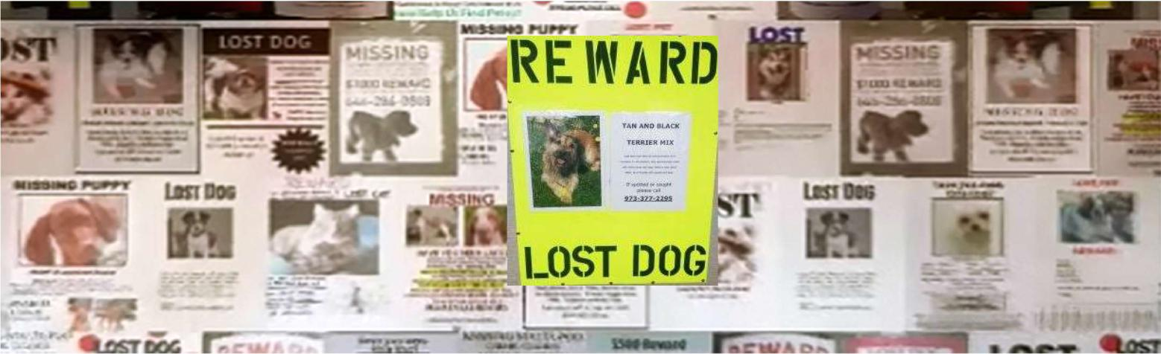

Please inquire within for lost pet assistance and free posters to aide in your search!

MISSING PET RECOVERY TIPS Sample

If you did not see your pet escape but cannot find him/her make sure to conduct a thorough search of your home including inside the underside of beds, couches and other chairs/sofas, attics and basements. Conduct a thorough search of your yard if applicable.

If possible have friends/family help search or assist in other ways.

The initial hours after your pet goes missing are crucial so start right away!

Search your immediate neighborhood including several blocks in each way, calling out your pets name, squeaking his/her favorite squeaky toy and pausing after to listen for any noises he/she may be making.

Ask around! Mention your missing pet to anyone you see walking around and ask if they saw a dog/cat in the area. If walking around at night make sure to have a leash with you and a flashlight to look for reflections of animal eyes.

Make posters and flyers up for your pet including “LOST DOG/CAT” in large letters, a large color photo, location last seen, behavior information (shy, friendly, etc.) and contact information.
Hand out flyers to neighbors, mail carriers, veterinary offices, local businesses, libraries, grocery store bulletin boards, etc.
Posters should be on vertical and neon colored poster board (size recommendation is 22”x28”) with an 8.5”x11” flyer in the middle. LOST DOG/CAT should be approximately 4” tall in thick permanent black marker. Flyer should be taped to poster inside a clear page protector to protect from rain damage.
Call your local animal shelters, rescues, animal control, veterinary offices/hospitals and police stations.
Place an ad on lost and found pet pages/groups on Facebook and/or Craigslist and contact newspapers to place ads.
Visit local animal shelters and rescues and ask to see any animals that have come in since your pet went missing, ask about leaving a photo with your contact information.
If your pet has been missing for several weeks consider asking local shelters or animal control if they rent out humane traps to safely catch your pet.
Another method is creating a page on Facebook such as “Bring Kitty Home” or “Where is Rover?” which will help broadening awareness of your missing pet but you may receive a helpful ‘outside of the box’ tip of what worked for someone who had lost a pet previously.

Be persistent, check as often as you can and do not give up hope- pets can be found days, weeks or months after they initially went missing.
Do not give up hope!

MISSING CAT RECOVERY TIPS Sample

Indoor Only Cats:

Cats are extremely territorial and the territory of an indoor only cat is often only inside They are also extremely scent oriented so be sure to take that into account
An indoor only cat who has gotten outside may become tremendously fearful of his new surroundings and look for the first place that offers protection or camouflage and hide in silence
Due to the fear, cats likely will not come when called

A majority of indoor only cats are found within a 5-home radius of where he went missing from Immediate search should be in the vicinity of his home and yard if applicable, then broaden
Check under cars, decks and gardening supplies/equipment, etc. since cats can fit into the smallest of spaces- leave no stone unturned
In addition to leaving out food and water for your cat, leaving out his/her used (do not clean it out) litter box and a blanket with his scent and yours may help him find his way back home
While going door to door ask if they would be willing to let you look under their deck/around their yard and garage
If you have a garage consider leaving it open slightly so that your cat may find his way in

Humane traps are effective and should be considered and placed within a close proximity to your home or where sightings have occurred

Outdoor Access Cats:

Cats with access to the outdoors will have a larger territory than indoor only cats, so focus on the areas you know your cat has been known to be
Outdoor access cats are likely within their territory so be sure to conduct a detailed search If your cat was chased by a dog or a predator, he may have gone outside his natural territory
and is hiding due to fear and disorientation

Humane traps are effective with outdoor access cats as well, however be sure to place the traps where you can monitor them via sight or wildlife camera
If using a wildlife camera be sure you can reach the trap quickly should any animal be caught to prevent harm to the animal via weather or predators

General Tips:

Cats are crepuscular, which means they are most active during dawn and dusk, try to conduct extra searches during these hours and speak with people

During the evening/night hours, use a flashlight to look for the ‘eye shine’ of cats To ensure a thorough search, ask neighbors if you can search their yards

Shy, skittish or fearful cats in general often exhibits behaviors most people think to be that of a feral cat so be sure to check with animal control frequently
Check with shelters frequently, visiting as often as you can in case your cat has been brought in Ask neighbors with garages if they would leave their door open slightly along with placing a

blanket and food/water

MISSING DOG RECOVERY TIPS

Extremely Social Dogs:

Likely to approach/come to any person who calls them

These types of dogs are likely to be taken in to someone’s home or brought to a shelter Canvas the area and go door to door talking to people

If you have more than one dog and your missing dog is social, consider bring your other dog with you on search to further entice your missing dog to come out
If your dog has a favorite noisy toy, bring it with you on your search and use that noise Hang large neon posters and hand out flyers to people and local businesses

Contact local shelters with a detailed description of your dog including microchip # if applicable, ask if there is an e-mail you can send a photo to or a way they can share it online
Share you’re a photo of your dog and information on multiple lost pets facebook pages/groups, consider posting an ad on craigslist
Visit shelters and rescues in person frequently

Leave your dogs bed/crate out with his and your scent on it

Shy and Fearful Dogs:

Less likely to approach people, even the owners in some cases, or come when called due to fear Distance traveled will depend on is he/she has been chased by anyone in effort to catch him/her If you have more than one dog and your missing dog is fearful, bring your more social dog on a

long training lead or long/dragline

May be recovered later than a social dog due to wariness of surroundings and people May eventually come out to find food but are prone to running at sudden movements
May need to be humanely trapped, so call shelters/animal control to see if they rent out humane traps for dogs
Consider renting/purchasing a wildlife camera to catch footage of what is coming around the trap so it can be effectively trapped
Canvas the area, hang posters, distribute flyers, share on social media (be sure to note something to the effect of “Fearful, do not chase!”, call shelters and rescues

Contact animal control and check in frequently to see if there have been any sightings or if dogs matching the description of your dog have been brought in

General Tips:

Dogs that escape due to opportunity (gate/door left open, habitual diggers or climbers, etc.) are more likely to be closer to home than a dog who is running due to panic or extreme fear
Consider tagging your car with paint markers, this turns your vehicle into a mobile flyer advertising your missing dog- hang a large color photo in window if possible

MISSING PET PREVENTION

There are few things more terrifying to a pet owner than when you suddenly realize your pet is missing. Here are some simple steps you can take to ensure your pet stays safe!

Dog Tips:

Keep tags up to date

Get your dog microchipped and keep your information with the microchip company up to date Consider writing/sewing your phone number on the inside of a flat collar if you dog cannot wear
tags due to allergies or other sensitivities

Use a flat collar only for ID tag purposes and not for walking to reduce the risk of it breaking To prevent your dog from backing out of his/her collar use a martingale, or no-slip, collar
Periodically check the fit on your dog’s harness and collar so he cannot slip out in a panic

Periodically check fencing to ensure there are no areas in need of maintenance that may result in your dog squeezing through
Check that nothing is placed next to the fence high enough to allow a dog to climb or jump over If your dog has a history of climbing fences consider installing Coyote Rollers
(http://www.coyoteroller.com)

During transport or any time your dog will be in and out of a car consider having someone hold his/her leash the whole time, not having the back windows open too much, having only one door open at a time when exiting the vehicle and having your dog in a crate until secured inside

Cat Tips:

Keep tags up to date

Get your cat microchipped and keep your information with the microchip company up to date Find a collar that is stretchy and soft with a Velcro closure, this will enable your cat to escape
should he be caught on anything so they will not wind up strangled but not break as easily as a plastic buckle

Always transport your cat in a carrier

Periodically check your cats carrier to ensure all parts are in working order and close/lock securely
If your cat is accustomed to wearing a harness to enjoy outdoor time, routinely check that nothing is frayed and it fits correctly
Never fit your cat for a harness outside

If you have a door darting cat, consider behavior modification/training so they do not attempt and wind up successful at getting outside
Check any screen doors or windows routinely for safety and security to prevent your cat accidentally escaping

Lost Pet Posters Sample

Keep it simple, large and BRIGHT!

Suggested size is 28”x22”

Keep them NEON to stand out from other signs and attract attention

Use 5 words or less –

LOST DOG/CAT,

REWARD LOST

DOG/CAT

Letters should stand a minimum of 4” tall

Hang posters vertically to reduce likelihood of posters becoming damaged by weather

Include one 8.5”x11” color photo of your pet (example photo was printed on a home computer) and on another include a description and contact information with a large phone number in a sleeve protector. Seal with clear packing tape.

4” stencils used on 22” x 28” poster
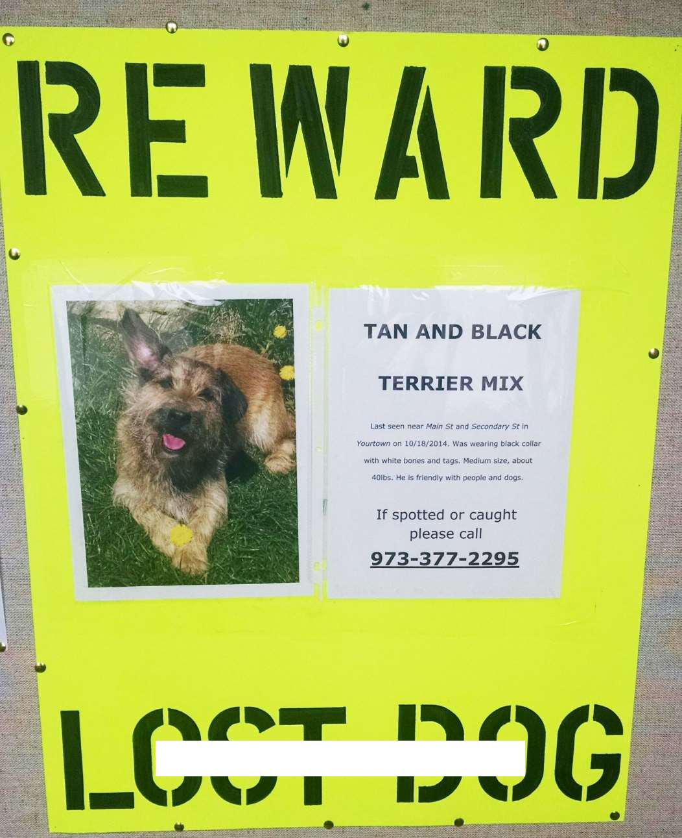

Hang posters at

intersections, near the last place the animal was seen and at any places where sightings took place. You can also display posters on yard signs in your yard.

FLYERS FOR MISSING PET RECOVERY POSTERS

KEY INFORMATION:

Use standard 8.5”x11” printer paper to print your flyers

Print on plain white paper to stand out against your neon poster

Place each flyer inside a plastic sheet protector and affix to poster board with clear packing tape Keep the text easy to read, adjust spacing and font sizes as necessary.
Note any tags or collar pet was wearing if applicable.

It is helpful to let anyone seeing your poster know if your pet is friendly with people and other animals.
Note last sighting or where pet went missing from and date.

Make sure your phone number is able to be reached and your voicemail is not full.

Since your poster board will already announce “LOST DOG”/”LOST CAT” these flyers will include more descriptive information and contact information
A brief description of your pet (color and breed- 4-5 words) will help those passing by the ability to picture your lost pet (TAN AND BLACK TERRIER MIX or GREY TABBY – STUB TAIL) and remember where they saw your poster so they can get your contact information if they see/have your pet.

Below is an example of the two 8.5”x11” sheets should look. One is a full page color photo of your missing pet. The other contains key information you want people to know. Keep it brief as the idea is to have someone who sees your poster remember as much about it as possible.

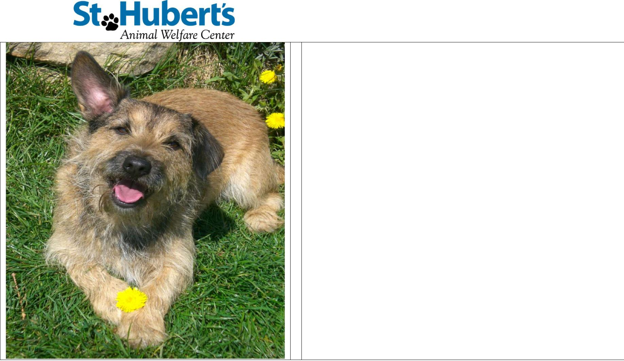
TAN AND BLA

TERRIER MI

Last seen near Main St. and Secondary St. in Yourt black collar with white bones and tags. Medium with people and dog

If spotted or caught ple

973-377-225

Missing Pet Help Sample
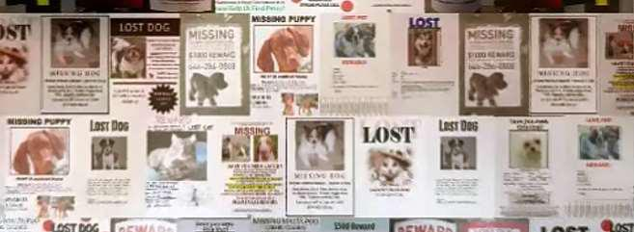

Realizing your beloved pet is missing is terrifying and many people don’t know where to look or what to do when it happens. We can help guide you through search techniques, effective posters and reunite your loved pet with you and your family.

Missing Pet Behavior

Most cats stay within their territory, which ranges depending on if a cat is indoor only or has outside access – 92% of indoor cats (84% outdoor access) are found within 3-5 homes
Cats will often hide in fear and remain silent- without coming to guardians

Dogs can travel much farther than cats, and travel distance is dependent upon temperament, personality, weather, etc.

Extremely social dogs are often taken in by the finder or brought to shelters much quicker than skittish dogs or cats

ID tags that are kept up to date are extremely effective in reuniting pets and their guardians, often these tags will result in the reunion without the animal having to stay in a shelter

Microchips are permanent identification implanted by a vet that contain your information, if kept up to date these can help reunite a family and their guardian with minimal time spent in a shelter

Spreading the word via posters, flyers and social media are life saving techniques that can help reunite pet and guardian if an ID tag falls off or pet is not microchipped

Lost Pet Email Sample

Dear NAME,

Thanks so much for reaching out to our Pet Helpline. It was a pleasure speaking with you earlier and I look forward to helping you reunite with PET’S NAME.

As per our discussion I’ve included a brief summary of techniques we discussed earlier and several additional resources on lost pet recovery. I know that dealing with a lost pet is unbearably painful and overwhelming and I’m here whenever you have any questions.

PREVIOUSLY DISCUSSED TIPS

LINK TO OR ATTACHMENT OF RELATED LOST PET HANDOUTS

LINK TO ANIMAL CONTROL DIRECTORY

LINK TO RETENTION FACEBOOK PAGE

I will post PET’S NAME’s photo and information on our Retention Facebook Page as well as additional communities that can be of assistance. If I come across any possible match or sightings I will let you know ASAP and we will touch base soon!

Warmly,

NAME

TITLE

CONTACT INFO

HANDOUT FLYERS FOR MISSING PET RECOVERY Sample

Physically searching for and talking to people in your neighborhood about your missing pet are great methods of finding your pet, however they are not foolproof. Unfortunately, you may miss a spot or someone won’t answer the door- your pet could be in that spot or show up in someone’s yard shortly after you leave. Perhaps the person who didn’t answer the door has been feeding your cat for several days or has seen your pet, but the timing wasn’t right. Never underestimate the power of communication through flyers. Many pets are reunited through flyers hung by both owner and/or finder! Follow these tips for creating effective flyers.

Print out on standard 8.5” x 11” computer printer paper (print from home or copy shop) Print at least 10 copies per intended drop off location such as:

  - animal shelters

  - veterinary offices

  - pet stores and groomers

  - police station

  - libraries and local businesses

For stores that have a public bulletin board, keep in mind it is common for people to take photos of flyers on their way in or out of a store

Ask your mail carrier to take a flyer (or several) on their delivery route Use the best quality and clearest color photo(s) of your pet available

If using multiple photos, chose no more than two – a full body shot and one of just the face The photo(s) should take up a large portion of your flyer
Font sizes vary however the largest font in example should be the largest font on your flyer Fonts should be kept uniform and clear so they are easy to read

Although large neon posters are encouraged for posting around town, if you are using flyers place the flyer inside a plastic sheet protector and seal open edge with packing/duct tape to prevent damage from rain

An example flyer:
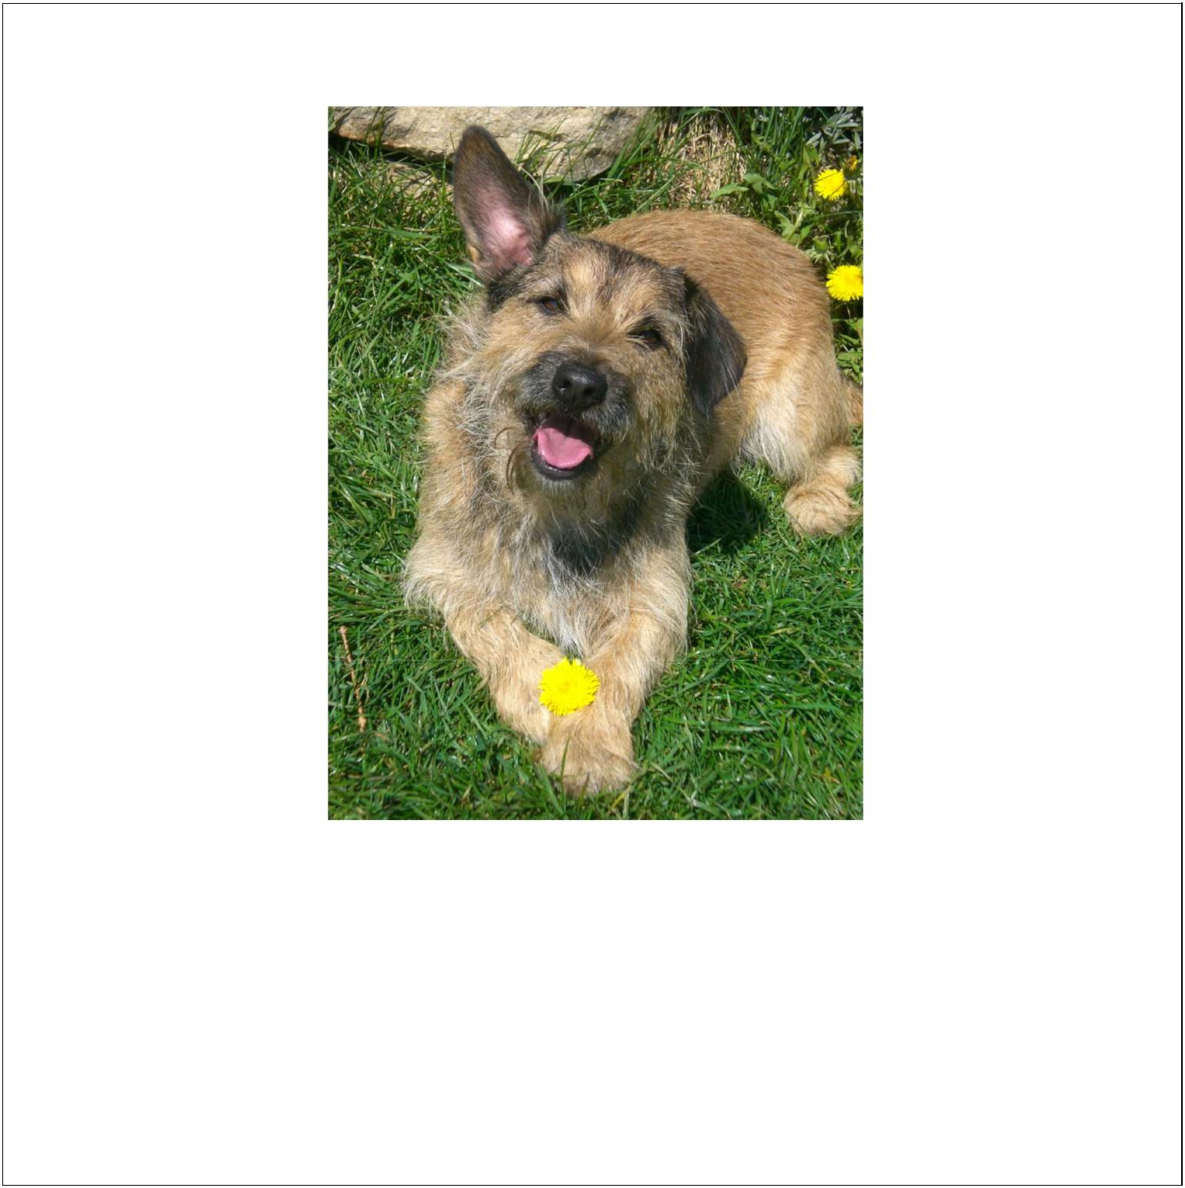
REWARD

LOST DOG

Tan & Black Terrier Mix

Description of lost pet including: general height/weight, nature of pet (friendly/timid/etc.), detailed coloring, any distinguishing markings or characteristics. Also include where the pet was lost and phone numbers where you can be reached at. Make sure all phone numbers are correct and current and number is bolded.

Please call (973) 377-2253

LOST AND FOUND FOLLOW-UPS Sample

Language does not have to be read word for word as we don’t want it to sound like a script. Add your own personality in your calls and make it personal!

Call first number listed (when there is more than one)

Collect pet name or owner name if it was not written on the card Introduce yourself and why you’re calling:

- Hi, I’m NAME calling from St. Hubert’s following up on a lost DOG/CAT report that you filed with us in MONTH of YEAR. Were you able to find PET NAME or
HIM/HER?

- IF YES AND ALIVE: Oh that’s great! How did you find HIM/HER? Was HE/SHE gone for long? That’s great you were able to find HIM/HER and thank you so much for your time and update! If you ever need anything give us a call!

- IF YES AND DECEASED: Oh, I’m so sorry to hear that. Its heart breaking to lose a pet and I’m sorry if I stirred up any painful emotions/memories for you. If you ever need anything give us a call!

- IF NO: I’m so sorry to hear that. If you’d like we can share on social media and send you some additional information.

In the event the pet has been missing for several months one can add “this way if HE/SHE was adopted someone may recognize HIM/HER and you can have some closure.”

IF YES: Great, would you rather e-mail us or have us reach out to you so you have our e-mail? Either give out helpline@sthuberts.org or take their e-mail down.

IF NO: Ok, I understand, I wish we had a better outcome for you. If you ever need anything give us a call!

Write all information and responses gathered from call.

Be sure to take notes on any additional details they provide.

If they mention any behavioral issues they’re having, give them the Helpline number (973-377-2253)

Why should my pet wear a collar and tag?
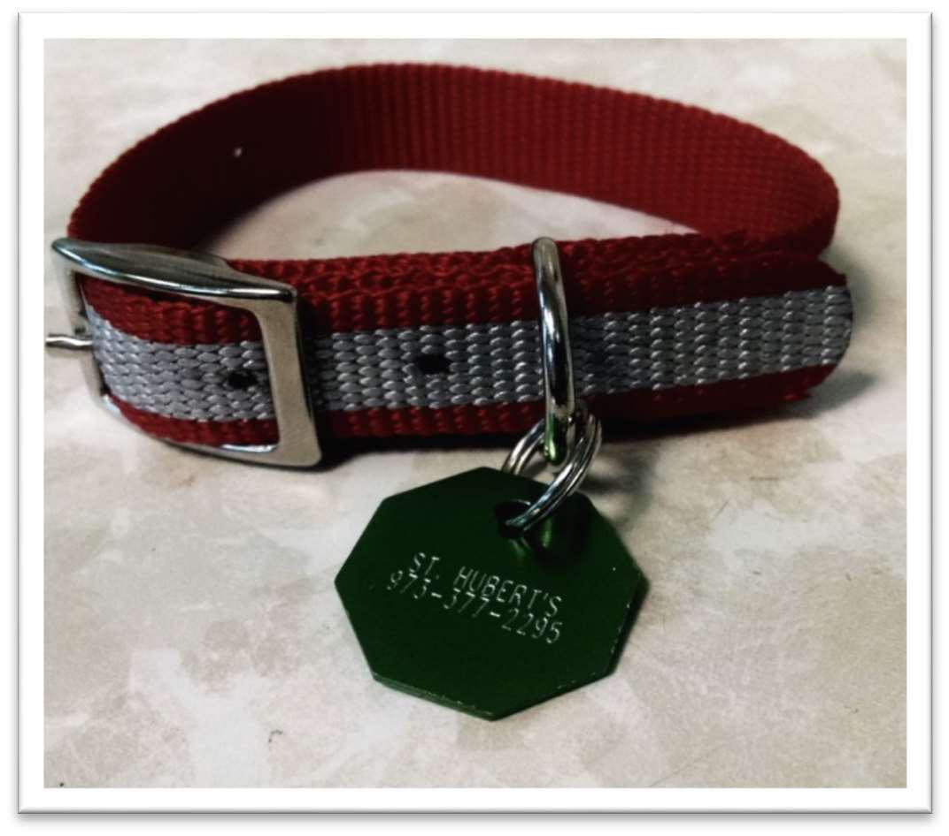

My cat/dog never goes outside/out of our yard, he doesn’t need a collar!

o It only takes a split second for a pet to slip past someone or for a door or gate to fail to close in time!

Collars with ID tags are the quickest way of being reunited with your pet should they get lost or you get separated

o Of lost pets, approximately 15-20% of dogs and only 2% of cats are reunited with their owners

o A collar and tag is typically identifiable on an animal from a distance, letting
those who spot your pet know he/she is a missing pet and not a stray or feral cat o ID tags will often allow you and your pet to be reunited directly, so he/she
wouldn’t have to enter a police station or shelter

o While microchips are the best permanent ID form available right now, a collar and tag will be your best and speediest way to get your pet back home!

If you are worried about your pet attempting to break free from his or her collar and getting stuck or injured

o Ensure the collar is comfortable (there are many options of collars lined with soft material) and fits snug which will reduce the likelihood of irritation as well as the collar getting stuck while attempting to remove it

o Try different collars to see which is tolerated by your pet (stretch safety [cats], breakaway[cats], plastic buckle, corded, metal buckle, plastic buckle, etc)

o Never use a martingale or no slip collar as the primary collar for your dog as these are designed to tighten when pulled and not allow a dog to escape

o Periodically check the collar for proper fit and damage/wear and tear checks

If your pet is fearful of tags consider a collar with an ID plate affixed to the collar itself or a collar embroidered with a contact number

o Tag silencers are also available widely at most pet stores or online

o Try leaving tags on the collar while doing something your pet enjoys such as tricks or giving treats as positive reinforcement

USE OF SOCIAL MEDIA TO REDUCE BEHAVIOR CALLS AND REDUCE “STRAY” TIME IN SHELTER Sample

We started the St. Hubert’s Pet Retention Program Facebook page to assist with disseminating vital information regarding common behavior issues facing pet parents as well as effective search and recovery techniques for lost pets.

It was immediately clear the big draw was lost and found, both information and advocating for the “strays” our animal control officer’s pick-up. There was and still is a large focus on Missing Pet Partnership’s model of thinking “lost not stray” in order to change public perception of what is commonly believed to be stray or feral cats in their neighborhood. Shortly after we began posting search and recovery techniques, data and photos of our ACO impounds we began asking for photos of missing pets when pet parents called to file a lost report. Subsequently we began receiving calls and e-mails from other pet parents asking us to share their pets as well. By providing pet parents with current search techniques we were able to ensure them the best chance of reuniting with their pet without their pet entering a shelter. Facebook has also allowed Good Samaritans the chance to snap photos of roaming pets and share with multiple animal shelters and rescues nearby which has assisted in the reunion of many pets and their families. Craigslist has also been used as a lost and found tool however it is not as popular, largely due to Facebook being so easily accessed via mobile devices and ease of sharing information to large groups of people.

We have also used our Facebook page to post information on common behavior questions, pet related events, pet food recalls, etc. Incorporating “national days” such as “National Hug Day”, where we illustrated the signals of dogs being uncomfortable with human hugs, and “National Answer Your Cat’s Question Day”, where we posted several Q&A style topics throughout the day has made the page fun and interactive. In posting behavior topics we keep it as short and simple as possible and link to an applicable handout on our website.

The use of social media has also allowed our organization to develop relationships with larger pet related communities to help a larger number of pets. We have noticed tip sheets we’ve created being distributed within those communities by various individuals. Not only does this get pertinent information to pet parents but it also gets our organizations program recognized.

MISSING/FOUND DOG/CAT – TOWN LOST/FOUND IN

For a lost pet –

NAME is A/AN ALTERED/UNALTERED BREED TYPE. HE/SHE was last seen on STREET NAME at TIME, DATE. HE/SHE is AGE and LIST ANY SPECIAL NEEDS. NAME WAS/WAS NOT wearing a collar WITH/WITHOUT I.D. tags and IS/IS NOT microchipped.

Please contact:

PHONE NUMBER

For a found pet –

A BREED TYPE was found on DATE ON/NEAR STREET NAME. (If animal has been taken to a vet for a microchip scan and quick once over that information is also included)

Please contact:

PHONE NUMBER

I’ve included several screen shots of types of topics we have posted about.
