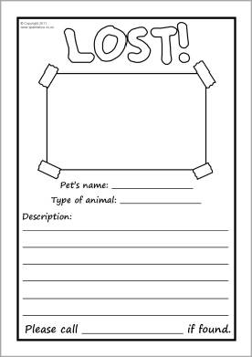

Your text here

Your text here

Your text here

Text here

Dog Photo