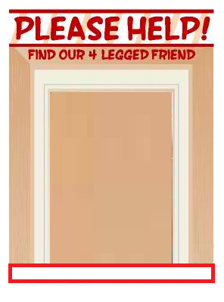

$300 – 422-222-224

Dog Photo