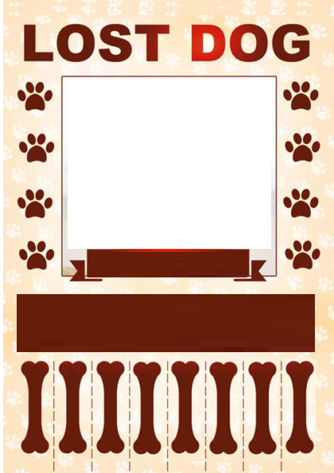

433-33-34

Dog Photo

REWARD$$