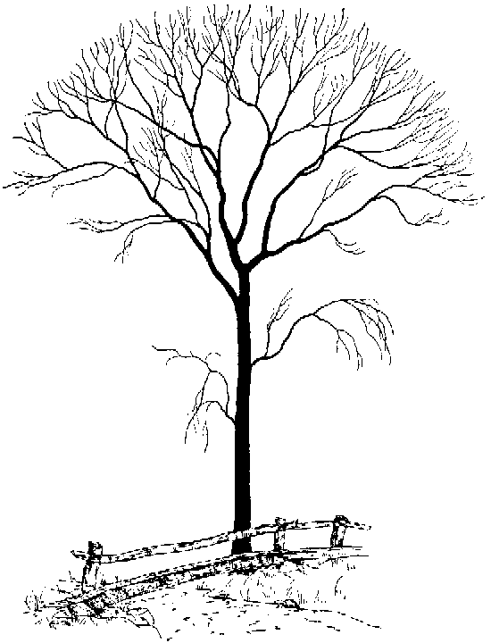

www.OpenOfficeTemplates.com

**me**

My Family Tree

**great-grandfather**

**great-grandfather**

**great-grandmother**

**great-grandmother**

**grandfather**

**grandmother**

**mother**

**grandmother**

**great-grandmother**

**great-grandmother**

**father**

**grandfather**

**great-grandfather**

**great-grandfather**

**sister/brother**

**sister/brother**

**sister/brother**

**sister/brother**