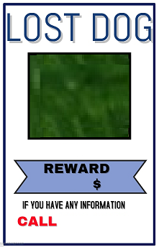

22-222-2222

Amount

Dog Photo