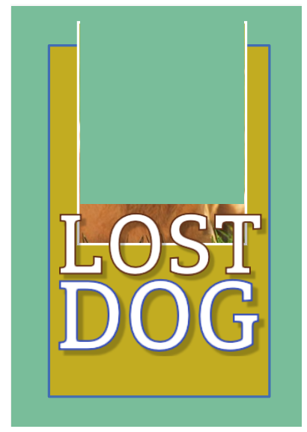

772-27-77

DOG PHOTO