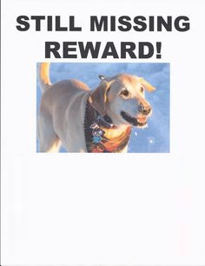

Any Info Pls. Contact

Joey

88-22-288-2

Mel 55-65-55-5

Find POLLY!

Color:

Breed:

Type: