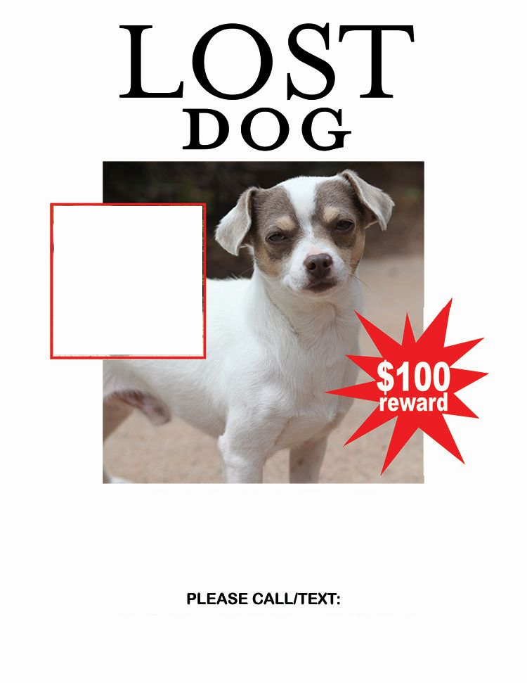

**Description of the Dog**

**Last Seen**

**Lost since when?**

Dog Photo