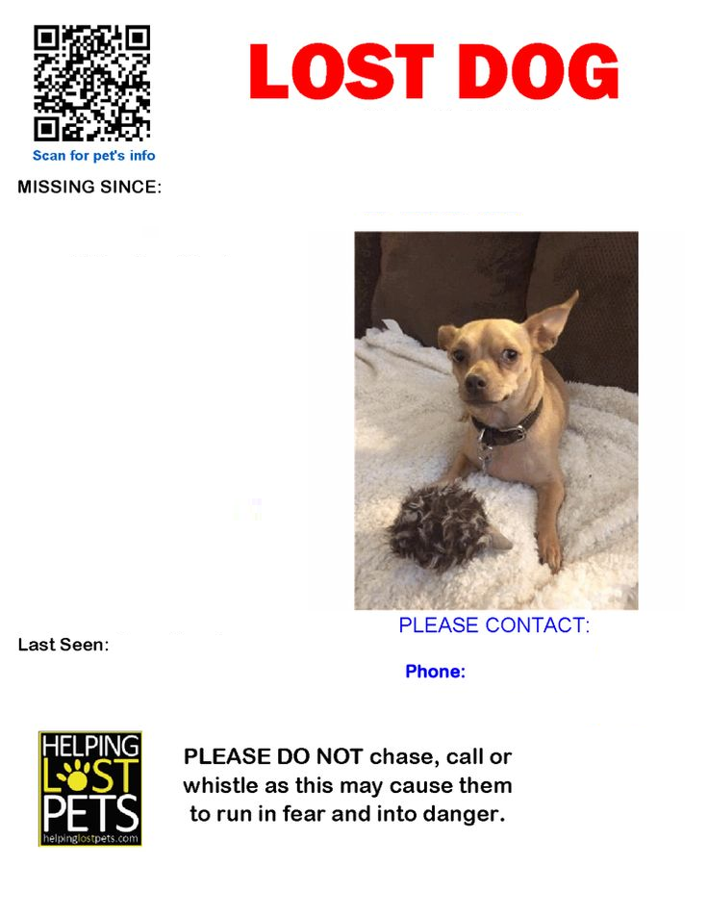

Dog description

Color, height, behavior

Dog Name /Picture