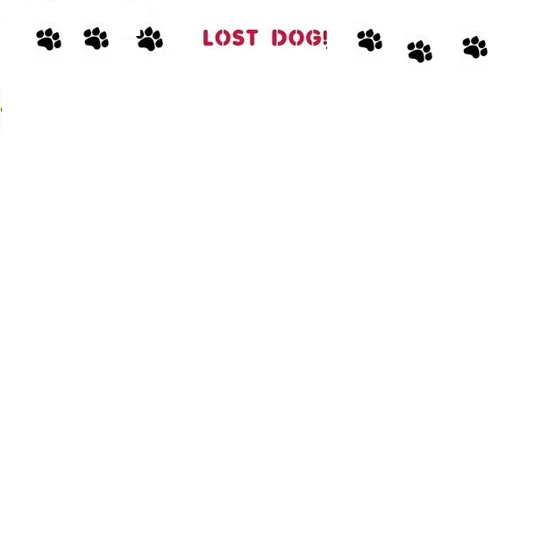

Please Help find me! Answer to my Name Polly. Reward $$$$ if Found.

Family Dearly misses her!

Picture of Dog