LOST DOG
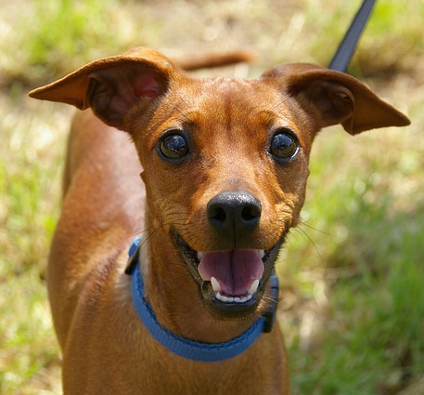 | ADDITIONAL DETAIL  NAME :  SEX :  AGE :  BREED :  WEIGHT :  HEIGHT :  COLOR :  UNIQUE SIGN :  [PUT OTHER IMPORTANT INFORMATION HERE]
LAST SEEN :
TEXT 1
TEXT 2
TEXT 3
IF YOU HAVE INFORMATION PLEASE CONTACT
(Phone Number)

