REWARD
LOST DOG

Put pet's photo here.

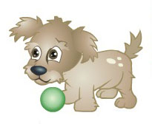

CALL:
Pet Name:
Color:
Weight:

Date Lost:
Location lost:

