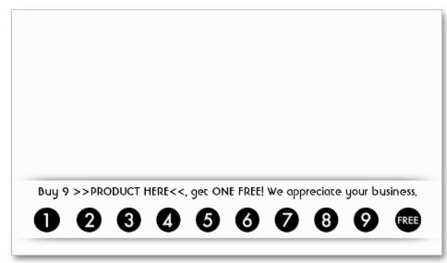

Product image

Company Name/Logo

Address

Zip