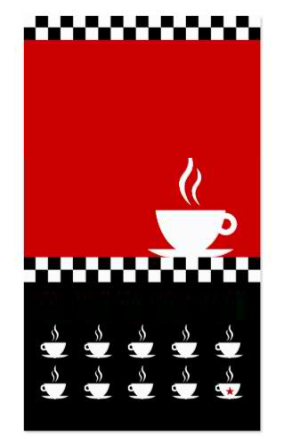

Punch the 9 cups and yours is free

Valid for 1 person only

Present this card

every visit