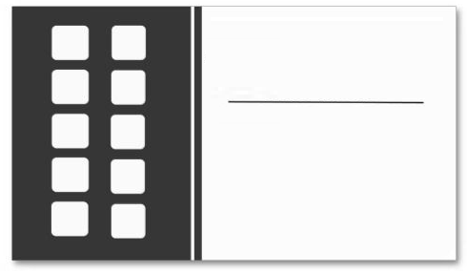

**FREE**

On your 10th punch

get your FREEBIE

Write Product Profiles