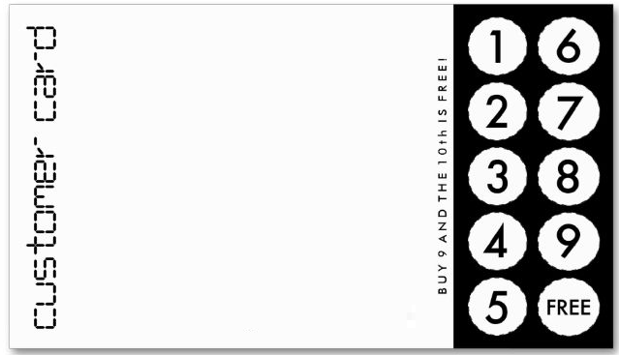

Insert Image of the products or services

Company Name

Phone

Address

Logo