HL Presentation Draft Outline Template
You may use this outline template to help you structure and organize your first draft of the HL presentation.
***Note: I strongly recommend that you BULLET POINT your outline ***
- How will I set the stage?
  - What is your political issue, case study, and global political challenge?
  - How will you communicate this information to the audience?

- What main points and perspectives do I want to communicate?
  - How will I demonstrate a balanced, focused and clear analysis of the political issue?
  - What key concepts will I discuss and how?
  - Who are the key stakeholders and how will I analyse their perspectives?
  - What theories are relevant to our understanding of the case study and political issue?
  - How is the case study relevant to the wider context of global politics? (optional, or can be included in the conclusion)
- How will I conclude?
  - What conclusions have you made about the political issue raised by the case study?
  - What is the significance of the case?
  - How is the case study relevant to the wider context of global politics? (optional, or can be included in the body)

Global Political Challenge Presentation Workflow (Source: IBO)
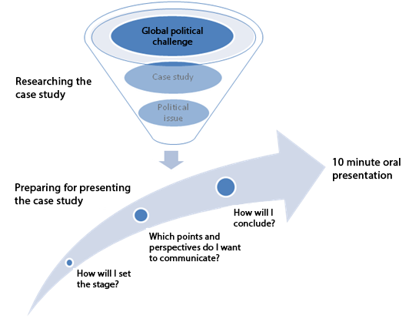

Marking Rubric for Oral Presentations
Does the student present a clear, focused and balanced analysis of the case study, highlighting a global political challenge?
Not level 1
0 marks
Level 1  Rudimentary  1-2 marks | The student demonstrates rudimentary knowledge of the case study.
Level 2  Basic  3–4 marks | The student demonstrates a basic understanding of the case study.  The student treats the case study in isolation.
Level 3  Satisfactory  5–6 marks | The student demonstrates a satisfactory understanding of a political issue raised by the case study, but the analysis lacks some clarity, focus and balance.  The student attempts to link the case study to the wider context of global politics, but these links are not always effective.
Level 4  Very good  7–8 marks | The student demonstrates a very good understanding of a political issue raised by the case study, with a generally clear and focused analysis and an acknowledgement of different perspectives on the issue.  The student makes effective connections between the case study and the wider context of global politics.
Level 5  Excellent  9–10 marks | The student demonstrates an excellent understanding of a political issue raised by the case study, with a clear and focused analysis and an exploration of different perspectives on the issue.  The student analyses the case study within the wider context of global politics, illustrating effectively the significance of the case.

