Section 2:
the event plan
2
CONTENTS – SECTION 2

part a: the event plan S2 - 03
Part B: additional event plans S2 - 14
Part c: occupancy permit S2 - 50
Part d: SITING APPROVAL FOR PRESCRIBED STRUCTuRES S2 - 55

part a: the event plan

wHY DOES THE EVENT NEED A PLAN?
Every event regardless of its size and nature needs an event plan. The plan is a collection of all of the decisions and arrangements that the event organiser has made to ensure that the event is set up according to the site plan, to ensure that all the contractors know what their responsibilities are and so the public have a safe and enjoyable experience.
You will be required to submit your event plan to the Event Services Unit. Final approval will be contingent on you applying for the relevant permits and ensuring your event plan meets the requirements of the City of Greater Geelong and the relevant agencies.

HOW TO MAKE A BASIC EVENT PLAN
This section of the Guide will help you develop a basic event plan. Additional event planning documents that may be required in the event plan are listed in Section 2, The Event Plan, Part B, Additional Event Plans of this Guide.
Your Events Officer will advise you if any of these extra plans are required.

CONTENTS OF A BASIC EVENT PLAN
- Event overview
- Event program
- Event site plan
- Event build schedule
- Staff roles and contacts list
- Risk Management / Planning – go to Section 3 of this Guide

Once the event plan is developed and finalised you should distribute copies to:
- City of Greater Geelong – Event Services Unit
- Asset managers and agencies that have issued permits and approvals
- Your safety officer and chief wardens
- Your event staff
- Your contractors
- The emergency services
- Your volunteers
- Your participants (vendors, traders, performers etc)
- Your event committee and key stakeholders

NOTE: If the event is required to apply for a Division 2 Occupancy Permit (POPE) the event plan will also need to include planning information requested in the POPE Permit application.

EVENT OVERVIEW:
An event overview includes:

- Name of the event
- Organisers of the event (businesses or group)
- Place/location of the event
- Time of the event
- Reason for the event: Eg. ‘National under-23 qualifiers for the junior triathlon championships’ or ‘annual Christmas carols’
- Expected number of participants
- Expected number of spectators

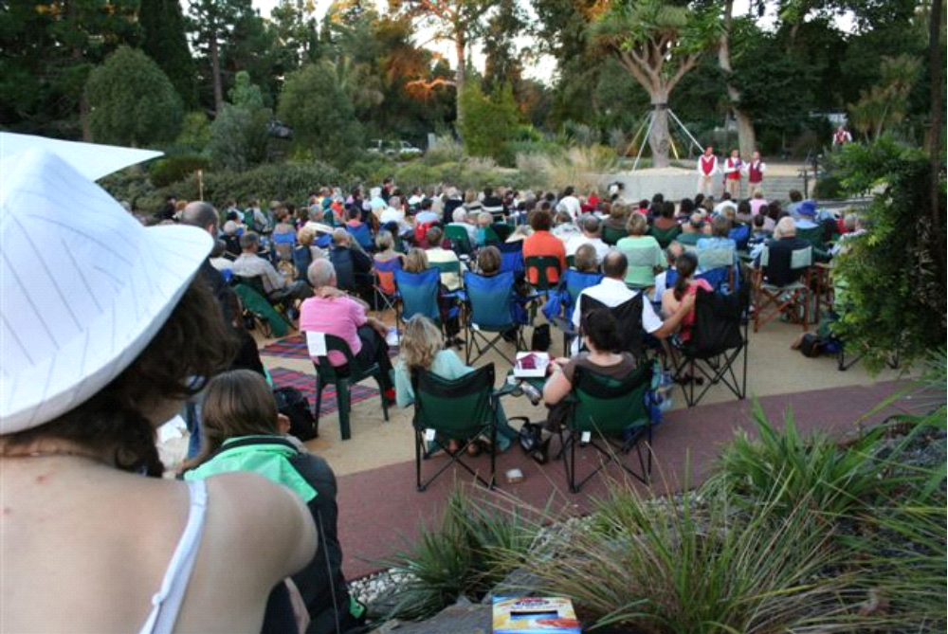
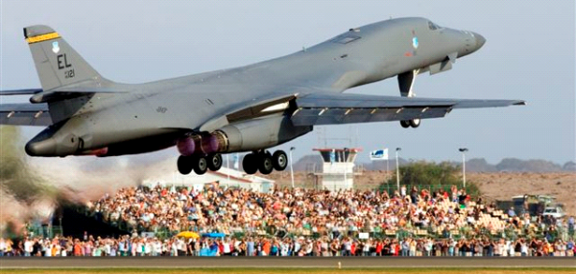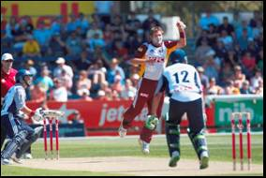
EVENT PROGRAM:
How to develop an event program
Include the draft activities planned for your event and show when and where these activities will happen.
Two basic event program examples have been provided below; one program is arts focused and the other sports focused. Changes to the event program can be updated at any time during the planning phase.

Example 1: Arts / Entertainment Event
ACTIVITY | LOCATION | Saturday 12 September
Event starts - public arrives |  | 10.00am
Food vendors open | See location on site plans | 10.00am
Mechanical rides start | See location on site plans | 10.00am
Stage program commences | On main stage marked on site plan | 11.00am-9.00pm
Bar opens | Licensed marquee marked on site plan | 12noon
VIP function starts | Licensed marquee marked on site plan | 1.00pm
Community race ends | At finish line marked on site plan | 5.00pm
Presentations and speeches | At main stage | 5.30pm
Fireworks display | On barges located on site plan | 9.00pm-9.30pm
Event finishes |  | 9.30pm

Example 2: Sporting Event
ACTIVITY | LOCATION | Saturday 12 September
Participant registration | Registration tent | 6.00am
Participant briefing | Transition area | 6.30am
Food vendors open | See location on site plan | 7.00am
Commentary starts | Stage area | 7.00am
RACE start – Women Amateurs | Swim ramp | 7.00am
RACE start – Men Amateurs | Swim ramp | 7.30am
RACE start - Elites | Swim ramp | 8.00am
VIP function starts | Licensed marquee marked on site plan | 10.00am
Stage program commences | On main stage marked on site plan | 9.00am-4.00pm
RACE fin– Women Amateurs | Finish line – Transvaal Square | 3.00pm
RACE fin – Men Amateurs | Finish line – Transvaal Square | 3.30pm
RACE fin - Elites | Finish line – Transvaal Square | 4.00pm
Presentations and speeches | At main stage | 4.00pm
Stage program finishes | At main stage | 5.00pm
Event finishes |  | 9.30pm

EVENT site plan:
WHAT IS A SITE PLAN?
A site plan is a map that shows the area on which the event is being staged or held within.
Throughout the site planning section in the Event Application Form you are asked to show information such as placement of equipment, existing services etc. This is so you can manage the site safely and determine in the planning stages how many people can attend the event site at any one time and the best location for the event’s services and equipment.
WHY IS A SITE PLAN REQUIRED?
A good site plan will assist you in applying for permits, positioning equipment and communicating with contractors, suppliers, vendors, performers, participants and spectators. A user-friendly version of the site plan could also be used in promotional information and made available at the event site. The site plan will also be used to communicate with emergency services providers during planning phases as well as during the event.
HOW TO MAKE A GOOD SITE PLAN
Start with a good map. This map will become the basis for the site map. Find a map on Google Earth or ask your Events Officer for assistance.
The map should show the immediate area surrounding the event site and include the names of the main roads or streets. It should also include all of the area’s pathways, roadways, buildings and fences. Ideally this plan is to scale, and includes measurements of the area and its structures.
The site plan should include every single bit of infrastructure that you plan to put on or use at the site. You should show the dimensions (width and length) of all temporary infrastructure and equipment. Consider using a legend in your site plan so the site is clear of boxes and arrows and easier to interpret.
Use a program or engage a professional. Start adding the event infrastructure / equipment to the map to build a site plan. Programs such as PowerPoint or Microsoft Word can be useful in building a site plan. Depending on the scale of the event, event contractors may be able to assist in developing the site plan. This can be a good idea, especially if the event is of a larger scale and complex.
MAINTAINING ACCESS – of the building line and for emergency vehicle access
Many events are held in an area where the road is closed and it is assumed that the whole area including the roadway and the footpath is available for the placement of infrastructure and equipment. This is not the case. The event organiser is required to keep the following areas clear and free of infrastructure:
On a footpath: an access path 1.8 metres out from the building line. This is to ensure that vision impaired people are able to use the building line as a guide to access the area safely.
On a roadway: a 4-metre wide access path from the start of the road closure to the end is required to be maintained and be free of infrastructure and equipment for the purpose of emergency vehicle access.
MAKING A SITE PLAN FOR A DIVISION 2 OCCUPANCY PERMIT (POPE) OR FOR SITING APPROVAL FOR PRESCRIBED TEMPORARY STRUCTURES.
If your event requires a Division 2 Occupancy Permit (POPE) or Siting Approval for the prescribed structures, then your site plan will need to be detailed and meet the requirements as set out in Part C & D of this Section. You will need to know though how many patrons you can fit into your site once you have added the infrastructure and back of house areas. An easy way to calculate how many people can fit into the site is as follows:
Square meterage of site boundary minus the square meterage of all infrastructure and back of house areas = the space that is left for the public attending the event. If 1,500 square meters was left and each person generally needs 1 square meter of space then 1500 people could fit in this event space.
NOTE: The dimensions of structures (temporary and permanent), the distance between immovable objects and the square meterage of the overall site must be shown on all maps.

SITE PLAN CHECKLIST
EXISTING INFRASTRUCTURE | TEMPORARY INFRASTRUCTURE
- Direction of north
- Significant trees
- Sensitive fauna or flora sites
- Bodies of water
Adjacent property owners,
- i.e. railway land, shopping centres
- Public telephone/s
 | - Pre-event promotional signage
- Existing fences, gates, barriers, bollards | Temporary fencing (mesh and picket)  - Any barriered areas  - Back of house areas
- Existing entry and exit points | - Temporary entry and exit points
Existing buildings and structures:
- Toilets, sheds, stages, huts etc
Large temporary structures:
- Tents and marquees (over 100m²)
- Stages (over 150m²)
- Prefabricated building (over 100m²)
- Aerial rigs
NOTE SITING APPROVAL REQUIRED
Small temporary structures
- Tents and marquees (under 100m²)
- Portable structures, site huts, toilets
- Stages (under 150m²)
- Any areas that have barriers
Temporary grandstands for more than 20 patrons
NOTE SITING APPROVAL REQUIRED
- Permanent seating areas | Temporary seating areas  - Chairs, rows and aisles and  - Show distance between each row and aisle  - Show accessible seating areas
- Existing pedestrian paths and walkways | Temporary pedestrian paths  - Walkways  - Including disabled paths
- Existing steps and ramps | - Temporary steps and ramps (including stages)
- Start/finish gantries and lines
- Route and direction of race

SITE PLAN CHECKLIST continued…
EXISTING INFRASTRUCTURE | TEMPORARY INFRASTRUCTURE
- Pyrotechnics firing area
- Public exclusion zone
- Existing amusement rides | - Air castles  - Mechanical rides  - Inflatable screens Division 2 POPE required
 | - Animal nursery
- Existing picnic and seating areas | - Temporary picnic, quiet and seating areas
- Restaurants, canteens | - Temporary food vendors
Licensed areas
- Show how area is cordoned off from public
- Type of fencing used, position, height)
- Service areas
- Security locations
- Ticket offices/registration areas
- Site offices
- Operation or communication centres
- Media areas
- Public information areas
- Lost children/property area
- Existing lighting towers/or lights | - Temporary lighting towers/or lights
- Existing sewerage outlets
- Existing toilets  - Show male  - Show female  - Show disabled | - Location of temporary toilets  - Show male  - Show female  - Show disabled
- Existing showers | - Locations of temporary showers
- Existing gas points | - Gas bottle locations and size
- Existing water fountains | - Temporary water taps, fountains, water trailers
- Existing garbage bins | - Temporary garbage bins  - Temporary skips
- Pedestrian paths | - Pedestrian barriers  - Temporary cross over road points
- Existing car parks including access car parks  - Existing bus stops/train stations  - Existing traffic lights and pedestrian crossings  - Existing disabled car parks | - Public parking areas and capacity  - Temporary access parking (disabled)  - Contractor entry/exit and drop off pick up areas  - Bus stops  - Taxi ranks  - Emergency vehicles

SITE PLAN CHECKLIST continued…
EXISTING INFRASTRUCTURE | TEMPORARY INFRASTRUCTURE
- Existing fire extinguishers  - Hose reels  - Water points  - Dams | Temporary fire fighting equipment  - Tankers  - Blankets  - Extinguishers
- Emergency access/egress routes | - Emergency and contractor vehicle path (min 4m wide)
- Emergency assembly areas | - Emergency assembly areas  - Align with exit gates (evacuation routes)
- Evacuation route | Temporary evacuation routes  - Security point locations,  - Exit gates and widths and  - Assembly areas
- Existing location and size of first aid facility | - Location and size of first aid facility
 | - Position of security guards
- Existing unsafe areas | Restricted or unsafe areas  - Fireworks discharge areas  - Fuel storage, generators  - Back of house for performers
EXTRA SITE PLANS
Some areas shown on the site plan may also need to have separate detailed plans.
For example a catering marquee may need to show how the equipment is positioned within the marquee.
A stage may need to show the wings, ramps, speaker stacks, canopies etc.
A seating area may need to show how the rows or seating are to be positioned and the distance between each, the aisle widths shown, measured and marked.
The clearance between rows of fixed seats should not be less than:
- 300mm if the distance to an aisle is less than 3.5m; or
- 500mm if the distance to an aisle is more than 3.5m

EVENT BUILD SCHEDULE and Supervisor roles
You are responsible for the site, your contractors and for the safety of the public.
As the event organiser you are responsible for providing a safe environment for the public in and around your event’s site, and this includes ensuring that your contractors are entering and exiting the site safely, that you have cordoned off the site so the public cannot access unsafe areas. It is your responsibility to manage any persons or contractors who are erecting, depositing or building equipment on the site. During the event set-up, staging, delivery and pack-up phases of the event.
Some event sites or structures on an event site may be deemed ‘constructions’ or ‘structures’ and therefore they must meet the Victorian Construction Regulations and comply with the Occupational Health and Safety Act 2004. Some contractors may need to provide you with Job Safety Analysis or Safe Work Method Statements to show you how they are going to construct their equipment safely.
Section 3, Risk Management / Planning of this Guide provides advice on complying with these regulations.
Most sites are deemed to be places of work and therefore they must comply with the 2009 OH&S Act. Serious fines can be issued by Worksafe and PIN notices which can cease your build and may result in the cancellation of your event. As the event organiser you must nominate appropriate staff or volunteers to manage the site build at all times that there are contractors on site. You should equip your site supervisors with safety vests, a build schedule and contractor contact list, they should also have copies of the relevant Job Safety Analysis and Safe Work Method Statements.
This is what you will need as a minimum when you are setting up and packing up a site.
Supervisors in high visibility vests or jackets who are scheduled to be on site BEFORE the first contractor and until the LAST contractor or piece of equipment has been removed
Supervisors with the final site plan
Supervisors with the final build schedule
Supervisors with contact names and phone numbers of contractors
Spotters at the entry and exit areas to walk vehicles onto the site
Enough hazard tape and orange plastic bollards to safely cordon off the work zones
Rubber or grass matting to fix trip hazards
Pedestrian barriers to fence off unsafe areas
Cable ties and red gaffer tape

NOTE: Once the set-up or build of the event has been completed, the bollards and pedestrian barriers can then be used to cordon off back of house and unsafe areas once the site has been built.
Once you have your event program and site plan you need to develop an event build schedule.
A detailed event build schedule is invaluable to control the build of the site and communicate with everyone involved—whether on or off site. You can use the schedule when ordering equipment, advising contractors as to when they should arrive, and on site during the event so that key staff know what is happening and when.

Example Event Build Schedule – this level of detail is important.
EVENT BUILD
DATE | ACTIVITY | CONTRACTOR | EVENT REP | TIME
Friday 11 Sept | Site hand over with local council | N/A | David Hands | 8.00am
Friday 11 Sept | Site services marked | Council | David Hands | 8.30am
Friday 11 Sept | SITE SUPERVISOR ARRIVES ON SITE |  | David Hands | 8.10am
Friday 11 Sept | Site cordoned off advisory signage | N/A | David Hands | 9.00am
Friday 11 Sept | Shipping container arrives | Ships Australia | Simon Walk | 9.30am
Friday 11 Sept | Fencing erected | AFF– Sarah Wire | Simon Walk | 10.00am
Friday 11 Sept | Portable toilets arrive | Toilet Hire – Karen Tipp | Simon Walk | 10.30am
Friday 11 Sept | Marquees trestles chairs | Marquees 4 Hire – Eric Hair | Steve Fast | 10.30am
Friday 11 Sept | Bins and skips arrive | Event Clean – Chelsea Cans | Simon Walk | 11.00am
Friday 11 Sept | Generators arrive | General Gens – Peter Power | Simon Walk | 11.00am
Friday 11 Sept | Fire extinguishers arrive | No Fire – Heath Mades | Simon Walk | 11.00am
Friday 11 Sept | Gas bottles arrive | Go Gas – David Das | Simon Walk | 11.00am
Friday 11 Sept | Electrician on site | Event Electrics – Jamie Pleg | Simon Walk | 11.00am
Friday 11 Sept | Speakers installed | Speak away – Jess Tell | Simon Walk | 11.30pm
Friday 11 Sept | Barwon Water trailer arrives | BW – Plumber | Steve Fast | 12.00noon
Friday 11 Sept | Sound check | Speak away – Jess Tell | Simon Walk | 12.00noon
Friday 11 Sept | Stall holders set up | Various | Steve Fast | 1.00pm
Friday 11 Sept | Mechanical rides set up | KT Rides – Fred Spin | Steve Fast | 2.00pm
Friday 11 Sept | Contractors/vendors off site | Various | Steve Fast | 5.30pm
Friday 11 Sept | Security arrives | SSE- Mike Seccy | Simon Walk | 6.00pm Sat 7am Sun
Saturday 12 Sept | Roads closed | Stop Traffic – Fred Sign | Steve Fast | 6.00am
Saturday 12 Sept | Site safety check | Safety Officer | David Hands | 8.30am
Saturday 12 Sept | Volunteers briefing at site office |  | David Hands | 9.15am
Saturday 12 Sept | Staff and security briefing at site office |  | Simon Walk | 9.30am
Saturday 12 Sept | Vendors arrive | Various | Steve Fast | 10.00am 9.30pm
Saturday 12 Sept | St Johns arrive | St Johns – Mike First | Simon Walk | 10.00am 10.00pm
Saturday 12 Sept | Cleaning staff arrive/start | Clean Site – Sara Spring | Simon Walk | 10.00am -11.00pm
Saturday 12 Sept | Event opens |  | David Hands | 10.00am 9.30pm
Saturday 12 Sept | Event closes/Safety check of site |  | David Hands | 9.30pm
Saturday 12 Sept | Roads opened | Stop Traffic – Fred Sign | Steve Fast | 9.30pm
Saturday 12 Sept | Security arrives | SSE Mike Seccy | Steve Fast | 9.30pm

EVENT PACK-UP
DATE | ACTIVITY | CONTRACTOR | EVENT REP | TIME
Sunday 13 Sept | SITE SUPERVISOR ARRIVES & CHECKS THE SITE |  | David Hands | 6:40am
Sunday 13 Sept | Site cordoned off, bollards opened | N/A | David Hands | 7.00am
Sunday 13 Sept | Contractors/vendors pack up | Various | Steve Fast | 8.00am
Sunday 13 Sept | Marquees trestles chairs pack up | Marquees 4 Hire – Eric Hair | Steve Fast | 10.00am
Sunday 13 Sept | Portable toilets leave | Toilet Hire – Karen Tipp | Simon Walk | 10.00am
Sunday 13 Sept | Mechanical rides pack up | KT Rides – Fred Spin | Steve Fast | 10.00am
Sunday 13 Sept | Electrician on site | Event Electrics – Jamie Pleg | Simon Walk | 10.00am
Sunday 13 Sept | Fire extinguishers collected | No Fire – Heath Mades | Simon Walk | 10.00am
Sunday 13 Sept | Gas bottles collected | Go Gas – David Das | Simon Walk | 10.00am
Sunday 13 Sept | Speakers dismantled | Speak away – Jess Tell | Simon Walk | 10.00am
Sunday 13 Sept | Generators collected | General Gens – Peter Power | Simon Walk | 10.00am
Sunday 13 Sept | Barwon Water trailer leaves | BW – Plumber | Steve Fast | 10.00am
Sunday 13 Sept | Fencing dismantled | AFF– Sarah Wire | Simon Walk | 11.00am
Sunday 13 Sept | Shipping container leaves | Ships Australia | Simon Walk | 12.00noon
Sunday 13 Sept | Cleaning arrive final site clean | Event Clean – Chelsea Cans | Simon Walk | 12.00noon
Sunday 13 Sept | Bins and skips leave | Event Clean – Chelsea Cans | Simon Walk | 2.00pm
Sunday 13 Sept | SITE SUPERVISOR CHECKS & LEAVES THE SITE |  | David Hands | 2:15pm
Monday 14 Sept | Site hand back with local council |  | David Hands | 9.00am

STAFF ROLES AND CONTACT LIST
During event planning period, you will have allocated people to be responsible for different aspects of the planning and running of the event. Distribute this list of people’s roles and contacts so they can communicate with each other and understand who is responsible for which element.
Example of Staff Roles and Contact List
EVENT STAFF
RESPONSIBILITY |  | EVENT REP |  | PHONE NO.
Site Manager//Supervisor |  | David Hands |  | 0411 xxx xxx
Site Management Support |  | Simon Walk |  | 0415 xxx xxx
Liquor Licence |  | Joan Beard |  | 0412 xxx xxx
Food Vendors |  | Josie Noone |  | 0417 xxx xxx
Stall Holders |  | Josie Noone |  | 0417 xxx xxx
Safety Officer |  | Liz Laylor |  | 0478 xxx xxx
Chief Warden |  | David Hands |  | 0411 xxx xxx
Volunteer Coordinator |  | Sarah Tiff |  | 0415 xxx xxx
VIP Host |  | Meg Tiff |  | 0452 xxx xxx
Media Management |  | Meg Tiff |  | 0425 xxx xxx
Stage Production |  | Josh Gross |  | 0418 xxx xxx
Race Director |  | Lara Lane |  | 0415 xxx xxx
CONTRACTORS AND SUPPLIERS
SERVICE | COMPANY NAME |  | STAFF |  | PHONE NO.
Traffic Management | Stop Traffic |  | Fred Sign |  | 0415 xxx xxx
Fencing | AFF |  | Sarah Wire |  | 0425 xxx xxx
Portable Toilets | Dunniroos |  | Sam Flush |  | 0485 xxx xxx
Marquee Hire | Tents Australia |  | Fred Pole |  | 0485 xxx xxx
Cleaners | Clean Site |  | Sara Spring |  | 0415 xxx xxx
Waste Hire | Go Aways |  | Dave Dert |  | 0425 xxx xxx
Electrician | Sparky Time |  | Eric Tass |  | 0417 xxx xxx
Staging | On Stage Events |  | Tim Todd |  | 0487 xxx xxx
Mechanical Rides | Spin Around |  | Alvie Marks |  | 0528 xxx xxx
Fire Extinguishers | Bramfords |  | David Door |  | 0428 xxx xxx
Security | Secure Event |  | Jane Nece |  | 0452 xxx xxx
Shipping Containers | Ships Australia |  | Doug Poon |  | 0428 xxx xxx
Fire Extinguishers | No Fire |  | Heath Mades |  | 0428 xxx xxx
First Aid | St Johns Ambulance |  | Jess Lance |  | 0425 xxx xxx
FOOD VENDORS
NAME OF BUSINESS | LOCATION ON SITE MAP |  | Name |  | PHONE NO
Sammy’s Sausages | FV1 |  | Sam Snake |  | 0428 xxx xxx
Jane’s Juices | FV2 |  | Jane Hare |  | 0452 xxx xxx
Laurie’s Lollies | FV3 |  | Laurie Lake |  | 0428 xxx xxx
Bills Bar and Bistro | FV3 |  | Bill Lion |  | 0428 xxx xxx

Part B: additional event plans
It is likely you will need to include additional planning documents with your basic event plan. Your Events Officer will advise you about this when assessing your Event Application.
The following additional planning documents may be required (some or all):
- Traffic and Transport Plan
- Power Management Plan
- Lighting Plan
- Water Management Plan
- Waste and Toilets Management Plan
- Recycling Plan
- Noise Management Plan
- Food Management Plan
- Liquor Management Plan
- Asset Protection Plan
- Accessibility Plan

This section provides advice on how to develop each of these plans, as well as information as to what detail should be provided in a Division 2 Occupancy Permit (POPE) application form and overall event plan.

traffic and transport plan

Roads and Traffic – the agencies and the permits
There are a number of agencies that issue approval to use the road and issue permits to conduct a road race or an event conducted on a roadway.
ON ROAD EVENT PLANNING:
For a 'major' event held on roads, a pre planning meeting should be held with the relevant agencies/stakeholders 12-18 months out to commence the in-principle feedback from the agencies, prior to application for permits being made.
At the pre planning meeting the event organiser should present a colour Google Earth map with direction of course overlaid on the proposed road ways, this map should show at a minimum: CFA headquarters, hospitals, ambulance stations, schools, train lines and stations, bus routes, and bus stops.
The course plan should be accompanied with the dates and times that the race will start and finish and include the number of participants and the type of race and detail regarding the start/finish area and duration of build and dismantle schedule.

This pre planning meeting will cover the following topics:
1. If the course is available and what any conditions may be.
2. If the road managers can provide in-principle approval of the proposed road closures and what any conditions may be.
3. If the transport representatives can provide in-principled approval of the impacts on public transport and what the event organisers will be required to do during the planning and implementation.
4. If the Victoria Police are prepared to issue an On Road Cycling Permit.
5. If VicRoads are prepared to issue an Exemption to the Road Rules (an in-principle approval from the Victoria Police would then activate VicRoads to apply for an exemption to the Road Rules).
6. If part of the course is required to be declared a 'tow away zone' or a clearway and what the requirements of the event organiser will be to facilitate the clearway.
The event organiser should also be made aware as to what the communications requirements will be in relation to costs and resources to be carried by the event organiser.
Certain businesses or access arrangements may be discussed and form part of the in-principal approval to proceed with the permits stage of the planning phase.
*If the agencies are comfortable with the event organiser’s initial plans and the event organiser accepts the conditions of the in-principal approvals, then the event organiser will be directed to apply for the relevant permits listed below.
The following information provides advice about who manages which roads in the region and when permits may be required.
1. About closing or changing the traffic conditions of a City of Greater Geelong road
The City of Greater Geelong is generally responsible for major roads, collector (service) roads and local roads. If the event impacts a Council road by changing the normal traffic conditions, then the event organiser needs to get approval from the City of Greater Geelong’s Traffic Engineering Department.
Once you have been given in-principle approval from the City of Greater Geelong to use the road and an Event Application Form has been submitted, you need to employ a traffic management company to:
- develop a Traffic Management Plan
- implement and manage the road closure, and
- provide insurance cover for the treatments to the traffic during the road closure
NOTE: All traffic management costs including planning, implementation and communications are to be managed and borne by the event organiser.
A meeting may be held with the event organiser, the traffic management contractor, VicRoads, Victoria Police, Public Transport Victoria, the relevant City of Greater Geelong Asset Manager, and the City of Greater Geelong’s Traffic Engineering Department to assess the draft Traffic Management Plan. It is then submitted to the City’s Traffic Engineering Department for approval.
You need to complete the City of Greater Geelong MOC Application to Partially Close or Occupy a Road or Road Reserve. The Traffic Management Plan is to be sent to the Events Unit with this form, who will send it to the Traffic Engineering department on your behalf.
During the planning stages you will be given advice from the relevant agencies as to what the impacts are, and what is expected of you to manage and minimise impacts on the community.
The City of Greater Geelong MOC Application to Partially Close or Occupy a Road or Road Reserve outlines the event organiser’s obligations and plans that need to be provided to manage these impacts.
2. About closing or changing the conditions of a VicRoads road
VicRoads are generally responsible for freeways and primary and secondary state arterial roads. Again, refer to the Melways ‘map symbols’ page. If the event impacts a VicRoads road, you need to contact VicRoads and discuss the proposal. If VicRoads supports the use of the road for the event, they will supply you with an application for consent to use a road. Permit issued under the Road Management Act 2004 – Worksite – Traffic Management Code of Practice.
The below application time frames apply when conducting an event on VicRoads roadways:
Item | Time Frame
Initial Event Proposal  - Including proposed traffic management, road closures and communications plans  - VicRoads in-principle support letter | 6 to 12 months prior to event (depending on network impact)  6 to 12 months prior to event
Round 1  - VicRoads comments / amendment requests | 5 months prior to event
Round 2  - VicRoads comments / amendment requests  - VicRoads No Objection letter | 4 months prior to event  3 to 4 months prior to event
Round 3  - VicRoads comments / amendment requests | 3 to 4 months prior to event (if needed)
Final  - Traffic Management Plan  - VicRoads Event Approval Letter  - VicRoads Declaration under Section 99B (4) of the Road Safety Act 1986  - VicRoads Declaration under Section 99B (4) of the Road Safety Act 1986 Approval Letter | 3 months prior to event  3 months prior to event  2 to 3 months prior to event  2 to 3 months prior to event
3. To reduce the speed limit on any road
If the Traffic Management Plan includes the temporary reduction of existing speed limits then you need to apply to VicRoads for permission. VicRoads will supply you with an application for consent to use a road. Permit issued under the Road Management Act 2004 – Worksite – Traffic Management Code of Practice.
4. Using classified roads
Under the Road Safety Regulations, 2009 certain roadways have been designated for use by specific classes of vehicles. The classifications are:
- Class 1: oversize or overmass, special purpose, agricultural, vehicles carrying large items
- Class 2: B doubles, controlled access buses, car carriers, livestock carriers
- Class 3: truck and dog combinations travelling at gross mass higher 42.5 tonnes, hay trucks, container trucks
If your event is planning on closing a classified road, then the following process applies:
STEP 1: seek in-principle approval from VicRoads and identify appropriate alternate route
STEP 2: update your traffic management company of VicRoads conditions
STEP 3: draft the wording required to be placed in the Victorian Government Gazette and submit to VicRoads for approval (your City of Greater Geelong Events Officer can assist you with the wording for the gazette)
STEP 4: VicRoads approves and submits the gazette to the Minister of Roads and Transport for approval under the Road Safety (vehicles) Regulations, 2009. The costs for gazetting the roads are to be borne by the event organiser and VicRoads can advise during the planning phase as to what these costs are likely to be.
For further information go to www.legislation.vic.gov.au

VicRoads – South Western Victoria
Road Safety / Events Advisor
180 Fyans Street, South Geelong Victoria 3220
PO Box 775 South Geelong VIC 3220
T: (03) 5225 2558
E: ronald.hinkley@roads.vic.gov.au

5. To conduct a competitive event on any road
If you are planning on staging a competitive on-road event, or a large recreational ride or activity, and require police support, you should submit an Event Application Form to the City’s Events Unit at least six months prior to the event date in order to meet Victoria Police timelines.
You need to contact the local Victoria Police Geelong Highway Patrol Unit no later than six months prior to the event date to seek their advice and support – in some cases for road events that have a significant impact on the road, 12 months pre planning is required. Your Event Officer will advise you as to what time frames are required. Once in-principle support has been gained, you need to submit an application to Victoria Police – Road Safety Strategic Services Division for permission to conduct a race under the provisions of:
- Regulation 27(1) of the Road Safety (Traffic Management) Regulations 2009 applies to competitors for any part of the race
- Regulation 27(2) of the Road Safety (Traffic Management) Regulations 2009 applies to marshals and competitors if they are contained within the approved police rolling road closure. Cyclists may pass through a school zone at a speed greater than 40km/h however, police may decide not to permit this and the competitors would need to obey the police
You will also need to apply for permits relevant to the road authority (City of Greater Geelong and/or VicRoads) and you will need to get in-principal support six to twelve months from the event date.
For advice as to how to meet the Geelong Highway Patrol requirements when submitting an application, please see the end of this section.
6. To conduct a non-competitive recreational ride or activity on any road
If you are planning on staging a non-competitive recreational activity for less than 30 participants, you may need to apply to the relevant road authority for a permit to close or change the conditions of a road. The Victoria Police Geelong Highway Patrol Unit should also be advised of your plans.
A Cycling Signage and Marshal Plan may need to be developed in accordance with the Road Management Act 2004 – Worksite – Traffic Management Code of Practice and be implemented by a qualified traffic controller in accordance with section 99A(3) of the Road Safety Act 1986. The plan should include the positioning of marshals and traffic controllers, as well as the location of advisory signage (such as Cyclist Race in Progress / Cycling Event Ahead / Cyclist Ahead).
7. To apply for a tow away zone/clearway
Tow away zones are sometimes required for major sporting events. If the City of Greater Geelong and/or VicRoads agree that this is an event requirement, then the proposal will be considered. If in-principle approval is provided, an application to the Minister for Transport would be made on your behalf by the City of Greater Geelong. You will then be advised as to what the communications requirements will be and estimation as to what the event organiser’s costs will be to set-up and facilitate the clearway.
8. To apply for an exemption to the Road Rules Act – competitors, race organisers and commissaries
Exemptions to the Road Rules Act are sometimes required for major sporting events. If the City of Greater Geelong, VicRoads and the Victoria Police Geelong Highway Patrol Unit agree that this is an event requirement then the proposal will be considered. You will need to write a letter of request to VicRoads (the Minister for Transport has delegated this authority to VicRoads). This exemption is only available for ‘rolling road closures’.
An application to the Victoria Police to Conduct a Race under the Provisions of Regulation 26 of the Road Safety (Traffic Management) Regulations 2009 also needs to be completed.
9. Events that affect public transport – notification to Public Transport Victoria
If your event is likely to impact regular public transport services, you need to complete the Public Transport Victoria Event Notification Form. This needs to be sent to Public Transport Victoria, and you will need to comply with their planning requests. There are penalties for not complying with the notification and planning process.
http://corp.ptv.vic.gov.au/managing-victoria-s-public-transport-network/notification-of-events-affecting-public-transport/
FOR CONTACT DETAILS FOR ALL OF THE AGENCIES REFERRED TO IN THIS SECTION GO TO THE TRAFFIC AND TRANSPORT CONTACTS IN SECTION 7 OF THIS GUIDE.

SUMMARY OF ROAD CLOSURE PERMITS AND AGENCIES
Prior to application, the Event organiser must seek in-principal support from Victoria Police Geelong Highway Patrol Unit, City of Greater Geelong and VicRoads – large events may require 6-12 months pre-event support from the various agencies.
Road Authority | Process | Application
1.  To close a Council road | Event organiser applies to City of Greater Geelong Engineering Department for in-principle approval to use the roadway.  TIME FRAME: 8 weeks | Application to the City of Greater Geelong via the ‘EVENTS’ MOC Application process.  AS 1742.3 - 2009 Traffic Control Devices For Works on Roads.
2.  To close a VicRoads road or change a traffic signal. | Event organiser applies to VicRoads for in-principle approval to use the roadway.  PERMIT TIME FRAME:  >close a VicRoads road – 6 weeks  >change a traffic signal – 10 working days | Application to VicRoads for consent to use a roadway for an event under the Roads Managements Act 2004 – Worksite – Traffic Management Code of Practice.
3.  To reduce the speed limit on a Council road or a VicRoads road | Event organiser applies to VicRoads for in-principle approval to use the roadway.  PERMIT TIME FRAME:  VicRoads – 10 working days  City of Greater Geelong – 6 weeks | Application to VicRoads to use a roadway for an event under the Roads Managements Act 2004 – Worksite – Traffic Management Code of Practice.
4.  Detouring of vehicle classes | Event organiser applies to Vic Roads for a gazette to detour traffic  TIME FRAME: 6 weeks | Application to Vic Roads, Minister of Roads and Transport under Road Safety (Vehicles) Regulations, 2009
5.  To conduct a competitive on road event or large recreational ride or activity (more than 30 participants) on Council or VicRoads road. | Event organiser to apply to the Victoria Police Road Safety and Awareness Unit.  PERMIT TIME FRAMES:  Victoria Police – 6 months  VicRoads – 8 weeks  City of Greater Geelong – 6 weeks | Application to Victoria Police to:  Conduct a Race under the Provisions of Regulation 26 of the Road Safety (Traffic Management) Regulations 2009.
6.  To conduct a recreational ride or activity for less than 30 participants on a Council road or VicRoads road | Event organiser to advise the City of Greater Geelong and/or VicRoads and receive in-principle approval to use the roadways.  PERMIT TIME FRAMES:  VicRoads – 8 weeks  City of Greater Geelong – 6 weeks | Application to the City of Greater Geelong via the ‘EVENTS’ MOC  Application to VicRoads to use a roadway for an event under the Roads Managements Act 2004.  Submission of an approved cycling signage and marshal plan.  The event organiser may also have to make an Application to Conduct Races Under the Provisions of Regulation 26 of the Road Safety (Traffic Management) Regulations 2009.  Support from the Victoria Police Geelong Highway Patrol Unit may also be required.

SUMMARY OF ROAD CLOSURE PERMITS AND AGENCIES CONTINUED..
7.  To apply for a Tow Away Zone//Clear way | Event organiser to advise the City of Greater Geelong Events Project Officer and VicRoads will consider the proposal. | If in-principle approval is provided, application to the Minister for the Tow Away or Clear way would be made by the City’s Events unit on the event organiser’s behalf.  The Events Unit will advise the communication requirements and cost implications to the event organiser.  Other relevant road closure or use permits would also have to be applied for.
8.  To apply for an exemption to Road Rules s99b to enable competitors, race organisers and commissaries to have a blanket exemption for road rules.  This exemption is available for rolling road closures only. | Event organiser to write a letter to VicRoads outlining the event’s exemption requirements.  VicRoads will request approval from the Minister of Transport on the event organiser’s behalf.  NO EXEMPTION to school crossing zones weekdays  8am - 9am  2pm - 4pm | Letter to VicRoads 3 months prior to event date.  Application to the Victoria Police Road Safety and Awareness Unit to:  Conduct a Race Under the Provisions of Regulation 26 of the Road Safety (Traffic Management) Regulations 2009.
9.  Events that impact public transport. | Notify Public Transport Victoria. | Notify the Special Events Team Public Transport Division, Public Transport Victoria at least 150 days before the event starts.

How to meet the Victoria Police Geelong Highway Patrol requirements when submitting an application to stage a sporting event within the Western Region Division.
If you are staging an on road event, then it is vital for the success of your event that you work closely with the Geelong Highway Patrol Unit. The Geelong Highway Patrol Unit signs off on the Victoria Police Event Permits and coordinates police resources such as police solos.
The Western Region Division 1 has a designated Geelong Highway Patrol member who coordinates all traffic operations and events within the Geelong City Council area. This member will be present at the pre planning and planning stages of the event.
There is a Geelong Highway Patrol document that is available for you to refer to during the planning process.
HOW TO DEVELOP A DRAFT TRAFFIC PLAN
If the event organiser has applied to close a road and identified that the event affects public transport, restricts access to parking or draws large crowds to the site, then the Traffic Management Plan will need to show how traffic will be managed.
The plan will also need to show what the road activity is and where. Also what is being implemented during the event to manage these changes? The relevant agencies will use this information to advise you what has to be done to manage the impacts of the road closure and to ensure compliance.
This information will eventually be translated into a public map or diagram to communicate to residents and business as to what access and egress arrangements are in place during the road closure period.
How to minimise impacts
When selecting a course and schedule you need to consider who will be impacted by the event and minimise inconvenience to the community.
Where there are impacts due to changed traffic conditions, you have an obligation to communicate to the appropriate people, and make special arrangements where necessary. You should be prepared to make changes to the course and/or schedule, based on advice from the agencies.
For example, the event could:
- Impact a business delivery schedule
- Impact a public transport service (route or stop)
- Impact a school crossing due to the timing of the event
- Impact on a business’s staff or contractor parking/loading area. You may have to arrange alternative staff parking
- Impact access to cleaners or contractors of a business within the event site/road closure. You may need to advise the business that they will need to make alternative arrangements
- Impact a service delivery schedule e.g. rubbish collection, postal delivery etc
- The road closure might also close roads that lead into function centres, sports grounds or local parks and you may need to maintain access during the event. You could develop a pass system and brief the marshals to allow entry to users. Or develop a plan so that access is maintained for users but not for event patrons
- Impact a resident from accessing their home. You may be able to close or open the road earlier than first thought, or there may be a period during the event when you can provide access to their home
- If you are planning on using barriers along the course, then a Barrier Plan will need to be developed and implemented. The plan should include:
- When and where the barriers are being dropped off
- When the barriers are being positioned
- Where the pedestrian crossover points will be and how they will be signed and marshalled
- When the barriers will be packed up
The list below explains what information will need to be included in the Traffic Management Plan to create a Site Plan overlay for the Traffic Management Plan.
The list below highlights what should be included in the Traffic Management Plan:
- The time that the road or sections of the road would be closed
- The time/s that the road, road ways or sections of the road would be open and in what stages
- Show where any rolling road closures will be implemented
- Show where the completely shut down sections of the course will be and what times
- Show if it will be a full or partial road closure. What lanes will be open? In what direction will the traffic flow?
- Will there be slip lanes for vehicle access available? if so, show where and how these lanes will be managed
- Will there be speed reductions? Show where and what the speed limit may be reduced to
- Provide a Barrier Plan and show any public transport stops and/or stations
- Show on the plan any schools, traffic lights, bridges, hospitals, fire stations, service stations, cemeteries and shopping centres
The list below highlights what should be overlaid in the Traffic Management Plan:
- Show the start and finish area
- Show the course and direction of the route
- If impacted what are the changed arrangements for public transport?
- If bus stops, taxi ranks etc are impacted show where the current and proposed temporary stops, ranks and detours will be. Describe changes to public transport
- Does the course cross any train lines? If so, what is the train timetable? Also consider the frequency of freight trains
- Will there be traffic movement? If so what will the movements be east/west and north/south. Be street or road specific
- Will vehicles be permitted onto the course? If so what vehicles (escorted public, race officials)? When will this be permitted and how will it be managed?
- What are the access arrangements for residents and businesses?
- Explain what the impact to car parks or changes to parking restrictions might be
- Show and describe the role of traffic controllers
- Show the position and describe the role of marshals
- Show the position and describe the role of Victoria Police
- Show where the pedestrian barriers will be placed and pedestrian crossover points

HOW TO DEVELOP A TRAFFIC COMMUNICATION PLAN
You may also need to develop and implement a Traffic Communication Plan. This plan will demonstrate how you will communicate changed traffic conditions and access arrangements to residents and traders.
Your Events Officer can provide you with a document that outlines your responsibilities as event organiser and the minimum communication requirements.
NOTE: The City of Greater Geelong will not approve the use of Variable Message Boards (VMS Boards) for promoting an event. They can only be legally used to advise motorists and pedestrians of changed traffic conditions. VicRoads must approve the placement of VMS on all roads prior to their implementation.
TRAFFIC MANAGEMENT-UNDERSTANDING THE ROLE OF THE POLICE, LOCAL LAWS, TRAFFIC CONTROLLERS AND EVENT MARSHALS
Police do not manage road closures, the traffic management company does. Police offer assistance only and the level of assistance is pre-arranged during the application process. There may be Victoria Police costs to the event.
Minor events that impact roads might be sufficiently managed by traffic controllers and marshals.
Major impacts on roads (e.g. on-road competitive cycling events) often need police, traffic controllers and marshals to assist with the management of the changed traffic conditions.
During an event, a police officer can close a road, stop and direct traffic or provide vehicles to lead parades and sporting events. If the police who are monitoring or providing assistance deem the event to be dangerous, they have the power to stop the event.
During an event, traffic controllers can close a road, install speed reductions and direct traffic in accordance with the plan that has been approved by the City’s Engineering Department and/or VicRoads, and complies with the Code of Practice.
During an event, a local laws officer can advise vehicles as to where they should park, and when necessary, book or fine a vehicle for a parking offence.
During an event, marshals can assist at pedestrian crossings, assist with parking, provide information about staff rest stops and drinking stations and provide general information to participants and spectators. They can also assist with communications to the event coordinator.
During an event, marshals should be adequately briefed, be positioned in a safe area, be provided with personal protection such as a reflective vest, and have contact with a supervisor.
During an event, marshals should not:
- be under the age of 18 and/or assigned to a position at the event where they may be exposed to trauma (i.e. on a cycle course or race track)
- remove or reposition any traffic equipment. If this is required, they should advise their coordinator to make contact with the traffic controller to do so
- direct or control traffic
LOOKING AFTER THE EVENT MARSHALS/VOLUNTEERS
It is the responsibility of the event organiser to ensure that workers, volunteers, contractors and event marshals are cared for and protected (Part 5, OHS Act 2004).
You should:
- Arrange fair and reasonable shifts for marshals and/or volunteers
- Provide access to water, food, sun block and shelter
- Provide each marshal with copies of the Traffic Management Plan which should show public diversion routes, explain changed access times etc. They should be familiar with their immediate location so they can provide access advice to the motorist if necessary and/or a copy of the plan
- Provide high visibility vests
- Take into consideration as to how the marshal is able to get to and from their location on the course

Also ensure that marshals are:
- Regularly checked on to ensure they are safe and there are no issues
- Can be communicated with and have access to their supervisor’s mobile/radio
- Positioned in the safest position (i.e. not seated behind a road closure sign, where they would not be visible from the other side to oncoming traffic—the driver will only see a sign)
- Briefed with not only the task at hand, but also an event program, and the process for a member of the public to provide feedback. They should also be aware as to what they cannot do – i.e. direct traffic

PROVIDING PEDESTRIAN CROSSOVER POINTS
Pedestrian crossover points are used to assist spectators and participants to safely cross a road:
- Include crossover points in your Traffic Management Plan
- Locate crossover points at existing traffic lights or pedestrian cross ways to ensure that the footpath is suitable for prams, wheelchairs and general foot traffic
- Ensure crossover points are signed and visible from a distance
- Assign a marshal, who is in a vest to every crossover point that is in a vest and briefed to assist the public to cross when safe to do so
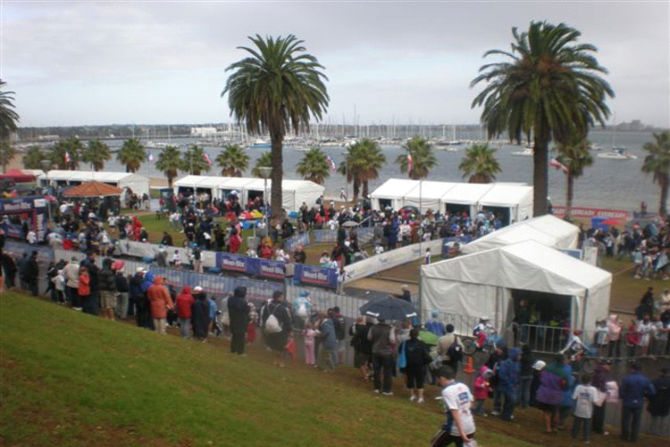
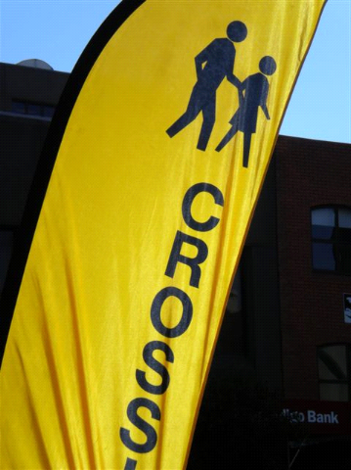
- Include crossover points on your public event program
Following is an example of a Traffic Management Plan developed for the Geelong Summer Festival.
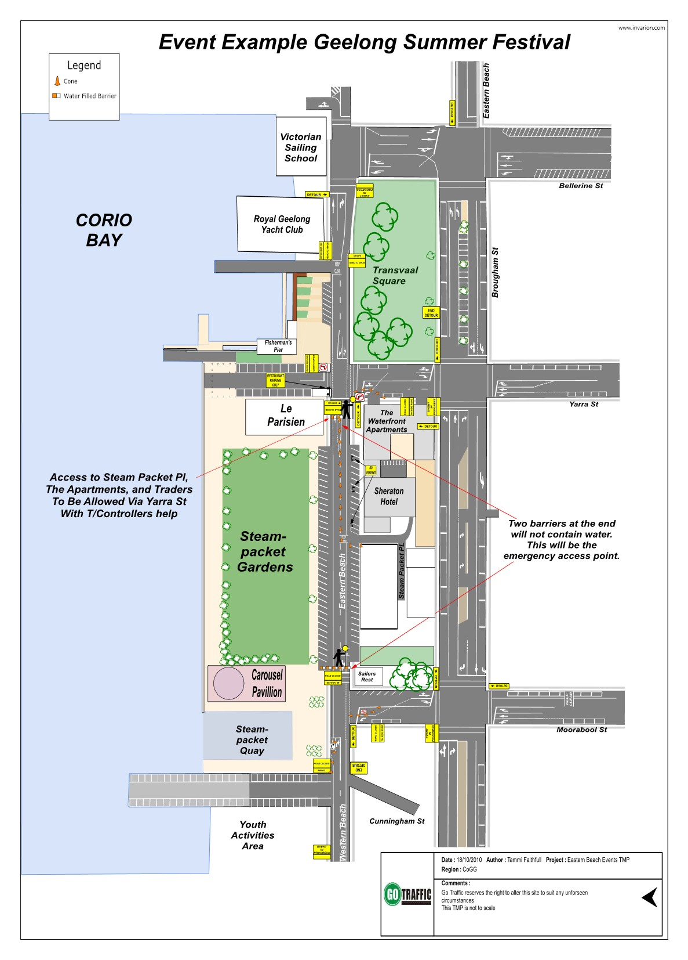
TRANSPORT PLANNING
PUBLIC TRANSPORT PLAN – EVENTS AFFECTING PUBLIC TRANSPORT
If the event impacts public transport (rail, buses, taxis), Public Transport Victoria must be notified and an ‘Event Notification Form (Form 2)’ completed and submitted for approval. Refer to the website for advice on what plan is required: http://corp.ptv.vic.gov.au/contact-us/notification-of-events-affecting-public-transport/
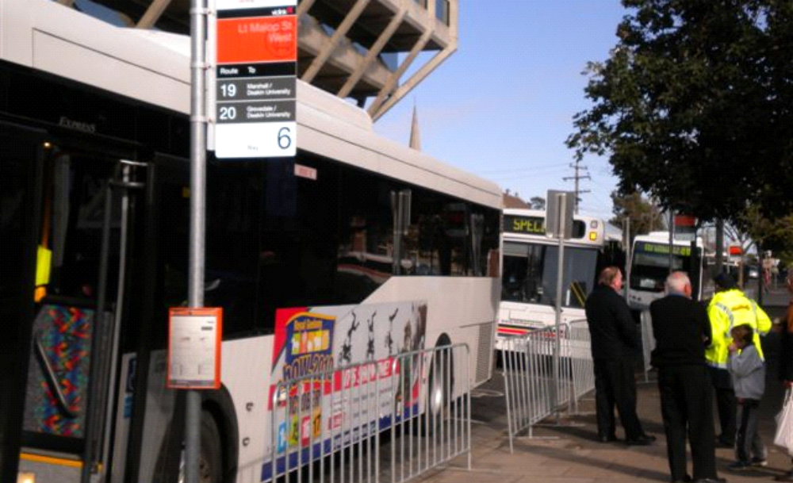
It the event does not impact public transport, it is a good idea to include information in your briefings, programs or event plan about public transport details (including times, locations and routes) to distribute to the event spectators and participants.

HOW TO DEVELOP A TRANSPORT PLAN
You should have completed the Public Transport Victoria ‘Event Notification Form (Form 2)’ to determine if extra services are required, or if there is an impact on an existing transport service (such as causing an alteration to a route or cancelling a service).
A City of Greater Geelong Events Officer will contact you if a Transport Plan is needed as part of the event management plan.
PEOPLE GETTING TO YOUR EVENT
You need to consider how spectators and participants are travelling to the event.
PARKING
The Parking Plan should take into account how many people will be attending the event by private vehicles, and what parking is available. Consider public and private car parks and show the location on your promotional material. It’s a good idea to make contact with car park operators to discuss operating times.
SHUTTLE BUSES
Familiarise yourself with the local transport timetables and consider where patrons are likely to be coming from.
For example, if a number of patrons are likely to catch a train or a bus to the nearest station or stop, and there is not a local bus service that links the train station to the site and it is too far to walk, consider hiring and coordinating shuttle buses to transport the patrons to and from the event site.
If the patrons are likely to head to another location after your event is finished then you may consider hiring shuttle buses as safe means of transport.
Providing a shuttle service to and from your event can assist patronage of events and minimise other traffic disruptions.
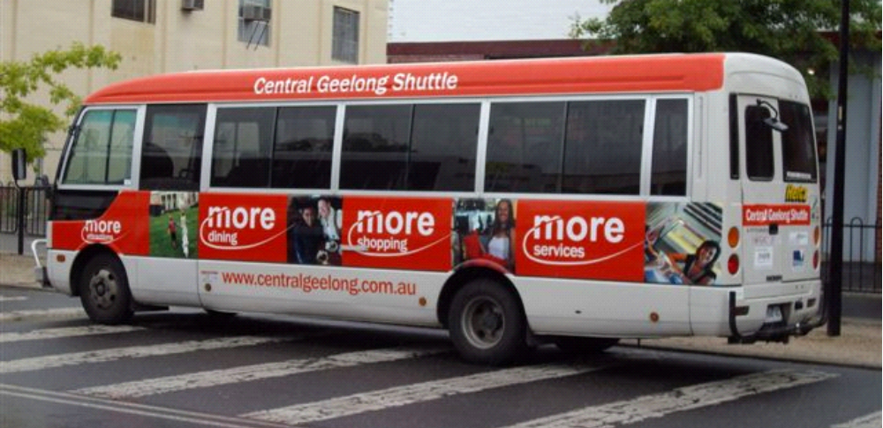
TAXIS
Make contact with the local taxi company and advise them of the event finish time. Request that taxis are directed to a nominated location and time/s to the event site. Consider arranging a temporary taxi rank on site and include this in your communication to patrons.
TRAVELSMART PROGRAM
The Travel Smart Special Events Resource Kit is designed to help event organisers reduce reliance on car travel to and from the event. The kit will help you to identify alternatives to car travel and support people who choose to use alternative modes of transport.
Download the kit from: http://www.travelsmart.gov.au/events/index.html#download.
WALK OR RIDE THE CITY OF GREATER GEELONG
The City of Greater Geelong has developed a ‘Walk or Ride the City of Greater Geelong’ map. Ask your Events Officer to provide you with a copy.
HOW TO DEVELOP A PARKING PLAN
Depending on the size of your event you may be asked to develop a Parking, Transport and Access Plan.
You will need to know approximately how many vehicles will require parking spaces and at what times. The Traffic Management Plan and these plans should include the following:
Participant parking
Identify the requirements of the participants and arrange suitable parking (i.e. how many parks are required, will the participants have equipment to carry, and are they likely to cycle from their vehicle to the event?) Pre-event communication to participants should include information about location of parking, cost, opening and closing hours etc. Consider placing temporary signs at the entry to these car parks to assist with communications.
Contractor and staff parking
Generally the City does not permit event contractors to park their vehicles on an event site unless it is during the set-up and pack-up phase. This is why it is important for event organisers to designate staff and contractor parking and ensure that pre-event communication of these arrangements takes place.
If there are suitable commercial parking areas close to the event site that could be used as participant, spectator, VIP, contractor or staff parking, it is worth contacting the owner to discuss car park availability.
If you have a website or Facebook page it is a good idea to promote available parking to your event audience. Provide a map to show car parking locations.
If there are no existing public car parks available near the site, and it is agreed that there is an area of the site that can be used as a temporary car park, then it will be your responsibility to manage this car park.
You could consult with the traffic management company or experienced service club to develop a plan of the parking arrangements. Locate the entry and exit points, examine how the vehicles will be positioned to maximise parking spaces and maintain emergency access. The plan should also identify how many vehicles can park in the area, what equipment is required to manage the car park and what the staff roles and positions will be.
BUILDING CAR PARKING INTO YOUR TRAFFIC MANAGEMENT PLAN
You may require traffic controller and/or event marshals to manage parking.
Signage with clear messages can be very helpful, especially for the following:
- Car park open and closure times
- Accessible parking
- VIP areas
- No parking times
- Bus/taxi/disabled drop offs/pick ups

Other important considerations
Lighting
Consider the adequacy of existing lighting at car parks, the venue and along connecting pathways. Is the lighting always on or does it need to be manually turned on? Ensure that the lights are pointed the correct way so that they provide light to the required areas and don’t blind drivers of vehicles.
It is also worth considering if it will be a dark or a well lit night, depending on the size of the moon and the weather forecast.
If there is not enough lighting you need to factor in temporary lighting.
If delays are expected exiting the car parks you may need to think about temporary toilets and bins being positioned in these areas.
Pathways
Pathways connecting the car parks to the event sites should be checked for trip hazards and staffed by security to ensure the safety of patrons. It is also worthwhile erecting temporary signs to show the route from the venue to the car parks and vice versa so that patrons take the right path.
power management plan

Assessing the event’s power requirements
To determine how much power will be required to operate the event, the event organiser needs to know where the existing power is, how much power is available, who needs power and how much power they need. Once this information has been collected then the event organiser should make available and allocate the power to event participants and contractors.
Knowing what the event’s power requirements are and having the right amount of power in the right spot at the right time is one of the most important investments in pre-event planning that an event organiser can make.
To find out where and how much power is available on site the event organiser should arrange with the Events Officer to gain access to the on site power boxes and visit the site with the event electrician to make an assessment.
To find out what equipment needs power and how much power the equipment needs (3 phase, 10 amps etc) ask the event participants and contractors during the planning stage what their requirements are and record the information.
As a guide:
- Typically food vendors and merchants may need to access 15amp and 30amp power points.
- Mobile food vans may have a generator or need access to mains power
- Stages and technicians operating large scale equipment and machines may need access to 3 phase power
- Inflatable and mechanical ride operators may have a generator or need access to mains power
- Temporary lights, if not supplied with a generator, will need power
After it has been determined what power supply is available on site and where it is located the event organiser should be able to gauge if the power supply is sufficient to cater for all the event’s electrical requirements or if extra power such as a generator is required.
Provide the electrician with the information regarding the event’s power requirements. The electrician should advise the event organiser if the on site mains power is able to support the event’s power requirements and if a generator is required.
Questions that should be answered when calculating the event’s power requirements:
- Is the mains power on site able to cater for the event’s power requirements?
- Is a distribution board required?
- Is a generator required?
The event electrician should advise the event organiser if a generator is required to meet the events power requirements. The event electrician should stipulate what size generator, how the power will be distributed to the event participants and if and when it would need refuelling.
The site plan should show where all the power sources are and include any power leads.
The event’s Risk Assessment should address how power is managed safely at the event.
For information on managing the event’s power safely and the industry standards go to Section 3, Risk Management, Part F, Power Management of this Guide.

LIGHTING PLAN – include in YOUR POWER MANAGEMENT PLAN

Where are lights needed on your event site?
- The public will need lights for safe access of the site. If permanent lighting is not sufficient then portable lighting towers may be required
- Temporary portable toilets will need lights. Single units often do not come equipped with lights; however an electrician can install temporary lights
- Some public toilets have lights and some do not
- Food vendors in vans will usually have existing lights to operate and to serve customers
- Merchants in temporary marquees will require lights to operate and to serve customers
- Ticket booths, first aid and information booths need lights
- Stages and back of house performance areas need lights
- Temporary structures need lights, as do the aisles and exits. Auxiliary battery power or generators should be installed to provide lighting in a blackout situation. This will be a requirement of any Division 2 Occupancy (POPE) and Siting Approval Permits
- Many concerts are performed with only stage lighting. Access to the main lights or house lights is essential in case of an emergency. The location of the controls for these lights (and the operation of the controls) must be known to emergency personnel and safety officers—as well as to those responsible for their operation
Once it has been ascertained where lighting is required, it may be necessary for your event electrician to provide temporary lights, lead and power sources.
The position of lights should be indicated on the Site Plan.
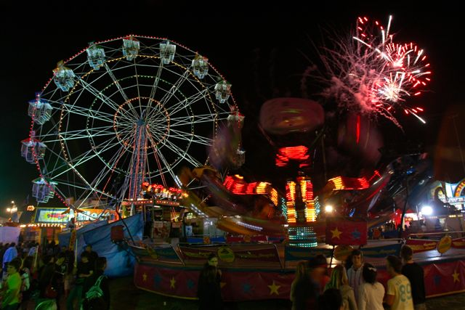
water management plan
For larger community events in the region, Barwon Water has a mobile drinking fountain available to make sure members of the public attending the event have access to drinking water. Contact Barwon Water for more information and to fill in an application form for hire.
NOTE: some commercial suppliers of portable toilets may also hire portable drinking fountains.
You will need to assess the event’s water requirements. Is there enough water available on site? Where is it located? Is an additional supply required?
Consider:
- Will you or are you required to offer drinking water?
- The supply of free drinking water is a condition of the Division 2 Occupancy Permit (POPE)
- Do food vendors need water for hand washing and general operations?
- If the water point can’t be connected to food vendors (usually because of position) you will need to advise them to bring a reserve of potable water
- Do temporary toilets need to be connected to water? If no water is available, advise the toilet supplier
- Does the cleaning contractor need access to water?
- If portable fountains or water trailers need to be connected to a water point
- Are water and/or a water tanks required as part of the event’s Fire Management Plan?

In developing your Water Management Plan you will need to know:
- The quantity and quality of water required
- What water is available on site and what can it be used for
- How water is to be transported, stored and distributed around the site
- Where waste water should be disposed of
- If there are any reserves of water remaining after the event, can it be deposited on site to benefit the landscape, or returned?
- If there is no accessible water on site can you bring in a local water tanker and a local supplier of water to fill the tanker? The additional water may need to be recycled water or potable (drinkable water) – depending on what it is to be used for

NOTE: A plumber may need to be engaged by the event organiser to assist with plumbing in toilets and providing drinking water tap fittings etc.
The Risk Assessment should address the safe management of water at the event.
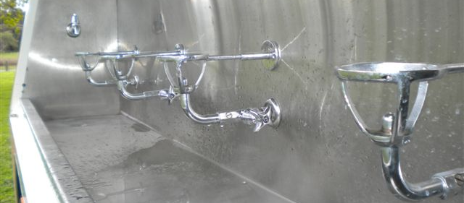
Providing free drinking water at your event is a great idea.
waste management plan
Waste can be generated at all times during an event as well as set-up, registration and pack-up stages. It is your responsibility to manage the event’s waste and leave the site and its facilities in a clean and tidy condition.
MASS BALLOON RELEASE – PROTECTING OUR ENVIRONMENT
Mass balloon releases are strongly discouraged by the Environmental Protection Agency, Marine Victoria, Parks Victoria and the City of Greater Geelong Environment Department and asset managers.
Once a balloon is released it will continue to climb in elevation until the atmospheric pressure causes it to pop, slowly deflate, float down to Earth and fall on land or into the ocean. The balloon is now considered to be litter.
Balloons, whether they are biodegradable or not, fall back to Earth as litter and if they land in the rivers or sea, or are washed into the waterways, they become a danger to the marine life.
A great alternative for event organisers is to release bubbles instead. If you want to see just how damaging mass balloon releases can be visit http://balloonsblow.org/
It is likely that your event will not gain approval if you proceed with this element of your event program.
RECEPTACLES AND TOILETS
Existing bins and toilets that are on site should be included in the Waste Management Plan, which means it is your responsibility to clean and monitor them during and post-event.
What generates waste at an event?
- Boxes, bottles, napkins and plastic wrapping from food and drink vendors
- Contractors’ and event related signage, cables, materials, string tape and other equipment
- Animal nurseries
- Everyone uses the bins and (may) litter the ground
- Everyone uses the toilets

How to manage Waste:
- Monitor and clean existing and temporary toilets during the event
- Provide extra toilets
- Monitor and clean existing and temporary bins during the event
- Provide extra bins (garbage bins and skips)
- Hire professional cleaning staff who have the right equipment and cleaning stock and make sure they are there at the right times to monitor and clean
- Communicate your Waste Management Plan to event participants

Toilets:
- There are two types of temporary toilets. Toilets that need to be plumbed into a sewer main and those that are pumped out during or after the event
- Toilets that hold the waste may need to be emptied during the event and it is important to position the toilets on site so that this can happen when needed
- There are limited sites in the municipality that have sewerage points for events. Toilets that do need to be plumbed into an existing sewerage outlet need permission from Barwon Water prior to the event. You will need a plumber to connect the equipment

To seek permission from Barwon Water to connect into an existing sewer pipe contact:

Barwon Water – Sewerage Connections
T: 5226 9288 / 1300 656 007 and hold the line after options.
M: 0408 993 756
E: info@barwonwater.vic.gov.au

The number of toilets required to be available depends on the following:
- Anticipated number of patrons attending the event and their gender
- If alcohol is available at the event
- The length of the event program
- If a Division 2 Occupancy Permit (POPE) is required
A Division 2 Occupancy Permit (POPE) requires that a specific amount of toilets are provided for the number of persons attending the event. To estimate the number of toilets required please refer to the following information:
Toilet ratios at a no-alcohol event:
- One toilet and washbasin for every 200 females and or males
- Male toilet facilities may include pans and urinals however at least 30% of the facilities must be pans
Toilet ratios at an event where alcohol is available for a 1–3 hours:
- One toilet and washbasin for every 100 females and or males
- Male toilet facilities may include pans and urinals however at least 30% of the facilities must be pans
Toilet ratios at an event where alcohol is available for more than 3 hours:
- One toilet and washbasin for every 75 females and or males
- Male toilet facilities may include pans and urinals however at least 30% of the facilities must be pans
NOTE: - this guide should be used by all event organisers and not just those applying for a Division 2 Occupancy Permit (POPE).
Existing and/or additional toilet facilities should:
- Be accessible (this includes the position and terrain that they are located in)
- Be located away from food storage/service areas
- Be well lit so as not to provide a security or safety risk
- Be cleaned and re-stocked regularly
- Have soap and hand drying equipment
- Have nappy changing facilities

Accessible toilets
- At least one wheelchair accessible unisex toilet must be provided at any event for every 100 toilet pans provided

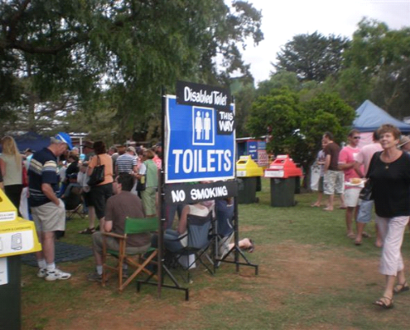
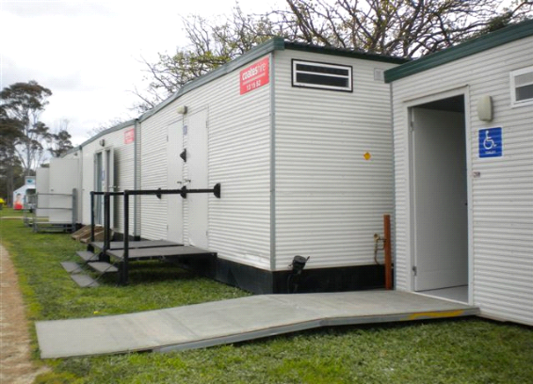
Portable toilets come in a variety of styles and sizes. Porta-loos are the most common form. Shed based toilets are often used for larger events.
How to develop a Waste Management Plan:
You can develop the plan yourself and contract a waste management/cleaning company to implement it. Another option is to engage a waste management contractor to both develop and implement the plan on your behalf.
The Waste Management Plan should include information about:
- Cleaning and restocking of existing toilets
- Emptying existing on site bins
- Cleaning and restocking of temporary toilets
- Emptying temporary bins
- Delivery and emptying of skips
- Pick up of ground litter
- Cleaning of event infrastructure such as tables and chairs
As a first step you should assess who will generate waste at the event and estimate how much. This will help in working out if you need temporary infrastructure to manage the event’s waste and where it needs to be positioned. It will also help you determine when the waste will be generated and when cleaning will be needed.
The Cleaning Schedule details should include the following information:
- When the infrastructure (skips and bins) arrives and leaves the site
- When the cleaners arrive and leave the site
- The roles of the cleaners on site
Things to consider when developing a Cleaning Schedule:
- Set-up phase–generally it is a good idea to have minimum cleaners on site as the event participants are bumping in so they can collect any cardboard and boxes, position and line the bins, and stock the toilets
- Peak spectator times–the maximum amount of cleaners should be on site during these times to monitor the toilets, pick up ground litter, empty bins, wipe tables etc
- End of event–cleaning staff should be doing a final clean and remove all their equipment.
- Pack up–assign an event staff member to ensure that any leftover waste from event participants (cardboard boxes, unused stock etc.) and promotional activity (eg. cable ties) is removed from the site
- Include delivery times of temporary equipment and start/finish times of cleaning staff
- Also include vehicle access and parking arrangements for cleaning staff
- Event organiser to undertake a walk through of site prior to cleaning staff leaving to ensure site is cleaned prior to the contracted staff leaving

NOTE: Many sites have existing Council bins on location and you are welcome to incorporate this infrastructure into the Waste Management Plan. Many of the bins are locked. Your Events Officer can provide you with a key prior to the event so cleaning staff can line the bins. The bins should be locked and left empty at the end of the event.
NOTE: Many sites have public toilets and you can also include these in your Waste Management Plan. The plan should include re-stocking of the toilets throughout the event (paper and hand towel) and emptying of the waste paper bins within the toilets. The toilets should be left in tidy condition.
A site plan showing the existing bins and toilets, temporary bins and toilets, the event impact zone (the area outside of the site precinct that is likely to have litter generated as a result of the event), and the location of skips should form part of the Waste Management Plan and also be provided to the cleaning contractor.
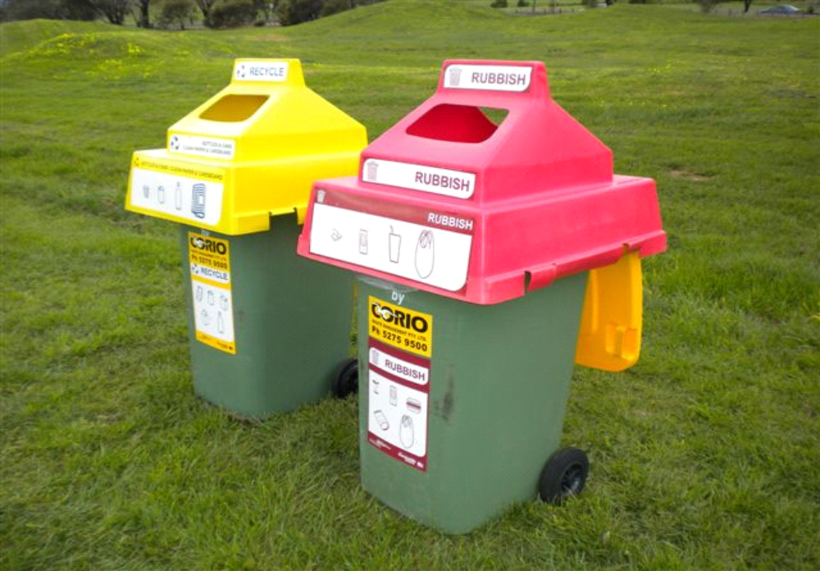
The City encourages all events to have recycling as part of their event’s Waste Management Plan – achieved by using capped bins.
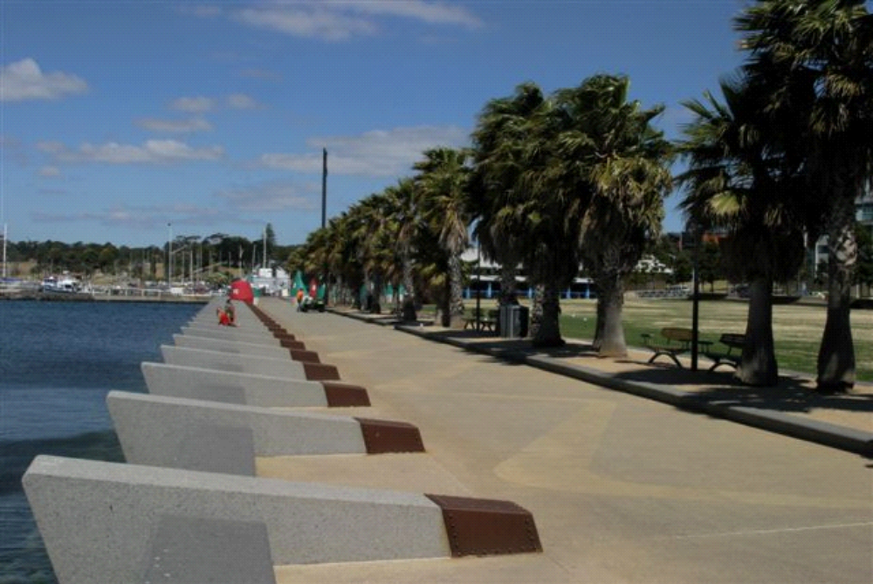
Existing bins such as those evenly spaced around Steampacket Gardens can be used for events, but must be managed as part of the event’s Waste Management Plan. This means they need to be cleaned and emptied during the event by your waste contractor.
RECYCLING PLAN

Including recycling in the Waste Management Plan:

Why should waste be recycled at your event?
Recycling at the event shows the participants, spectators and general community that you are taking responsibility for the impact of the event on the local environment. Recycling also lessens the event’s environmental footprint.
The City of Greater Geelong strongly encourages the recycling of waste generated at events.

How can waste be recycled?
Barwon Region Waste Management Group can help you with best practice waste management. Download a free action plan template and support pack from www.brwmg.vic.gov.au/events/resources.html
This information should be transferred to the pre-event waste management planning.
Complete the checklist and communicate to the event participants about the type of materials that can or cannot be brought to the event.
Calculate the amount of rubbish generated at the event.
Order the number of mobile garbage bins required to collect the waste. Allocate the bins to accommodate the amount of rubbish estimated will be generated at the event. For example if it is estimated that 70% of the waste generated will be recyclable plastic and glass then allocated 70% of the bins for this purpose.
Book the red and yellow bin caps that differentiate the bins. (Red is for general rubbish. Yellow is for recyclable plastic and glass.)
Cardboard should be flattened, weighted and stored at the back of the stalls by the event participants and collected prior to the event opening, during (if necessary) and then again at the end of the event.
Show on the Site Plan the position of allocated bins and the optimal locations for red and yellow bins. They are often positioned together in high traffic areas, i.e. near food courts.
Book the skips to collect the red and yellow streams of rubbish. There is a choice of skip sizes and it should be estimated how much rubbish the event will generate so that the correct skip sizes can be ordered. Position these skips on the Site Plan.

How do I book the red and yellow bin caps?
Event bin caps (these are the red and yellow rubbish and recycling caps that sit on top of wheelie bins) are available to support the waste system. Caps can be booked from GDP Industries in North Geelong; the booking form can also be downloaded from: www.brwmg.vic.gov.au/events/resources.html
If further assistance or advice is required in developing the event’s recycling Waste Management Plan contact:
Barwon Regional Waste Management Group
Regional Education Officer
T: 03 5277 9656
F: 03 5277 9979
E: tina.perfrement@brwmg.vic.gov.au
E: admin@brwmg.vic.gov.au
W: www.brwmg.vic.gov.au

NOTE: A new online Sustainable Events Planner has been developed by the Sustainable Living Foundation–to view the resource visit: www.slf.org.au/eventplanner
Summary of how to include recycling in your Waste Management Plan:
1. Plan to recycle:
Download the checklist and support pack from www.brwmg.vic.gov.au/events/resources.html

2. Communicate to event participants about the Waste Management Plan:
Include this information in Expression of Interest forms, contracts etc.

3. Estimate and order the amount and size of equipment needed:
This includes mobile garbage bins, caps and skips.
HINT: different coloured liners for the two types of bins helps the cleaners to put the right rubbish in the right skip.

4. Communicate the final plans to the event cleaners and your event supervisors.


noise management plan

What noise needs to be managed?
If the event is outdoors and has amplified music, a speaker system providing directions to participants and/or operating mechanical equipment, then the event organiser will be required to develop a Noise Management Plan as part of the Event Plan. The plan should be developed in accordance with the Environmental Protection Authority (EPA) Noise Level Guidelines as explained in Section 1 of this Guide.

What are the Noise Level Guidelines and how do they relate to events?

The Noise Level Guidelines in relation to outdoor events is set by the State Environment Protection Policy which is administered by the Environmental Protection Authority.
The following information has been summarised from the Victorian Government Gazette No: S43 August 1989 Environmental Protection Act 1970
STATE ENVIRONMENT PROTECTIONS POLICY (CONTROL OF NOISE FROM PUBLIC PREMISES) No. N-2
In this policy the Environmental Protection Authority advises that the noise level guidelines in relation to amplified sound are:

- for a five hour period between the hours of 9am and 10pm from Monday to Thursday
- for a ten hour period between the hours of 10am and 11pm on a Friday or a Saturday
- for a ten hour period between the hours of 10am and 10pm on a Sunday

During any of these times the noise level limit for outdoor venues is set at 65dB (A). Noise should not exceed this level inside the closest residence or business to the event site.
There are also general noise level guidelines in relation to machine operations or building such as ‘noisy machinery’ i.e. trucks, earth moving equipment, hammering are only permitted during the following times:

- for a five hour period between the hours of 9am and 10pm from Monday to Thursday
- for a ten hour period between the hours 10am and 11pm on a Friday or a Saturday
- for a ten hour period between the hours of 10am and 10pm on a Sunday

During any of these times the maximum noise level limit for outdoor venues is 65dB(A). This noise level should not be exceeded inside the closest residence or business to the event site.

How to develop a Noise Management Plan:
- Identify the groups that are likely to be affected (this could include residents, business and wildlife)
- Show on the site plan the position and direction of speakers, ideally speaker horns be faced towards open areas, ie. water
- List the times when sound testing will be undertaken (also include in the Event Build Schedule)
- List the times when amplified sound will be used during the event program
- Document a noise reporting and control procedure for when the noise is being generated. It is likely that a professional noise consultant will be required to measure the noise of the event during the sound testing, during the event and at specific locations. Should the noise levels exceed 65dB(A) at any time the consultant should immediately advise the event organiser or the sound technician to lower the sound levels

You may also need to provide a post-event noise report to the City’s Events Unit.

FOOD management PLAN

How to work well with food vendors:
As the event organiser you are responsible for the management of food vendors, including site placement, provision of services (such as waste management), access to services (power and water) and risk management. It is up to you to invite and coordinate food vendors to participate in the event. The advice listed below should assist you in working well with your food vendors.
Ensure that you have received advice from the Events Unit as to the types and amounts of food vendors that will be permitted to participate at your event site, before you invite any vendors to participate.
Develop an Expression of Interest form that they provide to potential vendors. You should, at a minimum ask for a copy of their Food Registration Certificate, the type of structure they operate from, its dimensions and which services they will need access to.
Promote healthy eating options at the event. Offer a variety of food choices with a healthy food option being the priority. For more information refer to the Healthy Foods chart on page S2-41 of this Guide.
Once you have confirmed participating vendors provide details to your Events Officer that includes the information in the example shown below. This information will be forwarded on to the City’s Health and Local Laws Unit and they will liaise with the vendors in regards to food permits and safety plans.
Receive advice from the City’s Health and Local Laws Unit regarding the status of vendors food permits and plans. Include these food vendors in the Event Plan and on the site plan. For more information about permits go to Section 1, How to apply for an Event, Part B, The Event Application of this Guide.
Name of vendor business | Name and contact details of food provider | Type of food being served or sold (menu) | Type of structure used | Current Temporary Food Permit with the City of Greater Geelong or other
 |  | Exposed Food  Pre Packaged Food  Sausage Sizzle  Beverage  Alcohol | Van  Marquee  Stall  Trestle/Cart | Refer to the Food Vendor Responsibilities section of this Guide.
Example  Marcus Meatballs | Marcus Marsone  1 Hill Street  Hill Park 3546  Ph 0433 xxx xxx | EXPOSED FOOD  Meatballs  Spaghetti  Juices | Mobile Food Van | YES  Hill Park Council Mobile Food Van Permit

Providing on site services to vendors:
It is your role to provide vendors with access to utilities. Pre-planning begins when you invite food vendors to take part in the event. Your expression of interest form should include questions about what services they will need access to. Some vendors may be completely self sufficient, some may just need power; some may need power, water and a marquee.
Once you know where and how much power and water is available on site and the type of utilities each vendor needs, you can start allocating available power and/or arranging the hire of generators, distribution boxes and power cables. For more information go to Section 2, The Event Plan, Part B, Additional Event Plans of this Guide.
You will also need to manage the on site provision and use of gas bottles and appliances. To ensure your event meets the Gas Safety Guidelines go to Section 3, Risk Management of this Guide.
Your Waste Management Plan needs to cover how you will deal with the waste generated by food vendors – and will be an important part of your overall Event Plan. Go to Section 2, The Event Plan, Part B, Additional Event Plans for more detailed information regarding waste management planning.
It is a very good idea to nominate a Food Safety Supervisor and list them in your Event Plan. The Food Safety Supervisor will be responsible for coordinating the food vendors from bump in, overseeing access to utilities and food safety.
Food vans on site plans:
Show the position and the dimensions of the van, and the customer serving area. If the van is accessing power, show the location of the power source and the distance from the source to the van. If the food vendor has a stand-alone generator then the site plan should show the position of the generator and how it will be made inaccessible to the public.
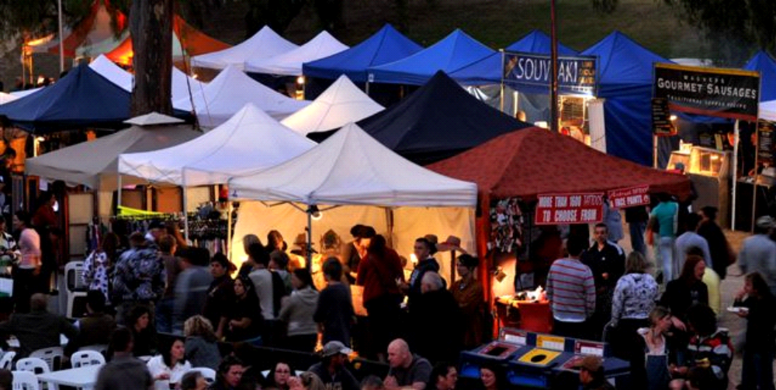
Food marquees on site plans:
Follow the City’s Health and Local Laws Structural Requirements Checklist. Each marquee and its dimensions should be shown on the site plan. The internal set-up of each food marquee should be drawn as separate plans and indicate the following:
- back of house - preparation areas
- cool rooms
- fire prevention equipment
- flooring used
- garbage disposal area
- generators, location of electrical leads and connections
- hand washing and dishwashing facilities (must be separate to those provided at toilets)
- hot plates, ovens or oil, and bain-marie
- preparation and service tables
- protective barriers to ensure separation of hot areas from the public

If the marquee is accessing power, the site plan should show the location of the power source and the distance from the source to the marquee. If the marquee has a stand-alone generator then the site plan should show where the generator will be positioned and how it will be made inaccessible to the public.
Promoting healthy eating at events:
The City of Greater Geelong supports and encourages healthy eating at events. It is recommended you select food and beverage vendors who provide healthy food and drink choices on their menus. Consuming healthy food and beverages has the potential to influence the health related behaviours of staff, performers and the general public. The benefit of offering healthy food and beverages at the event means that the general public, staff and performers can feel energised and hydrated.
To increase the options of healthy food at the event aim to ensure:
- easy access to drinking water either freely available or adequate quantity for sale and well promoted
- fresh fruit options are available
- salads and vegetable based dishes and / or fresh salad or vegetables are available and promoted
- there are a good proportion of food vendors offering well promoted healthy food and drink choices (*)
- vegetarian options are available and promoted
- where tea and coffee are available, also provide herbal teas and decaffeinated coffee.
(*) Food and drinks can be classified into three categories, Green, Amber and Red, according to their nutritional value. A quick guide is provided below to assist you:

GREEN: Everyday Foods  Healthiest choices:  - high in nutrients and fibre  - low in saturated fat and/or sugar  - help to avoid excess kilojoule intake  Include as many as possible in preference to other suppliers.  These choices should be well promoted. | Includes:  Breads, cereals, pasta, noodles  Fresh fruit and vegetables.  Low fat dairy foods & drinks  Lean meats, poultry and fish.  Water | Menu suggestions:  Wholemeal or wholegrain sandwiches and wraps. Pasta, rice and noodle dishes  Salads and vegetables  Fruit – fresh and fresh fruit based sweet dishes  Water  Low fat plain and flavoured milk drinks, (300 ml size),  Reduced fat yoghurts,  Cheese and fruit platters  Mini tandoori and satay skewers  Falafel /lamb kofta balls with dip  Lean meat, poultry, fish meals with salad or vegetables  Healthy BBQ options
AMBER: Select Carefully  Choose carefully:  - moderate amounts of added fat/sugar and or salt  - limited nutrition value  - large quantities add to excess kilojoule intake | Includes:  Processed meats, baked foods and foods sautéed in light oil  Sell in smaller serving sizes | Mini pies and sausage rolls in low fat pastry  Mini savoury quiches  Mini vegetable spring rolls/samousas (baked)  Mini pizzas  Chicken drummettes  Full fat dairy foods and drinks  Mini sweet and savoury muffins
RED: Occasional Foods  Eat occasionally:  - high in fats, sugar or oil  - very low in nutritional value  - contribute to excess kilojoule intake  - limit proportion of these foods and drinks sold at events | Includes:  Foods that are deep fried  Sweet food and drinks with high amounts of sugar  Confectionery | Sugar sweetened drinks – eg. soft drink (full sugar), sports drinks, fruit flavoured drinks  Hot chips/wedges  Large pies and sausage rolls  Danish pastries  Large sweet muffins  Cakes/slices/cookies  Chocolate and confectionery

For further information go to The Healthy Canteen Manual available from:
http://www.education.vic.gov.au/management/schooloperations/healthycanteen/foodplanner/default.htm

For more advice go to the National Heart Foundation of Australia’s Healthier Catering Guidelines and download ‘A Healthier Serve’.
http://www.heartfoundation.org.au/SiteCollectionDocuments/Healthier-Serve.pdf
Other Permits:
A Permit to Burn is not generally required from the City of Greater Geelong if the open fire for cooking has minimum 3m clearance around and above the fire area, and that someone oversees the open flame or coals at all times.
If these requirements cannot be adhered to log onto: http://www.geelongaustralia.com.au/ct/service/task/item/8cd8f4dfd9d5bb0.aspx
A CFA section 40 Permit may be required for open flame/gas cooking on Total Fire Ban days.
Refer to Section 3, Part J of the Guide, Fire Management for more information.
Where gas bottles and appliances are being used for cooking, the event organiser should refer to Section 3, Part H Gas Safety of the Guide for more information.

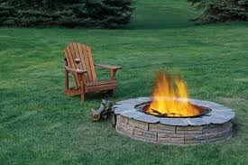
alcohol permits and the management PLAN
You will need a permit for the event if you are selling or serving alcohol as the event organiser is responsible for the service of alcohol at the event.
The Liquor Control Reform Act 1998 stipulates that anyone selling or serving liquor needs to obtain the correct licence. A liquor licence is required whenever liquor is supplied either directly or as part of an inclusive charge. There are different types of licences required for certain types of events or selling arrangements.
>TEMPORARY LIMITED LIQUOR LICENCE: Apply to the Victorian Commission for Gambling and Liquor Regulations (VCGLR)
>MAJOR EVENTS LICENCE: Apply to the Victorian Commission for Gambling and Liquor Regulations (VCGLR)
>CONSUMPTION OF LIQUOR PERMIT: Apply to City of Greater Geelong Local Laws Unit.

HOW DO I KNOW WHAT SORT OF PERMIT I NEED TO APPLY FOR?
The Victoria Police and Council Licensing Officer will offer you advice as to what sort of permit you should apply for and provide you with feedback in relation to your Liquor Management Plan.
Along with obtaining the correct licence, you will also be required to develop a Liquor Management Plan, which shows where security will be, what their roles are, the serving of alcohol responsibility etc.
Once you have applied for your licence, you can check its status by going to:
https://liquor.justice.vic.gov.au/alarm_internet/alarm_internet.asp?wci=start_alarm_internet

TYPES OF LIQUOR PERMITS
TEMPORARY LIMITED LIQUOR LICENCE
A Limited Liquor Licence is required for events that are one-off (providing they are not classified as a "major event").
- extension of trading hours at a licensed premises
- indoor theatre productions of limited duration
- point of sale at a sporting club’s game day (you must provide a full description of the location of the point of sale); if not endorsed on the permanent licence
- private functions held indoors such as a wedding, trivia night, 21st birthday, ball or presentation night
- sales promotions of limited duration, eg. gift hampers, mail order, internet sales, wine drives
- redline areas temporarily extending outside of the premises existing licensed area

How to apply for a Temporary Limited Liquor Licence:
For more information and to make application go to the Victorian Commission for Gambling and Liquor Regulations (VCGLR):
http://www.vcglr.vic.gov.au/home/liquor/new+applicants/apply/apply for_a_temporary_limited_licence
NOTE: An application for Temporary Limited Licence should be lodged at least 8 weeks before the event commences.

MAJOR EVENT LICENCE
A Major Event Licence is required for promoters, businesses or clubs holding large-scale events that are likely to have a significant impact, such as:
- where you expect a large crowd (over 5,000 patrons) to attend and/or have a significant impact taking into account certain criteria
- requiring significant regulatory enforcement effort or oversight
- having a significant impact on the provision and organisation of public transport or emergency services
- having a significant impact on public safety and/or the amenity of the area in which the event is to be held
- Wineries planning to be a stall holder at a Major Event – advice should be sought from VCGLR by the event organiser as to what permits need to be applied for. Don’t assume that if the winery has a licence (i.e cellar door or individual) that this will be the only licence they need to apply for
- VIP areas, pop up bards at a venue, outside its normal use that exceed 5,000 people
Please NOTE: your alcohol permit may not stipulate conditions however, the Victorian Commission for Gambling and Liquor Regulations (VCGLR) expect the local agencies such as the Police and Council representatives to further stipulate conditions.
These conditions may be in reference to the amount, type and role of security guards, the type of fencing to delineate the ‘red line area’ signage and the management of minors in the area etc.
You will be expected to demonstrate as to how you will adhere to and implement these conditions in your Event Management Plan.
How to apply for Major Event Licence:
For more information and to make application go to the Victorian Commission for Gambling and Liquor Regulations (VCGLR)
http://www.vcglr.vic.gov.au/home/liquor/new+applicants/apply/apply_for_a_major_event_licence
NOTE: An application for a Major Event Licence should be lodged at least 3 months before the event. Licensed area to be included in your Site Plan, POPE application etc.
Download and complete the Major Event Licence Application Form (PDF, 833 KB) Details on how to lodge your completed application are included in the form.
Lodging an application does not mean that the application will be approved and you should NOT advertise or promote the selling of liquor at the event before approval is granted.
CONSUMPTION OF LIQUOR PERMIT
If the Victoria Police Licensing Inspector and the City of Greater Geelong Health & Local Laws Unit determines that a Consumption of Liquor in a Public Place Permit is appropriate for your event then an application for Consumption of Liquor in a Public Place Permit can be made through City of Greater Geelong Health & Local Laws Unit.
Permits are generally issued with conditions such as the serving area needs to be contained within a fenced area, entry is restricted to people aged over 18 years, specified number of security staff and no glass. The permit will also be subject to approval and conditions set by the Liquor Licensing Inspector at Geelong Police. Applicants will need $10 million public liability cover.
Permit conditions need to be included in your Liquor Management Plan
NOTE: This recommendation is usually only made for a private function rather than for an event.
LIQUOR MANAGEMENT PLAN
Before lodging your licence application you should have the following information available:
- An overview of the event program and target audience
- Location and number of security and their role/s
- Location of alcohol service area/s on the site plan
- Maximum number of people attending the event
- Plans to control the serving of alcohol to people over 18 i.e. limit of drinks that each person can purchase at any one time and the type (strength).
- Plans to ensure that patrons leave the venue in an orderly manner
- The price of alcohol
- Times that alcohol will be available
- Type of drinking containers that the alcohol will be served in (suggest polycarbonate, cans or plastic and no glass)
- Types of alcohol available
- Venue/s or locations within the site that are serving alcohol
- Who is serving the alcohol and whether they are all RSA trained
- Will there be ‘token or cash’ arrangements for purchasing alcohol over the bar?
- Wristbands to ensure participants are eligible to purchase alcohol

NOTE: Under the Food Act 1984 the sale of beverages and alcohol are considered ‘food’ and therefore require a Temporary Food Permit.
If your application is successful your licence will stipulate the conditions under which you (the licensee) may operate.
Depending on the nature of the event the City’s Events Unit requires an Alcohol Management Plan to be included in the Event Plan.
Safe and legal management of alcohol should form part of your Risk Assessment.

Victorian Commission for Gambling and Liquor Regulations (VCGLR)
49 Elizabeth Street, North Richmond Victoria 3051
GPO Box 1988 Melbourne VIC 3001
T: 1300 182 457
F: 03 9098 5036
E: contact@vcglr.vic.gov.au
W: www.vcglr.vic.gov.au

ASSET PROTECTION PLAN – PROTECTING THE SITE
The Events Unit may ask you to prepare an Asset Protection Plan to demonstrate how you will protect the site and reduce the likelihood of damage during the set-up, delivery and pack-up of the event.
It is your responsibility as the event organiser to ensure that the site is safe for employees, contractors and the general public during the construction stage (set up) during the delivery of the event and during the pack-up stage.
The event organiser is also obliged to return the site to the City of Greater Geelong in the same condition in which it was received. While general wear and tear is expected, any damage to the asset will need to be repaired at your expense.

How to develop an Asset Protection Plan:
It is always good practice to use common sense and monitor the movements of all contractors on site.
Follow these steps to minimise site damage, and document in your Asset Protection Plan:
- At the site hand over you should have assessed and recorded its pre-event standard (refer Section One Site Responsibility)
- Ensure that food vendors do not drip oil or drop food and drink from service areas onto grassed or paved areas. This can be managed by stipulating protective matting in food preparation and serving areas. A bond can be placed on vendors to cover any damage.
- Ensure that generators and other machines are lifted carefully onto the site to reduce the risk of fuel leaks
- Ensure that heavy equipment is not dropped onto the grass
- Have a site supervisor to oversee the delivery and pack-up phases of the event
- Manage the contractors and communicate to them prior to the event as to how they are expected to protect the asset
- Oil must be collected and taken away and melted ice should only be poured into approved drains. Oil and ice will damage a grassed site. Oil and food on paved areas may require special chemical cleans to remove any stains generated by the event.
- Place boards or terra track on high traffic areas during the event build
- Plan ahead so that any marquees and stages on grassed sites can be set up at the latest possible stage. The longer the grass is covered the more risk of it dying and needing to be replaced
- Position ply boards under heavy equipment (i.e. legs of stages) to spread the load on both grass and paved areas
- Position skip bins on flat ground to ensure that when rubbish is placed in the bin it doesn’t spill out onto the ground
- Position terra track or boards to act as drop off points for heavy equipment
- Request a site plan showing services to reduce the risk of a water pipe being punctured and flooding the site during the build
- Some builds require a path of board, or terra trak to be laid down so that heavy vehicles can access the site without doing damage
- Terra trak can be placed in wet areas to protect the grass during the event. For example outside toilet blocks or serving areas. If the event is held over more than one day or evening the track should be rolled up to let the grass breathe overnight

INCLUSIVE eventS
By planning for and promoting an inclusive event, it is likely that more people will attend the event and have a fantastic experience. People who will benefit from an inclusive event include:
- Carers, family and friends who might accompany a person with a disability
- Elderly people
- Parents and people with prams
- People with a permanent or temporary physical disability

It is estimated that 20 percent of the general community have a disability, with 5.6% of the population in Geelong requiring assistance with core activities due to a disability. The Disability Discrimination Act 1992 (DDA) provides protection against unfavourable or unfair treatment of people with a disability. Therefore dignified and equitable access must, by law, be provided at planned events and public activities.

How to plan for an inclusive event:
This checklist has been developed to assist event organisers to plan for an inclusive event. The most effective way to hold an inclusive event is to think about access and inclusion at the early stages of planning.

At your event, have you considered: | Yes | No
Consulting Rural Access in regards to your event?
Rural Access are part of Aged & Disability Services at CoGG and are able to assist in accessing information and making considerations to ensure your event is inclusive.
If you can involve people with a disability in planning the event?
If the event’s location promotes community inclusion?
The timing of the event and its suitability for your target audience?
If there is accessible public transport available?
Are there accessible parking spaces near the entrance to the event?
If you are temporarily using the existing accessible parking bays, you should plan to replace them near the site. Discuss these options with your Events Project Officer.
Is the path from the parking area to the event space firm and level?
Is the main entrance free from steps and/or is there a ramp?
NOTE: Portable ramps and fluoro stick bollards are available for hire from the City’s Rural Access Unit.
Positioning colour contrasting at step edging and tactile ground surface indicators at the top and bottom of any steps?
Are the entry ways to temporary structures easy to open and at least 800mm wide?
Can patrons access the customer service areas and food counters? At least one low height counter should be available.
Are staff/volunteers aware of different access and communication styles?
NOTE: Rural Access has an online Accessible Communications resource.
Offering a free ticket to the companion of a person with a disability?
NOTE: A companion card promotes the right of people with a disability, which require a companion, to fair ticketing at Victorian events and venues.

Continued……At your event, have you considered: | Yes | No
Offering other concessions, such as for Pensions, Health Care Cards and Students?
The availability of an accessible toilet. NOTE: There are a number of suppliers for accessible toilet hire in Geelong. Contact Rural Access for information and advice.
The accessibility of pathways to all public facilities?
Clear signage to all facilities, in large print and in contrasting colours?
NOTE: Rural Access has some portable signage available for hire.
Having a hearing loop/other assistive communication technology available and promoted? NOTE: Rural Access may be able to assist by providing assistive hearing equipment for indoor use.
Using captioning or having an Auslan interpreter during presentations?
Access to any stage or microphone area.
Spectator Events: Is an accessible viewing platform available for people with a disability?
Is there a 10amp ‘RECHARGE POINT’ available at your event or nearby? NOTE: RECHARGE POINTS can be found on the Geelong Australia website.
Lighting throughout venue?
Non-slip flooring or low pile carpet?
Providing a rest area where participants can have a break from noise and weather extremities.
Assembly areas and access arrangements in the event of an emergency evacuation?
Providing wheelchairs for loan?
Promoting your event as inclusive in all advertising and on the event website?
Producing written materials in an accessible format and/or ‘Easy English’?
NOTE: Rural Access may be able to assist you with information about accessible documentation.
Including a mobility map in promotional materials indicating the location of accessible parking, entrances and toilets?
NOTE: Visit the Central Geelong Mobility Access Directory for accessibility of shop fronts :http://www.geelongaustralia.com.au/directory/access
Promoting the event as widely as possible, including to all local disability organisations.
NOTE: Rural Access may be able to assist with contacts.
Implementing changes to plans for future events based on feedback received? NOTE: Rural Access may be able to assist in discussing the successes and limitations of the event.
Show on the event program and/or the information boards at the site the following:
- Access ramps and their locations
- Scooter recharge points
- Rest areas
- Accessible toilets
- Wheelchair hire
Working with Rural Access:
The City of Greater Geelong’s Rural Access team supports event organisers to plan and develop strategies to build inclusive communities, and aims to promote social inclusion and remove barriers to access and participation. This includes supporting event organisers in planning for and delivering successful inclusive events. For more information regarding inclusive events or the use of any of the City’s resources, please contact Rural Access:

Rural Access
City of Greater Geelong
PO Box 104 Geelong VIC 3220
T: (03) 5272 4735
M: 0403 387 171 (call or SMS with contact details)
E: ccarlyon@geelongcity.vic.gov.au

How to set up the City’s access ramps
The City has two access ramps and six portable ‘stick’ guide posts for loan. Ramps can be positioned in places to improve access for people in wheelchairs, with walkers and prams at the event site and can be loaned from the City’s Rural Access Unit.
To install the access ramps you will need:
- To think about the best place to position the ramps. Near main precincts, toilets, information areas, stages etc (not where the area is crowded or inaccessible)
- To identify where the ramps will be used by patrons on the event site plan. For example near a disabled car park or drop off zone
- A trailer or a van to collect and return the ramps
- A person nominated to install the ramps to ensure that they are safe and secure.
- A barrier on either side of the ramp
- A flag or helium balloons to assist in patrons identifying the ramps from a distance
- It is also a good idea to mark the access ramps on the event program site maps
- Ensure their collection and implementation to the event opening to public

NOTE: Events that have a POPE permit must be accessible and inclusive.

Access Audits Australia may also have information and support to ensure your event is inclusive. For information please go to:

Access Audits Australia
T: (03) 9431 3472
E: AAAaxs@bigpond.net.au
W: www.accessauditsaustralia.com.au

Part c: occupancy permit (POPE)
WHEN IS A DIVISION 2 OCCUPANCY PERMIT (POPE) REQUIRED?
“Public Entertainment” is defined in the Victorian Building Act 1993 as being “an entertainment or meeting to which admission may be ordinarily gained by members of the public”, ie the general public are eligible to attend the entertainment or meeting. If your event provides Public Entertainment then you may require a POPE permit.
A summary of the Building Act 1993 requirements in relation to a POPE are as follows:
A Division 2 Occupancy Permit (POPE) is required where:
- admission to an event may ordinarily be gained by members of the public; and
- the venue has an area greater than 500m²; and
- the event is enclosed or substantially enclosed i.e. a controlled space (by fencing, structures, or natural features) that a reasonable person would see as being an exclusive area); and/or
- admission to the event is gained by payment of money or giving of other considerations

Events that are organised and controlled by a “community-based organisation” and where the number of persons attending the event does not exceed 5,000 (at any one time) are not be required to apply for a POPE Occupancy Permit. NOTE: There may be exceptions to this rule.
For the purpose of definition a “community - based organisation” means a body, whether or not a corporate body that:
- is not established primarily for the purpose of profit or gain made in the conduct of its activities to any members of the organisation; and
- does not distribute any part of any profit or gain made in the conduct of its activities to any members of the organisation; and
- operates in a community wholly for:
  - a philanthropic or benevolent purpose, including the promotion of art, culture, science, religion, education or charity; or
  - any sporting or recreational purpose, including the benefiting of any sporting or recreation club or association
EXEMPTION EXAMPLE
A public market conducted by a Rotary Club where the number of persons attending the market at any one time did not exceed 5,000 would not require a POPE Occupancy Permit.
The City of Greater Geelong Municipal Surveyor will assess whether a Division 2 Occupancy Permit (POPE) is required based on the information provided in the Event Application Form and the draft site plan.
WHY DOES AN EVENT NEED A DIVISION 2 OCCUPANCY PERMIT (POPE)?
It is the event organiser’s legal duty to provide a safe environment for all event participants and spectators at events.
It is a requirement of the Victorian Building Act 1993. A Division 2 Occupancy Permit (POPE) ensures the health, safety and amenity of all participants and spectators attending a place of public entertainment.
Should you fail to obtain a Division 2 Occupancy Permit (POPE) prior to conducting your event you would be in breach of the Building Act 1993 and you may be subject to substantial fines and closure of the event.
HOW TO APPLY
If the event requires a Division 2 Occupancy Permit (POPE) then the City’s Building Department will provide the event organiser with an application from, checklist and fact sheet upon request.
Application for a POPE permit must be made to the Municipal Building Surveyor by lodging an “application form” “for a Division 2 Occupancy Permit” with all relevant supporting documentation at least 20 working days prior to the commencement of the event. The supporting documentation includes a copy of the nominated Safety Officers Qualification from the Metropolitan Fire & Emergency Services Boards. There is more information and advice regarding these qualifications in this section of this Guide.
The Division 2 Occupancy Permit (POPE) will be processed by the City’s Municipal Building Surveyor and the applicant will be advised if any further information is required or needs to be clarified.
A Division 2 Occupancy Permit (POPE) application relies on a compliant site plan, an Event Plan that details how the requirements of the public’s health, safety and amenity needs are provided for. The Event Plan should also include an Emergency Management Plan. The Emergency Management Plan must also include an Evacuation Plan.
Refer to the Emergency Management Planning Section to understand what information is required in this plan. Go to Section 4 of this Guide for more information.

WHAT ARE THE FEES?
There is a fee associated with processing a Division 2 Occupancy Permit (POPE). The flag fall fee is $382.00 per application, which allows for three hours of the Municipal Officer’s time to asses the application.
Additional fees may be incurred ($143.50 for every extra hour) should it take the Municipal Officer more time to follow up in-complete applications with the event organiser.

IS THE DIVISION 2 OCCUPANCY PERMIT SITE PLAN COMPLIANT AND READY TO LODGE WITH THE APPLICATION?
Go to Section 2, Part A Event Site Plan—What Information Should Be On A Site Plan and use the checklist to see what information the site plan should show when you submitting an application for a Division 2 Occupancy Permit (POPE).
The event organiser should familiarise themselves with the site. Measure the site area in square metres. Calculate how much of the area will be taken up with event equipment to determine how many patrons can fit into the event site, and what services they will need to ensure their safety and wellbeing. The general rule is 1(one) square metre of space per person. This information will help you work out how many tickets can be sold,.
For example if the site has a total area of 2,000 square metres and 500 square metres of this space will be taken up for staging, toilets, food vendors and site huts, then the remaining area of 1,500 square metres is available to accommodate approximately 1,500 patrons.
- The site plan will have to link with the Event Plan and the Emergency Management Plan.

IS THE SAFETY OFFICER QUALIFIED?
Regulation 1105 of the Building Regulations 2006 outlines the conditions that may apply to an Occupancy Permit for a Place of Public Entertainment (POPE) which include the engagement and responsibilities of qualified Safety Officers to be in attendance at a POPE to provide for the safety of the public.
A qualified Safety Officer needs to have passed a formal training course that is currently being offered by the Community Resilience Department (CRD) which is a division of the Metropolitan Fire & Emergency Services Board (MFB). The course is registered with the Victorian Registration Qualification Authority (VRQA) and designed for persons assigned to the role as a Safety Officer – Place of Public Entertainment (SO – POPE).
The course is structured to comply with the roles and responsibilities of the position of a ‘SO – POPE’ as detailed in Part 11 of the Building Regulations – Regulation 1105. Persons who successfully demonstrate competence upon completing the course will be eligible for a Statement of Attainment as a ‘SO – POPE’. At this stage, the accreditation does not need to be renewed once it has been achieved.
What are the responsibilities of the Safety Officer?
Safety Officers who have been engaged to be in attendance at a POPE’d site must ensure that prior to commencement of the event they review a copy of the POPE permit and its conditions.
The Safety Officer should be very familiar with the Division 2 Occupancy Permit (POPE), the Site Plan, the Event Risk Assessment, Emergency Management and Evacuation Plan prior to the event. The Safety Officer should be easily identifiable at all times (high visibility jacket with title of Safety Officer).
The Safety Officer should inspect the site prior to the public arriving to identify any safety issues and then report them to the event organiser to be fixed in a timely manner. You may consider engaging a Safety Officer to assist in the development of the event’s Risk Assessment and Emergency Management/Evacuation Plan.
Depending on the duration and numbers of people expected to attend, there may be a requirement for more than one safety officer. The Municipal Building Surveyor will nominate the initial number required, however the event organiser will need to take into account the numbers required should a shift change be required due to the length of the event.
A comprehensive list of the Safety Officer’s Responsibilities is provided in the Safety Officer Fact Sheet which is provided along with the Division 2 Occupancy Permit (POPE) application form.
The Safety Officer’s primary areas of responsibility generally include:
- ensuring that the event is compliant with the conditions of the Division 2 Occupancy Permit (POPE)
- ensuring that the site is safe at all times and free from hazards and risks
- maintaining access to all egress areas, and the operation of passage ways and exits
- the availability of specified drinking water facilities
- the availability of specified public toilet facilities and the condition of those facilities
- the exclusion of the public from unsafe areas
- the keeping, testing and storage of flammable material or explosive items and equipment, the ignition of fireworks and the discharge of pistols or other shooting devices in a safe and responsible manner to the extent that is not required by any other act or regulations
- the operation of safety elements, equipment and systems including fire suppression equipment, exit signs and emergency lights
- the safe and efficient operation of fire fighting equipment
- the safe installation of temporary utilities such as power, water, gas and cooking facilities
- to activate the Emergency Evacuation Plan (if required)
For more information on Safety Officers and training programs please contact:
Metropolitan Fire Brigade, Melbourne
Community Resilience Department (CRD) and Workplace Emergency Management (WEM)
T: 1300 668 006
E: wem@mfb.vic.gov.au
ADEQUATE SANITARY FACILITIES
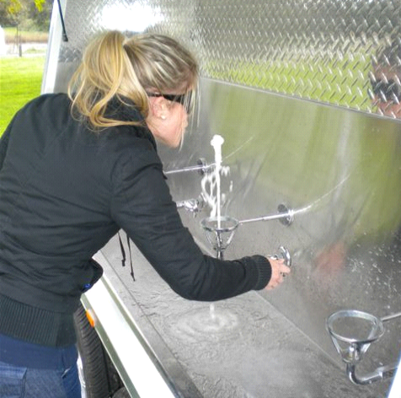
Go to Section 2, The Event Plan, Part B, Additional Event Plans - Waste Management of this Guide to check the correct amount and types of sanitary (toilets) facilities required at an event that has requires a Division 2 Occupancy Permit (POPE).

ADEQUATE FREE DRINKING WATER
Free drinking water must be provided to patrons at any event issued with a Division 2 Occupancy Permit (POPE). This may be in the form of water fountains, bottled drinking water or other. The water must be potable drinking water (fit for consumption by humans).
To provide easy and ample access to water, calculate how much water you will need and where the locations will be.
As a guide use the ratio of one water fountain or outlet for every 200 patrons. On your Division 2 Occupancy Permit (POPE) Application form you need to indicate the number of fountains/outlets and their positions on the site map.

ADVISORY SIGNAGE PLAN
Develop an advisory signage plan once you know the layout of the site and position of equipment.
Inexpensive, weather-proof corflute signs (with eyelets in the corners) can be made and positioned around the site to advise patrons as to how the site operates and where to go in an emergency. Think about designing the signs so they can be used again.
Signage could include the following information:
- Alcohol areas and rules of consumption
- Baby change areas
- Conditions of entry
- Disability areas
- Emergency evacuation routes and assembly areas
- Entrances and exits for emergency evacuation procedures
- First aid
- Food courts
- Marshal points
- No smoking areas
- Parking information – temporary taxi pick up, temporary disabled drop off/pick up areas
- Picnic areas
- Program
- Public information centre
- Public telephone
- Start/finish areas (sporting events/parades etc)
- Ticket sale points
- Toilets
- Water

DEVELOPING AN EMERGENCY MANAGEMENT PLAN
An Emergency Management Plan will need to be developed to ensure the safety of the event patrons and staff. Go to Section 4, Emergency Management Planning of this Guide for advice on how to develop an Emergency Management Plan.
What happens after the Division 2 Occupancy Permit (POPE) has been issued by the Municipal Building Surveyor?
- You will be advised that the permit has been issued and to collect copies of the permit prior to the event from the City of Greater Geelong Building Department, 100 Brougham Street, Geelong (Mon-Fri 8am-5pm)
- You will be required to distribute the Safety Officer’s copy of the permit so they can abide by and implement any of the conditions
- The permit must then be displayed in a waterproof pocket in a prominent position that is also marked on the final and approved site plan

Please NOTE: Prior to the event, you need to distribute the Division 2 Occupancy Permit (POPE) to the Safety Officer. Final Event Plans and Emergency Management Plans should also be distributed to staff and contractors who have responsibility for the safety of patrons at the event.
All relevant approvals must be obtained prior to occupying the event. Failure to comply may result in penalties and fines being issued including cancellation of the event.
For further information please contact our Building Department on 03 5272 4450.

Part d: SITING APPROVAL FOR PRESCRIBED STRUCTuRES
SITING APPROVAL FOR PRESCRIBED TEMPORARY STRUCTURES
Certain temporary structures are classified under the Building Act 1003 as being a Prescribed Temporary Structures. Prescribed Temporary Structures must be issued with an Occupancy Permit from the Victorian Building Authority. You will need this permit, along with the Engineering Specifications to make application for Siting Approval to City’s Municipal Building Surveyor.

The purpose of the Siting Approval is to ensure that the prescribed temporary structures are suitable constructions for the proposed site and meet the minimum Safety and Evacuation Standards.

The Siting Approval is issued on the following conditions:
- That the siting of the Prescribed Temporary Structure is approved by the Municipal Building Surveyor
- That the erection of the Prescribed Temporary Structure is carried out by a registered building practitioner
- That a Certificate of Compliance – Inspection is issued by a registered building practitioner and displayed on the structure prior to occupation
Prescribed Temporary Structures are defined as:
- Seating stands for more than 20 persons
- Stage/s or platforms (including sky borders and stage wings) exceeding 150m² in floor area
- Tents, marquees and booths, with a floor area greater than 100m²
- Prefabricated building greater than 100m² not placed directly on the ground

Structures with a lower size or capacity than a Prescribed Temporary Structure and open air inflatable cinema screens may also require structural verification.
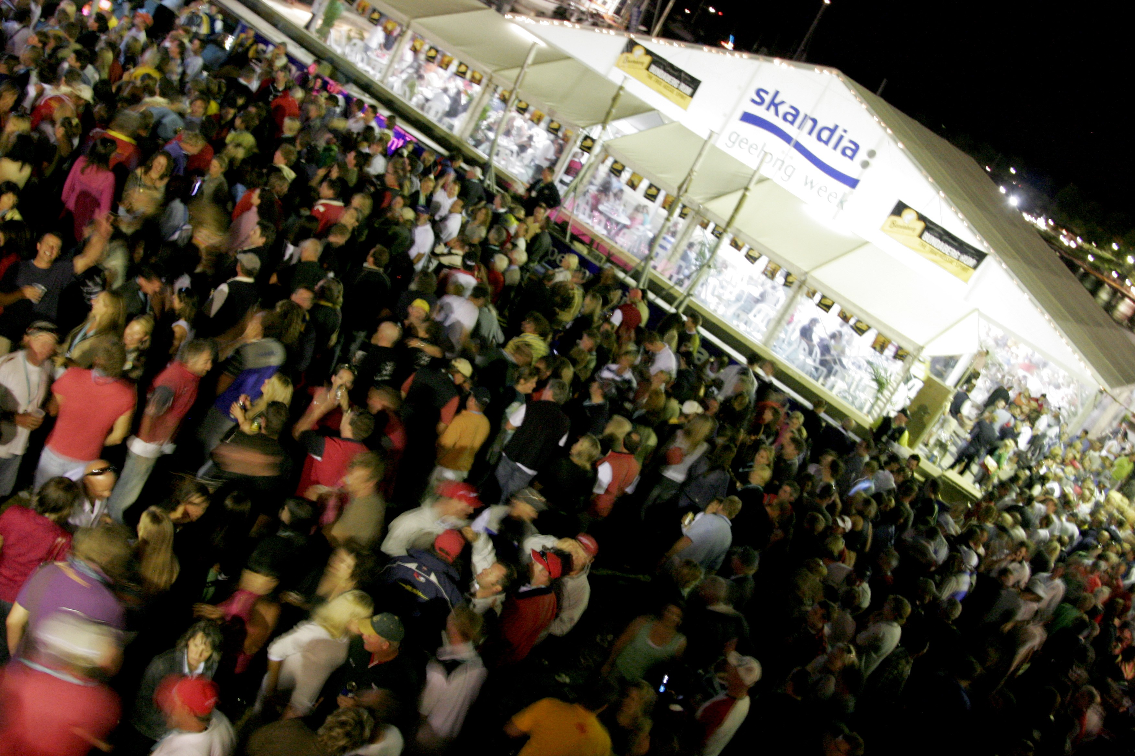

HOW TO APPLY FOR SITING APPROVAL
Either the event organiser or owner of the equipment may make the application for Siting Approval.
The minimum flagfall fee of $202.00 for processing an application will be invoiced to the hire/event organiser who makes the application. Assessment time exceeding 1.5 hours may incur additional fees @ $143.50 per hour.
The table below shows what the steps are for applying for Siting Approval:
Task | Responsibility
Engage a hire company to provide the equipment required.  Ask the hire company to visit the site and check that the structure is suitable for the site and that once erected it will be able to comply with the structure’s engineering specifications. | Event organiser
Complete the Siting Approval Application with all supporting documentation and the application fee to the Municipal Building Surveyor no less than 20 days prior to the erection date. | Hirer or event organiser
Provide a site plan that is to scale and a floor plan of each structure on the site plan.  **Ensure that the site plan complies with the requirements listed within the Siting Approval for Prescribed Temporary Structures Checklist provided on the next page. | Hirer or event organiser
For each structure provide the information requested to describe the marquee in the ‘Type of Prescribed Temporary Structures’ section  **Ensure that each structure has its relevant Victorian Building Authority Division 2 Occupancy Permit. | Hire company can provide this information
Each structure must be erected by a qualified building practitioner. The building practitioner is usually an employee of the hire company.  **Ensure the following information is provided.  Name of practitioner who will erect the marquee on the day and sign the Certificate of Compliance Inspection Permit post-erection.  Registration number of the practitioner. | Hire company can provide this information
Ensure that your contractor is ready to be responsive and follow up with any outstanding documentation that the Building Surveyor may require. | Hire company and event organiser
Receive an Occupancy Permit from the City’s Building Surveyor and attach it to the building. | Event organiser
“Certificate of Compliance – Inspection” to be issued by the relevant building practitioner following the inspection of the completed structure and prior to occupation of the structure. | Building practitioner
Attach “Certificate of Compliance – Inspection and Victorian Building Authority Occupancy Permit” to the structure.  Provide a copy of the “Certificate of Compliance – Inspection” to the Municipal Building Surveyor. | Event organiser

Every Prescribed Temporary Structure needs to meet minimum safety requirements. These are set out in the Safety Guidelines for Prescribed Temporary Structures FACT SHEET.

The information listed below provides a summary of other information that may be requested from you to manage your structure and site safely. Your Events Officer will advise you if additional plans are required.

SITING APPROVAL APPLICATION CHECKLIST
PLAN OR INFORMATION REQUESTED | MORE INFORMATION
Management of fire risks  Fire extinguishers checked, positioned, attached and signed appropriately within the structure refer to notes on Safety Guidelines for Prescribed Temporary Structures FACT SHEET and relevant Building Commission Occupancy Permit.  Relevant permits from CFA for naked flames | Go to Section 3, Part J - FIRE MANAGEMENT RISK REDUCTION PLANNING
Risk management of structures
All structures must be secured appropriately. Go to Section 3, Risk Management of this Guide for advice on how to manage all structures safely.
Evacuation Plan  - All exits clearly marked  - Unobstructed exits | Go to Section 4, Part E - EVACUATION PLANNING
Gas cylinder storage | Go to Section 3, Part H - GAS SAFETY AND THE CODE OF PRACTICE
Waste management | Go to Section 2, Part B - WASTE MANAGEMENT PLANNING
Structural compliance
Refer to the notes provided in the Safety Guidelines for Temporary Structures FACT SHEET which is available from the Municipal Building Surveyor.
Power Management Plan | Go to Section 2, Part B - POWER MANAGEMENT PLANNING

Open air cinemas – some information you should know before choosing your supplier.
You may need to apply for a POPE Division 2 Occupancy Permit for an open air cinema. You should check that your screen contractor is able to provide you with the documentation listed below before you engage them. If you are confident that the company is able to provide you with the plans and certificates listed below then the next step would be to apply for Place of Public Entertainment Occupancy Permit with the City of Greater Geelong’s Municipal Building Surveyor.

Documentation required to be submitted when applying for an Occupancy Permit:
A structural design of the screen structure that has been prepared by a suitably registered engineer.
The structural design must include:
- Computations and summary of the structural limitations of the screen
- Anchorage details for the screen taking into account average and gust wind speed limitations for all applicable wind directions and exposures
- The screen structure’s Certificate of Compliance – Design
- Procedure for monitoring wind speeds during the cinema screening activity, this procedure should include:
1. The reference authority to determine average and gust wind speed
2. The time frames (in the lead up to and during the events) when average gust wind speeds should be monitored

The Building Surveyor can advise you during the planning phase as to how to develop these plans.


