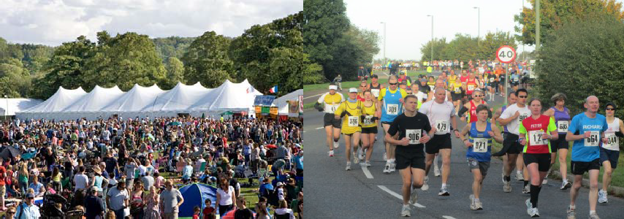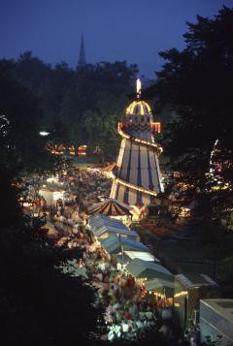

EVENT PLAN

Environment & Economy - Highways and Transport - Network Management
November 2010

Contents

Introduction

Section One Event Organisation

Section Two Event Management Section Three Risk Assessment Section Four Emergency Management
Section Five Major Emergency Reporting Section Six Media Handling

Appendix A Programme of Events

Appendix B Site Plans

Appendix C Emergency Situation Response Plan Appendix D Emergency Exits Site Plans Appendix E Telephone Directory & radio call list Appendix F Risk Assessment
Appendix G Lost Persons

Appendix H Road Closures

Appendix I Car Parking and Traffic Management Plan Appendix J Stewarding
Appendix K Festival Organisational and Safety Action Plan

Introduction

Aim Objectives
Contingency Arrangements

Section One - Event Organisation

Information
- What is the event?
- Where and when does the event take place?
- Who is likely to attend the event?
- How many people are likely to attend the event?

Roles and responsibilities
- Event Organiser
- Event Safety Officer
- Stewards
- Police
- Ambulance Service
- Fire & Rescue Service
- Emergency Planning Unit
- Port Authorities

Site Management
- Site design
- Site rig up & de-rig timescales
- Concessions sitting
- Alcohol / non alcohol areas
- VIP arrangements
- Signposting
  - Directional on roads
  - Site signposting
- Refuse collection

Marketing and PR
- Marketing Plan
- PR Plan
- Evaluation plan

Budget
- Budget
- Cash flow

Insurance
- Event
- Public liability
- Self employed staff cover
- Contractors

Section Two - Event Management

Event Control
- Location
- Opening Times

Opening and Closure of the Event
- Crowd Profile
- Crowd Management
  - Entry and exit points
- Crowd Capacity
- Steward Ratio
- Crowd Control Barriers

Communications
- Public Address System
- Communications Briefing

Steward Management
- Briefings
- Use of operational manual
- Clothing and ID First Aid Provision
Security
- Cash storage
- Staff/performers ID

Traffic management
- Road Closures
- Car Parking
- Coaches
- Public Transport
- Pedestrian routes

Arrangements for the Disabled
- Viewing points
- Car parking
- Access in and out of events Lost Children Point/s
Lost property points Noise management

Section Three - Risk Assessment

Section Four - Emergency Management Procedures

Untoward Incidents Emergency Situations Fire Hazards
Bomb Threats

Suspicious Packages and Vehicles Evacuation Procedures & Assembly points Public Information

Section Five - Major Incident Procedures

Overall Co-ordination Local Authority Response
Emergency Access/Egress Routes Cordons

Section Six - Media Handling

Appendix A Programme of Events

Time | Location |  | Action

Environment & Economy - Highways and Transport - Network Management
November 2010

Appendix B Site Plans
- Plans and maps of event

Appendix C Emergency Situation Response Plan
- Step by step plan of emergency response

Appendix D Emergency Exits Site Plans
- Site plan showing emergency exits

Environment & Economy - Highways and Transport - Network Management
November 2010

Appendix E Telephone Directory & radio call list

Name | Event role | Location | Mobile Telephone No. | Radio Call sign

Environment & Economy - Highways and Transport - Network Management
November 2010

Appendix F Risk Assessment

Activity/situation:
Venue: |  | Assessment date:
Area: |  | Assessment review date: |  | By:
Safety Advisory Group Members |  | Version number |  | Signed off by SAG |  | Date

Task | Hazard | Persons at risk | Severity | Likelihood | Risk Factor |  | Existing controls | Additional controls

Assessor name: Verifier (as necessary): |  |  | Date:

Severity x Likelihood = risk factor

Severity | Likelihood | Risk Factor | Action
1 - trivial injury | 1 - remote | 1, 2 | No action / low priority
2 - minor injury | 2 - possible | 3, 4 | Low priority
3 - “3 day injury” | 3 - likely | 5, 6 | Medium priority
4 - major injury | 4 - highly likely | 7, 8 | High priority
5 - death | 5 - certain | 8 - 10 | Urgent action

Appendix G Reporting a Lost Person

Appendix H Road Closures

Appendix I Car Parking and Traffic Management Plan

- Car Parking
- Signage
- Monitoring
- Security

Appendix J Overall Steward Requirements

Location | Day | Time | Steward reference | Radio call | Remarks

Environment & Economy - Highways and Transport - Network Management
November 2010

Appendix K

Organisational and Safety Action Plan
Minute by minute guide to the event to be managed by safety officer

Date | Time | Location | Action | By | Done

Environment & Economy - Highways and Transport - Network Management
November 2010

