

- O NTHLY SCHO O L NEW SLETTER

SEPTEM BER 2020
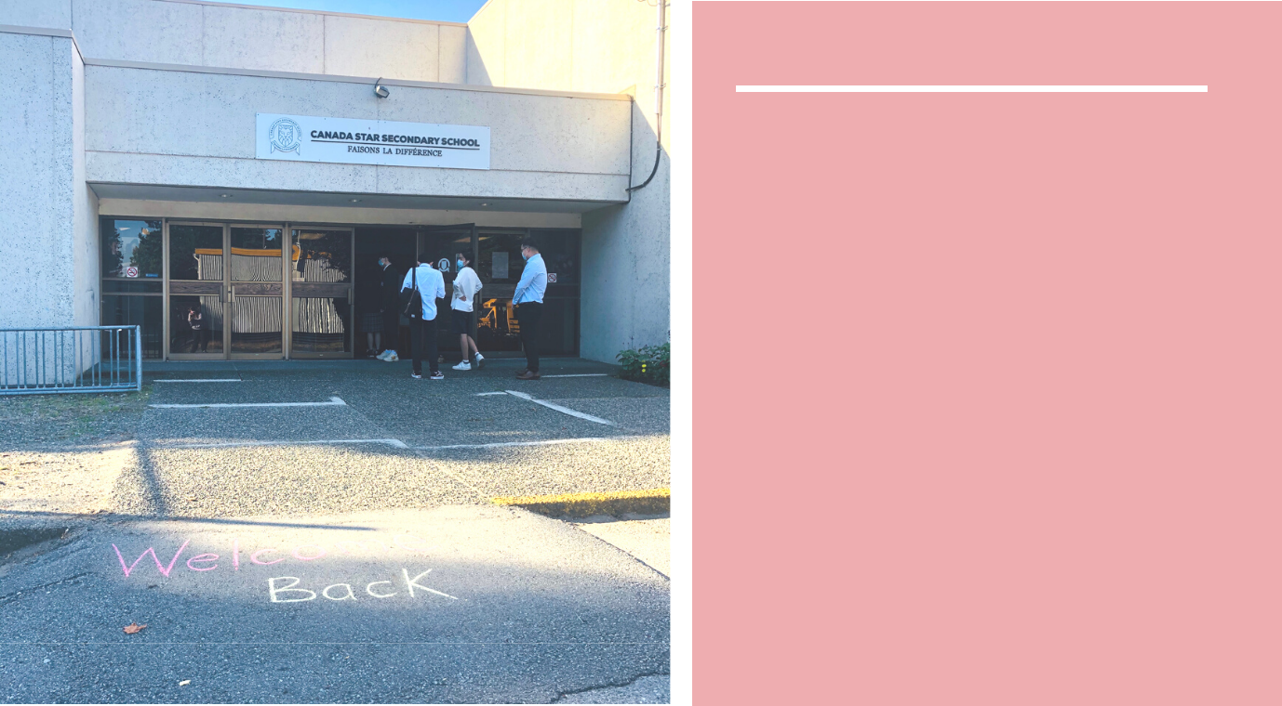

W HAT'S INSIDE

Letter from the Principal

Septem ber new s! W hat's going on at school, inside and outside the classroom s.

N ew classes, new clubs, new school bus and even a new lunchroom ! A nd m uch m ore...
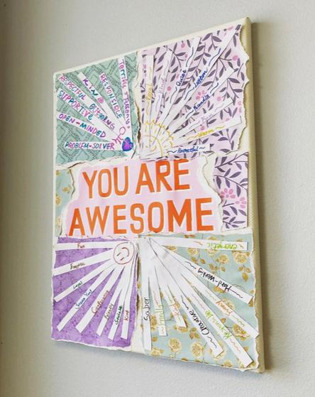

- ELCOM E BACK TO THE CLASSROOM ! W E ARE SO HAPPY YOU ARE HERE!

BY FABIAN A M ARTIN EZ - DIRECTO R O F ADM ISSIO N S, M ARKETIN G & COM M UNICATIONS

W e are excited to finally get to say W ELC O M E B A C K TO SC H O O L!! W e m issed our students so very m uch!! W e are happy to have you back w ith us for another year of learning, and to see som e new faces around the school.

Even though this year m ay feel a little bit different, w ith all the new m easures w e have in place to keep everyone at the school safe, w e are sure it w ill be a year filled w ith new friendships, learning, and personal grow th. C ontinue reading to see all the exciting things w e did this m onth!
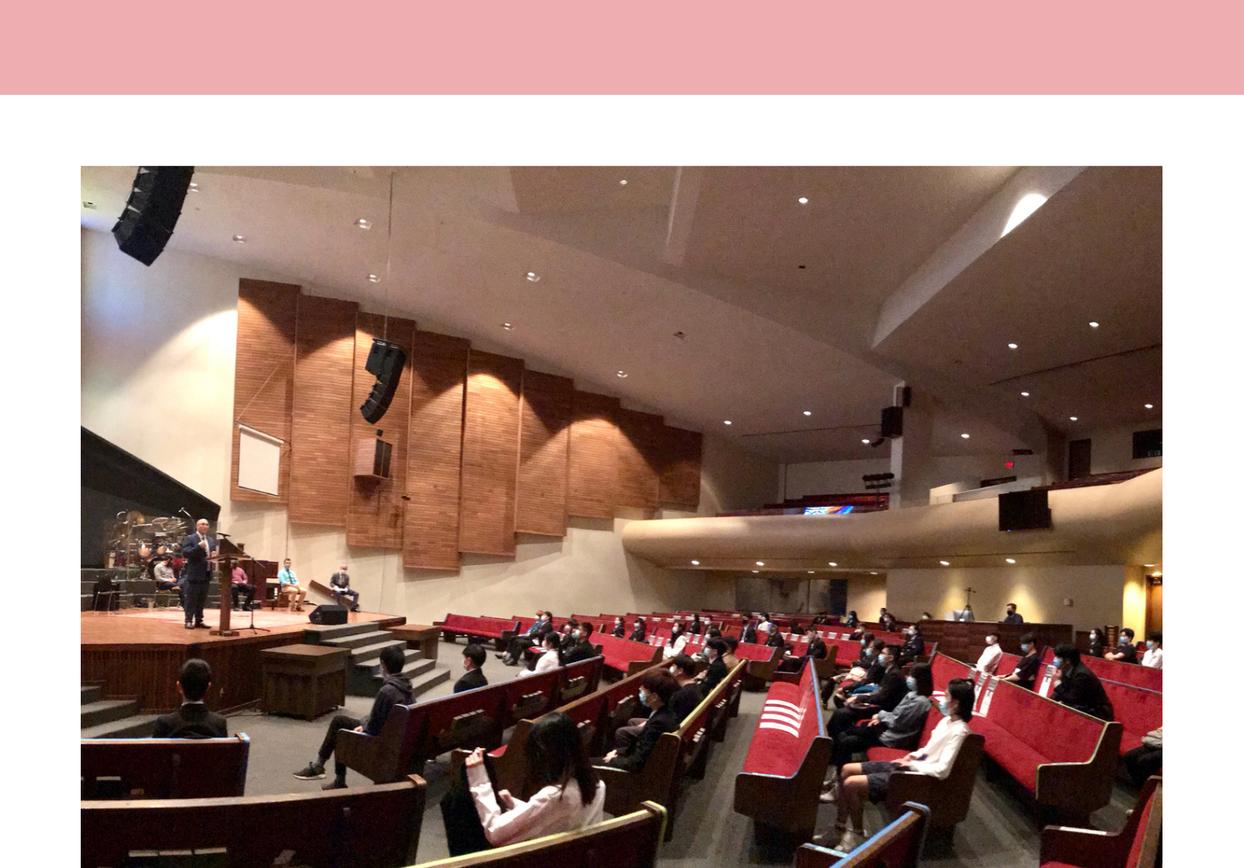

LETTER FRO M TH E PRIN CIPA L

DEAR PAREN T/CARER,

It is w ith particular pleasure that I w rite to you in our first new sletter of the academ ic year, now that allpupils have returned to full-tim e school.

W e are delighted to w elcom e our pupils back after so

- any m onths apart and it is truly w onderfulto w alk the schooland hear the buzz oflearning once again.

I w ould like to reiterate how im pressed w e have been w ith the start that the pupils have m ade. W e have asked them to cope w ith considerable change over a short space of tim e and they have done so adm irably. W e are proud to say that w e have had 100% attendance since w e have started the new academ ic year.

Please refer to our w ebsite for updated safety plans.

They can be found at:

https://canadastarsecondary.ca/covid-19-response/

Please know that this inform ation w ill be updated as

necessary. Your child’s safety is our top priority.

In addition to w elcom ing back our students and returning teachers, w e are pleased to w elcom e M r. Jarrett H ennig to our faculty. H e com es to us w ith a w ealth of experience and he is currently teaching D ram a, ELL, and Career Life Connections. H e w ill be adding AP Psychology to his list next sem ester. There certainly has been a trem endous am ount of excitem ent in his classes already!

Iw ould once again like to thank you for allyour support and understanding during the last few m onths. There

- ay be m ore challenges ahead, but Iam confident that w e can w ork together as the Canada Star Secondary SchoolFam ily to find a w ay forw ard and ensure that our young people have the very best educational experience possible.

Kind regards,

Robert Anstey, Principal

SEPTEM BER 2020 PAGE | 02

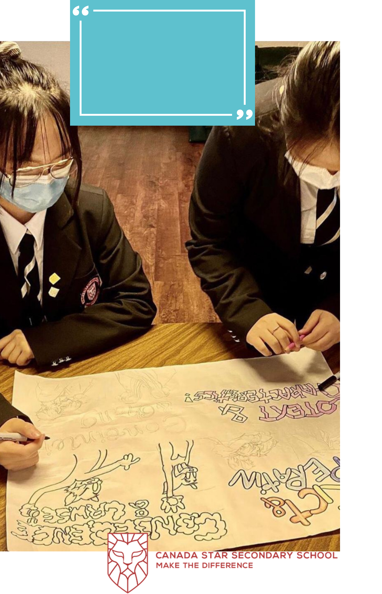
TO BUILD ON THE CONCEPT OF ONE

COHORT, STUDENTS IN LITERARY STUDIES

11 AND ENGLISH STUDIES 12 STARTED

THEIR FIRST FULL DAY OF SCHOOL

WRITING ENCOURAGING MESSAGES FOR

THE SCHOOL AND FOR THE WIDER

COMMUNITY. WHILE THE GRADE 11S

SPENT MOST OF SEPTEMBER POLISHING

UP THEIR WRITING SKILLS THROUGH

MEMOIR COMPOSITIONS, GRADE 12

STUDENTS PRACTICED THEIR CRITICAL

THINKING SKILLS, TOOK INSPIRATION

FROM ART, AND DEBATED THEMES.
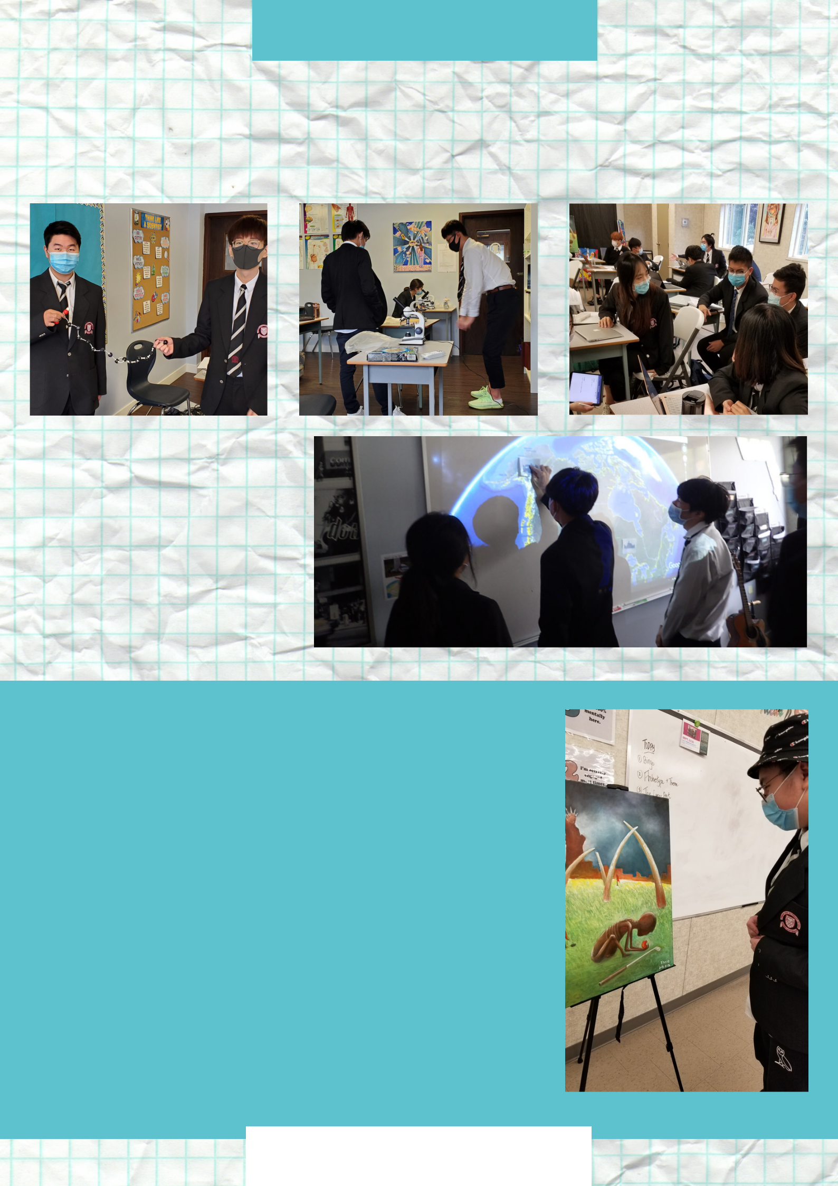
SEPTEMBER

In the classroom

The first two weeks were amazing so far - the students were completely amped to be at school, and we've had near perfect attendance. It's evident from these kids' participation in class that they are excited to be here, and have developed a great relationship with each other and the teachers already. - Mr. Tanner

Learning can be lots of fun!

Mr Mazzon and his Grade 12 Anatomy and Physiology students are building saturated and unsaturated fatty acid chains. Also, they are looking at cell division under the microscopes to have a visual representation of the process.

Tensions and Dilemmas in Community Development.What happens when there is conflict between the needs of the majority and the needs of the individual? Who wins? Students debate this question after reading the Shining Houses.

Making Predictions - Students in English Studies 12, with Mrs. Tong, take inspiration from student-created art to make predictions about the short story “The Large Ant.”t
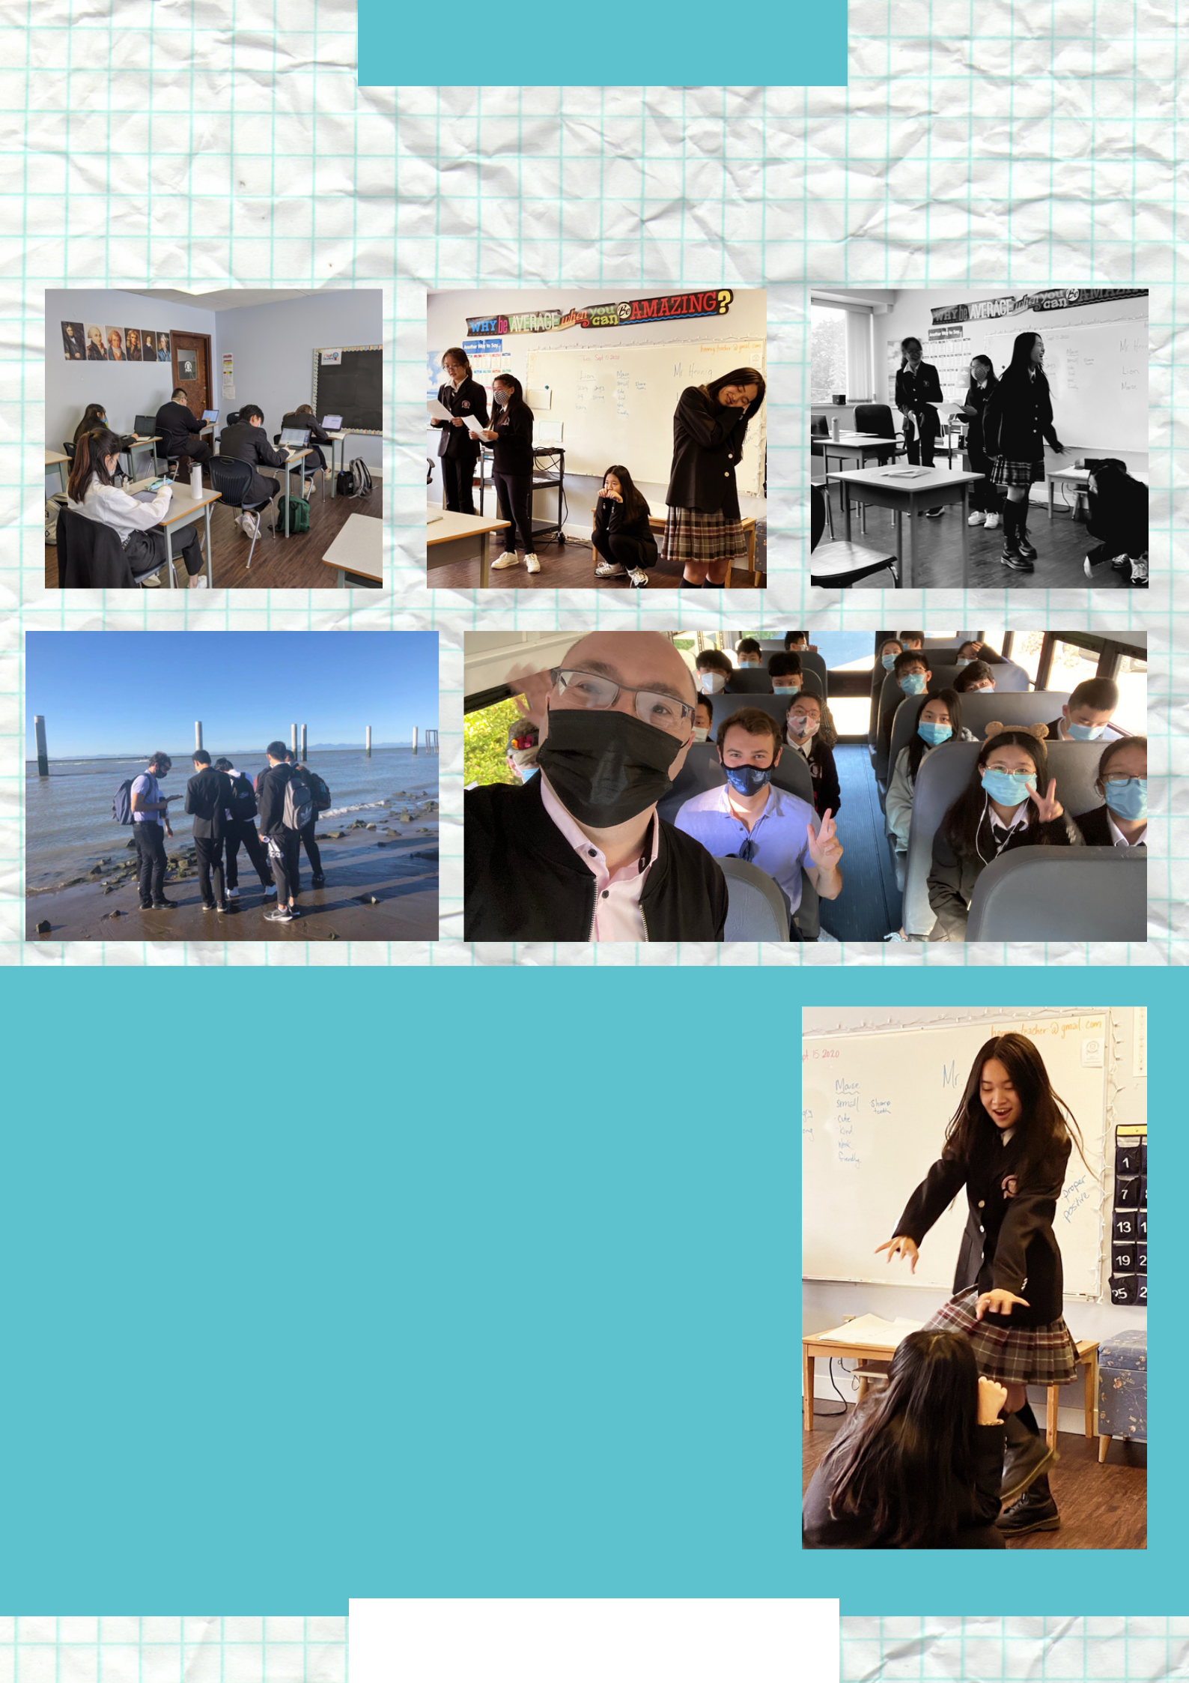
SEPTEMBER

In the classroom

This is why we love our school

Calculus 12 students are finding a lot of positives about Mr.Chiang’s classes. They are always on task! They love the learning environment that Mr.Chiang creates for them, and they can not help but study hard!

The Grade 8/9 Drama students got to try out their acting skills with Mr. Hennig, by reading and rehearsing a short skit during class called "The Lion and the Mouse". They demonstrated wonderful courage by presenting for Mr. Anstey and Mrs. Ellis! We look forward to doing more short skits throughout the year. Up next, the Drama 8/9 will be creating their own puppet shows.

Science students were off to their first field trip of the year!

More adventures to come in the next few months!
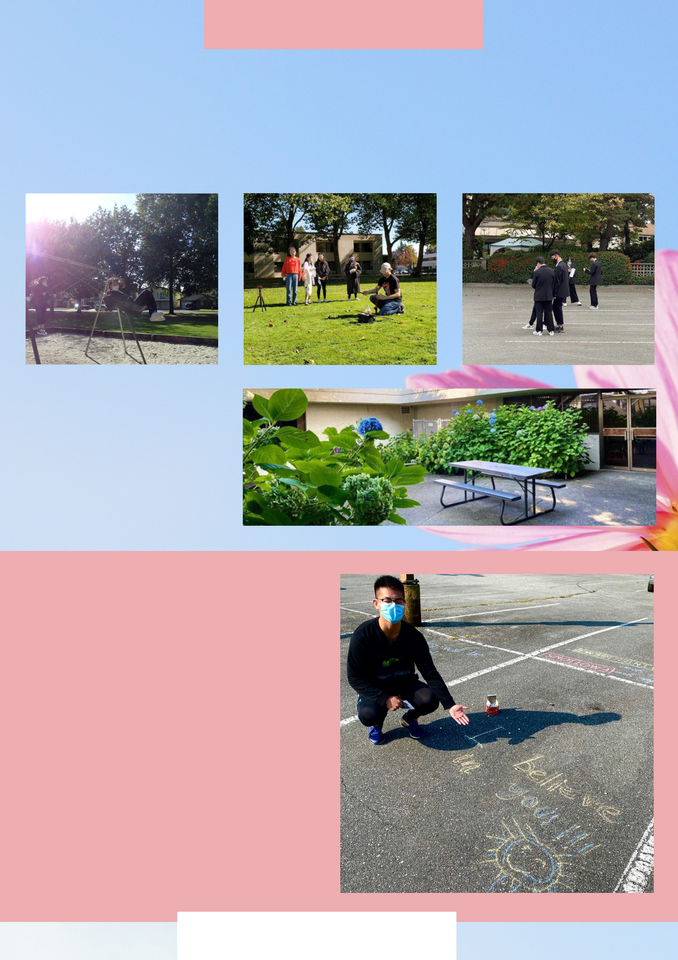
Enjoying the outdoors

Thanks to the beautiful weather, our students have been able to spend a lot of time outside, either learning, playing or enjoying their lunch.

Students got to spend some time outside!

Mr. Tanner was especially excited to be working with the grade 8s and 9s for Social Studies and Science. They have already performed several experiments in which the students have realized they already possess key understanding of science, and they are currently each building a water bottle rocket to test work.

Students in Literary Studies 11 and English Studies 12 invade the parking lot with encouraging messages.

We want to thank you for always having a positive attitude, even in these challenging times. Keep up the positive vibes!

NEW CLUBS

Our teachers, Mr. Duncan and Mr. Mason, have already started the basketball and badminton clubs! Interested in starting your own club at school? Let us know, we will be happy to help you make it happen.

AP COURSES
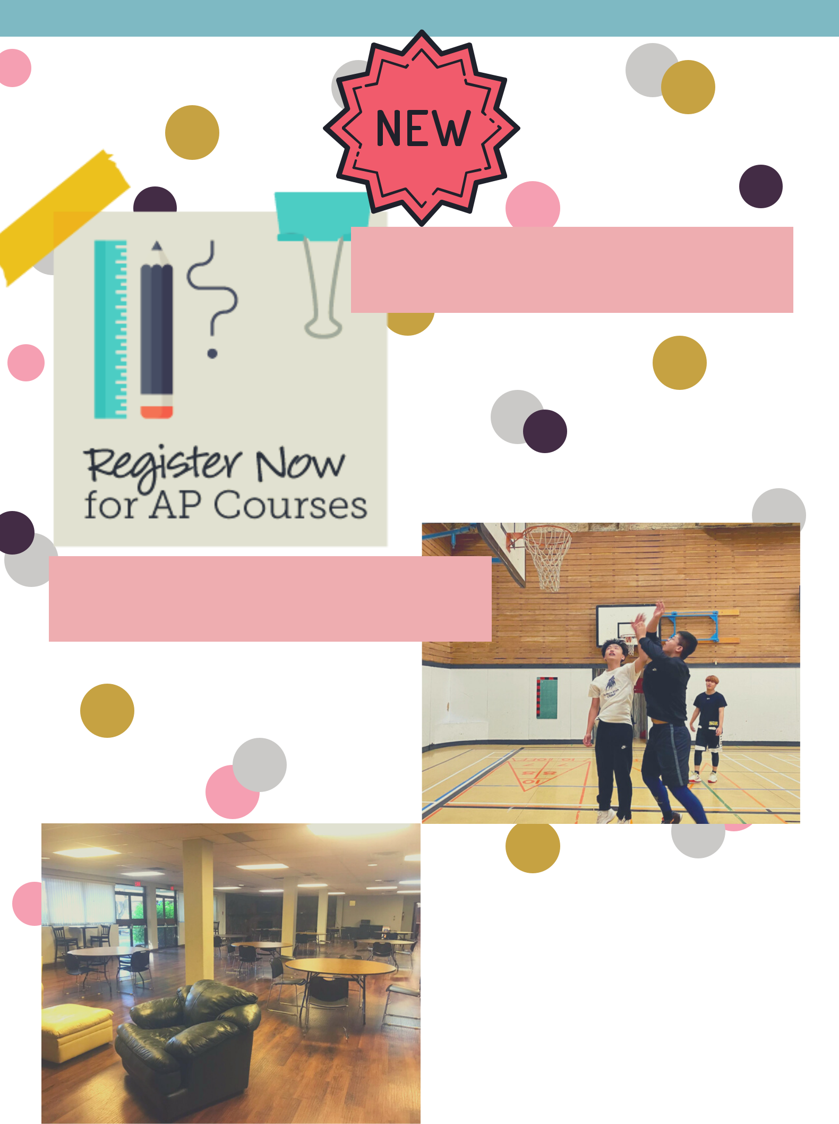

New AP courses will run twice per week after school, starting November, get high school credits and a head start into your university program!

For more info or to register contact:

admissions@canadastarsecondary.ca

NEW LUNCHROOM 

The Fireside Room is our new lunchroom, proving an inviting, pleasant, and safe environment for the students to eat. It is also a great place for some of the classes. We hope all students will enjoy this new space!

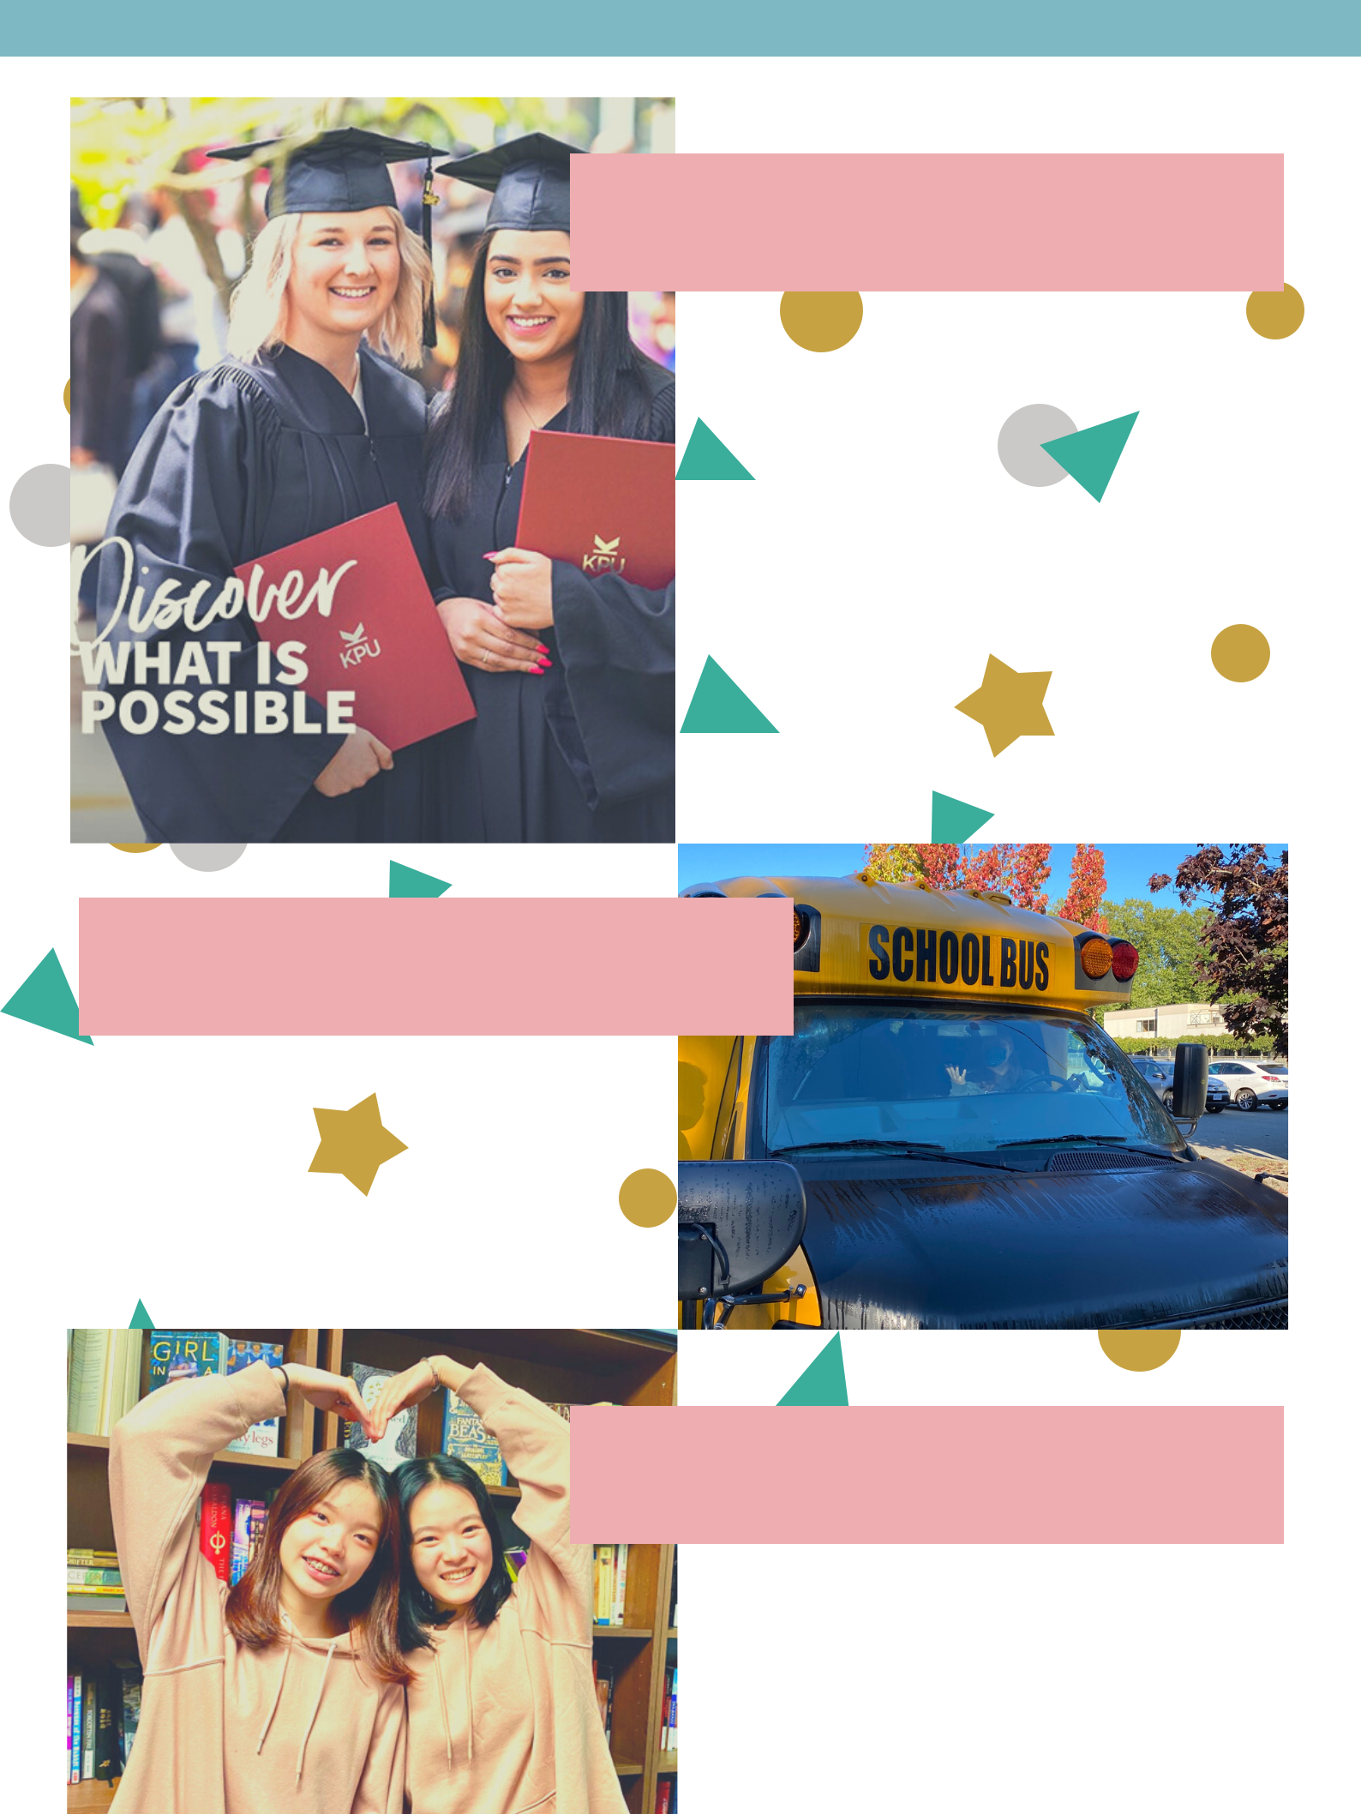
DUAL CREDITS

Kwantlen Polytechnic University

representatives will do a

presentation to grade 11 and 12

students on October 2nd to answer

all your questions.

The deadline to apply for Spring

2021 concurrent studies with KPU is

October 12, 2020, visit the school

office to register!

OUR SCHOOL BUS
>

Did you get a chance to see our new school bus in the parking lot? We will be able to use it for field trips, and activities. We can't wait to explore our beautiful city on the new bus with you!

REFER A FRIEND

Don't forget our student referral program! You and your friend can receive a $500 referral fee, if they register to school.

Spread the word, let the world know we are AMAZING!

