
JANUARY 2020 | VOLUME 1 - ISSUE 1

WHAT'S THE

NEWS....

The monthly newsletter for Phoenix-Talent Schools


Inside the January issue:

High School Graduation Success

Student Success Act

We are growing

Mark your calendar


Nice work! This has been a district-wide effort. Everyone from kindergarten through high school had something to do with such successful growth. Many from our community and outside our community have expressed congratulations on your hard work. So proud! Keep up the great work!
JANUARY 2020 | VOLUME 1 - ISSUE 1
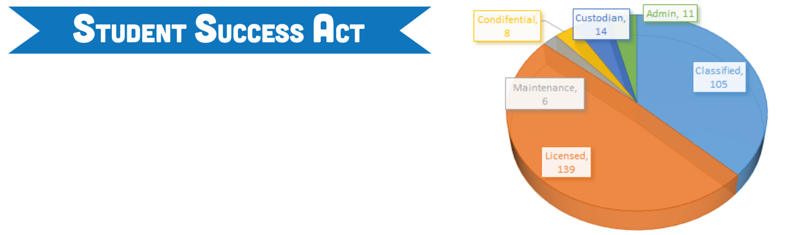

This is such an exciting time for Phoenix-Talent Schools!
Not only are we in the middle of upgrading and building
facilities that will serve our community for many years to
come, we are also in the planning stages of implementing a
monumental decision by the 2019 legislature to invest in
the students of the State of Oregon! The portion of the
Student Success Act (SSA) in which K-12 school districts
get to plan for is called the Student Investment Account
(SIA). More information is provided by clicking the link | We have the best people to support our students and
below. | We have the best people to support our students and
below. | we are slowly growing to meet our current demands.
What has happened in this effort so far: | we are slowly growing to meet our current demands.
What has happened in this effort so far: | We are excited because the Student Success Act will
1) A community engagement campaign was launched | We are excited because the Student Success Act will
1) A community engagement campaign was launched | offer additional opportunities to hire the right
(students, parents, staff, community provided feedback). | offer additional opportunities to hire the right
(students, parents, staff, community provided feedback). | individuals based on all your input as well as the input of
2) A planning team has met 3 times to analyze the | individuals based on all your input as well as the input of
2) A planning team has met 3 times to analyze the | the community. We are feeling very grateful for your
feedback, categorize it and identify solutions to meet the | the community. We are feeling very grateful for your
feedback, categorize it and identify solutions to meet the | contributions!
community desires. | contributions!
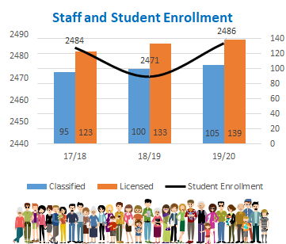

- Key 'outcomes' have been developed to guide our decisions.

Next Steps:

Begin the work of completing the application.

Share our progress with the School Board.

Provide opportunities for community review and comment on the SIA plan.

Submit the plan for ODE and work in conjunction with them to finalize benchmarks and progress targets.

This is a huge undertaking, in 5 short months, and I want to thank the team for their dedication, perseverance and the time they are spending on creating a plan to serve our kids!

Your SIA Team:

Students: Kelsey Bakke, Carola Landaverde, Kaia

Eikenberry, Victor Martinez
Staff: Melanie Kwiatkowski, Marcel D'Haem, Kelleen | FRIDAY, FEBRUARY 7
Seedborg, Samantha Dedrick, Clint Rodreick, Christie
Sanders | 8:00 AM @ PHS COMMONS
Parents: Eric Zurita, Rosa Ochoa | PROFESSIONAL DEVELOPMENT DAY
Community: Jonathon Chavez-Baez (SOU), Summer | T o p i c s I n c l u d e : I m p l i c i t B i a s t r a i n i n g ,
Brandon (ATI)
Brandon (ATI) | R e a d y t r a i n i n g , P A X G B G t r a i n i n g , g e n z
Board Member: Dawn Watson (Parent)
Board Member: Dawn Watson (Parent) | w o r k s h o p , c l o s e r e a d i n g s t r a t e g i e s a n d
Administrators: Brent Barry, Javier del Rio, Tiffanie
Administrators: Brent Barry, Javier del Rio, Tiffanie | s p e c i a l i z e d t r a i n i n g s f o r c l a s s i f i e d
Lambert, Toby Walker, Heather Lowe-Rogers
Lambert, Toby Walker, Heather Lowe-Rogers | s t a f f . . . s t a y t u n e d f o r s c h e d u l e n e x t w e e k !
Link to more information: | ""Don't judge me by my success, judge me by how many times I fell
https://www.oregon.gov/ode/StudentSuccess | down and got back up again"

-Nelson Mandela

