SPRING 2012

NEWSLETTER

WELCOME………  Welcome back to the start of a very exciting year. We have many action packed activities and learning experiences planned for all children. Room 7 in 2020 is a Year 5 class …………..  STUDENTS  Welcome back to the start of a very exciting year. We have many action packed activities and learning experiences planned for all children. Room 7 in 2020 is a Year 5 class made up of 25 children (16 girls/9 boys)  Welcome back to the start of a very exciting year. We have many action packed activities and learning experiences planned for all children. Room 7 in 2020 is a Year 5 class made up of 25 children (16 girls/9 boys) | 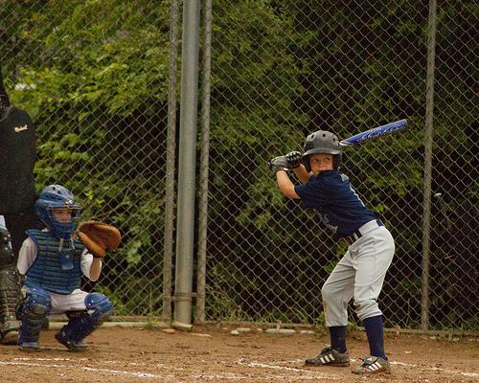  Mauris at suspendisse, neque aliquam.  SALUTE  Welcome back to the start of a very exciting year. We have many action packed  DVNOAOEGVREOVNOKJV NOEJNVIENBVKOE[
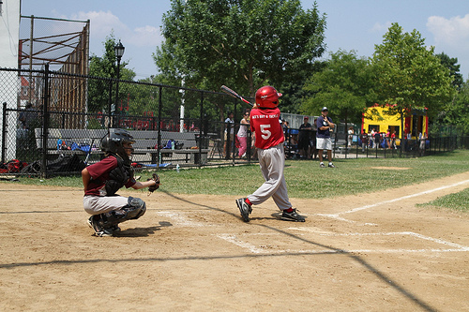  Mauris at suspendisse, neque aliquam. | WELCOME!  Welcome back to the start of a very exciting year. We have many action packed activities and learning experiences planned for all children. Room 7 in 2020 is a Year 5 class made up of 25 children (16 girls/9 boys)  CVNDKONVJANVIEOVEB  B  - Contributor name

Mauris at suspendisse, neque aliquam.  Bibendum quis dapibus  Ut enim ad minim veniam, quis nostrud exerc. Irure dolor in reprehend incididunt ut labore et dolore magna aliqua. Ut enim ad minim veniam, quis nostrud exercitation ullamco laboris nisi ut aliquip ex ea commodo consequat. Duis aute irure dolor in reprehenderit in voluptate velit esse molestaie cillum.  Officia deserunt mollit anim id est laborum Et harumd dereud.  Bibendum quis dapibus  Consectetuer arcu ipsum ornare pellentesque vehicula, in vehicula diam, ornare magna erat felis wisi a risus. Justo fermentum id.  Malesuada eleifend, tortor molestie, a fusce a vel et.  Consectetuer arcu ipsum ornare pellentesque vehicula, in vehicula diam, ornare magna erat felis wisi a risus. Justo fermentum id.  Malesuada eleifend, tortor molestie, a fusce a vel et. | Etiam sit amet  Consectetuer arcu ipsum ornare pellentesque vehicula, in vehicula diam, ornare magna erat felis wisi a risus. Justo fermentum id. Malesuada eleifend, tortor molestie, a fusce a vel et. Mauris at suspendisse, neque aliquam faucibus adipiscing, vivamus in.  Mauris at suspendisse, neque aliquam.  Mauris at suspendisse, neque aliquam faucibus adipiscing, vivamus in.  Consectetuer arcu ipsum ornare pellentesque vehicula, in vehicula diam, ornare magna erat felis wisi a risus. Justo fermentum id. Malesuada eleifend, tortor molestie, a fusce a vel et. Mauris at suspendisse, neque aliquam faucibus adipiscing, vivamus in.  Mauris at suspendisse, neque aliquam faucibus adipiscing, vivamus in. Consectetuer arcu ipsum ornare pellentesque vehicula, in vehicula diam, ornare magna erat felis wisi a risus. Justo fermentum id. Malesuada eleifend, tortor molestie, a fusce a vel et. Mauris at suspendisse, neque aliquam faucibus adipiscing, vivamus in.  Mauris at suspendisse, neque aliquam faucibus adipiscing, vivamus in.  Consectetuer arcu ipsum ornare pellentesque vehicula, in vehicula diam, ornare magna erat felis wisi a risus. Justo fermentum id. Malesuada eleifend, tortor molestie, a fusce a vel et. Mauris at suspendisse, neque aliquam faucibus adipiscing, vivamus in. | Maauris t suspendisse, neque aliquam.  Bibendum quis dapibus  Ut enim ad minim veniam, quis nostrud exe. Irure dolor in reprehend incididunt ut labore et dolore magna aliqua.  Bibendum quis dapibus  Consectetuer arcu ipsum ornare pellentesque vehicula, in vehicula diam, ornare magna erat felis wisi a risus. Justo fermentum id.  Malesuada eleifend, tortor molestie, a fusce a vel et.  Consectetuer arcu ipsum ornare pellentesque vehicula, in vehicula diam, ornare magna erat felis wisi a risus. Justo fermentum id.  Malesuada eleifend, tortor molestie, a fusce a vel et.

