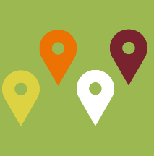
Focus Group
Recruitment Plan Template

The Focus Group Recruitment Plan Template is a tool for planning the focus groups. Following the Focus Group Planning Meeting, the template can be filled in with the plan for recruiting focus group participants and used to allow everyone to track progress toward recruitment goals.

Youth Focus Groups
DATE TIME:
LOCATION:
Recruiting Organization | Youth Population(s) Served | Youth Recruitment Goal
 | Total | 12
DATE TIME:
LOCATION:
Recruiting Organization | Youth Population(s) Served | Youth Recruitment Goal
 | Total | 12
DATE TIME:
LOCATION:
Recruiting Organization | Youth Population(s) Served | Youth Recruitment Goal
 | Total | 12
DATE TIME:
LOCATION:

Recruiting Organization | Youth Population(s) Served | Youth Recruitment Goal
 | Total | 12
Provider Focus Groups
DATE TIME:
LOCATION:
Organization | Youth Population(s) Served | Recruitment Goal
 | Total | 15

