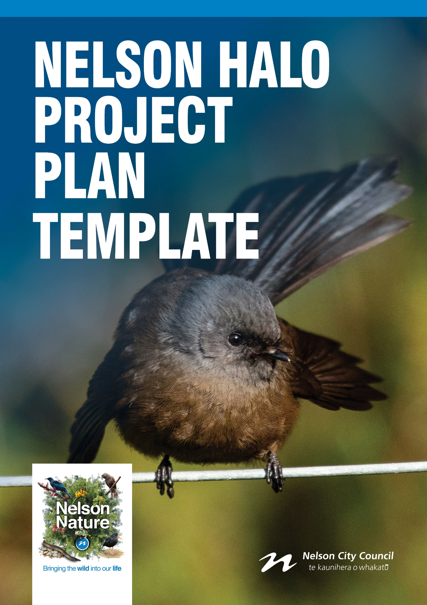

USING THIS DOCUMENT
This Project Plan template sits alongside the Nelson Halo Predator Trapping Guide (2019) and should be completed using the guidance given in that document. The purpose of this template is to help your group think about and capture all the factors that you need to consider when you are developing and undertaking a predator trapping project within the Nelson Halo or nearby areas.

Once you have completed the Project Plan for your group, you might want to add your group’s logo and change the cover image to something meaningful for your group.

Cover Image: South Island black morph fantail/pīwakawaka (Rhipidura fuliginosa), taken by Dan Burgin.
GROUP DETAILS | Comments
Community group name | Name (e.g. Nelson Maitai Reserve Trapping Group)  Click or tap here to enter text.
Desired conservation outcome(s) | What are you trying to protect and what are your desired outcomes and goals?  Click or tap here to enter text.
Number of members and types (paid and voluntary) | For example, 25, 2 full-time staff, and 23 registered volunteers, and possibly split between trapping volunteers and funding, or administrative roles.  Click or tap here to enter text.
Project site location | The physical address of the site(s). Include a map, even if just a screenshot of Google Maps or Top of the South Maps with a clear project boundary, drawn to this plan.  Click or tap here to enter text.
What type of site(s) make up the project site? | Is it private property, a reserve, a combination of these or something else? Are you focusing on one or two patches, or the whole area?  Click or tap here to enter text.
Activities present | Are there recreational facilities there, or is it private, residential, commercial or something else?  Click or tap here to enter text.
Legal status on any of the property | For example, if private land, does it have a covenant? Are there any restrictions around what activities can take place there?  Click or tap here to enter text.
Landowner permissions granted? | Is it owned by Nelson City Council or DOC, or is it privately owned? Have you been granted access? You must always have landowner permission before starting pest control.  Click or tap here to enter text.
Funding | Do you know how you will fund the project? Will your funding cover all your costs (trapping, bait, monitoring etc)? Knowing where your funding is coming from for each phase (e.g. grants, direct council support, fundraising, volunteers’ own donations etc) so the project can continue is essential.  Click or tap here to enter text.
GROUP DETAILS

HABITAT | Comments
Project site(s) type | List all that apply within your project site(s) using the types listed in Table 1 of the Nelson Halo Predator Trapping Guide. List as much detail as possible – for example, any wetland areas, coastal broadleaved forest, mānuka scrub, native forest, exotic pine plantation, backyards, or estuary.  Click or tap here to enter text.
Project site size(s) | Total hectares that will be under predator trapping.  Click or tap here to enter text.
Terrain and access | Is it steep, flat or mixed? Are there easy access points? Are there streams/waterways to cross and are they susceptible to flooding? Are there tracks, paths or boardwalks in place, or do these need to be installed?  Click or tap here to enter text.
Maintenance | How frequently are you going to undertake maintenance of your tracks, paths, traps and other site areas?  Click or tap here to enter text.
Additional features | If there are known significant natural areas (SNAs), heritage sites and buildings, power stations, or other features, please list them here.  Click or tap here to enter text.
PROJECT SITE(S)

PREDATOR TRAPPING DETAILS | Comments
Target species | The minimum should be rats, possums and stoats in accordance with the Nelson Wildlife Halo Operational Plan. Additional target species should also be considered – for example, hedgehogs, weasels and feral cats. You can always adjust your list if you need to.  Click or tap here to enter text.
Priority target species | The Nelson Wildlife Halo Operational Plan has three focal species – rats, stoats and possums – so these are your priority.  Click or tap here to enter text.
Trapping methods | List these one by one for each target species. Refer to the ‘Trapping Methods’ section in the Nelson Halo Predator Trapping Guide, and detail:  - Trap type(s) selected (weka proof?)  - Number of traps  - Grid layout based on project site(s) identified  - Number of trap lines  - Distance between traps  - Distance between trap lines  - How frequently will you be able to check the trap network?  - Bait/lure(s) to be used  - Signage locations and usage (do you have clear signs to let the public know?)  Click or tap here to enter text.
Maps | Have you created maps showing the locations of your traps? Are these maps available to your group members? Have you entered the trap locations to Trap.NZ?  Click or tap here to enter text.
Catch data | Where are you going to capture all of this data and how? Will volunteers need pads of paper, or are they going to use the Trap.NZ app? Have you created a profile for your group on Trap.NZ? Do you have a master spreadsheet for data to be inputted into as a backup? Who will update this?  Click or tap here to enter text.
Maintenance activities | Detail scheduled maintenance activities, frequency and methods to be used. For example, once every six months using scouring pads/wire brushes to clear built up fur in the trap, especially in the trap mechanism.  Click or tap here to enter text.
PREDATOR TRAPPING PLAN

MONITORING DETAILS | Comments
Predator monitoring methods | Monitoring the mammalian predators in your project site(s) is instrumental in successful trapping, as well as helping give results for funding applications and for promoting your group. Include:  - Required monitoring as determined by project site(s) type(s)  - Methods to be used (wax blocks/tracking tunnels/trail cameras/chew cards)  Click or tap here to enter text.
Predator monitoring frequency | How often are you going to check your units? If using different techniques, list each with your desired checking frequency, and who is going to check.  Click or tap here to enter text.
Signage | Have you created signs for the general public to let them know you have monitoring stations present?  Click or tap here to enter text.
Maps | Have you created maps showing the locations of your monitoring units? Are these maps available to your group members? Have you entered the monitoring unit locations to Trap.NZ?  Click or tap here to enter text.
Data | Are all your members clear on how they will collect and upload data from your monitoring?  Click or tap here to enter text.
Maintenance activities | Be sure to include regular checking of your signs to ensure they are still present and clear to read for the general public and your group members.  Click or tap here to enter text.
Outcome monitoring | List your methods of outcome monitoring for your project site(s). Who is going to undertake the monitoring and when? Who will oversee coordinating eBird data upload/download/analysis?  Click or tap here to enter text.
MONITORING PLAN

HEALTH & SAFETY DETAILS | Comments
Health & Safety Plan | Have you identified anything that may cause harm within your project and how you will manage these? Have you completed a Health & Safety Plan for your project and has everyone in your group read it? You should attach your Health & Safety Plan to this Project Plan.  Click or tap here to enter text.
Safety Officer | Do you have a Safety Officer appointed for your group to coordinate and manage all Health & Safety procedures and reporting? If so, insert their contact details here.  Click or tap here to enter text.
Training | Do you have a process in place to train new volunteers on your group’s operations and procedures? Record this here or in your Health & Safety Plan.  Click or tap here to enter text.
Personal Protective Equipment (PPE) and first aid | Are volunteers in your group equipped with suitable PPE, such as Hi Vis, gloves and sturdy boots, if they need it? Is a first aid available? Make sure everyone knows where all PPE and first aid kit is located.  Click or tap here to enter text.
Check-in procedure | Do you have a check-in and check-out procedure for volunteers in your group? Record this here or in your Health & Safety Plan.  Click or tap here to enter text.
Incident Reporting / Management | Do you have a procedure for reporting and managing incidents? Do you have a process for reviewing any incidents? Record this here or in your Health & Safety Plan.  Click or tap here to enter text.
HEALTH & SAFETY PLAN

REVIEW DETAILS | Comments
Review frequency and dates | When is your first annual review set for? Lock in the date and confirm commitment to it. Who will undertake the review? Is there a core group of people who need to be present?  Click or tap here to enter text.
Group details | Is funding secured for next year? Have you lost or gained staff/volunteers? Have you changed locations? Do site maps need updating?  Click or tap here to enter text.
Project site(s) | Have any of your sites changed due to natural or anthropogenic disturbance? Have you increased your block size and therefore need to change the grid overlay and update your maps?  Click or tap here to enter text.
Predator Trapping Plan | Look at your catch rates. Are you capturing your target species? Do you need to change your trapping locations? Have you lost any traps, or are you in need of purchasing new traps? Have you got an up-to-date database of all your catch rate data, and is it uploaded to Trap.NZ?  Click or tap here to enter text.
Predator Monitoring Plan | Are there any additional monitoring methods you need to incorporate? Are all group members able to get involved? Can you increase your effort?  Click or tap here to enter text.
Outcome Monitoring Plan | Have you seen any tangible changes in the rate of detection of the key indicator species you selected?  Click or tap here to enter text.
Health & Safety Plan | Does your Health & Safety Plan need updating? Are there any new hazards? Do any major incidents need to be reviewed?  Click or tap here to enter text.
Review Plan | Have you got next year’s review date committed to?  Click or tap here to enter text.
REVIEW PLAN

