INNOVATE - market gap analysis - template

INTRODUCTION 1
STEP 1: THE CURRENT STATE 2
Interpretation of segmentation 2
STEP 2: IDENTIFY THE BARRIERS & DRIVERS THE HOMEOWNERS FACE 3
Interpretation of barriers and drivers 3
STEP 3 WHICH ACTORS (COULD) DEAL WITH HOME ENERGY RENOVATION? 3
Interpretation of the actors mapping 4
STEP 4 WHICH SERVICES EXIST ON YOUR TERRITORY? 5
Interpretation of the services mapping 5
STEP 5 MARKET GAP & SWOT ANALYSIS OF YOUR ACTION 5

INTRODUCTION
This document is a practical guide to help you in the best way possible to carry out a market analysis. To this document WORD is associated an EXCEL document. The WORD is meant to be the most "narrative" part while the EXCEL is more practical - "practical".
As you progress through the steps, you will need to move from one document to another. At each stage, we provide some useful information for the proper conduct of this analysis.
We try to be as structured as possible to guide you through the process, but also to facilitate the compilation of the data.
In any case, all the information requested will hopefully help you to identify your target groups, their demands, offers from the construction sector, offers from the banking sector, as well as all the parties and involved stakeholders, etc. This will help you to define precisely your action and services for homeowner to be developed.

STEP 1: THE CURRENT STATE
Segmenting the market and describe the specific segments you want to focus on is very helpful to design the energy efficiency service you want to develop on your territory.
To do this, we suggest that you refer to the Excel table - tab [PROFILES] in order to categorize the market as much as possible.
For each category of market segmentation, examples of features have been proposed. You are free to adapt them according to your reality.
We have chosen to divide these categories into 4 large sub-categories. First, those related to housing characteristics. Secondly, those related to the characteristics of home owners and residents. Third, we propose to try to categorize the construction sector and real estate professionals. Fourth, in order to complete the market analysis, it is also necessary to know the existing funding and financing opportunities in the field of renovation.

We also added several categories that are optional. The tab "profiles empty" will help you to adapt the table to the context of your own territories.

It may be difficult to gather quantitative data regarding people’s housing evolution, reasons to undertake works, capacity to manage the renovation project, but in any case, considering these criteria and making assumptions regarding the segments you think you should concentrate on, will help you to be specific and focused on the content of the service you have to build-up and the marketing means you should be using.

Whether extracted from official statistics, market surveys or your own enquiries, it is up to you to interpret the information you will be able to gather in order to describe the market and to choose the market segments you wish to target.

Interpretation of segmentation
Add your interpretation here:
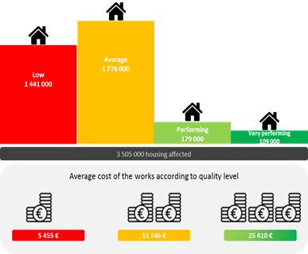
Example:
The survey performed by ADEME each year on housing energy-efficient refurbishments in France shows that, although many financial incentives and information campaigns are in place, less than one out of ten retrofits performed in France may be considered as energy-efficient:
Number and quality-level of refurbishments involving energy efficiency improvement in France

How this finding did influence Région Picardie’s action plan???

STEP 2: IDENTIFY THE BARRIERS & DRIVERS THE HOMEOWNERS FACE
Now that you have segmented your markets and you have been able to specify your target audience, you can focus on the concrete elements that will condition your action.
Concretely, this requires defining the barriers and drivers for your specific case in your territory. To help you, refer to the Excel table - tab [BARRIERS AND DRIVERS].
Most items have a description which guides you in your reflection. For each of these elements, we ask you to consider whether it constitutes a barrier or a driver (in your specific case) and shortly explain why. Feel free to complete and adapt these categories according to your realities.
To answer all these questions, different methods exist. Qualitative methods provide a lot of information about the decision-making processes, the needs, the barriers seen from the point of view of the customers. They sometimes provide answers in terms of innovations. In general, they help you understand the reasons better than figures.

Interpretation of barriers and drivers
Add your interpretation here:

STEP 3 WHICH ACTORS (COULD) DEAL WITH HOME ENERGY RENOVATION?
To further complement this market analysis, you can also reflect on different actors who will be involved (in one way or another) in your project. Complete the Excel table - tab [ACTORS MAP].
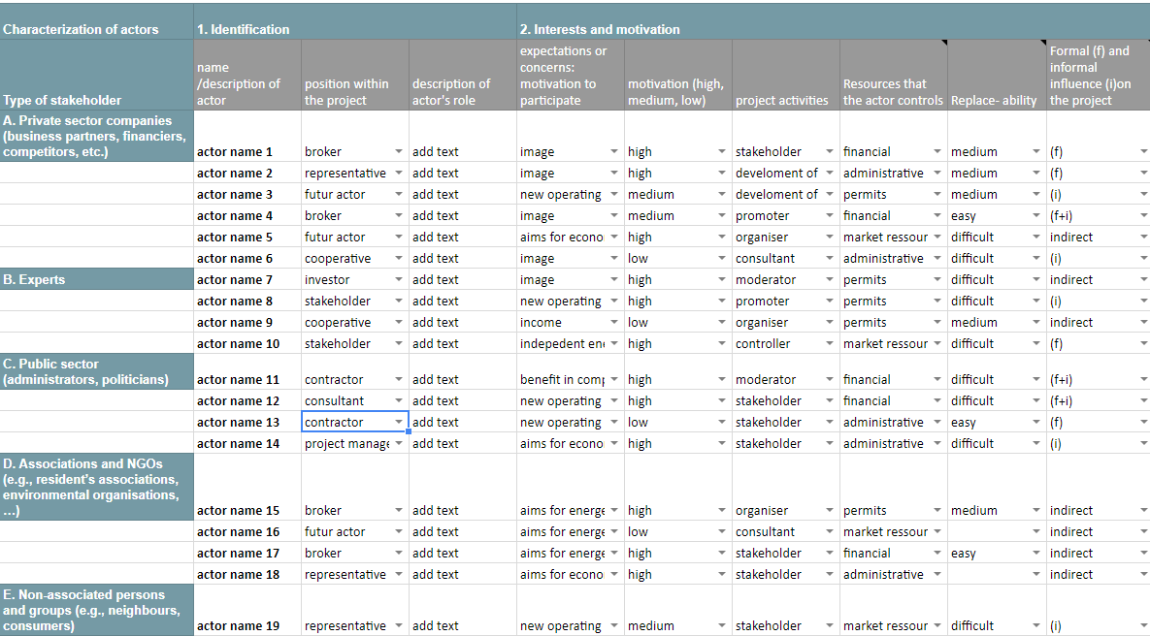
The map of the actors should be as complete as possible. It is likely that at this point you will not be able to complete everything. However, do not hesitate to add lines and even columns according to your experience, your knowledge and your relations with the different actors in your locality.
The table works with drop-down lists to facilitate the compilation.

In the ACTORS tab you will find drop-down lists with suggested items. If they are not suitable for you or you want to add more: right click on the cells you want to modify, select [data validation]. Then in [criteria], you can add new items by separating them with a comma.

Although at this stage this table does not seem particularly useful or pragmatic, it will subsequently become inevitable for all the actions related to your energy efficiency project. Keep it and update it regularly.

Description of actors is indeed important to support decision making process regarding measures such as:
- Setting-up a new actor (ex: a public company acting as aggregator of projects)
- Focusing on professionals rather than on customers (ex: setting-up a resource-platform for craftmen…)
- …

Interpretation of the actors mapping
Add your interpretation here:

STEP 4 WHICH SERVICES EXIST ON YOUR TERRITORY?
In order to complete your reflection, we propose you to identify the existing service(s) in your territory. The Excel table - tab [SERVICES MAP] also helps you to think about the missing elements in terms of services. What needs to be improved? What needs to be developed? This table will also serve as a basis for the next step in the development of your one stop shop - "a local action plan".

Interpretation of the services mapping
Add your interpretation here:

STEP 5 MARKET GAP & SWOT ANALYSIS OF YOUR ACTION
On the basis of all the above information (the target audience, the barriers, the motivations, the actors involved), you should now be in the position to describe the market gap on your territory. You can start to imagine the actions you can take to remove this market gap (e.g. provide independent advice, government involvement, financial incentives, other incentives, ambassadors involved in renovation, etc.) and evaluate your strengths and weaknesses as well as external opportunities and threats that can have impact on your action.

