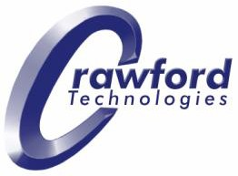

CrawfordTech Bank Statement Sample

Mary Jane Smith
100 Pine Street Metro, AA 09371
Account Summary

Opening Balance $5,234.09
Withdrawals $2,395.67
Deposits $2,872.45

Closing Balance on Apr 18, 2010 $5,710.87

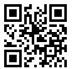
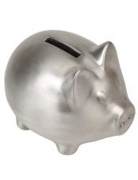
You are eligible for a $100 bonus
Scan this QR code with your Smartphone To find out more about a High Interest Savings Account – with the first $100 Deposit on us!

You may need to get a QR Code® reader from your SmartPhone App Store

Your Transaction Details
For Mar 15, 2010 to Apr 18, 2010

Account Number
00-123456

Branch Transit Number
098765

Contact Information 1-800-222-0123
Contact us by phone for questions, on this statement, change of personal information, and general inquiries, 24 hours a day, 7 days a week

TTY for the hearing impaired:
1-800-123-0007

Outside North America:
+1-123-4567

Your branch Main and Elm 100 Main Street Metropolis, AA 01234

Date | Details | Withdrawals | Deposits | Balance
Apr 8 | Opening Balance |  |  | 5,234.09
Apr 8 | Insurance |  | 272.45 | 5,506.54
Apr 10 | ATM | 200.00 |  | 5,306.54
Apr 12 | Internet Transfer |  | 250.00 | 5,556.54
Apr 12 | Payroll |  | 2100.00 | 7,656.54
Apr 13 | Bill payment | 135.07 |  | 7,521.47
Apr 14 | Direct debit | 200.00 |  | 7,321.47
Apr 14 | Deposit |  | 250.00 | 7.567.87
Apr 15 | Bill payment | 525.72 |  | 7,042.15
Apr 17 | Bill payment | 327.63 |  | 6,714.52
Apr 17 | Bill payment | 729.96 |  | 5,984.56
Apr 18 | Bill payment | 223.69 |  | 5,710.87
 | Closing Balance |  |  | $5,710.87

Are you ready to go
paperless?

Get your statements delivered directly to your email account

Avoid the monthly
$2 paper statement print fee!

Scan the QR Code below with your SmartPhone to sign up now!

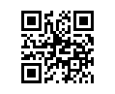
You may need to get a QR Code reader from your SmartPhone App Store

QR Code is a Resistered trademark of Denso Wave Corporation

