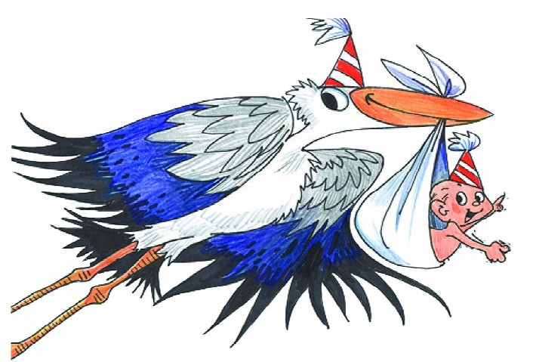
No Charge for listing. $10.00 with picture added.
Note: Please submit complete and correct information. Type or print!

Baby’s full name:

Girl or Boy
Date of Birth:
Time:

Place of Birth:

Weight: pounds ounces Length: inches

Parents Names & place of residence:

Siblings (and ages if desired):

Grandparents & place of residence:

Great-grandparents & place of residence

You must sign your name to the information as a means of verification.

Signature Date Daytime Phone

