Please indicate which publication:
Butler Eagle with photo - $15 Without photo - $10 Cranberry Eagle with photo - $12 Without photo - $8 Both Publications with photo - $20 Without photo - $12
Mail to: Community Department
P.O. Box 271 Butler, Pa 16003 Fax: 724-282-4180
Phone: 724-282-8000 x253
or
Drop off at Main Office 114 W. Diamond St. Butler, Pa 16001

PLEASE PRINT CLEARLY
community@butlereagle.com

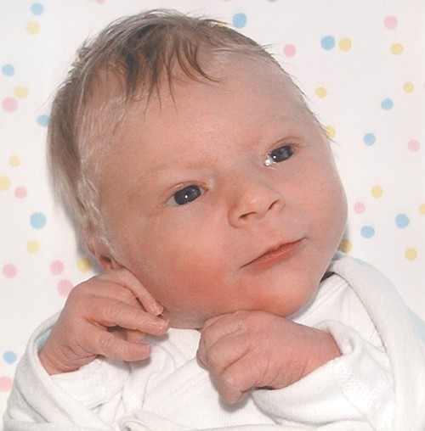
Hospital: Date of Birth: Time: a.m./p.m. Mother’s Name: City, State: Mother’s Maiden Name: Father’s Name: City, State:
Child’s Name and Gender Male Female

Maternal Grandparents with City, State:

Examples
With photo**

Paternal Grandparents with City, State:

Living Maternal Great-grandparents with City, State:
Born: April 12
To Heather (Adams) and Joe Smith of Butler a daughter named Mary Sue Smith, at 7:21 a.m. Grandparents are Dave & Laurie Jones of

Slippery Rock and Jim &
Lynn Smith of Cabot. Great-

Living Paternal Great-grandparents with City, State:

Signature of Mother: Phone: Signature of Father: Phone:
* If parents are not married BOTH signatures must appear on the form for BOTH names to be published! Include phone number for clarification.
Parents and grandparents can submit birth announcements if parents are married.

**Send color or black and white photo. High-resolution JPGs will be accepted via e-mail. Photos become the property of The Butler Eagle.
Published on Monday & Wednesday
Grandparents are Nancy & Ron Jones and Sarah Graham all of Butler.

Without photo
Born: April 12
To Heather (Adams) and Joe Smith of Butler a daughter named Mary Sue Smith, at 7:21 a.m. Grandparents are Dave & Laurie Jones of Slippery Rock and Jim & Lynn Smith of Cabot. Great- Grandparents are Nancy & Ron Jones and Sarah Graham all of Butler.

Payments accepted: Name on Credit Card

Cash Check
BE-BIRTH ANNOUNCEMENT FOR0

Address

City State Zip

Credit Card Number Expiration Date CVV Number (3 digit number on back of card)

Signature

