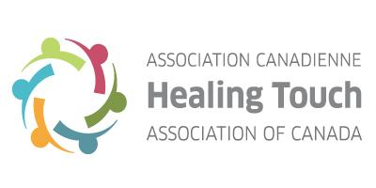

VENDOR APPLICATION FORM

Thank you for your interest in being a vendor at the "Pathway to The Heart” Conference being hosted by the Healing Touch Association of Canada. The Conference will take place at King’s University College in London, Ontario, May 14, 15 and 16, 2021.

- Vendor tables are available for
  - May 14 and 15, 2021 only.
  - To reserve your table(s) please complete the following and provide payment by e-transfer to:
treasurer@healingtouchassociation.ca.

Company Name :
Address:
Contact Person:
Phone:
E-Mail:

Registration Price: | One day: $80.00  Weekend: $120.00
Exhibitor table (4’ x 8’). | Display Time:  Friday 8:30 am - 8:00 pm  Saturday: 8:30am- 6:00pm
No. of Booths
Total Amount
(Due by March 1, 2021)

Thank you for your full payment for your vendor table(s). Tables are reserved on a selection criteria then first come first served basis. Applications are considered complete once payment is received. Selected vendors will be notified by email by March 15, 2021. If you have any questions please feel free to contact Ivy Tran at ivy.tran@hotmail.com.

On behalf of the Healing Touch Association of Canada and the London Organizing Committee a heartfelt and sincere thank you for making “Pathway to the Heart” a joyous success!

Warm regards,

2021 Conference Committee

