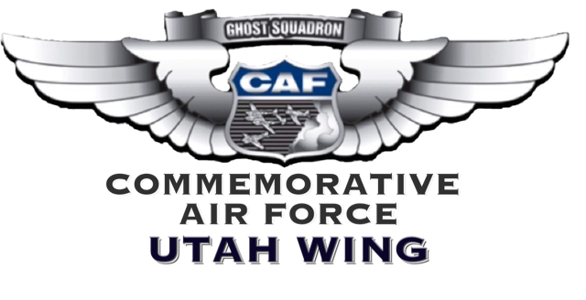
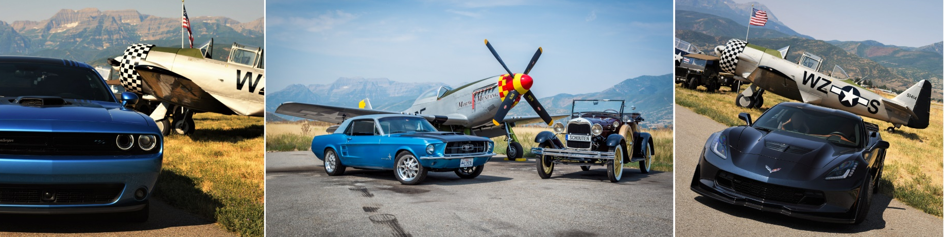
PLANES AND HORSEPOWER
VENDOR APPLICATION FORM
Planes and Horsepower will be opening up airport space to a limited number of vendors. Application does not guarantee acceptance. Minimum entry fee is $80.00 for a 10x10’ space, with additional charges based on space requirements. All vendors will also pay a 10% commission on gross sales at the conclusion of the show. All vendors will be required to obtain the necessary Utah State tax license and pay the appropriate taxes. Display only vendors will be exempt from this requirement. The Utah Wing reserves the right to exclude vendors on the basis of theme or any other interest to our event or organization.

Business Name: Contact:
Business Address:
Mailing Address:
City: State: Zip:
Phone: Email:
Business Website:
Category: Food □ Retail □ Other □
Short Description of Items Being Sold:

Sales Tax License Number (REQUIRED):
Method of Payment: Check □ Cash □ Online □

Vendors will be allowed to set up at 7 AM on August 8th. Any other setup requirements need to be cleared with airport management. No vendor will set up without direction from car show management. All vendors are bound by Heber City and airport regulations.

Rules and Regulations
- Food vendors must provide a ​copy of a Wasatch County Food Handler Permit sent to the Commemorative Air Force—UT Wing no later than one week before the show​. Contact ​Heber City (Utah) Health Dept. at 435-654-2700​ for more information. The permit must be displayed in a visible spot before any food is distributed and must be left in the visible spot until the event is over.
- Vendors are responsible for furnishing their own equipment. No tables, chairs, canopies, or ballast weights will be provided by the Utah Wing.
- Vendors are responsible for their own delivery, setup, take down, and complete removal of their displays. No equipment will be left on airport grounds after the event.
- Canopies and tent covers cannot be left set up on airport grounds overnight.
- The Utah Wing assumes no responsibility for the security of items on display or personal items.
- No generators are permitted.
- Vendors are responsible for securing their tents or canopies. Recommendation is to use at least 40-pound solid weights on each corner. Spikes or any sort of tiedown rods are prohibited.
- No refunds will be given for approved vendors who cancel or cannot make the event.
- Vendor is responsible for collecting and paying all applicable state sales taxes.

I agree to abide by the rules and regulations stated in this application and accept total responsibility for my booth space and property while attending the event. I agree that I am responsible to leave the space I occupied in good condition, as I found it. I agree that no vendor vehicles are permitted in the event area during the event and vehicles left within the perimeter will be towed at owners’ expense. Further, I agree that photographs taken of me, my booth, products, and/or works may be used by the Commemorative Air Force—Utah Wing for promotional purposes.

Signature Date

Email completed forms to James.A.Humpherys@gmail.com, or mail physical forms to the address below. Payment will be accepted with cash or check with the physical form or online at www.cafutahwing.org/bit.ly/CAFUTsales.
Please make checks payable to:

Commemorative Air Force—Utah Wing.
PO Box 507
Heber City, UT 84032

