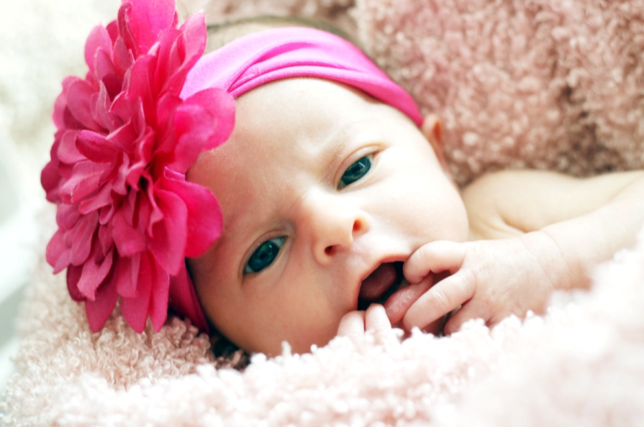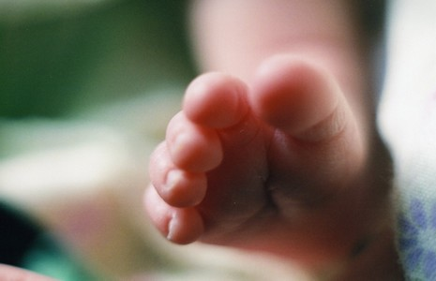

**Powered by: www.savewordtemplates.net**

With love,

[Your  
Family’s Names]

Announcing the birth of

Your Baby Girl

[Birth Date and Time]

[Pounds, Ounces, and Inches]