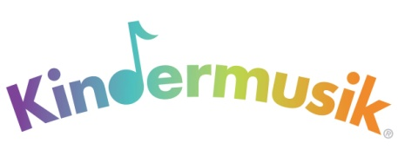

Release Form for Media Recording
I, the undersigned, do hereby consent and agree that Kindermusik International, its employees, licensees, or agents have the right to take photographs, videotape, or digital recordings of me to use these in any and all media, now or hereafter known. I further consent that my first name, my child’s age and first name only may be revealed therein or by descriptive text or commentary,. Kindermusik does not share or release private information to the public or any partners.
I do hereby release to Kindermusik International, its agents, and employees all rights to exhibit this work in print and electronic form publicly or privately and to market and sell copies. I waive any rights, claims, or interest I may have to control the use of my identity or likeness in whatever media used.
I understand that there will be no financial or other remuneration for recording me, either for initial or subsequent transmission or playback.
I also understand that Kindermusik International is not responsible for any expense or liability incurred as a result of my participation in this recording, including medical expenses due to any sickness or injury incurred as a result.
I represent that I am at least 18 years of age, have read and understand the foregoing statement, and am competent to execute this agreement.
Full Name: Date:
[1] Child’s First Name: [1] Child’s Age:
[2] Child’s First Name: [2] Child’s Age:
[3] Child’s First Name: [3] Child’s Age:
[Write additional children’s names and ages on back]
Address:
Signature:

