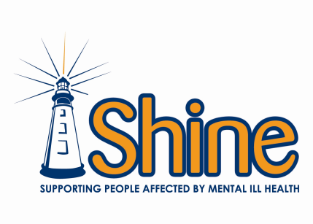
Media Release Form for Blog

I authorise Shine to publish my work on the www.shine.ie Blog and confirm that the submitted material is indeed my own work.

By signing this Media Release Form, I agree to let Shine publish my work on the www.shine.ie Blog and future Shine publications, such as newsletters and annual reports. I understand that these publications may also appear on www.shine.ie and any work published on the website can be picked up by search engines.
Signed: ________________________________________________________________

Participant’s Name (Block Capitals):__________________________________________________

Title of submission:_________________________________________________________________

