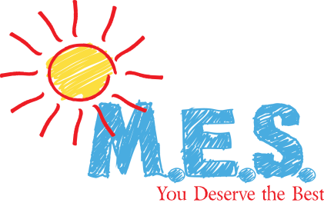

Media Release Form

\\\\

I, the parent(s)/guardian(s) of____________________________________,hereby authorize Marvin’s Education Services to use, reproduce, and/or publish all written and/or visual materials, including photographs that may pertain to me. I understand that this material may be used in various publications, public affair releases, recruitment materials, or other related endeavors. This material may also appear on several Internet web pages as well as social media. This authorization is perpetual and may only be withdrawn by specific rescission of this authorization. Consequently, Marvin’s Education Services may publish materials, use my name, photograph, and/or may reference my child/children in any manner that Marvin’s Education Services deem appropriate.

Signature of Parent / Guardian:

______________________________________

Date:
_________________

