C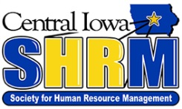
Social Media Release Form
I hereby consent to release for possible publication my name and/or photo(s) and/or video images taken by any authorized Central Iowa Society of Human Resource Management (“CISHRM”) representative, or any media representative for news and/or publicity purposes. This may include television, newspaper, magazine article, social media websites, and/or CISHRM publications (newsletters, flyers, brochures, web pages, etc.). I also agree to allow the publication or broadcast of my name in connection with any photo(s) and/or video images taken, and I understand that I will not receive remuneration for my voluntary participation or future use of any photo(s) and/or images of me. I understand that photos and/or videos for the media and/or World Wide Web may be used in publications and/or websites outside of CISHRM control.
This consent remains in effect indefinitely unless notice of revocation of authorization by consentor is submitted in writing to CISHRM. For more information please contact (________________).

NAME: ___________________________________________

ADDRESS: ________________________________________

CITY: ____________________________________________

STATE: _____________________ ZIP: ______________

SIGNATURE: ______________________________________

DATE: ___________________________________________

