MEDIA RELEASE FORM 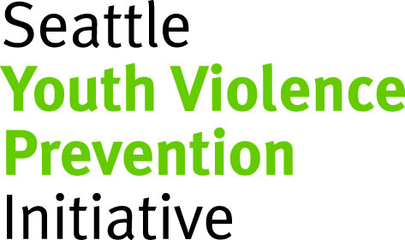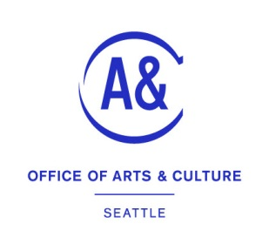

I hereby grant the Work Readiness Arts Partners: Seattle Youth Violence Prevention Initiative (SYVPI) and the Seattle Office of Arts & Culture (ARTS) permission to use information I share with them about myself and my experience and photographs of me in any and all of its publications, including websites, without payment or any other consideration.

I understand and agree that these materials will become the property of SYVPI & ARTS and will not be returned.

I irrevocably authorize SYVPI & ARTS to edit, copy, exhibit, publish, distribute or not use my story for purposes of publicizing the work of SYVPI & ARTS.

In addition, I waive the right to inspect or approve the finished product, including the written or electronic copy, where my information appears.

Additionally, I waive any right to compensation arising or related to the use of the information.
I hold harmless and release and forever discharge SYVPI from all claims, demands and causes of action which I or my representatives or other persons acting on my behalf may have by reason of this authorization.

_____I am 18 years of age and competent to contract in my own name.
_____I am under 18 years of age and a parent or legal guardian authorizes and contracts with his or her signature below.

___________________________________________ _________________________
Signature of Youth Date

___________________________________________
Printed name of youth

___________________________________________ _________________________
Signature of Parent or legal guardian Date

___________________________________________
Printed name of Parent or legal guardian

