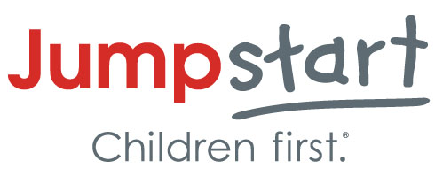

Media Release

I, ________________________________ ,
Please insert first and last name
consent for my child, ________________________________ .
Please insert first and last name

Jumpstart has permission to take photographs, publish my child’s story, and/or record my child on video and I agree that these photographs taken may be used for educational and/or publicity purposes only, including coverage on Jumpstart’s website, social media channels, and traditional media.

__________________________________________________________________
Signature Date

About Jumpstart
Jumpstart is a national early education organization working toward the day every child in America enters kindergarten prepared to succeed. Jumpstart delivers a research-based and cost-effective program by training college students and community volunteers to serve preschool-age children in low-income neighborhoods. Through a proven curriculum, these children develop the language and literacy skills they need to be ready for kindergarten, setting them on a path for lifelong success. Jumpstart is also a proud member of the AmeriCorps national service network. Learn more at jstart.org and follow us on Twitter at @Jumpstartkids.

