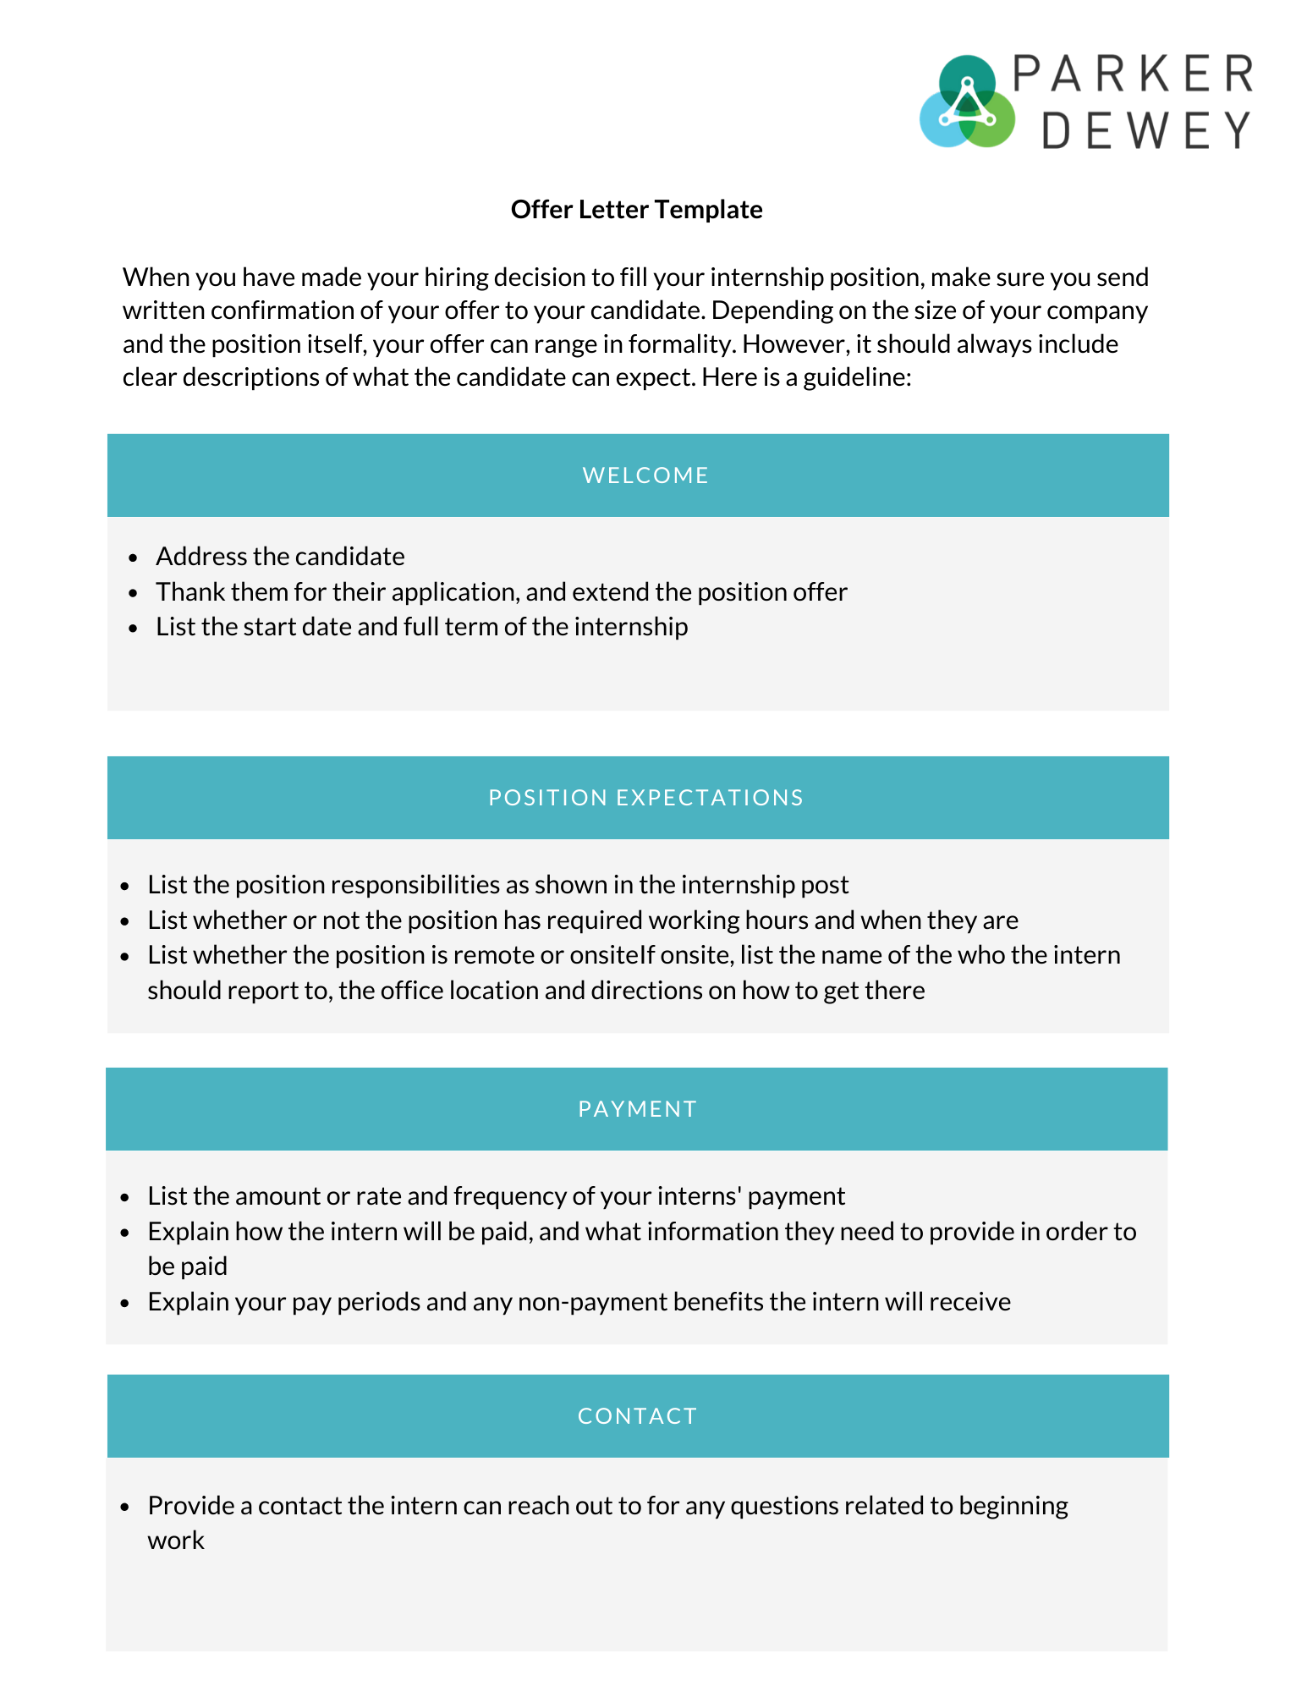
Dear [candidate],

We are pleased to offer you the position of [internship position name] and welcome you to [organization ]. Among all of our applicants, we believe you will be a great addition to the team. This Internship will begin on [internship start date] and run until [internship end date].

As a reminder, your role in this internship will be primarily focused on [primary internship role], and will include additional experiences and responsibilities such as:
- [internship responsibility job description]
- [internship responsibility job description]
- [internship responsibility job description]

Starting on [internship start date], your hours will generally be from [starting time] to [ending time], on [days of week]. This internship is [onsite or remote], at our offices at [office address]. When you arrive, [instruction for arriving at the correct office], ask for [internship supervisor] who will provide you with information you need to begin.

For your work at [organization name], you will be paid [rate or stipend amount/ frequency]. In order to enter you into our payroll system, please bring [requirements for being paid]. More information regarding pay periods and payment will be provided on your first day. Additionally, you will also receive [non-monetary employee benefits].

Once again, we are excited for you to begin working with us. Please feel free to email me with any questions you have before starting.

Sincerely,

