Notice of rent increase to resident/s of rooming house
Residential Tenancies Act 1997 (the Act) Section 101
Residential Tenancies Regulations 2019, Regulation 16

Note: Enter text in spaces provided only. This form will be invalid if you remove or change any questions or other text.
Use this form for giving notice to resident/s of a rent increase.
- Please note you can only use this form to notify of one rent increase at a time.
- Please note that owners cannot increase rent more often than once every 6 months.

How to use this form

1. Complete questions 1 to 7
You must complete all boxes.

2. Complete 8
Write in the new rent amount and the date on which the rent increase will start (date must be at least 60 days from the date of this notice).

3. Sign at 9 and write your name at 10

4. When the form is complete
Tear out the top two forms (Resident’s copy) and send both to the resident.
Keep the last copy of the form for your records.

How to serve this notice
You can serve this notice by hand, by post or by email (with consent).
If you send a notice by post, you must take into account the extra days it takes for the notice to be delivered. Australia Post has three different speeds for ordinary mail delivery – express, priority and regular mail, which may take up to six days. Priority and regular delivery speeds also apply for registered post. You may wish to keep evidence of the mail delivery method you relied on to send this notice.
For more information about Australia Post’s mail delivery options and times, visit the Australia Post website (auspost.com.au).
You can only send this notice by email if you already have the resident’s written consent to receive notices and other documents this way. The resident may have given consent in the residency agreement or separately in writing. A consent form is available from the Forms and publications section – Consumer Affairs Victoria website (consumer.vic.gov.au/forms).
If you send this notice by email, the provisions of the Electronic Transactions (Victoria) Act 2000 apply. For legal purposes, the time when a notice is received is when it can be retrieved from the email address the recipient nominated.
To help calculate the total minimum days to allow, depending on the notice period required and the method of delivery, visit the Giving notices – Residential Tenancies List page – Victorian Civil and Administrative Tribunal (VCAT) website (vcat.vic.gov.au/resources/giving-notices-residential-
tenancies-list).
If you need help with this notice, visit the Renting
section – Consumer Affairs Victoria website (consumer.vic.gov.au/renting) or call the Consumer Affairs Victoria Helpline on 1300 55 81 81.

Telephone Interpreter Service
If you have difficulty understanding English, contact the Translating and Interpreting Service (TIS) on 131 450 (for the cost of a local call) and ask to be put through to an Information Officer at Consumer Affairs Victoria on
1300 55 81 81.
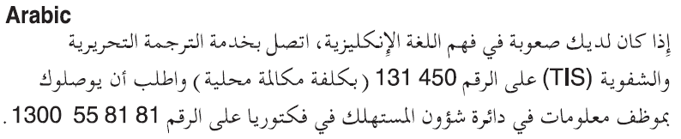
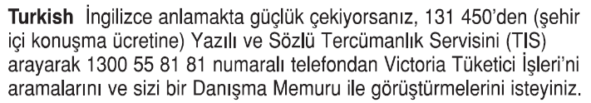
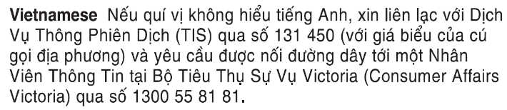
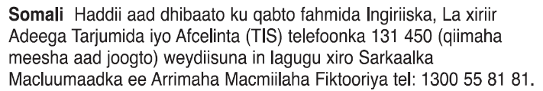
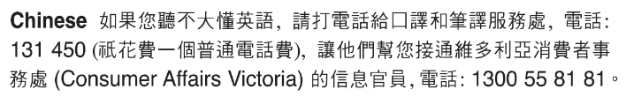
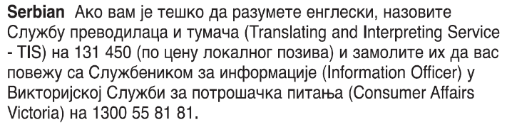
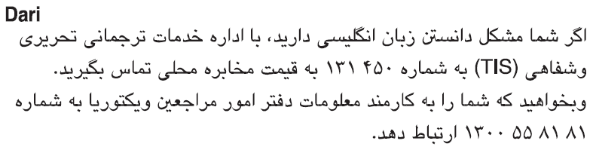
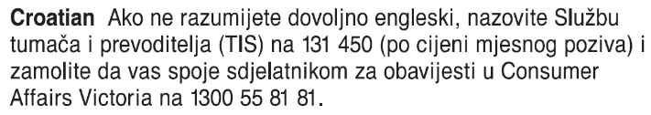
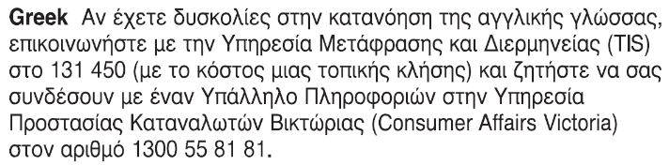
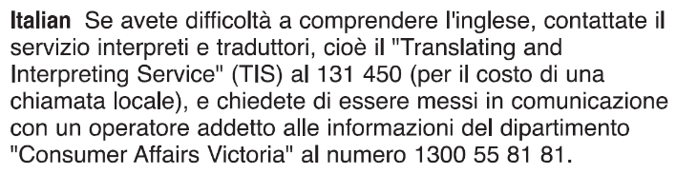

Notice of rent increase to resident/s of rooming house From the owner
Residential Tenancies Act 1997 (the Act) Section 101 Resident’s copy
Residential Tenancies Regulations 2019 Regulation 16

Resident details
- This notice is given to: (resident/s names)
- Regarding the rooming house at:
(write address and include room number)
- Resident/s address:
(if same address as 2, write ‘as above’)

Owner details
- Name of the owner of the rooming house:
(insert name of owner, cannot be an agent’s name)
- Address of owner (of the rooming house) for the purpose of serving documents: (can be an agent’s address)
- Contact telephone numbers: (of owner or agent)
Business hours:
After hours:

Service details
- This notice is given: (mark one method only and if posted note the delivery speed)
by hand:
by registered post:
by ordinary post:
by email:
Insert email address:
(if applicable)
on (date): | / /

Rent increase amount and start date
- I am giving you at least 60 days notice that I propose to increase the rent.
The current rent is: ($)
Per: (week/fortnight/month)
The new rent is: ($)
Per: (week/fortnight/month)
and will commence on:  (start date) | / /
- Signature of owner or agent:
- Name of owner or agent signing this notice:
- If you consider this proposed rent increase is excessive, you can apply to the Director of Consumer Affairs Victoria within 30 days after this notice is given to investigate and report on the proposed rent, under section 102 of the Residential Tenancies Act 1997.
Resident note: Excessive rent is determined according to the accepted market rental value of the premises.
- The rooming house owner cannot increase your rent more often than once every 6 months.
- Under a fixed term tenancy agreement, a rooming house owner cannot increase the rent before the fixed term ends unless the agreement specifically provides for an increase.
- If you need help with this notice, call the Consumer Affairs Victoria Helpline on 1300 55 81 81 or visit consumer.vic.gov.au/renting

Rent increase investigation (no cost)
(note: this section is not part of the notice)
If you request an investigation, it must be in writing.
You can apply for an investigation, by ticking the box below, writing your daytime telephone number, and posting a copy of this form to Director of Consumer Affairs Victoria, GPO Box 123 Melbourne 3001, or email to renting@justice.vic.gov.au
After your request has been received, a Residential Tenancies Inspector will contact you.
Yes the resident/s apply for a rent increase investigation:
Resident/s daytime telephone number:
Privacy notification – Consumer Affairs Victoria collects and handles your personal information consistent with the requirements of the Privacy and Data Protection Act 2014. Without this information we may be unable to process this transaction. You are able to request access to the personal information that we hold about you, and to request that it be corrected by contacting Consumer Affairs on 1300 55 81 81, the Information and Privacy Unit on 8684 0178 or the Freedom of Information Unit on 8684 0063.

Notice of rent increase to resident/s of rooming house From the owner
Residential Tenancies Act 1997 (the Act) Section 101 Resident’s copy
Residential Tenancies Regulations 2019 Regulation 16

Resident details
- This notice is given to: (resident/s names)
- Regarding the rooming house at:
(write address and include room number)
- Resident/s address:
(if same address as 2, write ‘as above’)

Owner details
- Name of the owner of the rooming house:
(insert name of owner, cannot be an agent’s name)
- Address of owner (of the rooming house) for the purpose of serving documents: (can be an agent’s address)
- Contact telephone numbers: (of owner or agent)
Business hours:
After hours:

Service details
- This notice is given: (mark one method only and if posted note the delivery speed)
by hand:
by registered post:
by ordinary post:
by email:
Insert email address:
(if applicable)
on (date): | / /

Rent increase amount and start date
- I am giving you at least 60 days notice that I propose to increase the rent.
The current rent is: ($)
Per: (week/fortnight/month)
The new rent is: ($)
Per: (week/fortnight/month)
and will commence on:  (start date) | / /
- Signature of owner or agent:
- Name of owner or agent signing this notice:
- If you consider this proposed rent increase is excessive, you can apply to the Director of Consumer Affairs Victoria within 30 days after this notice is given to investigate and report on the proposed rent, under section 102 of the Residential Tenancies Act 1997.
Resident note: Excessive rent is determined according to the accepted market rental value of the premises.
- The rooming house owner cannot increase your rent more often than once every 6 months.
- Under a fixed term tenancy agreement, a rooming house owner cannot increase the rent before the fixed term ends unless the agreement specifically provides for an increase.
- If you need help with this notice, call the Consumer Affairs Victoria Helpline on 1300 55 81 81 or visit consumer.vic.gov.au/renting

Rent increase investigation (no cost)
(note: this section is not part of the notice)
If you request an investigation, it must be in writing.
You can apply for an investigation, by ticking the box below, writing your daytime telephone number, and posting a copy of this form to Director of Consumer Affairs Victoria, GPO Box 123 Melbourne 3001, or email to renting@justice.vic.gov.au
After your request has been received, a Residential Tenancies Inspector will contact you.
Yes the resident/s apply for a rent increase investigation:
Resident/s daytime telephone number:
Privacy notification – Consumer Affairs Victoria collects and handles your personal information consistent with the requirements of the Privacy and Data Protection Act 2014. Without this information we may be unable to process this transaction. You are able to request access to the personal information that we hold about you, and to request that it be corrected by contacting Consumer Affairs on 1300 55 81 81, the Information and Privacy Unit on 8684 0178 or the Freedom of Information Unit on 8684 0063.

Notice of rent increase to resident/s of rooming house From the owner
Residential Tenancies Act 1997 (the Act) Section 101 Owner’s copy
Residential Tenancies Regulations 2019 Regulation 16

Resident details
- This notice is given to: (resident/s names)
- Regarding the rooming house at:
(write address and include room number)
- Resident/s address:
(if same address as 2, write ‘as above’)

Owner details
- Name of the owner of the rooming house:
(insert name of owner, cannot be an agent’s name)
- Address of owner (of the rooming house) for the purpose of serving documents: (can be an agent’s address)
- Contact telephone numbers: (of owner or agent)
Business hours:
After hours:

Service details
- This notice is given: (mark one method only and if posted note the delivery speed)
by hand:
by registered post:
by ordinary post:
by email:
Insert email address:
(if applicable)
on (date): | / /

Rent increase amount and start date
- I am giving you at least 60 days notice that I propose to increase the rent.
The current rent is: ($)
Per: (week/fortnight/month)
The new rent is: ($)
Per: (week/fortnight/month)
and will commence on:  (start date) | / /
- Signature of owner or agent:
- Name of owner or agent signing this notice:
- If you consider this proposed rent increase is excessive, you can apply to the Director of Consumer Affairs Victoria within 30 days after this notice is given to investigate and report on the proposed rent, under section 102 of the Residential Tenancies Act 1997.
Resident note: Excessive rent is determined according to the accepted market rental value of the premises.
- The rooming house owner cannot increase your rent more often than once every 6 months.
- Under a fixed term tenancy agreement, a rooming house owner cannot increase the rent before the fixed term ends unless the agreement specifically provides for an increase.
- If you need help with this notice, call the Consumer Affairs Victoria Helpline on 1300 55 81 81 or visit consumer.vic.gov.au/renting

Rent increase investigation (no cost)
(note: this section is not part of the notice)
If you request an investigation, it must be in writing.
You can apply for an investigation, by ticking the box below, writing your daytime telephone number, and posting a copy of this form to Director of Consumer Affairs Victoria, GPO Box 123 Melbourne 3001, or email to renting@justice.vic.gov.au
After your request has been received, a Residential Tenancies Inspector will contact you.
Yes the resident/s apply for a rent increase investigation:
Resident/s daytime telephone number:
Privacy notification – Consumer Affairs Victoria collects and handles your personal information consistent with the requirements of the Privacy and Data Protection Act 2014. Without this information we may be unable to process this transaction. You are able to request access to the personal information that we hold about you, and to request that it be corrected by contacting Consumer Affairs on 1300 55 81 81, the Information and Privacy Unit on 8684 0178 or the Freedom of Information Unit on 8684 0063.

